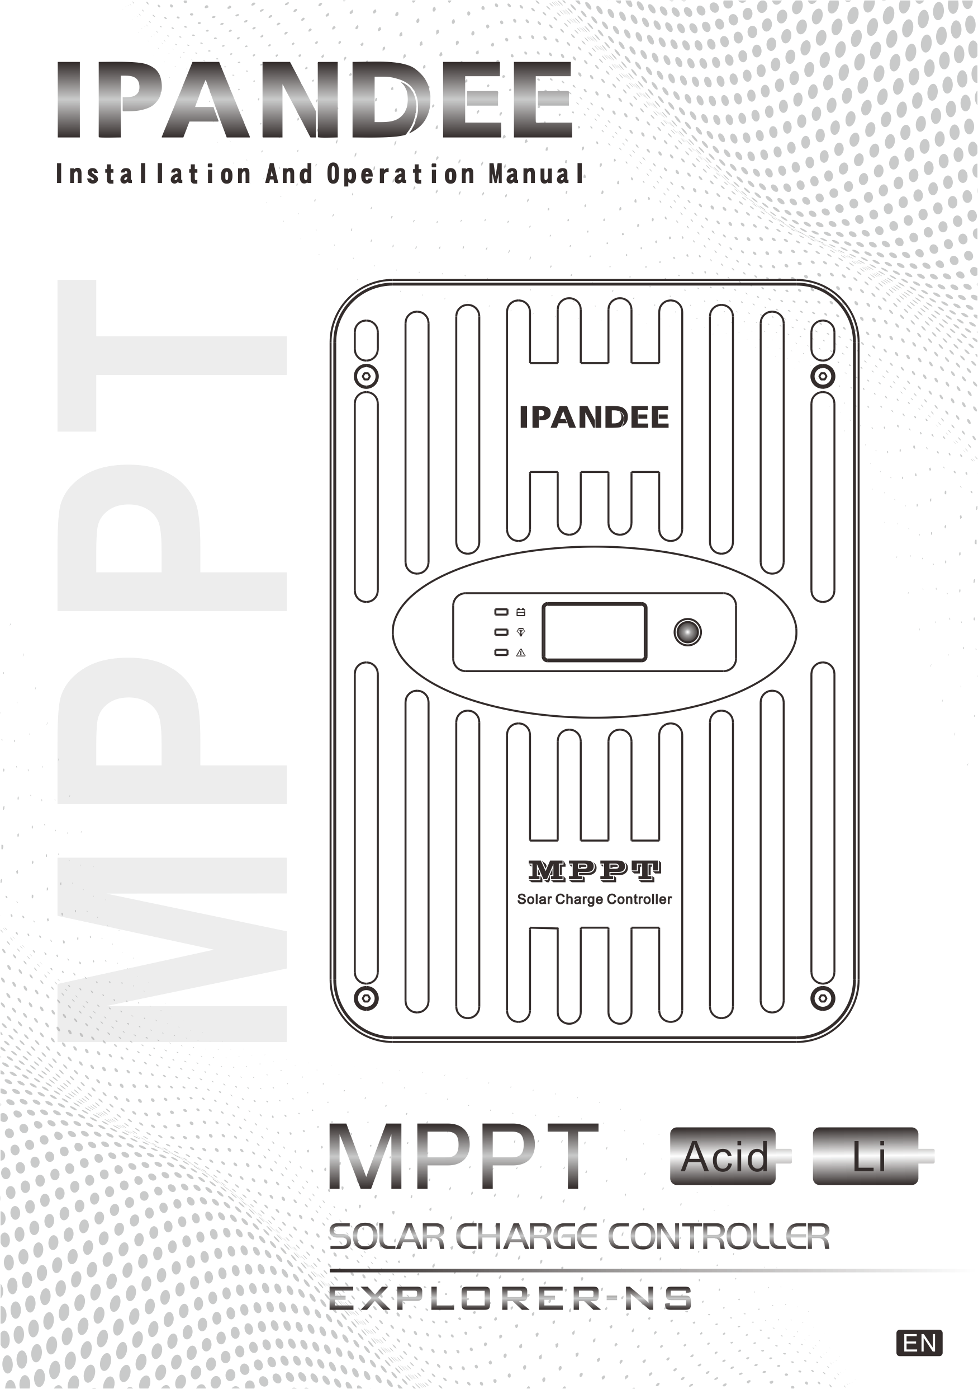

DIMENSIONS 1
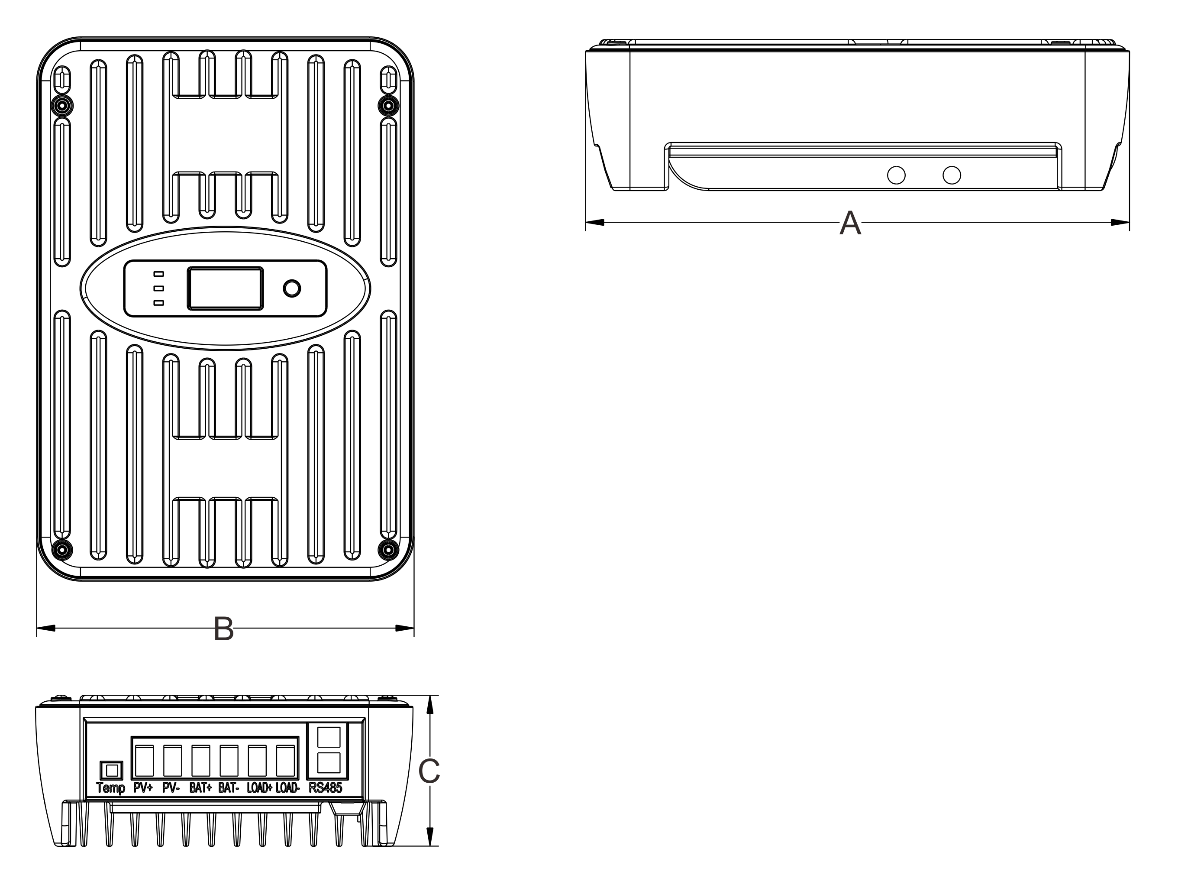

Type | A |  | B |  | C
 | in | mm | in | mm | in | mm
NS24L30 | 8.66 | 220 | 5.83 | 148 | 2.52 | 64
NS24L40 | 8.66 | 220 | 5.83 | 148 | 2.52 | 64
NS24H50 | 9.64 | 245 | 6.69 | 170 | 2.68 | 68
NS24H60 | 9.64 | 245 | 6.69 | 170 | 2.68 | 68

SPECIFICATION SUMMARY
Type | NS24L30 | NS24L40 | NS24H50 | NS24H60
Nominal Battery Voltage | 12/24V | 12/24V | 12/24V | 12/24V
Max.PV Open-Circuit Voltage* | 100V | 100V | 150V | 150V
Nominal Max.Input Power** | 420/840W | 560/1120W | 700/1400W | 840/1680W
Max.Battery Charging Current | 30A | 40A | 50A | 60A
Rated Load Current | 20A | 20A | 30A | 30A

*Array voltage should never exceed this limit.
**These power limits refer to the maximum wattage the MPPT can manage. Higher power arrays can be used without damaging the controller.

0 TABLE OF CONCENTS 0
1.0 Important Safely Instructions 1
2.0 General Information 4
2.1 Features 4
2.2 Attached Accessories 4
2.3 Optional Accessories 5
3.0 Installation Instructions 6
3.1 General Installation Notes 6
3.2 Mounting 7
4.0 Operation 9
4.1 Max Power Point Tracking Technology 9
4.2 Battery Charging 10
4.3 Load Control Information 11
4.4 LED Indications 12
4.5 Button And Display 13
5.0 Trouble Shooting 14
6.0 Technical Specifications 15

1.0 IMPORTANT SAFETY INSTRUCTIONS 0
SAVE THESE INSTRUCTIONS.
This manual contains important safety, installation, and operating for the MPPT solar controller.
The following symbols are used throughout this manual to indicate potentially dangerous conditions or mark important safety instructions:
WARNING: Indicates a potentially dangerous condition. Be careful when performing related operations.
CAUTION: Indicates a critical procedure for safe and proper operation of the controller.
NOTE: Indicates a procedure or function that is important to the safe and proper operation of the controller.
Safety Information 0
● Read all of the instructions and cautions in the manual before installation.
● There are no user serviceable parts inside the MPPT. Do not disassemble or attempt to repair the controller
WARNING: Risk Of Electrical Shock. NO POWER OR ACCESSORY TERMINALS ARE ELECTRICALLY ISOLATED FROM DC INPUT, AND MAY BE ENERGIZED WITH HAZARDOUS SOLAR VOLTAGE. UNDER CERTAIN FAULT CONDITIONS, BATTERY COULD BECOME OVER-CHARGED. TEST BETWEEN ALL TERMINALS AND GROUND BEFORE TOUCHING.
WARNING: THE COMMUNICATION PORT IS NOT AN ISOLATION SOURCE AND ISOLATION SIGNAL. PLEASE BE CAREFUL WHEN CONNECTING WITH OTHER EQUIPMENT.
● External solar and battery disconnects are required.
● Disconnect all sources of power to the controller before installing or adjusting the MPPT.

Installation Safety Precautions 0
WARNING: This unit does not contain GFDI device.

● Mount the MPPT indoors. Prevent exposure to the elements and do not allow water to enter the controller.
● Install the MPPT in a location that prevents casual contact. The MPPT heatsink can become very hot during operation.
● Use insulated tools when working with batteries.
● Avoid wearing jewelry during installation.
● The battery bank must be comprised of batteries of same type, make, and age.
● Do not smoke near the battery bank.
● Power connections must remain tight to avoid excessive heating from a loose connection.
● Use properly sized conductors and circuit interrupters.
● The grounding terminal is located at the bottom of the case.
The MPPT controller must be installed by a qualified technician in accordance with the electrical regulations of the country of installation.
A means of disconnecting all power supply poles must be provided. These disconnects must be incorporated in the fixed wiring.
The MPPT negative power terminals are common, and must be grounded as instructions, local codes, and regulations require.
A permanent, reliable earth ground must be established with connection to the MPPT ground terminal.
The grounding conductor must be secured against any accidental detachment.
Battery Safety 0
WARNING: A battery can present a risk of electrical shock or burn from large amounts of short-circuit current, fire, or explosion from vented gases. Observe proper precautions.
WARNING: Risk of Explosion. Proper disposal of batteries is required. Do not dispose of batteries in fire. Refer to local regulations or codes for requirements.
CAUTION: When replacing batteries, use properly specified number, sizes, types, and ratings based on application and system design.
CAUTION: Do not open or mutilate batteries. Released electrolyte is harmful to skin, and may be toxic.
● Servicing of batteries should be performed, or supervised, by personnel knowledgeable about batteries, and the proper safety precautions.
● Be very careful when working with large lead-acid batteries. Wear eye protection and have fresh water available in case there is contact with the battery acid.
● Remove watches, rings, jewelry and other metal objects before working with batteries.
● Wear rubber gloves and boots.
● Use tools with insulated handles and avoid placing tools or metal objects on top of batteries.
● Disconnect charging source prior to connecting or disconnecting battery terminals.
● Determine if battery is inadvertently grounded. If so, remove the source of contact with ground. Contact with any part of a grounded battery can result in electrical shock. The likelihood of such a shock can be reduced if battery grounds are removed during installation and maintenance (applicable to equipment and remote battery supplies not having a grounded supply circuit).
● Carefully read the battery manufacturer's instructions before installing / connecting to, or removing batteries from, the MPPT.
● Be very careful not to short circuit the cables connected to the battery.
● Have someone nearby to assist in case of an accident.
● Explosive battery gases can be present during charging. Be certain there is enough ventilation to release the gases.
● Never smoke in the battery area.
● If battery acid comes into contact with the skin, wash with soap and water. If the acid contacts the eye, flood with fresh water and get medical attention.
● Be sure the battery electrolyte level is correct before starting charging. Do not attempt to charge a frozen battery.
● Recycle the battery when it is replaced.

2.0 GENERAL INFORMATION 0
2.1 Features 0
The features of the MPPT are shown in below. An explanation of each feature is provided.
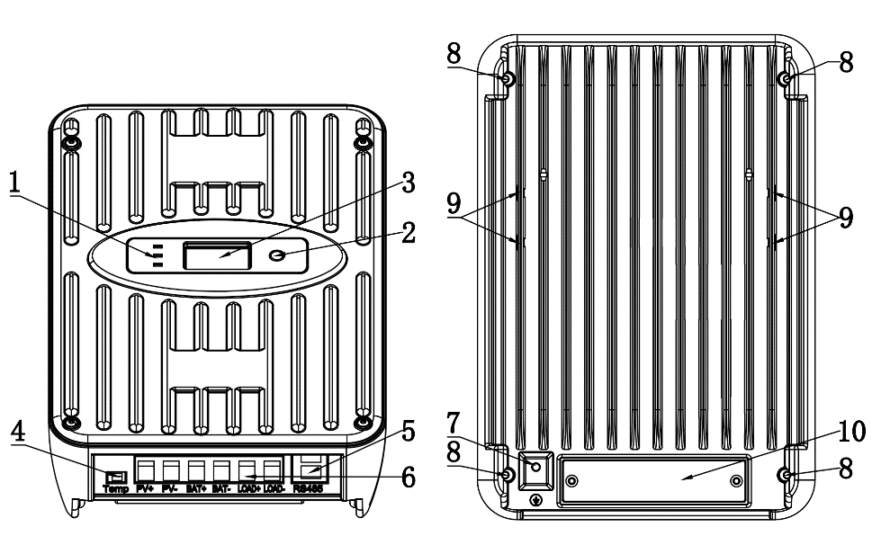
1 – Charging status / Load output status / Error LED
2 – Function button
3 – Digital OLED display
4 – Temperature sensor terminals
5 – Dual RJ45 serial communication ports
6 – Input and output terminals (PV+/PV-/BAT+/BAT-/LOAD+/LOAD-)
7 – Dedicated for grounding wire
8 – Reverse fixing hole
9 – Mounting holes for positively fixed fittings
10 – Terminal cover plate
2.2 Attached Accessories 0
1 – Aluminum alloy mounting hanger
2 – Temperature sensing cable
3 – Plastic expansion particles
4 – M4 screws
5 – User manual
2.3 Optional Accessories 0
The following accessories are available for purchase separately from your authorized dealer:
MH-M80(Meter)
The digital Remote Meter displays system operating information, error indications. Information is displayed on an OLED display. Additionally, 3 status LEDs provide system status at a glance. The Meter can easily set the parameters of the controller. The meter can be flush mounted in a wall or surface mounted using the mounting frame (included). The MH-M80 is supplied with 3.3 ft (1.0 m) of cable (Can be extended), a mounting frame, and mounting screws. The MH-M80 connects to the RJ-45 port on the MPPT. The MH-M80 cannot be used with other’s outside device.
MH-S80(Meter)
The digital Remote Meter displays system operating information, error indications. Information is displayed on an OLED display. The Meter can easily set the parameters of the controller. The Meter can be connected to 4 controllers at most, and the controllers of the same battery system can work in parallel. The meter can be flush mounted in a wall or surface mounted using the mounting frame (included). The MH-S80 is supplied with 3.3 ft (1.0 m) of cable (Can be extended), a mounting frame, and mounting screws. The MH-S80 connects to the RJ-45 port on the MPPT. The MH-S80 cannot be used with other’s outside device.
USB-RS485 Cable
The USB-RS485 cable converts the RJ45 electrical interface to a standard USB interface which enables communication between the MPPT and a personal computer (PC). The cable can be used for programming custom charging setpoints, and for logging data in SolarMate. The cable cannot be used with other’s outside device.
BT-02
A modular wiring box that can be added to MPPT controller. The box acts as a transmitter (Near field remote control), users can use the mobile app to control the MPPT through bluetooth. The wire box cannot be used with other’s outside device.
Cloud-Box-M2
A modular wiring box that can be added to MPPT controller. The box acts as a transmitter (Cloud remote control), users can use the mobile APP to control the MPPT through internet. The wire box cannot be used with other’s outside device.
3.0 INSTALLATION INSTRUCTIONS 0
3.1 General Installation Notes 0
● Read through the entire installation section first before beginning installation.
● Be very careful when working with batteries. Wear eye protection. Have fresh water available to wash and clean any contact with battery acid.
● Use insulated tools and avoid placing metal objects near the batteries.
WARNING: Never install the MPPT in an enclosure with vented/flooded batteries. Battery fumes are flammable and will corrode and destroy the MPPT circuits.
CAUTION: When installing the MPPT in an enclosure, ensure sufficient ventilation. Installation in a sealed enclosure will lead to over-heating，reduced power operation and a decreased product lifetime.
● Do not install in locations where water can enter the controller.
● Loose power connections and /or corroded wires may result in resistive connections that melt wire insulation, burn surrounding materials, or even cause fire. Ensure tight connections and use cable clamps to secure cables and prevent them from swaying in mobile applications.
● Preset charging profiles are generally designed for common batteries. Custom settings can be used for varied charging requirements (see sections 4.2 for details).
● The MPPT battery connection may be wired to one battery, or a bank of batteries.
● The MPPT prevents reverse current leakage at night, so a blocking diode is not required in the system.
● The MPPT is designed to regulate ONLY solar (photovoltaic) power. Connection to any other type of power source e.g. wind turbine or generator may void the warranty.
WARNING: Solar and battery fuses or DC breakers are required in the system. These protection devices are external to the MPPT controller.
WARNING: Installation must comply with Electrical Code requirements. Breakers and fuses may require lower ratings than referenced, so as not to exceed any specific wire ampacity.

3.2 Mounting 0
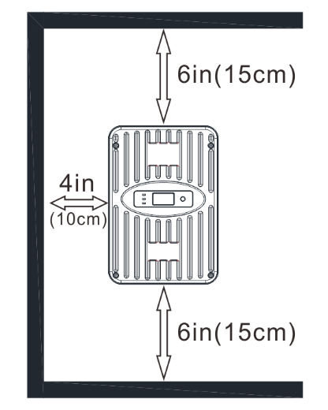
Inspect the controller for shipping damage. Do not install directly over an easily combustible surface since the heat sink may get hot under certain operating conditions.
For proper air flow, allow at least 15 cm (6 in) of space above and below the controller, and 50 mm (2 in) at the sides. Do not locate in an enclosure where battery gases can accumulate.
NOTE: The heat sink must be in a vertical position (fins up and down).
STEP 1: Check Controller Limitations
Verify that the highest temperature compensated solar array open-circuit voltage (Voc), and load current do not exceed the ratings of the MPPT version being installed. Multiple controllers can be installed in parallel on the same battery bank to achieve greater total charging current. In this type of system, each MPPT must have its own solar array. The load terminals of multiple controllers can only be wired together if the total load draw does not exceed the nameplate current of the LOWEST rated controller.
STEP 2: Fasten the installation accessories
Align the installation accessories with the mounting holes on the controller.
Fasten the installation accessories to the controller with M4 (4-M4 stainless steel screws are included)
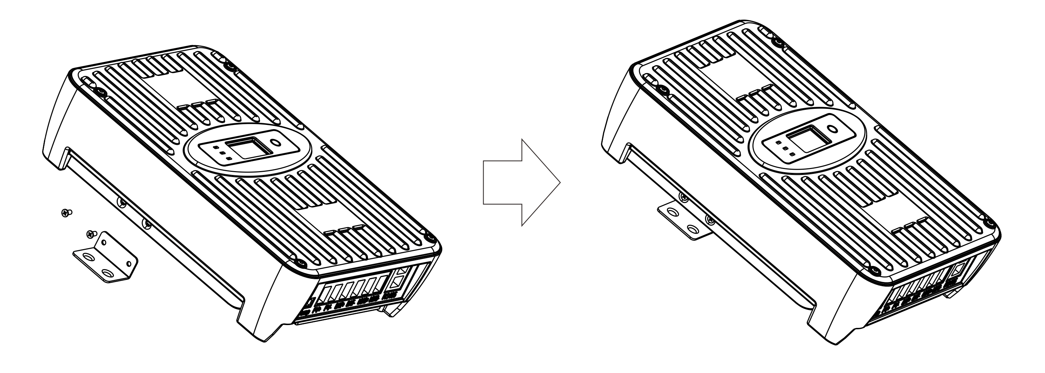
STEP 3: Connect input and output wires
Before wiring, it is necessary to open the cover plate on the back of the controller, then wiring according to the wire sequence and tighten the screws, and then install the cover plate again after confirmation.
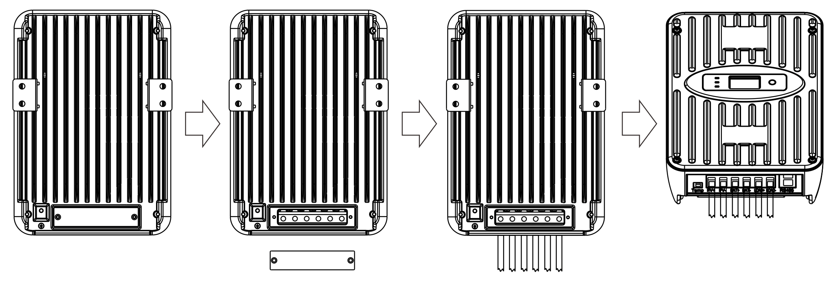
STEP 4: Drill mounting holes in the wall
Measure and mark the distance on the wall, drill 6mm holes and insert plastic expansion particles and tighten.
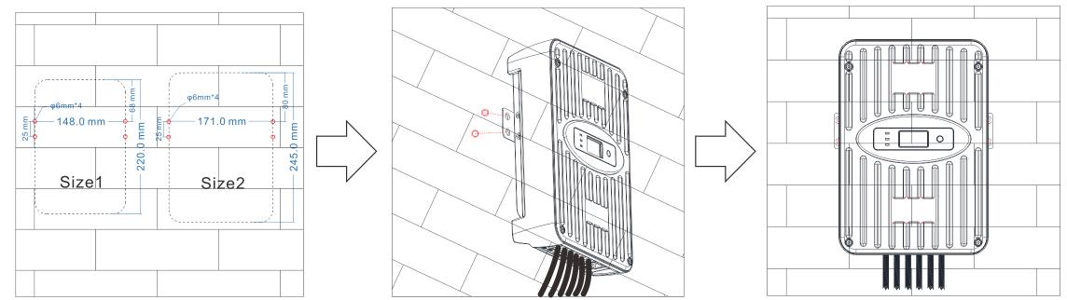
STEP 5: Mount the controller on the wall
Align the controller with the mounting hole, tighten the controller to the wall with M4 screws.
STEP 6: Power on and start working
Check that the solar panel and battery are in normal condition, and then switch on in the order of first battery and then solar panel.
NOTE: Before connecting the battery, measure the open-circuit voltage. It must be over 10 volts to start the controller. If the system voltage is set to Auto-detect, battery voltage over 18V will be detected as a 24V nominal battery, and the unit will charge accordingly. The 12/24V auto selection is only done at start-up.
Warning: Risk of damage
Disconnect the battery from the MPPT after the solar input is disconnected as far as possible. If the battery is removed during MPPT charging, there is a certain probability that the controller will be damaged.
To prevent damage, the power must be cut off under the following conditions:
Reverse order as power-up.

4.0 OPERATION 0
4.1 Max Power Point Tracking Technology 0
Power is the product of voltage and current (Volts x Amps), the following is true*:
(1) Power Into the MPPT = Power Out of the MPPT
(2) Volts In x Amps In = Volts Out x Amps Out
* assuming 100% efficiency i.e. if no losses in wiring and conversion existed.
If the solar module’s Vmp is greater than the battery voltage, it follows that the battery current must be proportionally greater than the solar input current so that input and output power are balanced. The greater the difference between the maximum power voltage and battery voltage, the greater the current boost.
Higher solar input voltage results in lower solar input current for a given input power. High voltage solar input strings allow for smaller gauge solar wiring. This is especially helpful for systems with long wiring runs between the solar array and the MPPT.
An Advantage Over Traditional Controllers Traditional controllers connect the solar module directly to the battery when recharging. This requires that the solar module operate in a voltage range that is below the module’s Vmp. In a 12V system, for example, the battery voltage may range from 10 - 15 Vdc but the module’s Vmp is typically around 17V. The figure below shows a typical current vs. voltage output curve for a nominal 12V charging system.
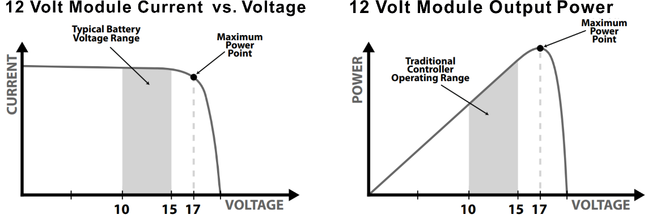

4.2 Battery Charging 0
Charging lead-acid batteries
The MPPT has a 4-stage battery charging algorithm for rapid, efficient, and safe battery charging.
1 - CC Stage (Constant Current Charging): Fast Charging
2 - CV Stage (Constant Voltage Charging): Absorption Charging
3 - CF Stage (Floating Charging): Protect the battery from long-term overcharge. And make up the loss of self-discharge
4 - Equalization Stage: Activate battery chemical reaction
Charging Lithium ion batteries
The MPPT will charge according to the specifications of lithium-ion battery, which is mainly divided into two stages. First stage, when the battery voltage is less than the saturation voltage, it will charge quickly, and the second stage, when the battery voltage is equal to the saturation voltage, it will absorb charge.
Battery Charge Setting 0
Charging parameters of lead-acid battery. All voltage settings listed are for nominal 12 Volt batteries. Multiply the voltage settings by two (2) for 24 Volt batteries.
Battery Charging Set-points (@ 25°C): [multiply voltages by (2) for 24 volt systems]
Bat Type | CV (volts) | CF (volts) | Equalize(volts) | Equalize(minutes)
Gel (GEL) | 14.2 | 13.8 | 14.4 | Custom
Sealed (SEL) | 14.4 | 13.8 | 14.6 | Custom
Flooded (FLD) | 14..6 | 13.8 | 14.8 | Custom
AGM | 14.1 | 13.7 | 14.4 | Custom
Custom | Custom | Custom | Custom | Custom
Charging parameters of lithium ion battery.
Bat Type | Nominal Voltage | Saturation Voltage | Cut-off Voltage
LiFePO4-4s | 12.8 | 14.4 | 10
LiFePO4-7s | 22.4 | 25.2 | 17.5
LiFePO4-8s | 25.6 | 28.8 | 20
Ternary-3s | 11.1 | 12.6 | 8.4
Ternary-6s | 22.2 | 25.2 | 16.8
Ternary-7s | 25.9 | 29.4 | 19.6
Custom | Custom | Custom | Custom
NOTE: These settings are general guidelines for use at the operator’s discretion. The MPPT can be set to satisfy a wide range of charging parameters. Consult the battery manufacturer for optimal battery charge settings.
4.3 Load Control Information 0
The primary purpose of the load control function is to disconnect system loads when the battery has discharged to a low state of charge, and reconnect system loads when the battery is sufficiently recharged. System loads may be lights, DC appliances, or other electronic devices. The total current draw of all loads must not exceed the MPPT 20 or 30 Amp maximum load rating.
CAUTION: Equipment Damage
Do not wire any AC inverter to the load terminals of the MPPT. Damage to the load control circuit may result. An inverter should be wired to the battery. If there is a possibility that any other load will sometimes exceed the maximum voltage or current limits, the device should be wired directly to the battery or battery bank.
General Load Control Notes:
Do not wire multiple MPPT load outputs together in parallel to power DC loads with a current draw greater than 20 or 30A, depending on the MPPT model in use.
Equal current sharing cannot be assured and an over-load condition will likely occur on one or more controllers.
Exercise caution when connecting loads with specific polarity to a live load circuit. A reverse polarity connection may damage the load. Always double check load connections before applying power.
The load output voltage range is the same as battery pack. For example, if the battery’s voltage is 25.2V, the instant load output voltage is 25.2V, too.
It can supply power to load output continuously if the load output current in within the rated range.
When the load output working current is 100%-120% of rated current for 5 mins, load output will be OFF.
As soon as load output working current is over 120% of rated current, the load output will be OFF immediately.
NOTE: To restart load output, user should set Load Type to “ON” or others manually through controller/APP/meter/PC.
Load Control Modes:
1 – ON/OFF Mode: The state of being on or off.
2 – Light (PV) Control Mode: On and off according to whether there is sunlight. Refer to the model shown in the figure.
3 – Dual-timer Interval Control Mode: On and off by two timers. Refer to the model shown in the figure.
4 – Time & Light (PV) Control Mode: On and off according to sunlight in hours.
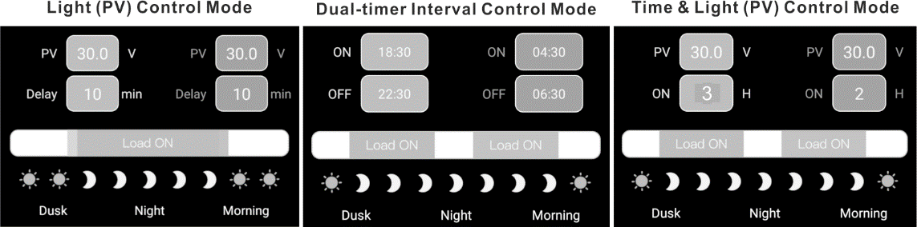
Note: Only ON/OFF mode can be set on the controller, and others need to be set through optional accessories.
Note: ON/OFF mode can be set, refer to 4.5
4.4 LED Indications 0
Green: It represents the state of load output. When it is always on, it indicates that it is currently in on mode and on state. When it flashes, it indicates that it is currently in on mode but does not meet the conditions of on. When it is off, it indicates off mode.
Bule: It indicates the charging state: when it flashes quickly, it indicates the fast charging state (CC), when it flashes slowly, it indicates the constant voltage charging state (CV), when it is always on, it indicates that it is in floating charge state (CF) or standby mode.
Red: It will flash when there is a fault but it can still run. It will always be on when the fault causes it to stop working. When it is off, it indicates normal.
4.5 Button And Display 0
The controller has a 1.3-inch OLED display and a function button. The user can ONLY set the battery type with preset parameters. Refer to the following figure for specific logic.
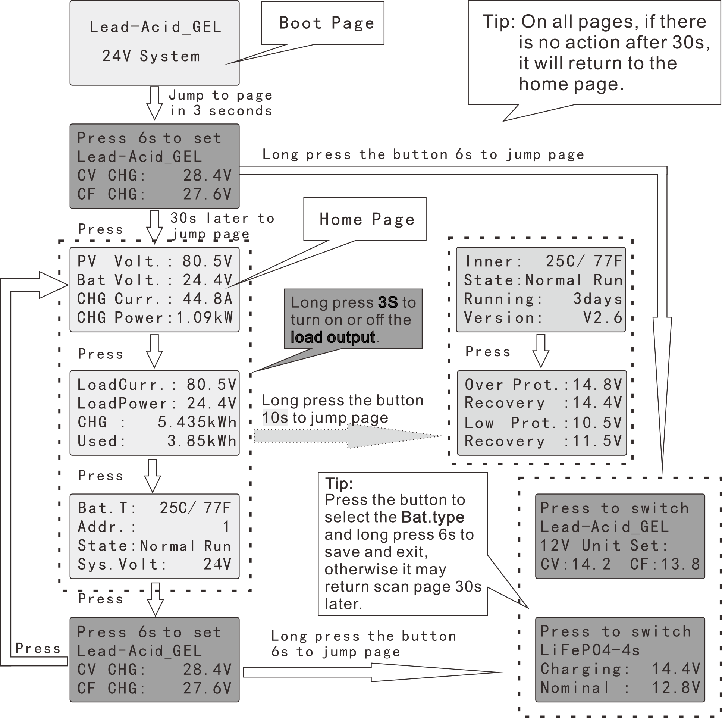
Note: If need to customize other parameters, you can implement them through optional accessories.

5.0 TROUBLE SHOOTING 0
WARNING: RISK OF ELECTRICAL SHOCK.
NO POWER OR ACCESSORY TERMINALS ARE ELECTRICALLY ISOLATED FROM DC INPUT, AND MAY BE ENERGIZED WITH HAZARDOUS SOLAR VOLTAGE. UNDER CERTAIN FAULT CONDITIONS, BATTERY COULD BECOME OVERCHARGED. TEST BETWEEN ALL TERMINALS AND GROUND BEFORE TOUCHING.
WARNING: Shock Hazard
A means of disconnecting all power supply poles must be provided. These disconnects must be incorporated in the fixed wiring. Open all power source disconnects before removing controller wiring cover, or accessing wiring.
Problem:
No LED indications, controller does not appear to be powered
Solution:
With a multi-meter, check the voltage at the battery terminals on the MPPT. Battery voltage must be 10 vdc or greater. If the voltage on the battery terminals of the controller is between 10 and 35 vdc, and no LEDs are lit, contact your authorized dealer for service. If no voltage is measured, check wiring connections, fuses, and breakers.
Problem:
The MPPT is not charging the battery.
Solution:
Check the fuses, breakers, and wiring connections in the power source wiring. With a multi-meter, check the array voltage directly at the MPPT solar input terminals. Input voltage must be greater than battery voltage before charging will begin.
Check whether the battery voltage in OLED is in the range of controller system recognition.
Problem:
The battery is in a low energy or empty for a long time.
Solution:
Possible reasons: 1. Solar panels quantity are too less to generate enough energy, increase solar panels quantity.
2. Battery capacity is too small to store enough energy, increase battery capacity.
States Description 0
Display In Oled | Description
Normal Run | No fault
HS Over | Heatsink overheating
PV Low | Low input voltage
BAT Low | Battery low
BAT Over | Battery Over
PV Over | Over input voltage
CHG Over | Charging overcurrent
DisC. Over | Discharging overcurrent

6.0 TECHNICAL SPECIFICATIONS 0
Common Negative MPPT Controller
Model: | NS24L30 | NS24L40 | NS24H50 | NS24H60
Electrical:
Nominal Battery Voltage | 12 or 24 Vdc
Battery Voltage Range | 9 ~ 30Vdc
Voltage Accuracy | < +/- 0.2V
Max.Battery Current | 30A | 40A | 50A | 60A
Max.PV Open-Circuit Voltage | 100V |  | 150V
Load Current Rating | 20A |  | 30A
Self-Consumption | 1~2W
Conversion Efficiency (Peak) | 97%
Mechanical:
Dimensions (Net) | 220x148x64 |  | 245x170x69
Dimensions (Pack) | 275x176x70 |  | 300x198x75
Weight (Net) | 1.5kg |  | 2.2kg
Weight (Pack) | 1.9kg |  | 2.6kg
Max.Wire Size | 25mm² / #3 Awg
Data & Communications
Communication Port | Dual RJ45
Comm.Protocols | Private protocol and MODBUS
PC Software | SolarMate
Meter | MH-M80 / MH-S80
Dry Contact Access Voltage | Via RJ45 port
Environmental:
Ambient Temperature Range | -30℃ ~ +50℃
Storage Temperature | -30℃ ~ +80℃
Humidity | 100% n.c.
IP (Ingress protection) | IP42
Protections 0
Reverse Polarity - battery and array
Solar Short-Circuit
High Heatsink Temperature - Current De-rating
Load Short-Circuit
Load Over-Current
Heatsink Temperature Limit
Over-volt / low-volt protection
Battery shedding
Wire Sizing Charts 0
2% Voltage Drop Charts for 75°C Stranded Copper Wire
1-Way Wire Distance (feet), 12 Volt System
Wire Size  (AWG) | 60A | 55A | 50A | 45A | 40A | 35A | 30A | 25A | 20A
2/0* | 22.4 | 24.4 | 26.9 | 29.9 | 33.6 | 38.4 | 44.8 | 53.8 | 67.2
1/0* | 17.7 | 19.3 | 21.3 | 23.6 | 26.6 | 30.4 | 35.5 | 42.6 | 53.2
2 | 11.2 | 12.2 | 13.4 | 14.9 | 16.8 | 19.2 | 22.4 | 26.9 | 33.6
4 | 7.1 | 7.7 | 8.5 | 9.4 | 10.6 | 12.1 | 14.1 | 17.0 | 21.2
6 | 4.4 | 4.8 | 5.3 | 5.9 | 6.6 | 7.5 | 8.8 | 10.6 | 13.2
8 | 2.8 | 3.1 | 3.4 | 3.7 | 4.2 | 4.8 | 5.6 | 6.7 | 8.4
10 | 1.7 | 1.9 | 2.1 | 2.3 | 2.6 | 3.0 | 3.5 | 4.2 | 5.2
1-Way Wire Distance (meters), 12 Volt System
Wire Size  (mm²) | 60A | 55A | 50A | 45A | 40A | 35A | 30A | 25A | 20A
70* | 6.8 | 7.4 | 8.2 | 9.1 | 10.2 | 11.7 | 13.7 | 16.4 | 20.5
50* | 5.4 | 5.9 | 6.5 | 7.2 | 8.1 | 9.3 | 10.8 | 13.0 | 16.2
35* | 3.4 | 3.7 | 4.1 | 4.5 | 5.1 | 5.8 | 6.8 | 8.2 | 10.2
25 | 2.1 | 2.3 | 2.6 | 2.9 | 3.2 | 3.7 | 4.3 | 5.2 | 6.4
16 | 1.3 | 1.5 | 1.6 | 1.8 | 2.0 | 2.3 | 2.7 | 3.2 | 4.0
10 | 0.8 | 0.9 | 1.0 | 1.1 | 1.3 | 1.5 | 1.7 | 2.0 | 2.5
6 | 0.5 | 0.6 | 0.6 | 0.8 | 0.8 | 0.9 | 1.1 | 1.3 | 1.6
Maximum 1-way wire distance for 12 Volt systems, stranded copper, 2% voltage drop
2% Voltage Drop Charts for 75°C Solid Copper Wire
1-Way Wire Distance (feet), 12 Volt System
Wire Size  (AWG) | 60A | 55A | 50A | 45A | 40A | 35A | 30A | 25A | 20A
2/0* | 27.8 | 30.3 | 33.4 | 37.1 | 41.7 | 47.7 | 55.6 | 66.7 | 83.4
1/0* | 22.1 | 24.1 | 26.5 | 29.4 | 33.1 | 37.8 | 44.1 | 53.0 | 66.2
2 | 13.9 | 15.1 | 16.6 | 18.5 | 20.8 | 23.8 | 27.7 | 33.3 | 41.6
4 | 8.7 | 9.5 | 10.5 | 11.6 | 13.1 | 15.0 | 17.5 | 21.0 | 26.2
6 | 5.5 | 6.0 | 6.6 | 7.3 | 8.2 | 9.4 | 10.9 | 13.1 | 16.4
8 | 3.5 | 3.8 | 4.2 | 4.6 | 5.2 | 5.9 | 6.9 | 8.3 | 10.4
10 | 2.2 | 2.4 | 2.6 | 2.9 | 3.3 | 3.8 | 4.4 | 5.3 | 6.6
1-Way Wire Distance (meters), 12 Volt System
Wire Size  (mm²) | 60A | 55A | 50A | 45A | 40A | 35A | 30A | 25A | 20A
70* | 8.5 | 9.2 | 10.2 | 11.3 | 12.7 | 14.5 | 16.9 | 20.3 | 25.4
50* | 6.7 | 7.3 | 8.1 | 9.0 | 10.1 | 11.5 | 13.4 | 16.1 | 20.2
35* | 4.2 | 4.6 | 5.1 | 5.6 | 6.3 | 7.2 | 8.5 | 10.1 | 12.7
25 | 2.7 | 2.9 | 3.2 | 3.5 | 4.0 | 4.6 | 5.3 | 6.4 | 8.0
16 | 1.7 | 1.8 | 2.0 | 2.2 | 2.5 | 2.9 | 3.3 | 4.0 | 5.0
10 | 1.1 | 1.1 | 1.3 | 1.4 | 1.6 | 1.8 | 2.1 | 2.5 | 3.2
6 | 0.7 | 0.7 | 0.8 | 0.9 | 1.0 | 1.1 | 1.3 | 1.6 | 2.0
Maximum 1-way wire distance for 12 Volt systems, solid copper, 2% voltage drop
Note: *Wires sizes larger than 4 AWG (25 mm2) must be terminated at a splicer block located outside of the MPPT. Use 4 AWG (25 mm2) or smaller wire to connect to the MPPT to the splicer block.
• The specified wire length is for a pair of conductors from the solar or battery source to the controller (1-way distance)
• For 24 volt systems, multiply the 1-way length in the table by 2.
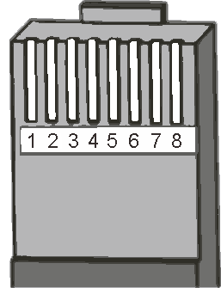
RJ45 Port Definition 0
PIN | Function
1 | RS485-A
2 | RS485-B
3 | Dry contact
4 | Dry contact
5 | GND(isolation)
6 | GND(isolation)
7 | +5V(isolation)
8 | +5V(isolation)
Serial Connection(String) Of Solar Panels 0
Voc * N = PVinput < 100Vdc
System Voltage | Voc<23V |  | Voc<31V |  | Voc<34V |  | Voc<38V |  | Voc<46V |  | Voc<62V
 | Max. | Best | Max. | Best | Max. | Best | Max. | Best | Max. | Best | Max. | Best
12V | 4 | 2 | 3 | 1 | 2 | 1 | 2 | 1 | 2 | 1 | 1 | 1
24V | 4 | 3 | 3 | 2 | 2 | 2 | 2 | 2 | 2 | 2 | 1 | 1
Voc * N = PVinput < 150Vdc
System Voltage | Voc<23V |  | Voc<31V |  | Voc<34V |  | Voc<38V |  | Voc<46V |  | Voc<62V
 | Max. | Best | Max. | Best | Max. | Best | Max. | Best | Max. | Best | Max. | Best
12V | 6 | 2 | 4 | 1 | 4 | 1 | 3 | 1 | 3 | 1 | 2 | 1
24V | 6 | 3 | 4 | 2 | 4 | 2 | 3 | 2 | 3 | 2 | 2 | 1
Note: The table is the quantity(N) of solar panels in series, for reference only.
Efficiency Graphs 0
