Product Specification
2/2021
Product | LCD Display
Mode | APT LCD 500S
Abbreviation | 500S
Client
Customer audit
Supplier | APT(Tianjin) Develop Co., Ltd.
 | 1001, Building 5 HuaDing, No.1 HuaKe 3 Road, Binhai hi-tech Industrial Development Zone, Tianjin, China
Tel | TEL:+86 22 83715556  FAX:+86 22 83719955
Email | yzhao@aptdevelop.com
- Product Name
  - LCD display
  - Model : APT LCD 500S
- Suppliers
  - APT (Tianjin) Develop Co., Ltd.
  - Email : yzhao@aptdevelop.com apt@aptdevelop.com
- Electrical Parameters
  - 24V/36V/48V/52V/COn battery supply
  - Rated operating current : 40mA
  - Off leakage current < 1uA
  - Max output current to controller : 100mA
  - Operating temperature : -20～70℃, Storage temperature : -30～80℃
- Dimensions & Material
  - Product shell is ABS, transparent window is made with high strength Acrylic.
  - Dimensions : host/L79mm*W40mm*H18mm
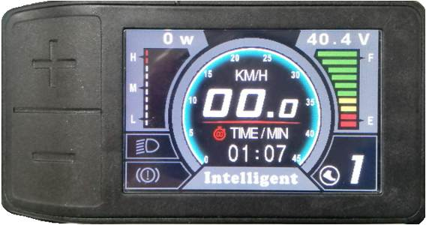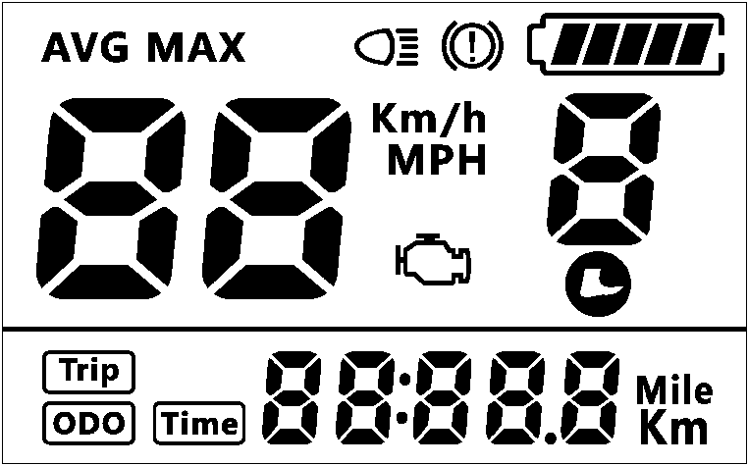
- Features
  - Suitable for low temperature，Max -20℃.
  - Ergonomic external button design, easy to operate.
  - Speed display: AVG SPEED, MAX SPEED, SPEED (Real-time).
  - Kilometer / Mile : Can be set according to customers’ habits.
- Assist level: 3-level/5-level/9-level/UbE optional.
- Mileage indicator: Odometer/Trip distance/Riding time.
- Error code indicator.
- Software upgraded: Software can be upgraded through UART.
- LCD screen instructions
- Functional Description
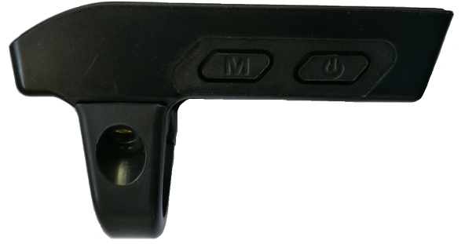
UP
DOWN
MODE

POWER
  - Power On/Off
Press and hold Power button for 2 seconds can turn on/off the display. The Display can automatically shut down when there is no operate & ride for X minutes（X could be 0~15）.
  - Assist level operating
Short press UP/DOWN button can change the assist level. Top assist level is 9, 0 for neutral. Level quantities can be adjusted according to the customer requirements.
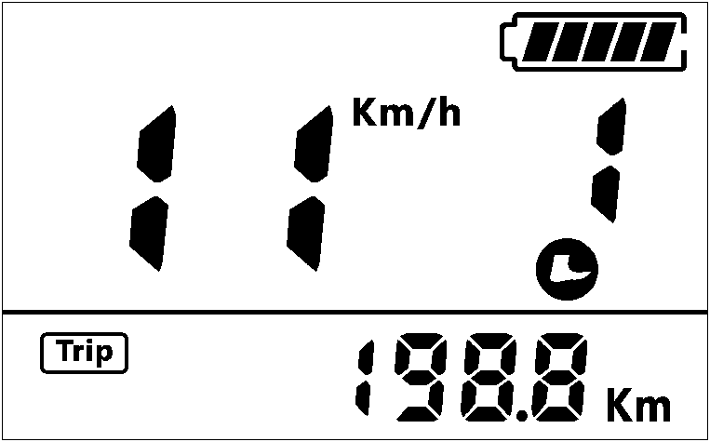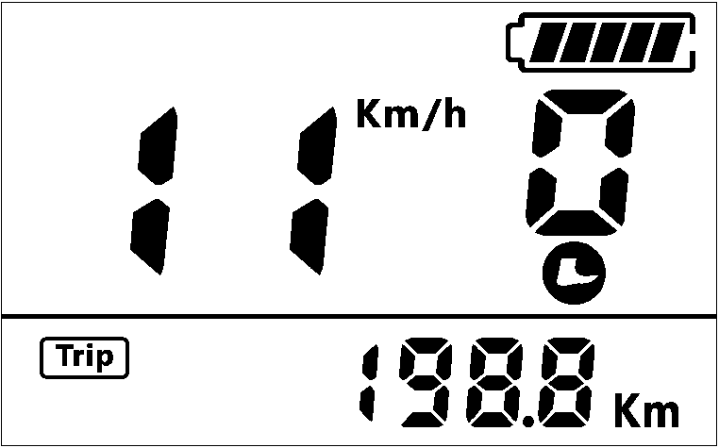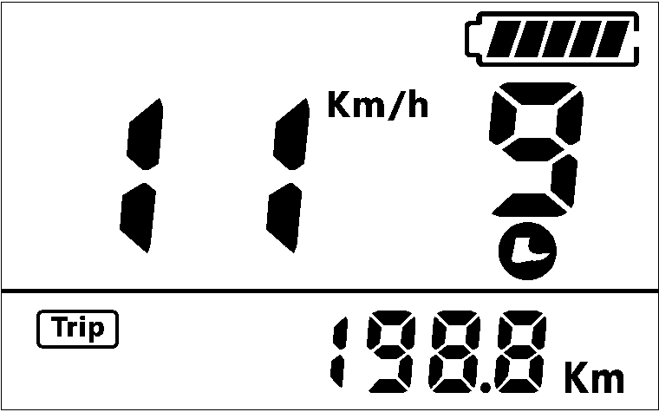
  - Speed & Mileage mode switch
Short press MODE button can change the speed and mileage mode, AVG SPEED→MAX SPEED→ TRIP→ODO→TIME.
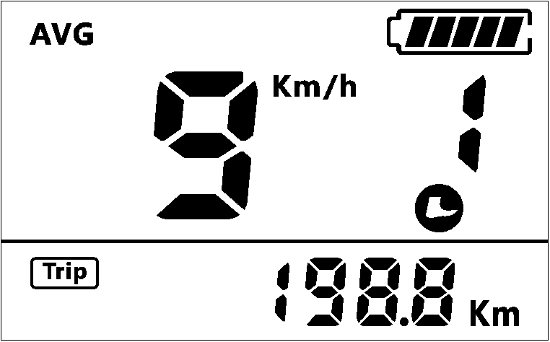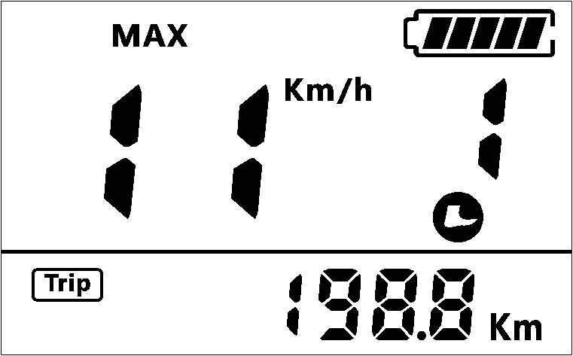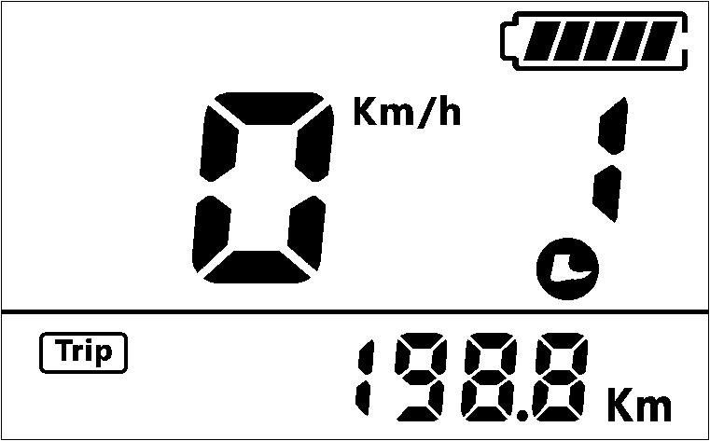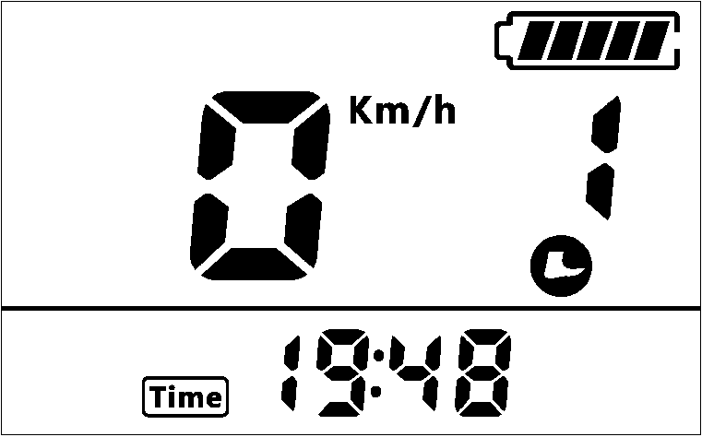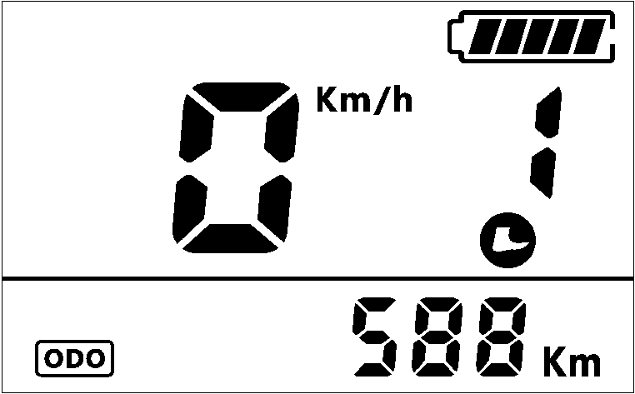
*If there is no operation for 5 seconds, display will return Speed (Real-Time) display automatically.
  - Headlight/backlight On/Off
Press and hold UP button for 2 seconds can turn on/off the headlight.
*The motor does not work when the battery voltage is low, Display still can keep the headlight on for a while when E-bike is in riding.
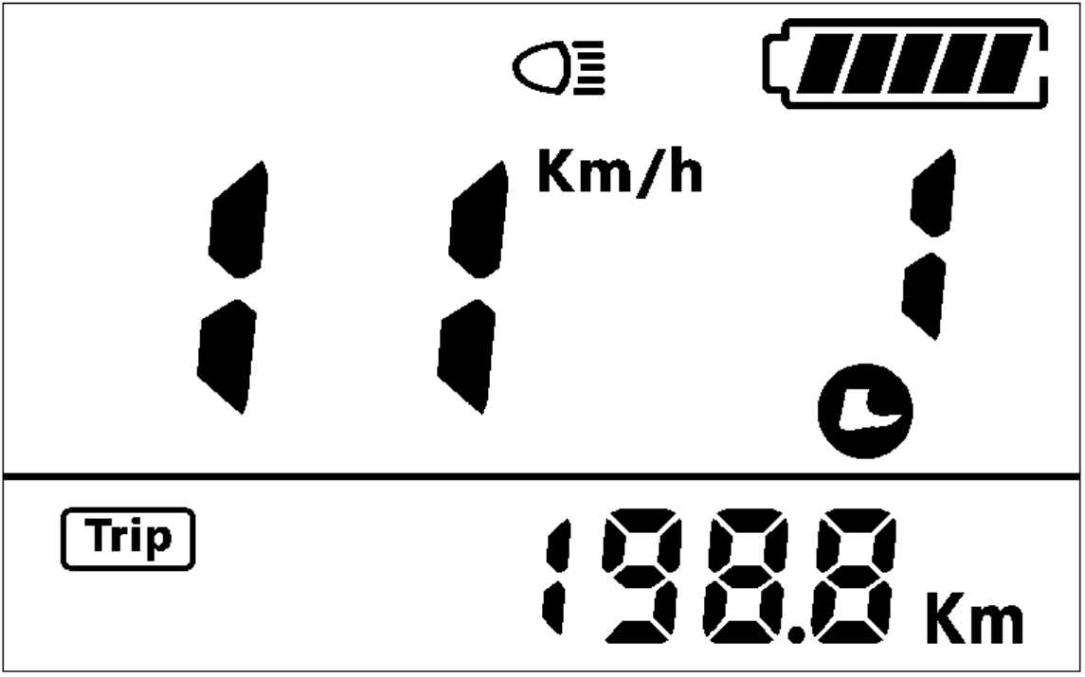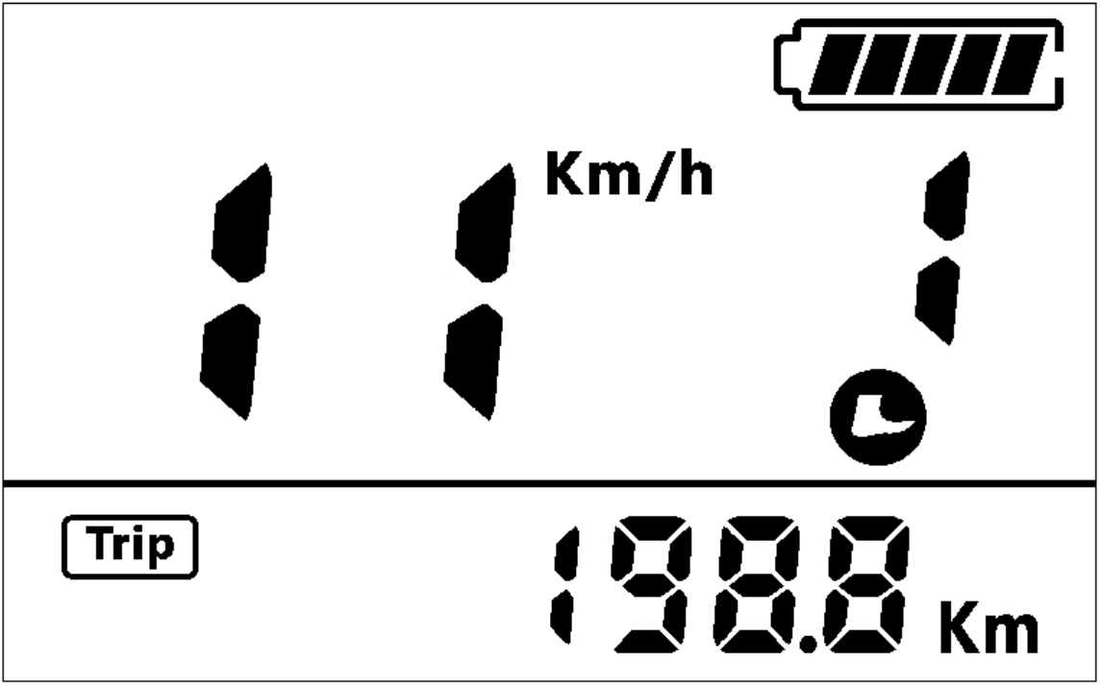
  - Walking mode (6km)
Press and hold DOWN button for 2 seconds can get into walking mode, out of the mode when release the button.
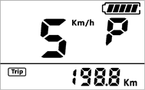
* This feature needs to be supported by controller.
- Parameter setting
Press and hold MODE button for 2 seconds can get into/ exit setting menu, press UP/DOWN button to change the parameter setting, press MODE button can switch to next item.
* Display will automatically quit menu when there is no operation for 10 seconds.
* For safety reasons, display can’t get into MENU when riding.
* Display will quit MENU when start riding.
The order of parameters is as follow.
Data clean up
Brightness
Auto off
Wheel
Password
Battery
Speed limit
System
Assist
  - Data clean up(Cr): Press Up/Down button to change no/yes.
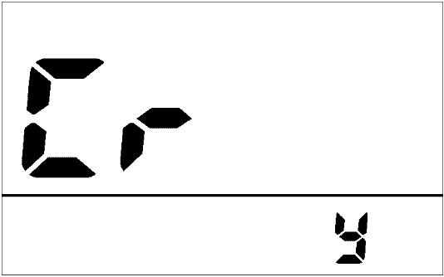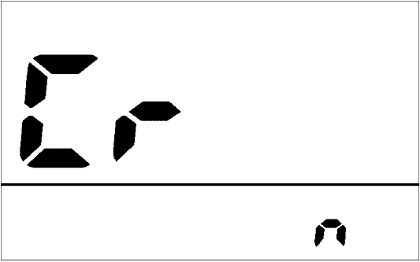
  - System (S7): Press Up/Down button to switch between Metric/Imperial.
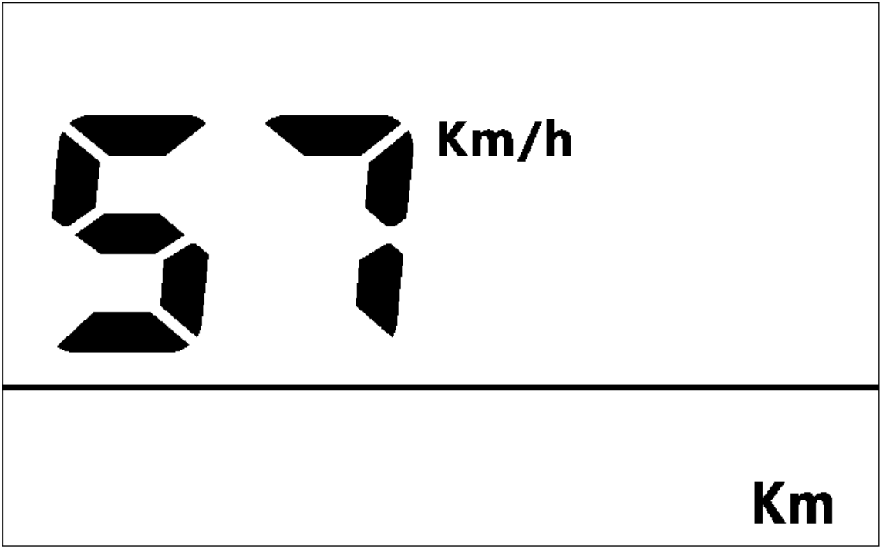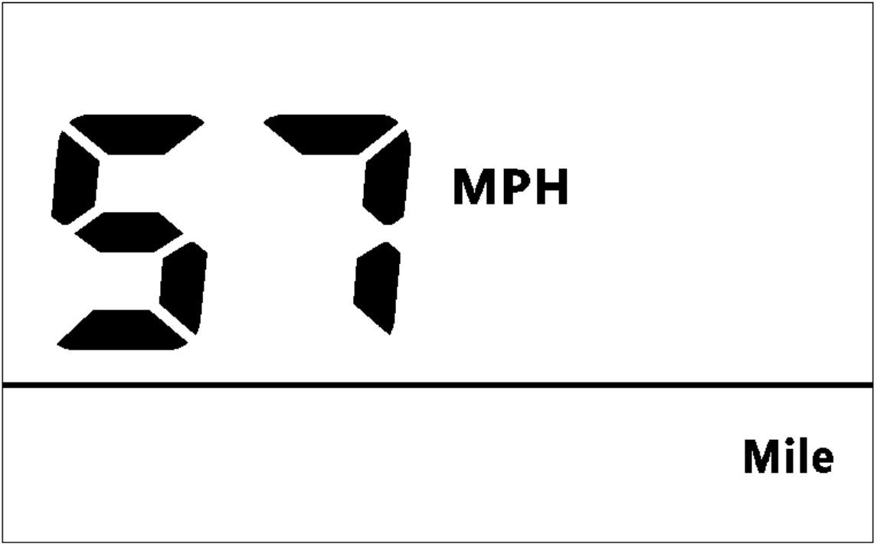
  - Brightness (bl): Press Up/Down button to change the brightness of the backlight, 1 is darkness, 5 is brightness.
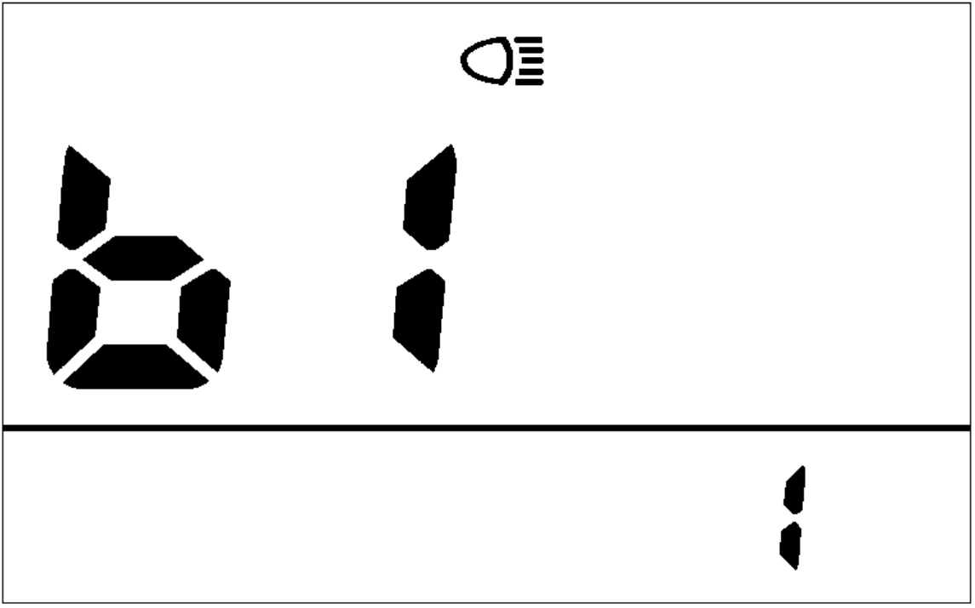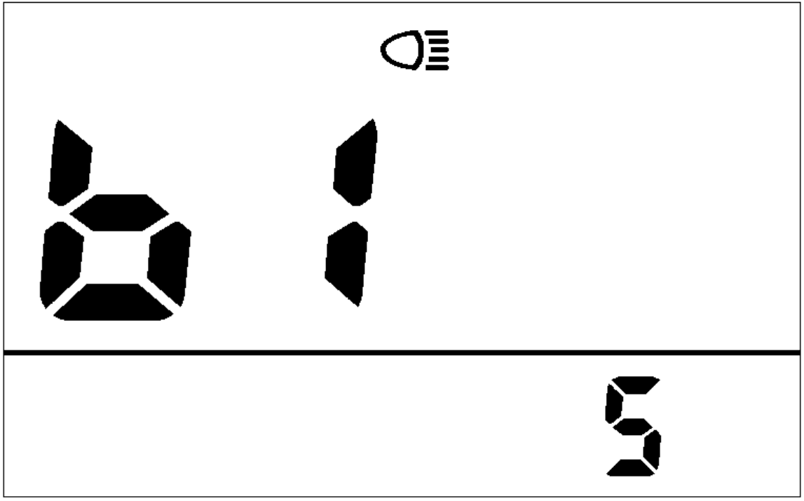
  - Auto off (OF): Press Up/Down button to change the auto power off time, from 0~15, the number represent time (minutes) to shut down, 0 means disable auto off function, default value is 5 minutes.
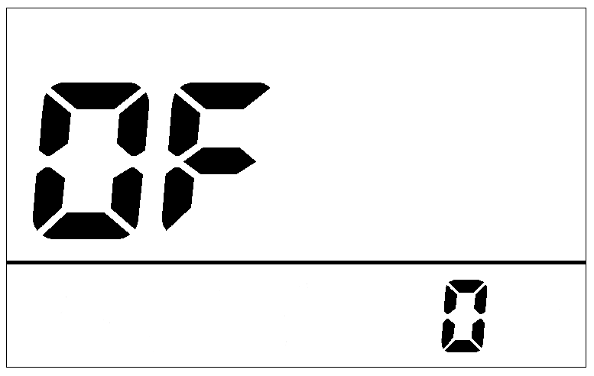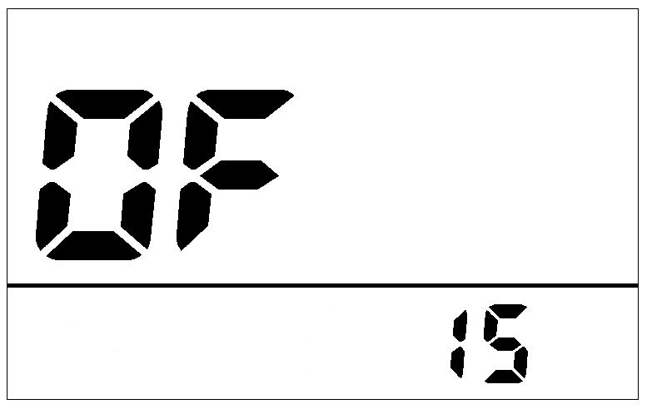
  - Wheel (Hd): Press Up/Down can change the wheel setting, optional wheel diameter is 6~34 inch.
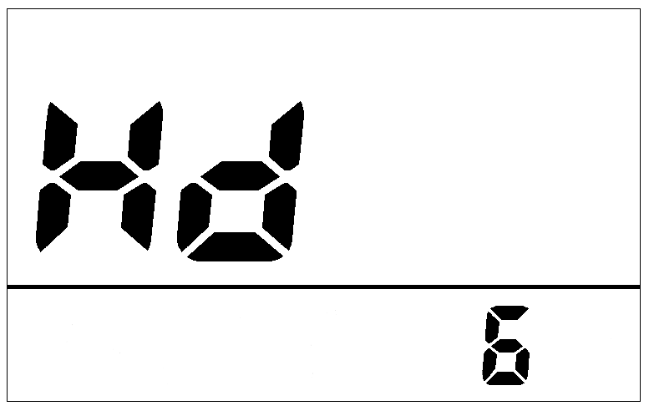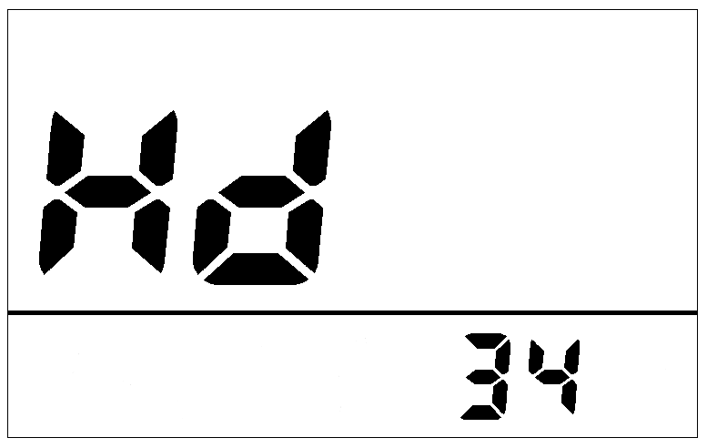
  - Password (Pd): Press MODE button can get into the advance setting menu, default password is ‘1919’.
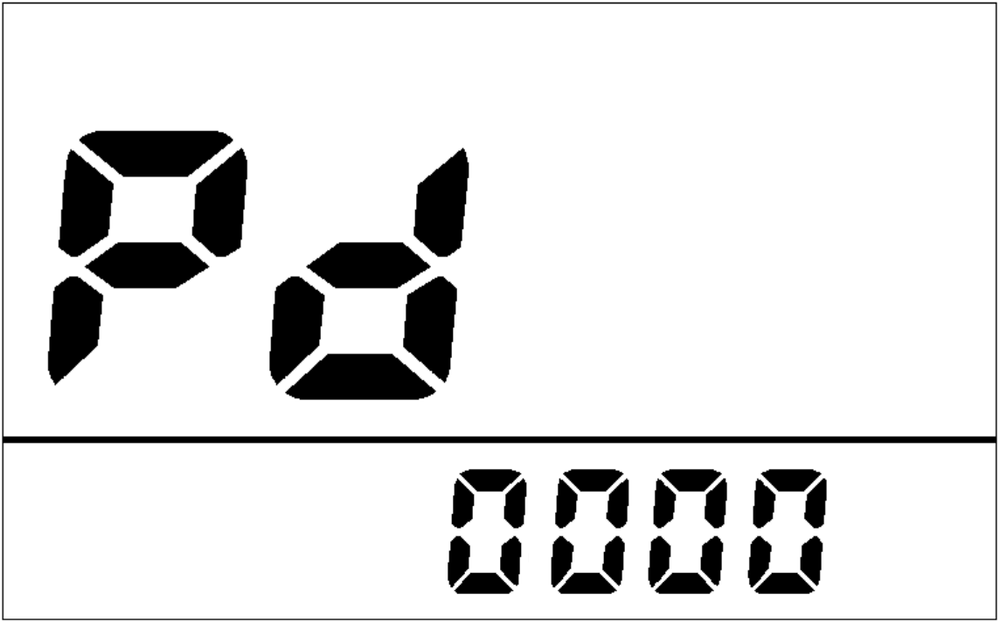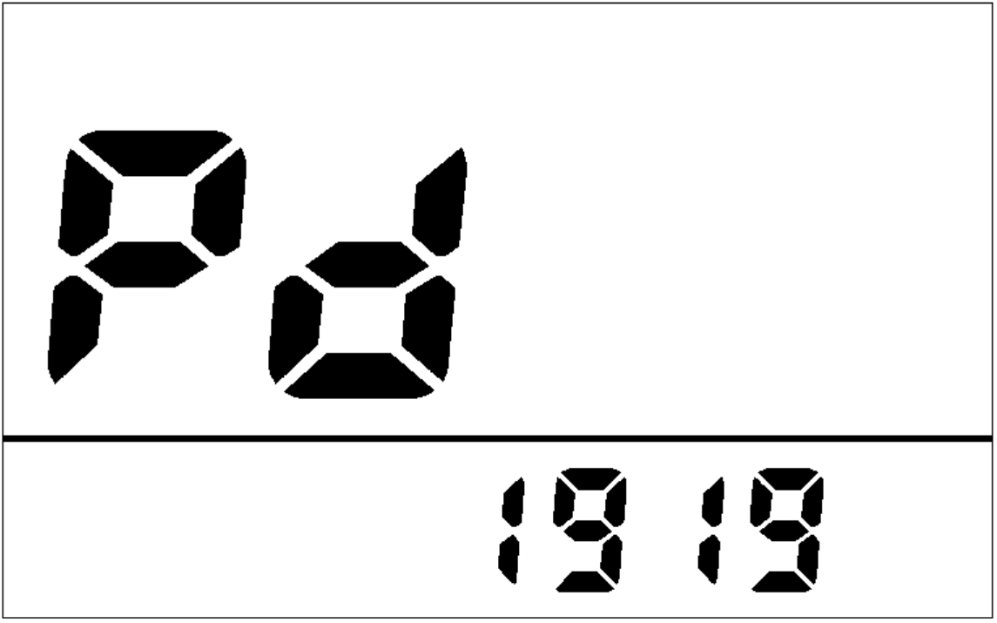
  - Speed limit (SL): Press Up/Down button will change speed limit, range 10km~100km.
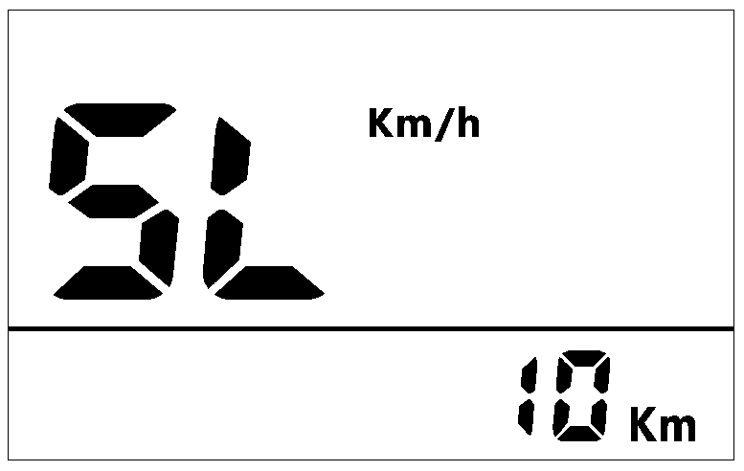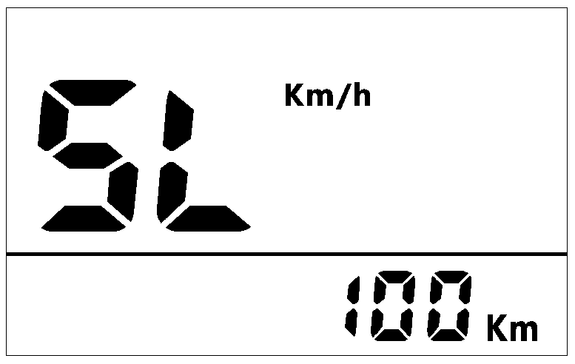
  - Battery (b0): Press Up/Down button to switch between 24V/36V/48V/52V/COn, Con means controller transfer voltage value.
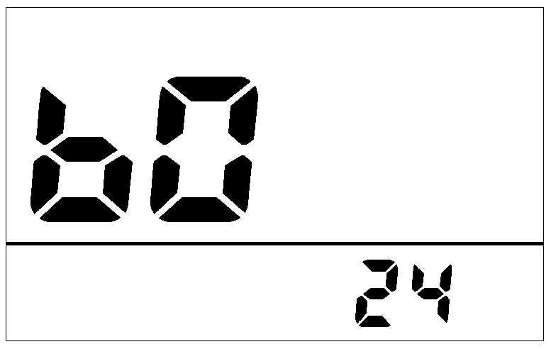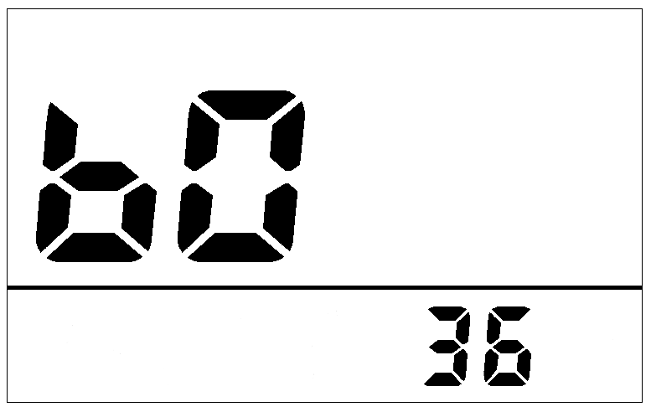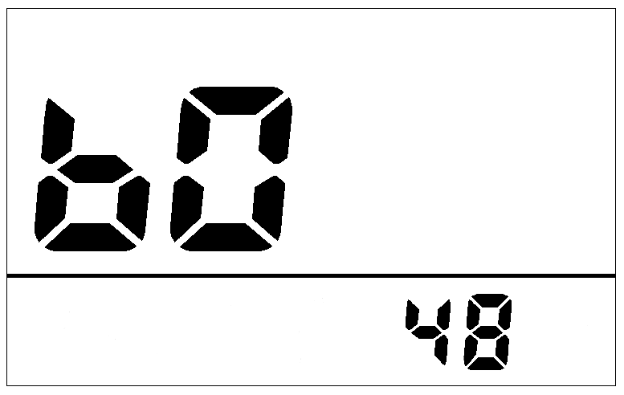
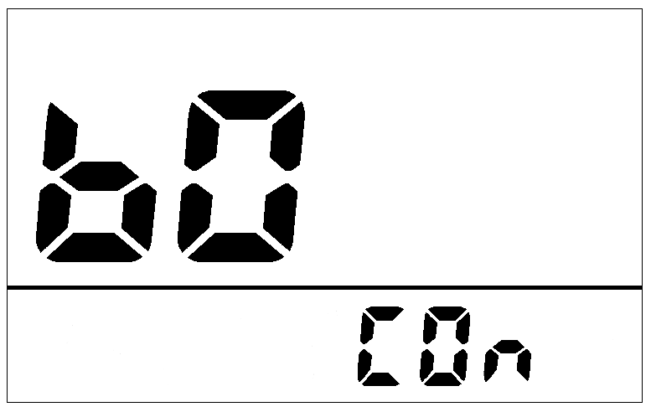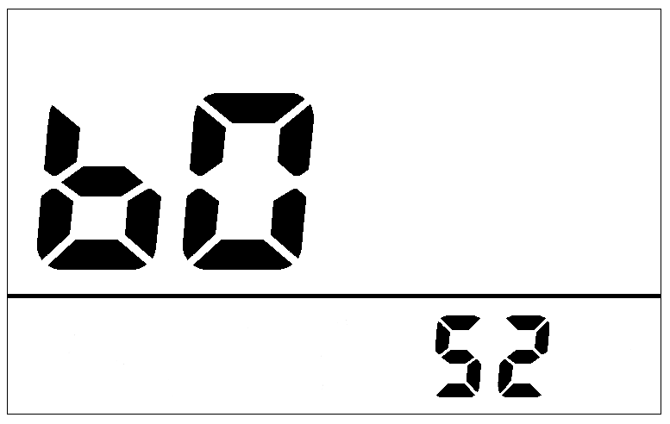
  - Assist levels (PS): This parameter can customize assist levels, options are UbE/3/5/9.UbE means user-defined assist levels setting.
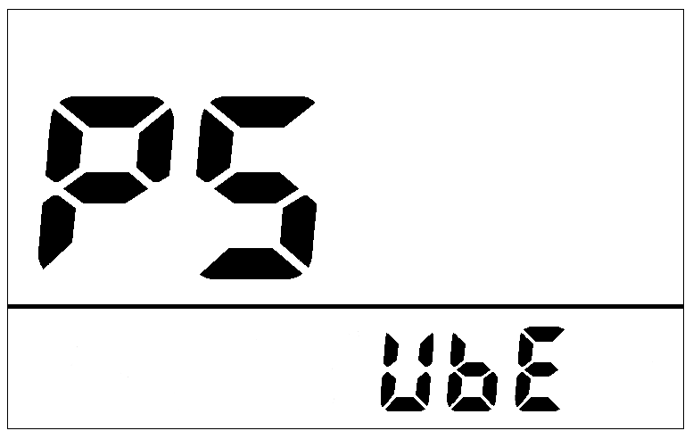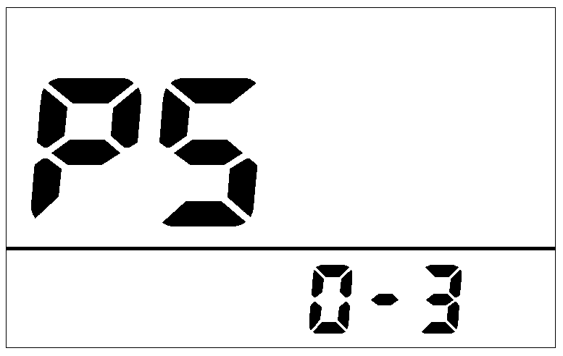
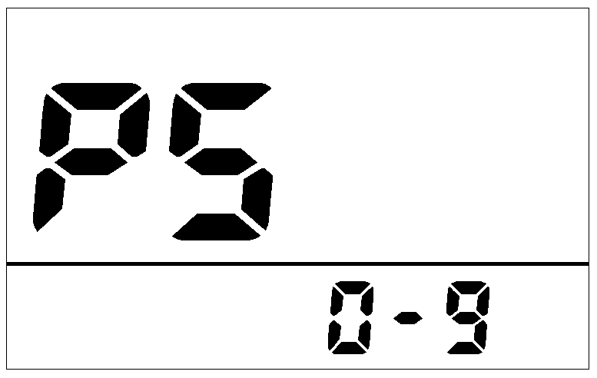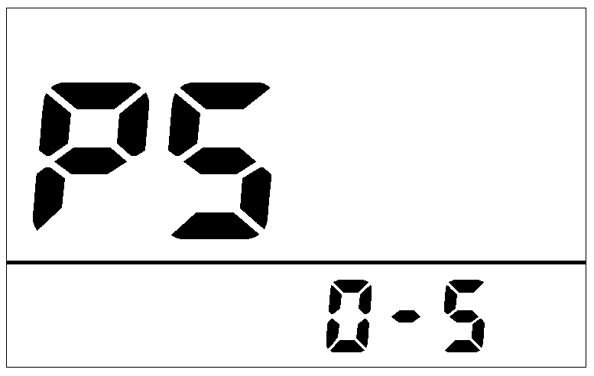
- Error Code define
500S can show warning message, icon shows on the screen, and show error code at the bottom of the screen, error code is from 01 E~0nE, and the definition see the table below.
Error Code | Error description | Handle
0x04 | Throttle turn back fault | Check throttle and connection.
0x05 | Throttle error | Check throttle and connection.
0x06 | Under voltage protection | Charge the battery
0x07 | Overvoltage protection | Charge the battery
0x08 | Hall error | Check the hall connection
0x09 | three-phase power error | Check three-phase power line connection
0x10 | The controller is overheated | Stop using 10 minutes to restart
0x11 | Motor overheating | Stop using 10 minutes to restart
0x12 | Sensor error | Check the sensor connection
0x13 | battery temperature abnormality | Stop using 10 minutes to restart
0x14 | Motor temperature sensor is abnormal | Check the sensor
0x15 | Controller temperature sensor failure | Check the sensor
0x21 | Speed sensor fault | Check the sensor
0x22 | BMS Communication Error | Check the cable connection
0x23 | Headlight error | Check the cable connection
0x24 | Headlight sensor error | Check the cable connection
0x25 | Torque signal error | Contact the supplier
0x26 | Torque sensor speed error | Contact the supplier
0x30 | Communication Error | Check the cable connection
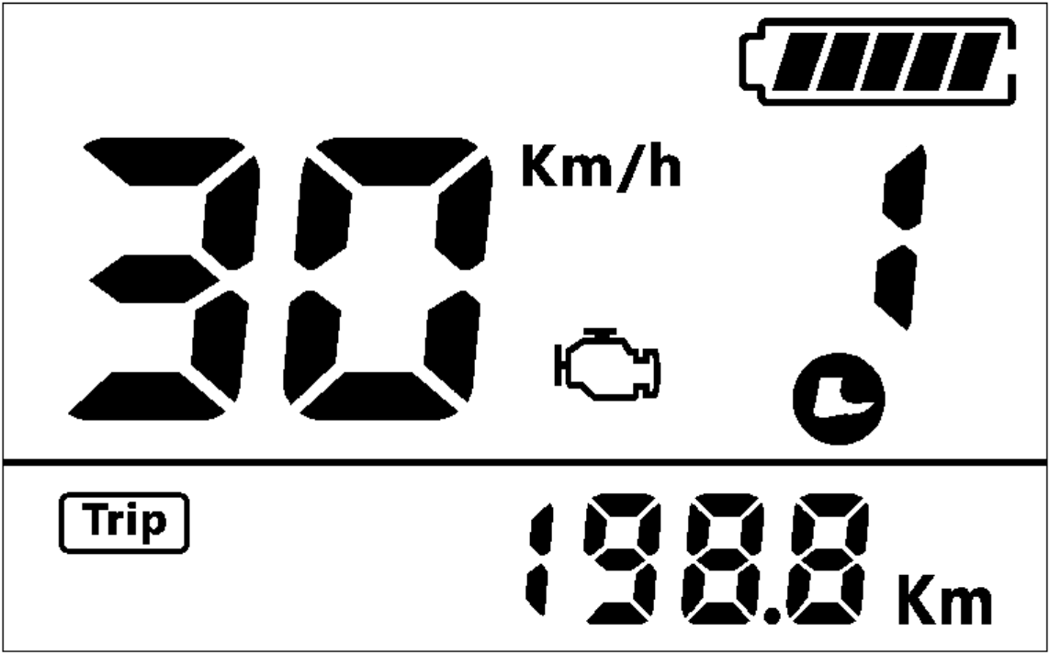
- Assembly instructions
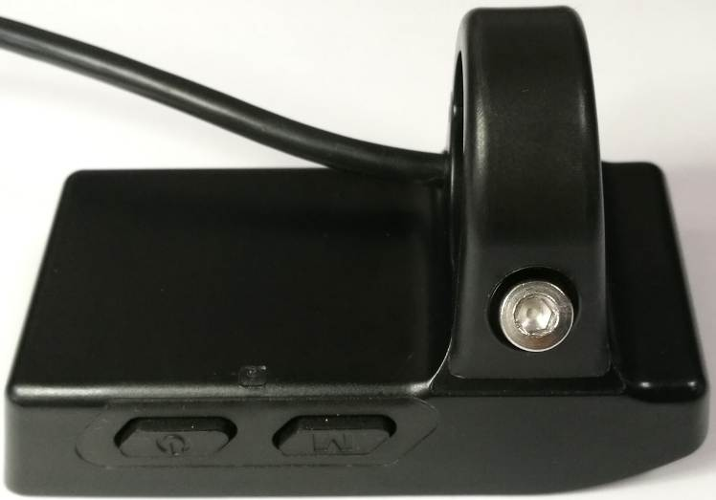
M4*10
Please pay attention to the screw’s torque value, damaged caused by excessive torque is not within the scope of the warranty.
- Connector descriptions
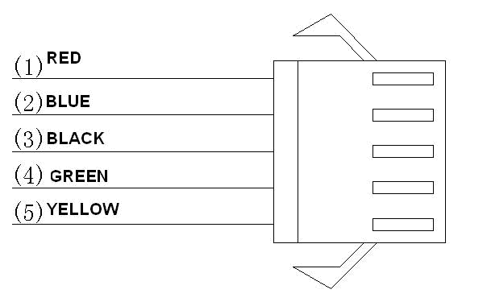
- Red wire : Anode(24V/36V/48V/52V)
- Blue wire : Power cord to the controller
- Black wire : GND
- Green wire : RxD (controller -> display)
- Yellow wire : TxD (display -> controller)
- Certification
CE / IP65 (water proof) / ROHS.

