BIGTREETECH
PI4B Adapter V1.0
User Manual

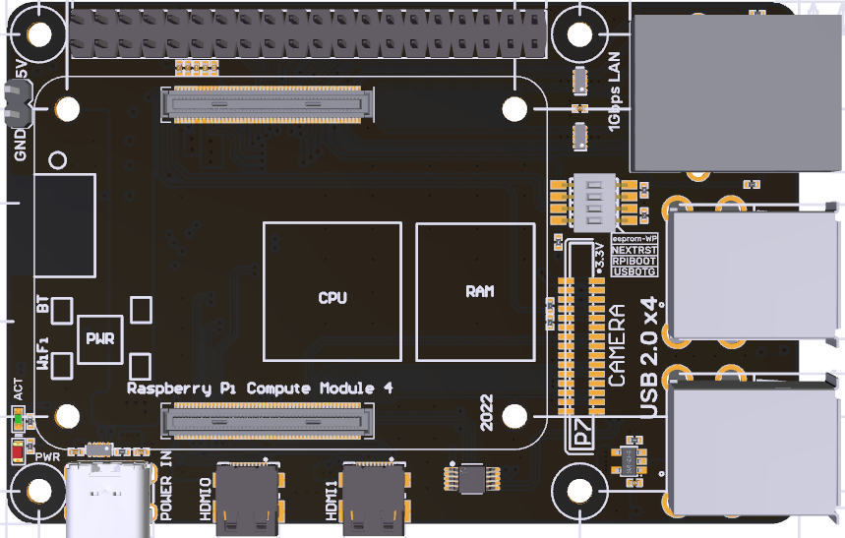

Contents
Contents 2
Revision History 3
1 Brief Introduction 4
1.1 Main Features 4
1.2 Product Parameters 4
1.3 Peripheral Interface 5
1.3.1 Product Size 5
1.3.2 Interface Diagram 5
1.3.3 Onboard Indicator Light 6
2 Interface Instruction 7
2.1 CM4 Installation 7
3 Write OS Image 7
3.1 Preparations 7
3.1.1 Download OS Image 7
3.1.2 Download and Install Raspberry Pi Imager 8
3.2 LITE Version(SD Card) 8
3.3 eMMC Version(Note: the eMMC version will not run the system from the SD card.) 11
4 System Settings 12
4.1 USB 2.0 Hub 12
4.2 DSI1 Display Interface 12
4.3 CSI1 Camera 12
5 Precautions 12

Revision History
Revision | Description | Date
01.00 | First Draft | 2022/03/17

1 Brief Introduction
BIGTREETECH PI4B Adapter V1.0 is a Raspberry Pi CM4 carrier board launched by Shenzhen Big Tree Technology Co., Ltd., when the Raspberry Pi CM4 is plugged in, it can be used as a Raspberry Pi 4, which brings convenience for customers to use the CM4.

1.1 Main Features
- Use Raspberry Pi 4B board outline, the same mounting hole dia;
- Support various versions of CM4 modules;
- Designed with Gigabit Ethernet interface, HDMI0 interface, HDMI1 interface, CAM interface, CSI interface;
- Equipped with ESD protection at the USB and network interfaces;
- 40 pin double-row pin header with the same function as Raspberry Pi;
- Adopting Type-C interface, which can be used to write CM4 with eMMC, and can supply power to the whole system at the same time;
- A 5V power interface is reserved, which can be connected to a 5V fan for CM4 heat dissipation.

1.2 Product Parameters
- Product Size: 85 x 54.29mm
- Installation Size: 58 x 49mm
- Power Input: Type-C 5±0.25V
- Module Type Support: various versions of Raspberry Pi CM4 modules.
- Interface Support: Micro HDMI x 2，USB 2.0x4，RJ45，CAM，CSI，Micro SD...

1.3 Peripheral Interface

1.3.1 Product Size
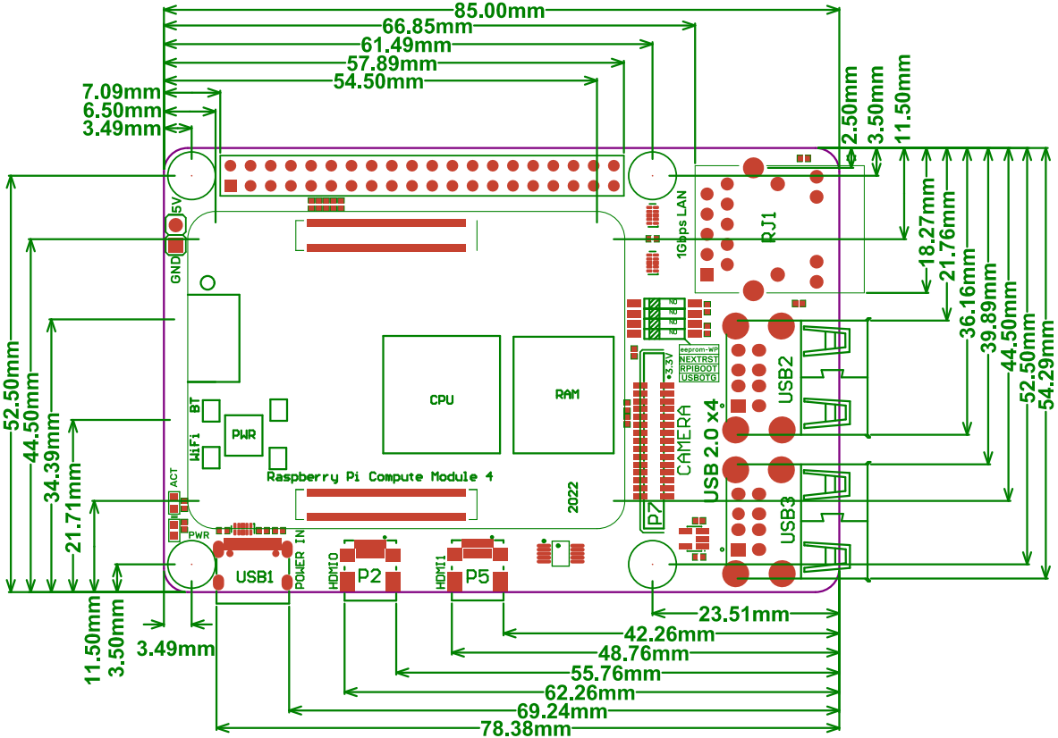

1.3.2 Interface Diagram
*Warning: The voltage of the Type-C port is 5V, and 12/24V is not allowed， otherwise, it will cause irreversible damage.
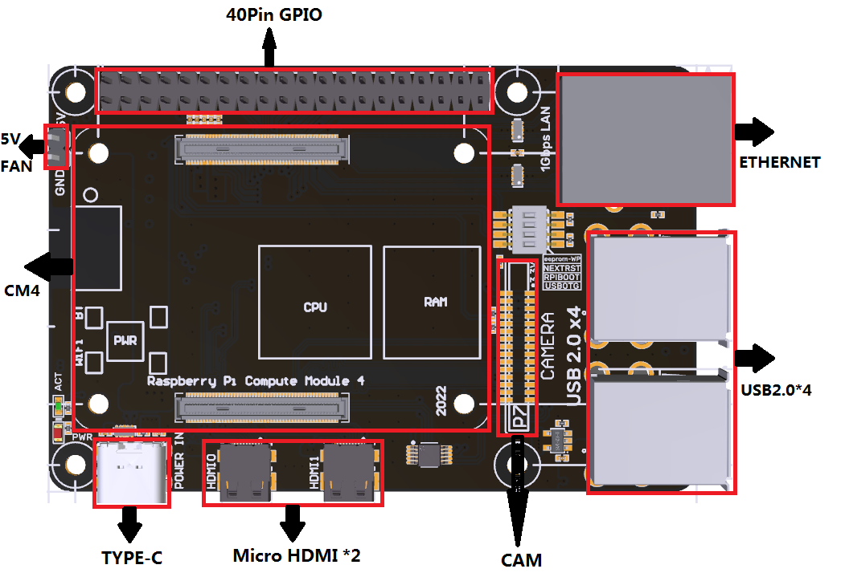

1.3.3 Onboard Indicator Light
Onboard 2 indicator lights. When powering on, the PWR (red) light will be on when the Raspberry Pi power supply is successfully started, and the ACT (green) light will flash when the system is running.
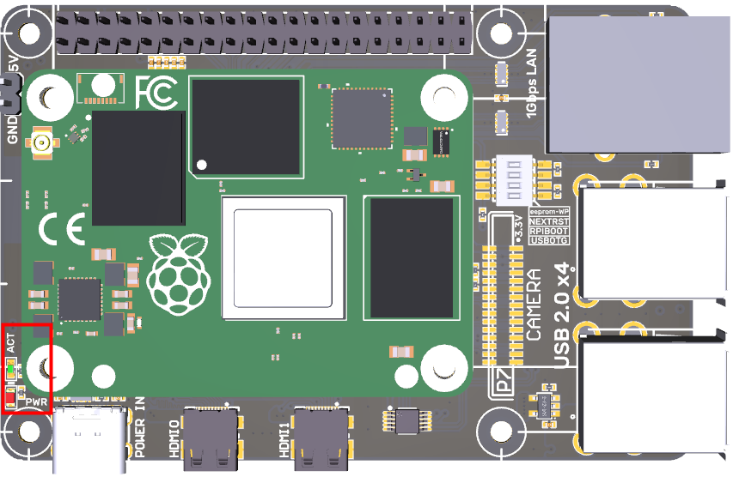

2 Interface Instruction

2.1 CM4 Installation
The installation direction of CM4 to BIGTREETECH PI4B Adapter V1.0 is shown below:
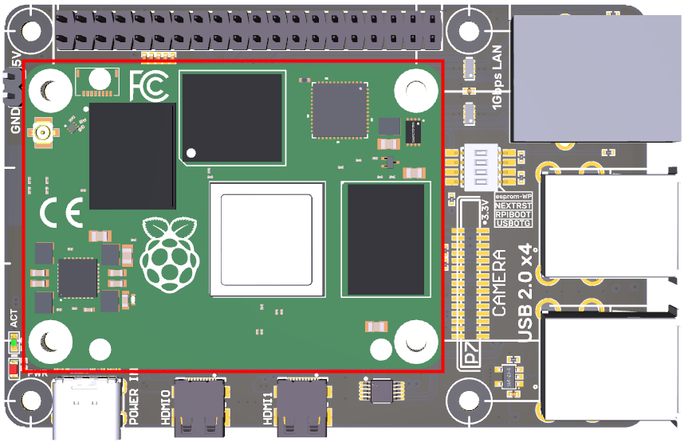

3 Write OS Image

3.1 Preparations

3.1.1 Download OS Image
Download the OS image from the official website of Raspberry Pi https://www.raspberrypi.com/software/operating-systems(You can also directly download the images of Fluidd and Mainsail, whose operation is slightly different from the standard Raspberry Pi 3B, 4B, etc. Pad5 needs to refer to the following system settings to enable the system's USB, DSI and other interfaces.)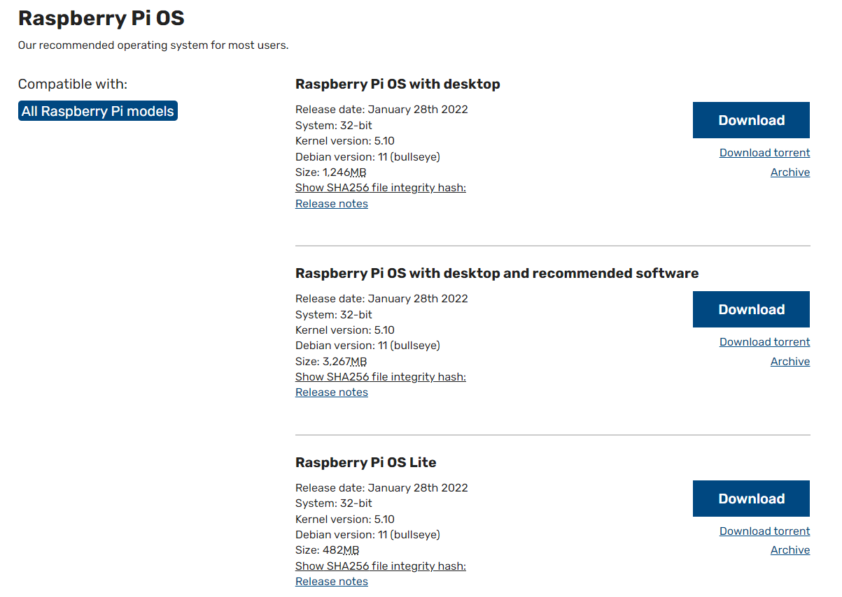

3.1.2 Download and Install Raspberry Pi Imager
Install the official Raspberry Pi Imager https://www.raspberrypi.com/software/

3.2 LITE Version(SD Card)
- Plug the Micro SD card into the computer via a card reader.
- Select Operating System.
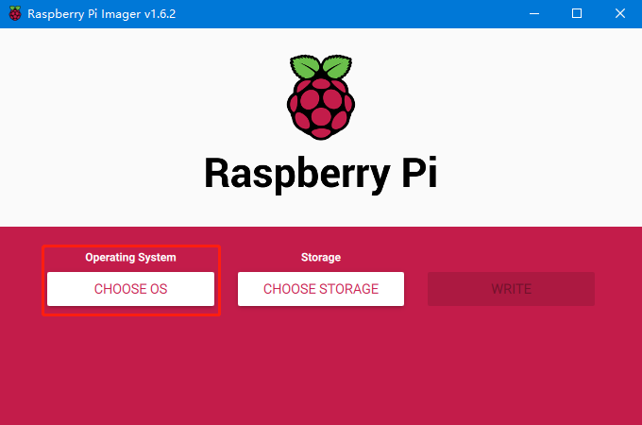
- Select "Use Custom", then select a custom.img from your computer.
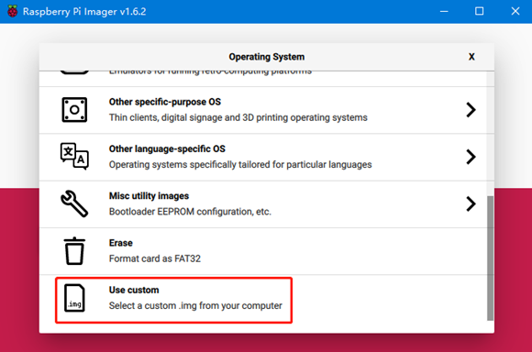
- Select the SD card and click "WRITE" (Write the image will format the SD card. Be careful not to select the wrong storage device, otherwise, the data will be formatted).
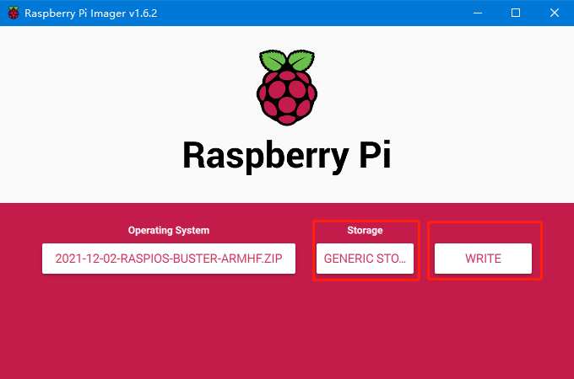
- Wait for the writing to finish.
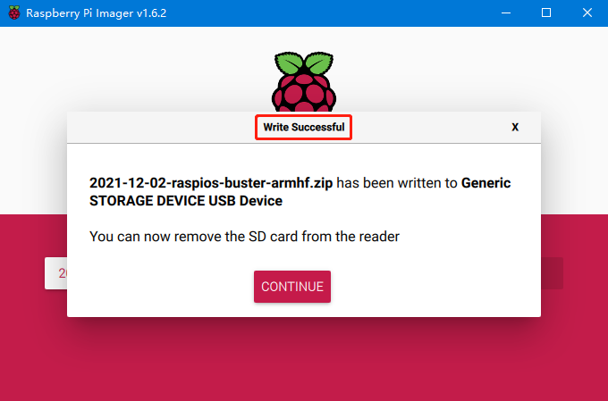
- Create a new blank file named "SSH" in the Boot drive of the system drive (note: there is no extension), and enable the SSH function of the system.

3.3 eMMC Version(Note: the eMMC version will not run the system from the SD card.)
- Install rpiboot
For Windows:
http://github.com/raspberrypi/usbboot/raw/master/win32/rpiboot_setup.exe
For Maca and Linux:
https://github.com/raspberrypi/usbboot#building
- Push the DIP switch 1 (USB OTG) and 2 (RPI BOOT) to ON to enter BOOT mode.
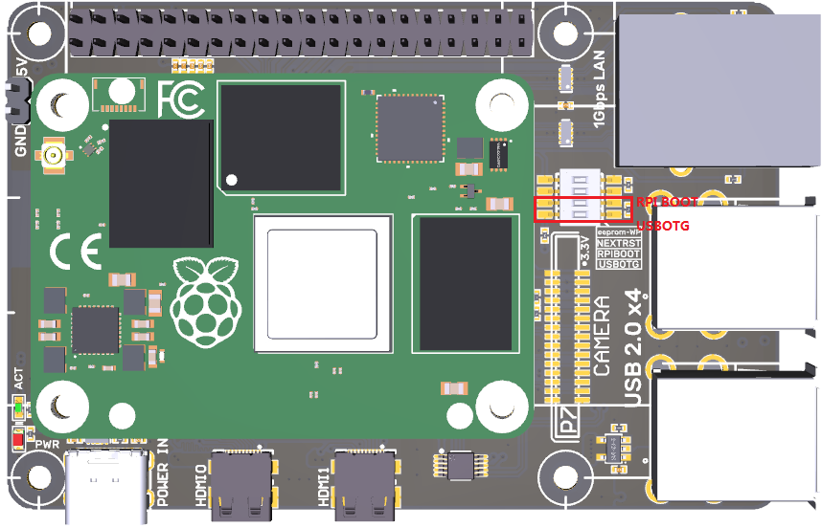
- Plug the Type-C into the USB port of the computer (in order to avoid problems caused by the insufficient USB power supply of the computer, it is best to use a USB-Hub with an external power supply, or use an external power supply to power the CM4 via the 5V port of the 40 pin pin header). Run sudo ./rpiboot (Mac/Linux) or rpiboot.exe on Windows, then the eMMC of CM4 will be recognized as a mass storage device by the computer (if rpiboot reports an error at this time, you can try to re-plug the USB).
- The step of using the Raspberry Pi Imager to write the OS image is exactly the same as the LITE version. Note: the SSH function should also be enabled.
- When the writing is completed, push the DIP switch 1 (USB OTG) and 2 (RPI BOOT) back to OFF to enter the normal working mode.

4 System Settings

4.1 USB 2.0 Hub
Pad5 is designed with a USB 2.0 Hub, in order to save power consumption, the USB port of CM4 is disabled by default. If you want to enable it, you need to add the following content to the config.txt file:
dtoverlay=dwc2,dr_mode=host

4.2 DSI1 Display Interface
The default display interface is HDMI. The onboard screen of BIGTREETECH PI4B Adapter V1.0 uses the DSI1 interface. You need to download the DSI1 driver and enter the following sentence in the command line: sudo wget https://datasheets.raspberrypi.com/cmio/dt-blob-disp1-cam1.bin -O /boot/dt-blob.bin
After downloading this driver and restarting, the screen of BIGTREETECH PI4B Adapter V1.0 will work normally. If you want to use the HDMI interface, you need to delete the downloaded /boot/dt-blob.bin driver and restart, then the HDMI can output normally.

4.3 CSI1 Camera
The DSI1 driver downloaded in Number 4.2 also includes the CSI1 driver. If you just want to install the CSI1 driver, not DSI1, please find the driver you want to use at https://datasheets.raspberrypi.com/licence.html and download it in the boot folder of CM4 and rename it to dt-blob.bin, and then refer to the settings here. https://projects.raspberrypi.org/en/projects/getting-started-with-picamera/

5 Precautions
- All unplugging and plugging operations should be performed under the condition of power off, including enabling the eMMC writing function.
- Pay attention to the heat dissipation of CM4. If the running application consumes too many system resources, the CM4 will get hot quite seriously.
- Handle the board gently to prevent damage.

If you need other resources for this product, please visit https://github.com/bigtreetech/ and find them yourself. If you cannot find the resources you need, you can contact our after-sales support.
If you encounter other problems during use, feel free to contact us, and we are answering them carefully; Any good opinions or suggestions on our products are also welcome, too, and we will consider them carefully. Thank you for choosing BIGTREETECH. Your support means a lot to us!

