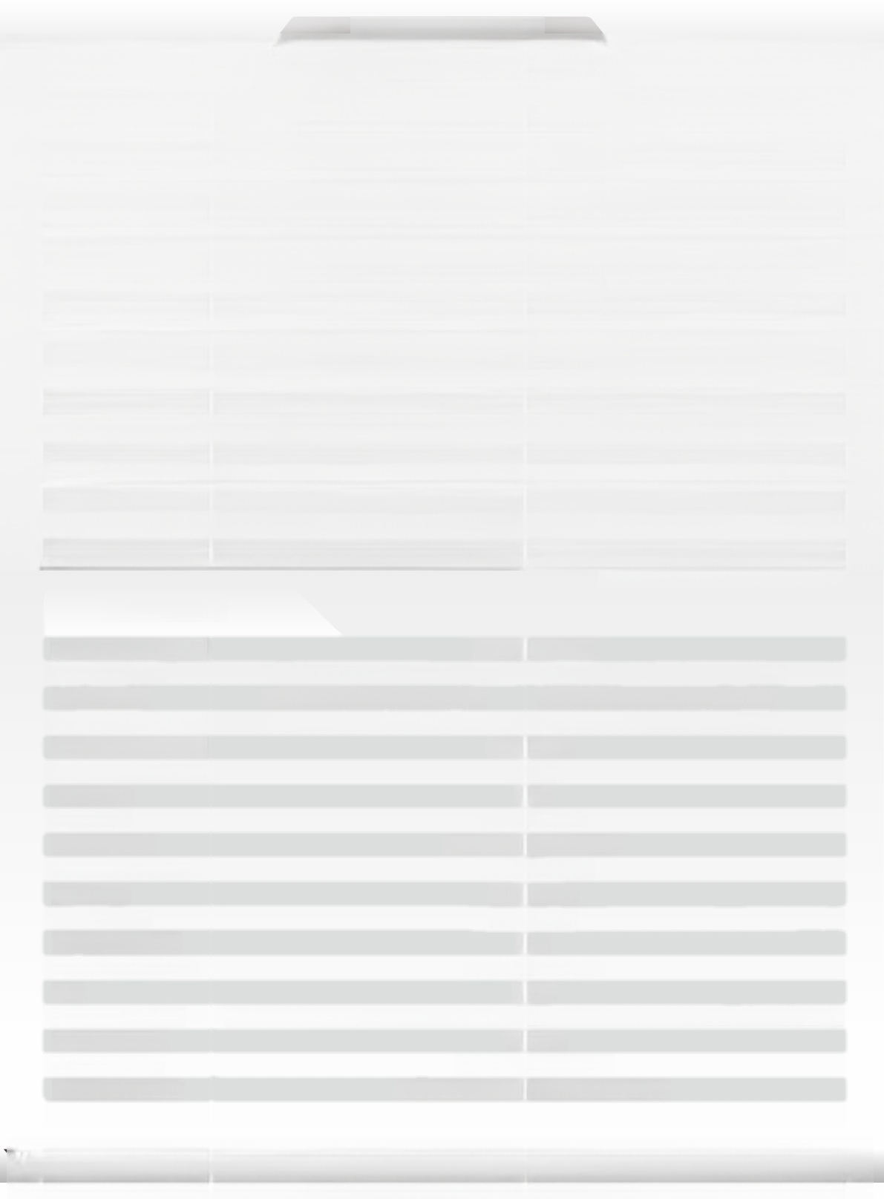**SPECIFICATION**

EARS

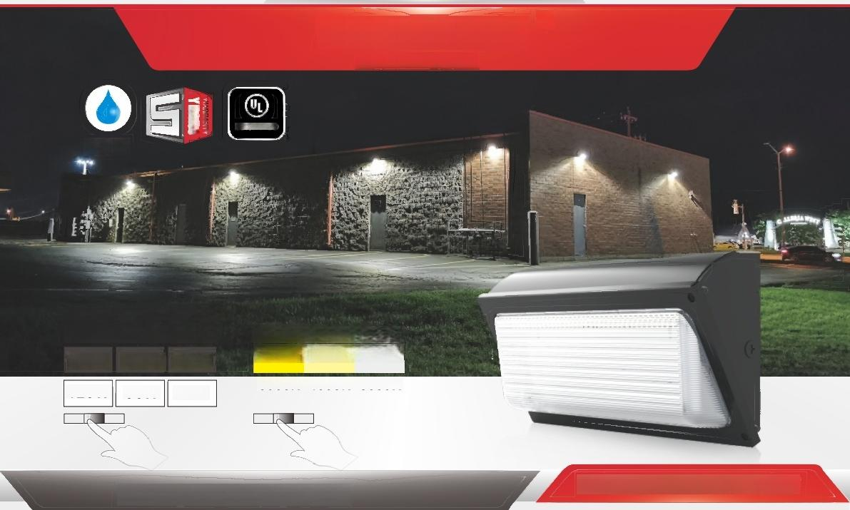

***NELED5***

**NEXLEDS LTD**

CERTIFIED

**IP65**

**3WTT Choosahle**

**3BGT Choosahs**

**Flip Switch to chanye CCT**

**3000K** **4000K** **5000K**

***LED WGII PGGK* NM-0WWP3-75W-DV-3C-3W**

**Fllp Switch to change WATT**

**75W**

**120W**

**60W**

**96W**

**45W**

**72W**

R

**NX-0WWP3-120W-DV-3C-3W**

**Specification**

|  |  |  |
| --- | --- | --- |
| PRODUCT NAME: | LED Wall Pack | |
| MODEL NO.: | NX-OWWP3-75W-DV-3C-3W | NX-OWWP3-120W-DV-3C-3W |
| WATTAGE: | 75W-60W-45W Changeable | 120W-96W-72W Changeable |
| SPECIFICATION: | AC120-347V;50/60Hz;700mA | AC120-347V;50/60Hz;1100mA |
| WORKING TEMP: | -40-45(℃) | |
| POWER FACTOR: | >0.9 | |
| CRI(RA): | >70 | |
| COLOR: | Dark Bronze | |
| MATERIAL: | Die-casting Aluminum | |
| LIGHT SOURCE: | Lumileds2835 | |
| LUMEN: | 130 lm/W | |
| LIFE TIME: | 50000 hrs | |
| BEAM ANGLE: | 90° | |
| PRODUCT SIZE: | 14x8.9x4.76 inch | |
| IP: | IP65 | |
| APPLICATION: | General outdoor security lighting,pathways,loading docks,perimeters and etc. | |
| WARRANTY: | 5 years | |
| STANDARD: | UL,c UL,DLC,FCC | |
| COLOR TEMP: | 3000K-4000K-5000K changeable | |



***NEXLEDS***G

**NEXLEDS LTD**

**www.nexleds.ca**

Email:sales@nexleds.ca

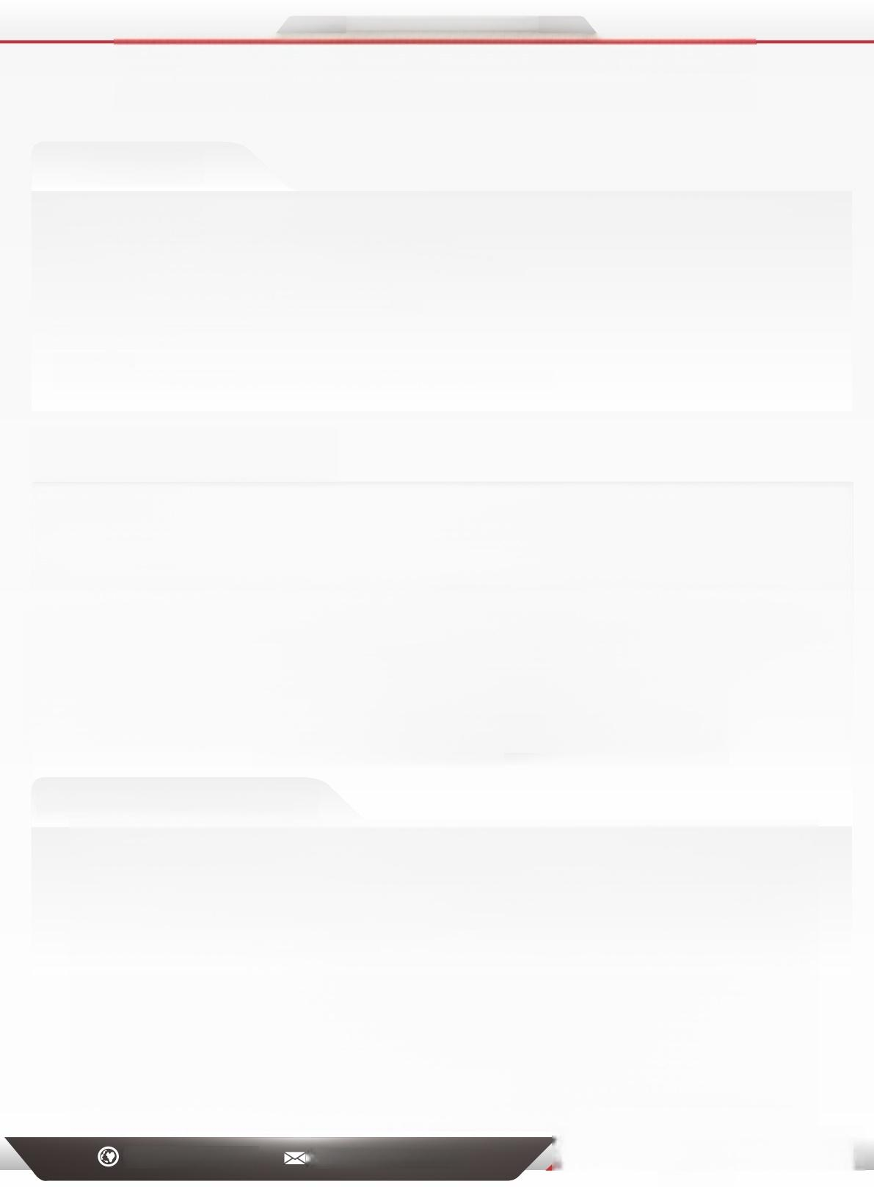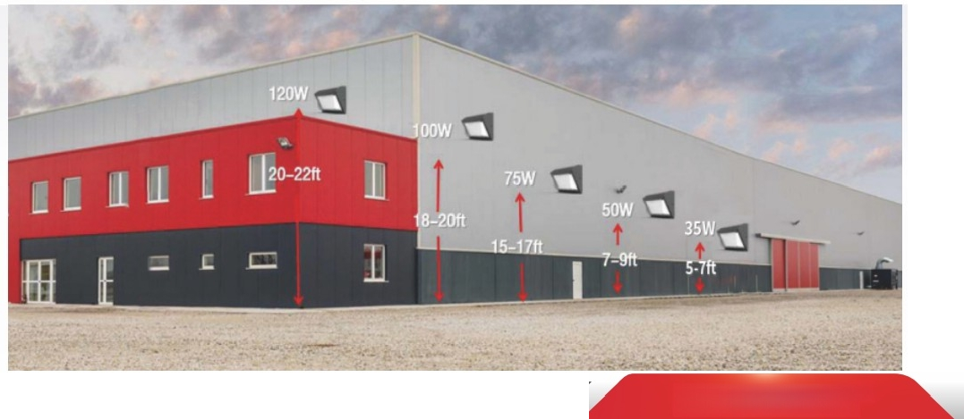**SPECIFICATION**



***NEXLED5***R

**NEXLEDS LTD**

***Feature:***

·Ultra-slim,die-cast aluminum housing with (3)available 1/2"threaded conduit hubs:(1)on back and (2)on 2 sides,(1)on bottom ·Powered by 0-10V dimming LED drivers

·Color Select Technology:Adjustable CCT (3000K,4000K,or 5000K)

·Borosilicate glass lens diffuses light source and provides uniform distribution

·Covers footprint of mid-size&large-size HID wallpacks

·Ambient operating temperature:-40°C/-40°F to 45℃/113°F

·UL listed for wet locations,IP65

·Power Factor:>0.9

·THD:<20%

·Meets FCC Part 15,Part B,Class A standards for conducted and radiated emissions



***Product Dimension***

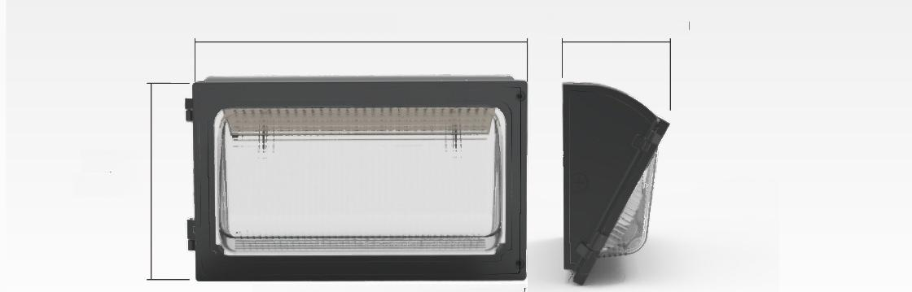**43/4”121mm**

14" 355mm

84/5"

226mm

**35W/50W/75W/100W/120W**

***Installation Reference:***

www.nexleds.ca Email:sales@nexleds.ca

*NEXLED5* ⑧

**NEXLEDSLTD**