深圳市嘉佰达电子科技有限公司
SHENZHEN JIABAIDA ELECTRONICS TECHNOLOGY.CO.,LTD

产 品 规 格 书
Product specification

客户名（CUSTOMER）:
产品名（SAMPLE NAME）: | 12~20串20A~80A软件板
产品型号（MODEL NAME）: | JBD-SP20S020A-铁锂系列
呈送日期（DATE）: | 2022-03-18
版本（VERSION）: | A02
客户签名盖章（SIGNATURES）:
编制（compiler） | 审核（Reviewer） | 批准（Approver）
张万连 | 易缘兵 | 张桥桥

修正记录(Correction record)
版本号  Version number | 页码  Page number | 修订人  Reviser | 修订日期  Revision date | 修订内容  Revised content | 备注  remarks
A01 | 全文 | 易缘兵 | 2021.11.05 | 全新拟制
A02 | 全文 | 张万连 | 2022.03.18 | 改为中英文对照格式

产品简介(Product introduction)
JBD-SP20S020A是专门针对12~20串锂电池包而设计的软件保护板方案， 该产品采用前端采集芯片+MCU架构，部分参数可以根据客户需求，通过上位机灵活调整。
JBD-SP20S020A is a software protection board scheme specially designed for 12~20 strings of lithium battery packs. The product adopts architecture of front-end acquisition chip + MCU, and some parameters can be flexibly adjusted through the host computer according to customer needs.

功能配置(Configuration)
功能(Function) | 配置(Configuration) | 功能(Function) | 配置(Configuration)
支持串数  (Number of strings supported) | 12~20S可选  （12 ~ 20 s optional） | 485通讯（隔离）  （485-communication (isolated) | 选配  (Optional)
持续电流  (Continuous current) | 20~80A可选  （20 ~ 80 a optional） | UART接口（隔离）  （UART interface (isolated) | /
NTC数量  (Number of NTCs) | 1路内置，2路外置  (1 built-in, 2 external) | CAN通讯  (CAN communication) | /
均衡功能  (Balance Function) | 被动均衡  (Passive equalization) | 232通讯  (232 Communication) | 不支持  (Not supported)
UART接口(非隔离）UART (non-isolated) | 标配  (Standard option) | 加热膜功能  (Heating function) | /
开关功能  (Switch function) | 选配  (Optional) | 蓝牙模块  (Module of Bluetooth) | 选配  (Optional)
充电限流功能  (Charging current limit) | 不支持  (Not supported) | 电池组串联  (Battery packs in series) | 不支持  (Not supported)
电池组并联  (Battery packs in parallel) | 不支持  (Not supported) | 二次保护功能  (Secondary protection function) | /
履历  (History storage) | / | LCD显示屏  (LCD display) | 选配  (Optional)
预放电功能  (Pre-discharge function) | / | LED指示灯接口  (LED indicator interface) | /
蜂鸣器  (Buzzer) | / | GPS接口  (GPS interface） | /

备注：UART接口（非隔离）不支持与充电器或负载通讯。
Note: The UART interface (non-isolated) does not support communication with chargers or loads.

参数设置(Parameter Setting)

基本参数(Basic parameter)
电芯规格（Cell specifications） | 12~20串铁锂（12~20 strings of iron lithium batteries）
接口类型(Interface type) | 充放电同口(Charge and discharge are both at the same port)
充电电压(charging voltage) | 3.6V*串数(3.6V*Number of strings)
单体电压范围(Cell voltage range) | 2.2~3.75V
持续充电电流(Continuous charging current) | 20A~80A可选
持续放电电流(Continuous discharging current) | 20A~80A可选
运行功耗(Consumption of running) | ≤20mA
休眠功耗(Consumption of sleep) | ≤3mA
休眠条件（Sleep conditions） | 无电流\通讯\保护状态下延时60±30S  Delay 60±30S under no current \ communication \ protection state
回路内阻(Circuit resistance) | ≤10mR
工作温度(Operating temperature) | -30℃~75℃
保护板结构尺寸(Structure size of PCB)
尺寸 (size) | 128±0.5mm * 88±0.5mm * 12-17±2mm  (长度*宽度*高度) (Length*Width*Height)
注：测试需在温度25±2℃, 相对湿度65±20% 的环境
Note: Test should be at temperature25±2°C, and relative humidity 65±20% of surroundings.

主要参数(Main parameter)
过压和欠压保护  (Overvoltage and undervoltage protection) | 项目(Project) | 规格(Specification) |  |  | 单位(Unit)
 |  | 最小值MIN | 典型值TYP | 最大值MAX
 | 过充保护电压(Overvoltage) | 3.700 | 3.750 | 3.800 | V
 | 过充保护延时(Overvoltage delay) | 1000 | 2000 | 3000 | mS
 | 过充保护释放(Overvoltage release) | 3.550 | 3.600 | 3.650 | V
 | 过放保护电压(Undervoltage) | 2.100 | 2.200 | 2.300 | V
 | 过放保护延时(Undervoltage delay) | 1000 | 2000 | 3000 | mS
 | 过放保护释放(Undervoltage release) | 2.400 | 2.500 | 2.600 | V
 | 过放保护释放条件(Undervoltage release conditions) | 60S内电压自恢复或者充电恢复(60S voltage self-recovery or charge recovery)
充电过流保护  (Overcurrent Charge) | 充电过流保护值(Overcurrent Charge protection value) | 见下面过流保护值配置表（See the configuration table of overcurrent protection value below）
 | 充电过流延时(Overcurrent Charge delay) | 7 | 10 | 13 | S
 | 充电过流释放条件(Charge over current release conditions) | 延时32S后自动恢复(Automatic recover after a delay of 32S)
放电过流保护  (Overcurrent Discharge) | 一级放电过流保护值  (1th Overcurrent Discharge) | 见下面过流保护值配置表（See the configuration table of overcurrent protection value below）
 | 一级放电过流保护延迟  (1th Overcurrent Discharge delay) | 7 | 10 | 13 | S
 | 二级放电过流保护电流值  (2th Overcurrent Discharge ) | 见下面过流保护值配置表（See the configuration table of overcurrent protection value below）
 | 二级放电过流2保护延迟  (2th Overcurrent Discharge delay) | 320 | 640 | 1280 | mS
 | 放电过流保护恢复条件  (Overcurrent Discharge release) | 延时32S后自动恢复(Automatic recover after a delay of 32S)
短路保护  (Short Circuit Discharge) | 短路保护电流(Short circuit protection current) | 见下面过流保护值配置表（See the configuration table of overcurrent protection value below）
 | 短路保护延迟时间(Short circuit protection delay time) | 200 | 400 | 800 | uS
 | 短路保护恢复(Short circuit protection recovery) | 断开负载后延时30s恢复。（Recover after 30S delay after disconnecting the load.）
短路说明：短路电流小于最小值或高于最大值可能会造成短路保护失效，短路电流超过1000A，不保证有短路保护，也不建议做短路保护测试。
(Short-circuit description: The short-circuit current is less than the minimum value or higher than the maximum value, which may cause the short-circuit protection to fail, and the short-circuit current exceeds 1000A, short-circuit protection is not guaranteed, and short-circuit protection testing is not recommended.)
充电高温保护Overtemperature Charge | 温度保护值(Temperature protection value) | 62 | 65 | 68 | ℃
 | 温度保护释放值(Temperature protection release value) | 52 | 55 | 58 | ℃
充电低温保护  (无加热功能）  Undertemperature Charge (no heating function) | 温度保护值(Temperature protection value) | -15 | -10 | -5 | ℃
 | 温度保护释放值(Temperature protection release value) | -10 | -5 | 0 | ℃
放电高温保护Overtemperature Discharge | 温度保护值(Temperature protection value) | 72 | 75 | 78 | ℃
 | 温度保护释放(Temperature protection release value) | 62 | 65 | 68 | ℃
放电低温保护Undertemperature Discharge | 温度保护值(Temperature protection value) | -25 | -20 | -15 | ℃
 | 温度保护释放(Temperature protection release value) | -15 | -10 | -5 | ℃
FET高温保护(内置)  high temperature protection of FET(Built-in) | 温度保护值(Temperature protection value) | 85 | 90 | 95 | ℃
 | 温度保护释放值(Temperature protection release value) | 65 | 70 | 75 | ℃
均衡功能  (Balance Function) | 均衡开启电压  (Equalization turn-on voltage) | 3.370 | 3.400 | 3.430 | V
 | 开启压差  (Difference opening voltage value) |  | 15 |  | mV
 | 均衡电流  (Balance current) |  |  | 60 | mA
 | 均衡模式  (Balance model) | 充电均衡  (Charge equalization)
 | 均衡类型  （Balance type） | 分时均衡/脉冲均衡  (Time sharing equalization/pulse equalization)
注：测试需在温度25±2℃, 相对湿度65±20% 的环境。
Note: Test should be at temperature25±2°C, and relative humidity 65±20% of surroundings.

3.3.过流保护值配置表(Overcurrent protection value configuration table)
持续电流  (Continuous current) | 充电过流保护值  (Charge over current protection value) | 一级放电过流保护值  (The first discharge over current protection value) | 二级放电过流保护值  (The second discharge over current protection value) | 短路保护值  (Short circuit protection value)
20A | 30±5A | 30±5A | 150±30A | 300±60A
30A | 40±5A | 40±5A | 150±30A | 500±100A
40A | 50±5A | 50±5A | 150±30A | 500±100A
50A | 60±5A | 60±5A | 250±50A | 700±140A
60A | 70±5A | 70±5A | 250±50A | 700±140A
70A | 80±5A | 80±5A | 350±60A | 900±180A
80A | 90±5A | 90±5A | 350±60A | 900±180A

3.4.参数设置 (parameter settings)

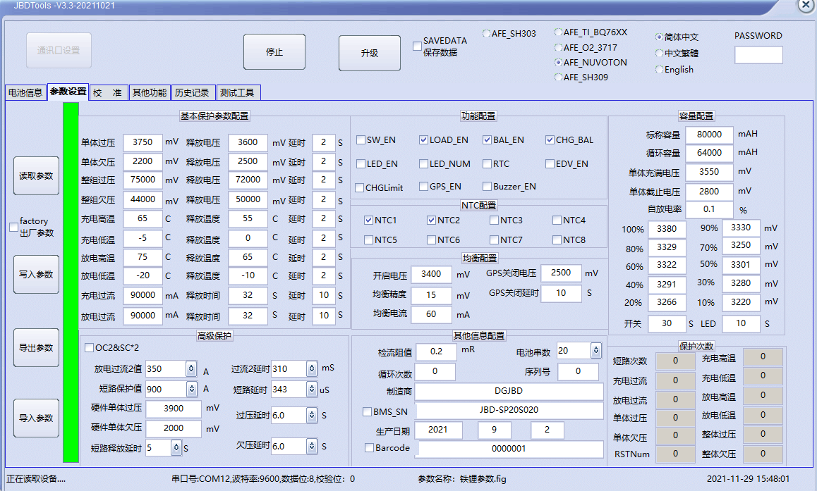

The diagram of upper computer

功能说明(Function Description)

过充保护和恢复(Overcharge protection and recovery)

单体过充保护及恢复(Cell overcharge protection and recovery)
当任意一节电芯电压高于单体过充电压设定值，并且持续时间达到单体过充延时，系统进入过充保护状态，关闭充电 MOS，不能对电池充电。
单体过充保护后，当所有单体电压降到单体过充恢复值以下时，解除过充保护状态。也可放电解除。
When the voltage of any cell is higher than the set value of the cell overcharge voltage, and the duration reaches the cell overcharge delay, the system enters the overcharge protection state, the charging MOS is turned off, and the battery cannot be charged.
After the cell overcharge protection, when the voltage of all cells drops below the cell overcharge recovery value, the overcharge protection state is released. It can also be released by discharge.

总体过充保护及恢复 (Entire overcharge protection and recovery)
当总体电压高于总体过压设定值，并且持续时间达到总体过充延时，系统进入过充保护状态， 关闭充电 MOS，不能对电池充电。
当总体电压降到总电压过压保护恢复值以下时，解除过充保护状态，也可放电解除。
When the entire voltage is higher than the entire overvoltage set value, and the duration reaches the entire overcharge delay, the system enters the overcharge protection state, turns off the charging MOS, and cannot charge the battery.
When the entire voltage drops below the recovery value of the entire voltage overvoltage protection, the overcharge protection state is released, and it can also be released by discharge.

过放保护和恢复(Over-discharge protection and recovery)

单体过放保护及恢复 (Cell over-discharge protection and recovery)

当最低节电压低于单体过放电压设定值，并且持续时间达到单体过放延时，系统进入过放保护状态，关闭放电 MOS，不能对电池放电。

发生单体过放保护后，对电池组充电可以解除过放保护状态。
When the minimum cell voltage is lower than the set value of the over-discharge voltage of the cell, and the duration reaches the over-discharge delay of the cell, the system enters the over-discharge protection state, turns off the discharge MOS, and cannot discharge the battery.
After the cell over-discharge protection occurs, charging the battery pack can release the over-discharge protection state.

总体过放保护及恢复(Entire over-discharge protection and recovery)

当总体电压低于总体过放电压设定值，并且持续时间达到总体过放延时，系统进入过放保护状 态，关闭放电 MOS，不能对电池放电。

发生总体过放保护后，对电池组充电可以解除过放保护状态。
When the entire voltage is lower than the entire over-discharge voltage set value, and the duration reaches the entire over-discharge delay, the system enters the over-discharge protection state, turns off the discharge MOS, and cannot discharge the battery.
After the entire over-discharge protection occurs, charging the battery pack can release the over-discharge protection state.

充电过流保护和恢复(Charging overcurrent protection and recovery)

当充电电流超过充电过流保护电流且持续的时间达到过流检测延迟时间，系统进入到充电过流保护状态，不能对电池进行充电。发生充电过流保护后延时自动恢复，如需不要自动恢复可将对应的释放时间设长; 放电也可以解除充电过流状态。
When the charging current exceeds the charging protection current and the duration reaches the overcurrent detection delay time, the system enters the charging overcurrent protection state and cannot charge the battery. After the charging overcurrent protection occurs, it will automatically recover after a delay. If you want to automatically recover or not, you can set the corresponding release time to be longer; the charging overcurrent state can also be released by discharging.

放电过流保护和恢复(Discharge overcurrent protection and recovery)
当放电电流超过放电过流保护电流且持续的时间达到过流检测延迟时间，系统进入到放电过流保护状态，关闭放电 MOS。发生放电过流后延时自动恢复，如需不要自动恢复可将对应的释放时间设长。充电也可以解除放电过流状态。放电有两级过流保护功能，对不同的电流值具有不同的响应速度，更加可靠地保护电池。
When the discharge current exceeds the discharge overcurrent protection current and the duration reaches the overcurrent detection delay time, the system enters the discharge overcurrent protection state and turns off the discharge MOS. Delayed automatic recovery after discharge overcurrent occurs, and the corresponding release time can be set longer if automatic recovery is required. Charging can also release the discharge overcurrent condition. Discharge has two-level overcurrent protection function, which has different response speeds for different current values, and protects the battery more reliably.

温度保护和恢复(Temperature Protection and Recovery)

充放电高温保护及恢复(Charge and discharge high temperature protection and recovery)
当充放电时 NTC 检测电芯表面的温度高于设定的高温保护温度时，管理系统进入高温保护状态，充电或放电 MOSFET 关闭，在该状态不能对电池包充电或放电。
当电芯表面的温度下降到高温恢复设定值时，管理系统从高温状态恢复，重新导通充放电MOS。
When the NTC detects that the temperature of the battery cell surface is higher than the setting of high temperature protection value during charging and discharging, the management system enters the high temperature protection state, the charging or discharging MOSFET is turned off, and the battery pack cannot be charged or discharged in this state.
When the temperature of the surface of the cell drops to the high temperature recovery set value, the management system recovers from the high temperature state and turns on the charge and discharge MOS again.

充放电低温保护和恢复 (Charge and discharge low temperature protection and recovery)
当充放电时NTC 检测电芯表面的温度低于设定的低温保护温度时，管理系统进入低温保护状态，充电或放电 MOSFET 关闭，在该状态不能对电池包充电或放电。
当电芯表面的温度上升到低温恢复设定值时，管理系统从低温状态恢复，重新导通充放电MOS。
When the NTC detects that the temperature of the cell surface is lower than the setting of low temperature protection value during charging and discharging, the management system enters the low temperature protection state, the charging or discharging MOSFET is turned off, and the battery pack cannot be charged or discharged in this state.
When the temperature of the cell surface rises to the low temperature recovery set value, the management system recovers from the low temperature state and turns on the charge and discharge MOS again.

均衡功能 (Balance function)
管理系统采用电阻旁路的方式进行电芯均衡,充电过程中电池组最高节单体电芯电压达到设定的均衡启动电压值，且电池组单体电芯最低电压与最高电压压差大于设定值时，达到条件的电芯均衡功能开启，相邻的两路均衡不能同时开启。
当电芯压差小于设定值或者电芯电压小于均衡开启电压时均衡停止。可设置充电均衡模式和静态均衡模式.
The management system uses the resistance bypass method to balance the cells. During the charging process, the voltage of the highest single cell of the battery pack reaches the set equilibrium starting voltage value, and the voltage difference between the minimum voltage and the maximum voltage of the single cell of the battery pack is greater than the set value. When the value is set, the equalization function of the cells that meet the conditions is enabled, and the two adjacent equalizers cannot be enabled at the same time.
The equalization stops when the cell voltage difference is less than the set value or the cell voltage is less than the equalization turn-on voltage. Charge balance mode and static balance mode can be set.

容量计算(Capacity calculation)
可以通过对电流、时间积分的方式精准地进行电池组的 SOC 计算。电池组满容量、及循环容量可以通过上位机进行设置，在进行完整充放电循环后容量可自动更新。 具有充放电循环次数计算功能，当电池组累积放电容量达到设定循环容量时，循环次数增加一次。
The SOC calculation of the battery pack can be accurately performed by integrating current and time. The full capacity and cycle capacity of the battery pack can be set through the host computer, and the capacity can be automatically updated after a complete charge and discharge cycle. It has the function of calculating the number of charge and discharge cycles. When the cumulative discharge capacity of the battery pack reaches the set cycle capacity, the number of cycles increases once.
注：新装电池请根据电池容量设定标称容量和循环容量，并进行一次容量学习，否则可能出现容量不准问题。 容量学习操作：先充满电至过压保护，然后放空电至欠压保护，再充一次电即可。
Note: For newly installed batteries, please set the nominal capacity and cycle capacity according to the battery capacity, and conduct a capacity study, otherwise the capacity inaccuracy may occur. Capacity learning operation: first fully charge to overvoltage protection, then discharge to under-voltage protection, and then charge it again.

休眠功能(Sleep function)
保护板处于静态时（无通讯，无电流，无均衡及过压保护。）延时1分钟后，进入休眠状态，进入此状态后，保护板仅降低检测电压电流的频率和自身功耗。通讯、拨开关、充放电可以自动退出休眠模式。
When the protection board is in static state (no communication, no current, no balance and overvoltage protection) . After a delay of 1 minute, it will enter the sleep state. After entering this state, the protection board will only reduce the frequency of detecting voltage and current and its own power consumption. Communication, dial switch, charging and discharging can automatically exit the sleep mode.

通讯功能(Communication)
保护板可通过通讯盒与电脑连接，通讯格式9600,8,N,1上位机接收保护板数据。
The protection board can be connected to the computer through the communication box. The communication format is 9600, 8, N, 1. The upper computer receives the protection board data.
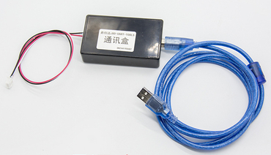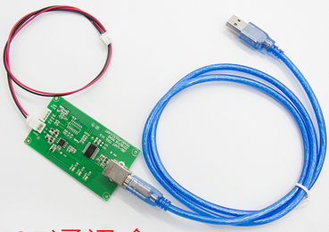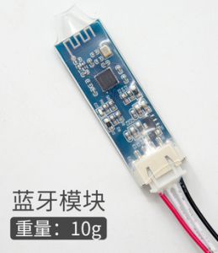
UART通讯盒 RS485通讯盒 蓝牙模块
(UART communication box) (RS485 communication box) (Bluetooth module)
注：上述三种工具都需要另行购买。Note: The above three tools need to be purchased separately.
连接方式：在电脑端安装我司通讯盒专用驱动程序后，将通讯盒的USB端插在电脑的USB端口，另一头接在已经接好电池的保护板对应接口。打开上位机，点通讯口设置，选择通讯盒对应CMO口，其他选项不用动，确认后点击开始，即可读取保护内数据。如需更改保护板参数，一定要先在参数页面点击读取参数后，再来更改参数。
The connection method: after installing the special driver for our communication box on the computer, insert the USB end of the communication box into the USB port of the computer, and connect the other end to the corresponding interface of the protection board that has been connected to the battery. Open the host computer, click the communication port settings, select the CMO port corresponding to the communication box, and do not change other options. After confirming, click Start to read the data in the protection. If you need to change the parameters of the protection board, you must first click on the parameter page to read the parameters, and then change the parameters.

主要物料(main material)
序号  (Number) | 物料名称  (Name of Material) | 生产厂家  (Manufacturer) | 数量  (Quantity)
1 | IC\QFP\NANO100SD3BN\LQFP64 | nuvoton | 1PCS
2 | MOS管\SMD\CRSS052N08N\TO-263 | 华润微 | XPCS
3 | IC\QFP\BQ7692003PW\TSSOP-20 | TI | 1PCS
4 | IC\QFP\BQ7694003DBTR\TSSOP-44 | TI | 1PCS
5 | 双NTC\10K\3950\250mm\带端子\HY2.0\±1％ | 仙桥 | 1PCS
配件(Accessories)
1 | 采集线\16PIN\HY2.0\带卡扣\24AWG\550MM\黑白红 | --- | 1PCS
2 | 采集线\5PIN\HY2.0\带卡扣\24AWG\550MM\黑白红 | --- | 1PCS

注：以上物料可能用同等规格参数或者更好的规格参数的物料替代，如有认证需求不允许更换物料，需要通知我司业务重新送样，受控规格书，最终解释权归嘉佰达所有。
Note: The above materials may be replaced by materials with the same specifications or better specifications. If there are certification requirements, the replacement of materials is not allowed, and we need to notify our business to send samples again. The controlled specifications, the final interpretation right belongs to Jiabaida.

示意图及尺寸(Schematic and Dimensions)

尺寸及安装点标注图(Dimensions and installation point drawing)

常规结构尺寸

General structure size

信号口定义(Signal port definition)

示意图标注接口标号（参考下图）

Schematic marking the interface label (refer to the following figure)

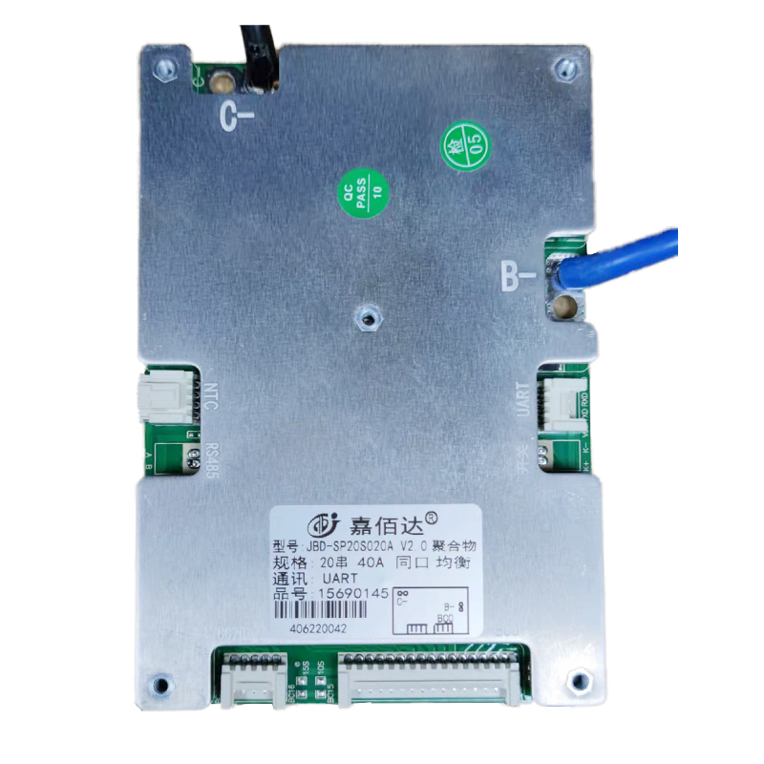
B-，电池负极
Battery negative
C-，负载和充电器负极
Load and charger negative
J6
J4
J1
J2
J5
NTC

标号  (Label) | 位号  (Tag number) | 接插件功能  (Connector) | 接插件示意图  (Schematic diagram) | PIN | PIN功能定义  (Pin function) | 备注  （Note）
1 | J6  (HY2.0-2P)带卡扣 | RS485 | 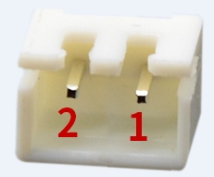 | 1 | RS485-B
 |  |  |  | 2 | RS485-A
2 | J4  (HY2.0-2P)带卡扣 | 放电开关接口  （discharge switch interface |  | 1 | SW+
 |  |  |  | 2 | SW-
3 | J1  (HY2.0-16P)  (带卡扣) | 电压检测插座  Voltage detection socket | 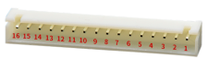 | 1 | 接最低节电芯负极  Connect to Negative Side of Cell 1. | BC0
 |  |  |  | 2 | 接第1节电芯正极  Connect to Positive Side of Cell 1 | BC1
 |  |  |  | 3 | 接第2节电芯正极  Connect to Positive Side of Cell 2 | BC2
 |  |  |  | 4 | 接第3节电芯正极  Connect to Positive Side of Cell 3 | BC3
 |  |  |  | 5 | 接第4节电芯正极  Connect to Positive Side of Cell 4 | BC4
 |  |  |  | 6 | 接第5节电芯正极  Connect to Positive Side of Cell 5 | BC5
 |  |  |  | 7 | 接第6节电芯正极  Connect to Positive Side of Cell 6 | BC6
 |  |  |  | 8 | 接第7节电芯正极  Connect to Positive Side of Cell 7 | BC7
 |  |  |  | 9 | 接第8节电芯正极  Connect to Positive Side of Cell 8 | BC8
 |  |  |  | 10 | 接第9节电芯正极  Connect to Positive Side of Cell 9 | BC9
 |  |  |  | 11 | 接第10节电芯正极  Connect to Positive Side of Cell 10 | BC10
 |  |  |  | 12 | 接第11节电芯正极  Connect to Positive Side of Cell 11 | BC11
 |  |  |  | 13 | 接第12节电芯正极  Connect to Positive Side of Cell 12 | BC12
 |  |  |  | 14 | 接第13节电芯正极  Connect to Positive Side of Cell 13 | BC13
 |  |  |  | 15 | 接第14节电芯正极  Connect to Positive Side of Cell 14 | BC14
 |  |  |  | 16 | 接第15节电芯正极  Connect to Positive Side of Cell 15 | BC15
4 | J2  (HY2.0-5P) (带卡扣) | 电压检测插座  Voltage detection socket | 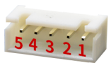 | 1 | 接第16节电芯正极  Connect to Positive Side of Cell 16 | BC16
 |  |  |  | 2 | 接第17节电芯正极  Connect to Positive Side of Cell 17 | BC17
 |  |  |  | 3 | 接第18节电芯正极  Connect to Positive Side of Cell 18 | BC18
 |  |  |  | 4 | 接第19节电芯正极  Connect to Positive Side of Cell 19 | BC19
 |  |  |  | 5 | 接第20节电芯正极  Connect to Positive Side of Cell 20 | BC20
5 | J5  (HY2.0-4P) (带卡扣) | UART\蓝牙接口  (UART \ Bluetooth interface) | 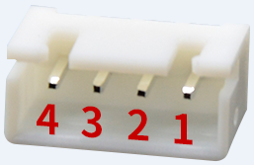 | 1 | GND UART接口地(UART-GND)
 |  |  |  | 2 | RXD 保护板数据接(RXD-BMS)
 |  |  |  | 3 | TXD 保护板数据发(TXD-BMS)
 |  |  |  | 4 | VDD 蓝牙供电  (Bluetooth power supply)
6 | RT2 RT3  (HY2.0-4P)  (带卡扣) | NTC接口 |  | 1 | NTC1
 |  |  |  | 2
 |  |  |  | 3 | NTC2
 |  |  |  | 4

备注：
1、J5-UART的地线为B-，为非隔离UART端口，不支持与充电器或负载通讯。
The ground wire of J5-UART is B-, which is a non-isolated UART port and does not support communication with chargers or loads.

其他串数接线方式(Other wiring connection mode)
19串 | 短接BC18-BC19接在第18串正极
18串 | 短接BC17-BC19接在第17串正极
17串 | 短接BC13-BC14接在第13串正极，短接BC17-BC19接在第16串正极
16串 | 短接BC8-BC9接在第8串正极，短接BC13-BC14接在第12串正极，短接BC17-BC19接在第15串正极
15串以下需要单独做板，20串不能直接改到串15及以下。
15串 | 单独做板，无需短接。
14串 | 短接BC13-BC14接在第13串正极
13串 | 短接BC8-BC9在第8串正极，短接BC13-BC14在第12串正极。
12串 | 短接BC3-BC4接在第3串正极，短接BC8-BC9接在第7串正极，短接BC13-BC14接在第11串正极。

环境适用性(Environmental suitability)

工作环境(The environment of working)
- BMS 保护板允许在下列条件下正常工作:
- 环境温度：-30℃ ~+75℃;
- 相对湿度：5% ~ 90%;
- 大气压力：86kPa~106 kPa;
- BMS The protective plate allows normal operation under the following conditions:
- Ambient temperature: -30°C ~+75°C;
- Relative humidity: 5% ~ 90%;
- Atmospheric pressure: 86kPa~106kPa;

存储环境 (The environment of storage)
BMS 保护板应存储在环境温度为-5°C~+40°C、相对湿度不大于 70%、清洁通风良好的库房 内，空气中不得含有腐蚀性气体及影响电气绝缘的介质，不得受任何机械冲击或重压。不受阳光直射，与热源(暖气设备等)之间的距离不得少于2m。在以上存储条件下，BMS保护板可存放一年。
BMS The protection board should be stored in a clean and well-ventilated warehouse with an ambient temperature of -5°C~+40°C, a relative humidity of not more than 70%, and the air must not contain corrosive gases and media that affect electrical insulation, and must not be affected by any mechanical Shock or heavy pressure. Not subject to direct sunlight, and the distance from the heat source (heating equipment, etc.) should not be less than 2m. Under the above storage conditions, the BMS protection board can be stored for one year.

包装运输(Packing and shipping)

标志(Logo)
BMS 保护板应有下列清晰耐久标志:
- 产品名称、型号
- 电芯型号
- 出厂日期及编号

包装(Package)
- 包装应符合防潮、防振动的要求，包装箱应牢固可靠，箱内应衬有防潮材料，产品 在箱内不应窜动。
- 外部纸箱包装箱，单板防静电袋加气泡袋包装;
- The packaging should meet the requirements of moisture-proof and anti-vibration, the packing box should be firm and reliable, the inside of the box should be lined with moisture-proof material, and the product should not move in the box.
- External carton box, veneer anti-static bag plus bubble bag packaging;

运输(transportation)
- 在运输中，产品不得受剧烈机械冲撞、暴晒、雨淋、化学腐蚀性物品及有害气体侵蚀; 5.3.2 在装卸过程中，产品轻搬轻放，严禁摔掷、重压。
- 包装箱码放高度小于 5 层。
- During transportation, the product shall not be subject to severe mechanical impact, exposure to the sun, rain, chemical corrosive substances and harmful gases; 5.3.2 During the loading and unloading process, the product should be handled with care, and it is strictly forbidden to throw or press it.
- The height of the packing boxes shall be less than 5 layers.

注意事项(Precautions)
- 本电池管理系统常规是不能串联使用的，需要定制版本才支持串联使用。
- 多个使用本管理系统的电池包并联时，应确保并联之前各电池包的最大压差低于 3V。
- 多个使用本管理系统的电池包并联使用时，适配器总的充电冲击电流可能施加到单个电池包上， 应确保适配器总的充电冲击电流不超过单个管理系统充电冲击电流的最大值。
- 本管理系统的短路保护功能适用于多种应用情景，但并不能保证可以在任意条件下短路。当电池 包和短路回路的内阻值总和低于 40mΩ、电池组容量超出额定值 20%、短路电流超过 1800A、短路回路的电感非常大或者短路的导线总长度非常长时，请自行测试确定是否可以使用本管理系统。
- 焊接电池引线时，一定不可有错接或反接。如果确实已接错，这块电路板可能已损坏，需要重新测试合格后才可使用。
- 装配时管理系统不要直接接触到电芯表面，以免损坏电路板。装配要牢固可靠。
- 使用中注意引线头、烙铁、焊锡等不要碰到电路板上的元器件，否则有可能损坏本电路板。焊接本电路板请不要使用膏状助焊剂，否则有可能导致本电路板工作不正常。
- 使用过程要注意防静电、防潮、防水等。
- 使用过程中请遵循设计参数及使用条件，不得超过本规格书中的值，否则有可能损坏管理系统。
- 本规格书中的参数、功能和外形仅供参考，以保护板实物为准
- 将电池组和管理系统组合好以后，初次上电如发现无电压输出或充不进电，请检查接线是否正确。
- This battery management system cannot be used in series in general, and requires a customized version to support series use.
- When multiple battery packs using this management system are connected in parallel, make sure that the maximum voltage difference of each battery pack is lower than 3V before parallel connection.
- When multiple battery packs using this management system are used in parallel, the total charging inrush current of the adapter may be applied to a single battery pack. It should be ensured that the total charging inrush current of the adapter does not exceed the maximum charging inrush current of a single management system.
- The short-circuit protection function of this management system is suitable for a variety of application scenarios, but it does not guarantee that it can be short-circuited under any conditions. When the total internal resistance of the battery pack and the short-circuit loop is lower than 40mΩ, the capacity of the battery pack exceeds the rated value by 20%, the short-circuit current exceeds 1800A, the inductance of the short-circuit loop is very large, or the total length of the short-circuit wire is very long, please test yourself to determine whether This management system can be used.
- When soldering the battery leads, there must be no wrong or reverse connection. If it is indeed connected incorrectly, the circuit board may be damaged and needs to be re-tested before it can be used.
- When assembling, the management system should not directly touch the surface of the cell to avoid damage to the circuit board. Assembly should be firm and reliable.
- During use, be careful not to touch the components on the circuit board such as lead tips, soldering iron, solder, etc., otherwise the circuit board may be damaged. Please do not use paste flux when soldering this circuit board, otherwise it may cause this circuit board to work abnormally.
- During use, pay attention to anti-static, moisture-proof, waterproof, etc.
- During use, please follow the design parameters and conditions of use, and must not exceed the values ​​in this specification, otherwise the management system may be damaged.
- The parameters, functions and appearances in this specification are for reference only, and the actual protection board shall prevail.
- After the battery pack and the management system are combined, please check whether the wiring is correct if you find that there is no voltage output or charging fails when the battery is powered on for the first time.

