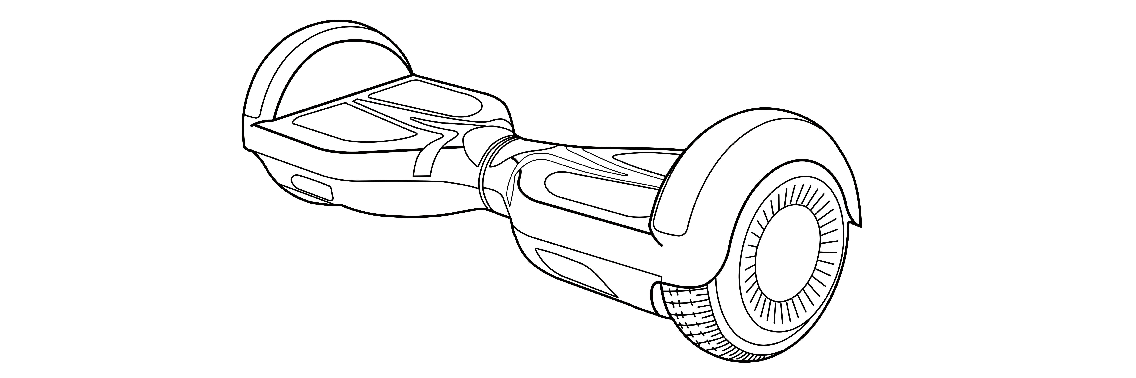
SIMATE ®

User Manual

V2021.0.1

- Thank you for choosing one of our Self-balancing electric scooters series
- Self-balancing electric scooters are high-tech products, light and double wheeled vehicles
- Please read all safety instructions before operating this vehicle.
- <User's Manual > can guide you through all the functions and usage of the product
WARNING!
Warning: this product might be limited to use on private road (check the regulations in force in the territory of use). We recommend using suitable protective equipment.
- Please familiarize yourself with how to operate the product before using it for the first time.
This way you can use it at its best condition, otherwise you may crash, fall or lose control of the scooter, etc.
- The v User Manual > can help you learn to drive this electric scooter safely.
- v User Manual > has told all the instruction and notes, If the operator fails to follow the instructions or violate the warning, our company won't be responsible for any related results.
- If you want to get the services and technology support, you can contact the local agency or our company.

CATALOG
Chapter I General information
- About the manual 3
- The risk of driving 3
- The preparation before operation 3
- Related explanation 3
Chapter II product introduction
- Description of the electric scooter 4
- Accessories 4
- Operating principal 5
Chapter III Information indicate devices
  - Pedal sensor 6
  - Indicator 6
  - Bluetooth Speaker 6
Chapter IV safety use
- The weight limitation of the operator 7
- Range per charge 7
- Max. speed 7
Chapter V Learn how to use it
- Operation steps 8
- Protect function 9
- Riding practice 10
- Reset 10
Chapter VI Safety drive 11
Chapter VII The usage of the battery
- The volume of the battery 13
- Charging steps 13
- The temperature is too high or too low 14
- The specification of the battery 14
- The transport of the battery 14
Chapter VIII The maintenance of the electric scooter
- Cleaning 15
- Storage 15
Chapter IX The specification of electric scooter 16
Chapter X packing list 16
- About the manual
Please read all instructions for safe assembly and operation before operating this vehicle.
< User Manual > can guide you through the functions and usage of self-balancing electric scooter. The user's manual is applied to all the smart Vehicle made by our factory.
If you have any questions or you cannot get the information you want from the manual please Contact our company or your local representative.
- The risk of driving
Self-balancing electric scooter is a smart transport and recreation tool. Its technology and the progress of production is tested seriously. However, if you don't follow the requests of the manual, you may get hurt.

WARNING!
No matter when and where falling, losing control, crushing ,etc, including violating the rules of the user's manual may cause you injury.
In order to avoid getting injured, please read this manual carefully.
- The preparation before operation.
Before using, the battery should be checked whether full charged. Please find more details in Chapter VII.You may be injured when you do not follow the rules in the manual.
- Related explanation
Please pay more attention to "WARNING" and "NOTE" which are all capital alphabets.
WARNING! | Your importer behavior will involve you into a dangerous condition.
NOTE： | The matters and the related using methods that need your attention.

2.1 Description of the electric scooter
Self-balancing electric scooter which can go forwards, backwards, steering and stop controlled by dynamic equilibrium. It possesses fashionable appearance, simple operation, easy to control, low-carbon and environmental protection, etc advantage. It is a great companion.
- Accessories
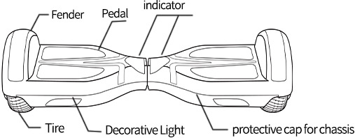

6.5"
- Operating principal
- Self-balancing electric scooter adapts Dynamic equilibrium, using internal gyroscope and acceleration sensors. The status of the electric scooter is controlled by the center-of gravity.
by the center-of gravity of the user And it is adjusted by motor which is controlled by servo control system. When you lean forward, it will sense your actions to accelerate. When you need to swerve, slow it down and move your foot forwards or backgrounds then the center-of gravity of the body moves left or right therefore the scooter can realize left or right.
•
Self-balancing electric scooter has inertial dynamic stabilization system, so it can keep anterior-posterior balance but cannot guarantee the left and right. Therefore the scooter needs to be operated slowly when swerved,, you may get injured because of the large centrifugal force.
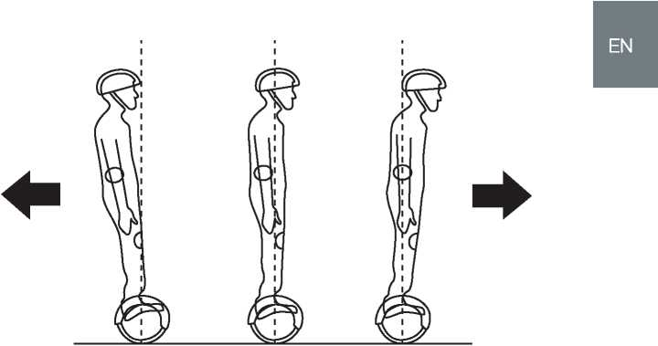
- Pedal sensor
Self-balancing electric scooter has 4 sensors below the pedals, when the operator step on the pedal, the scooter will adjusted itself to balancing pattern automatically.
When ridding it, you have to make sure that the pedal is being stepped on, please don't step on the parts outside the pedal.
Don't put things on the pedals to make the scooter cannot be turned off and increase the possibility of crushing and even cause personal injury and damage the scooter itself.
- Indicator
The indicator is located in the middle of the scooter. It is applied for operation information.
- Battery indicator part: Green light means full charged, when the green light turns yellow means t here is half battery, turns red means 20% battery, the scooter need charging.
- Operation indicator: when the pedal is triggered, the operation indicator will lights then the system come into operating conditions, when the system runs error, the indicator will turn red.
- Bluetooth Speaker
If you have purchased a Bluetooth version, you will hear a Bluetooth tone after booting up, it will be a short piece of music or a sentence voice. Then you can connect your scooter with your smartphone via Bluetooth.
We hopes every operator can ride the scooter safely and enjoy it. Thinking back to the experiences when you learn riding bike, driving cars, go skiing or use other transportation tools, all of them can help you can help you to learn about the scooter faster.
- Follow the <User's manual>, you can ride self-balancing electric scooter safely. We highly advise you read the manual carefully at the first time.
Before riding, make sure the tires are good, the spare parts are tight, If there is anything abnormal, please contact the agency for repairing immediately.
- Please read the manual carefully, from it you will get much important information, including speed limitation, indicator warning and turn off safely, etc.
- Please never use the scooter do anything may cause personal injury and property loss.
- Please don't modify the spare parts of the electric scooter. Because it can influence the capacity of the scooter badly and even destroy it, meanwhile, some side-effects may happen.
- The weight limitation of the operator
- The reason of the weight limitation: 1, guarantee the safety of the operator; 2 decrease the damage of overloaded.
- Maximum load: 100KGS
- Minimum load: 20KGS
Overloading may make you fall
WARNING!:
- Range per charge
The range per charge is related to many factors, for example:
- Topography: When driving on a flat road, the driving mileage will be longer, otherwise the driving mileage will be shortened.
- Weight: The body weight of the operator can influence the driving mileage Temperature: Place the scooter at a appropriate temperature will increase driving mileage. On contrast, if place it at an extreme temperature, it will decrease the driving mileage.
- Maintenance: If the scooter is properly charged and the battery is in good condition, it will increase the driving mileage. In the opposite case, it will reduce the driving mileage.
- Speed and driving style: Maintaining a moderate speed will increase the driving mileage. Conversely, frequent starts, stops, accelerations, and deceleration will reduce the driving mileage.
- Max Speed
- The maximum speed of the scooter depends on the model you have chosen.
- When the scooter exceeds the maximum speed, it will sound an alarm.
- In the permissive speed, the electric scooter can balance itself well. When the speed is faster than the permissive speed, it will turn up to warn the operator to slow down.
<User's Manual> has told all the instructions and notes, the operator must read it carefully and follow these instructions. It is very important for you to know all these notes.

5.1 Learn how to use it
Step 1: Press the power switch to turn on self-balancing electric scooter.
Step 2: The preparations for driving. First, step on one foot to trigger the foot switch on the pedal, and the system will enter self-balancing state. Then step on the other foot to the other side to operate it.
Step 3: lake control of the scooter forwards or backwards.The movement of the body cannot be dramatic while driving.
NOTE:
If the scooter doesn't at balancing condition when you trigger the foot-switch, the buzzer will alarm. And the warning LED will light, the system cannot come into self-balancing condition. At this moment you shouldn't operate.
Step 4: Control the left and right direction of the scooter.
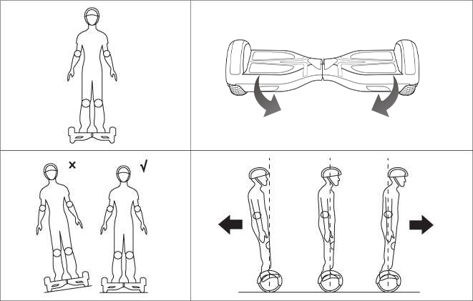
Step 5: Get off. Before getting off, make sure the scooter is still on, then leave one foot and then leave the other foot.

You are forbidden to turning violently when drive fast , otherwise it will be dangerous.
You are forbidden to ride sideways or swerve on the slope, for It will lead to the balance angel skewing then endanger your safety.

5.2 Protect function
- During operation, if the system runs incorrectly or be illegally operated, the scooter will prompt operators in different ways like prohibit riding, alarm indicator lights, buzzer alarm beeps intermittently. The system cannot enter self-balancing mode.
- When step on the scooter, the pedal go forwards or backwards more than 10 degrees.
- The voltage of the battery is too low.
- During charging .
- During operation, the pedal unturned and prohibit operation.
- Over speeding.
- The power is not enough.
- The electric scooter shaking back and forth for more than 30 seconds.
- System enters into protection mode, alarm indicator lights, buzzer alarms of high frequency.
- The platform goes forwards or backwards more than 35 degrees, the electric scooter will directly into the stop mode.
- Tire stall, two seconds later the electric scooter enters power off mode.
- The battery voltage is lower than the protection value, 15 seconds later the electric scooter enters into power off mode.
- Continuing large current discharge (such as a long-time climbing a very steep slope), 15 seconds later the electric scooter enters into power off mode.

WARNING!
When the scooter enters the off state, the system will automatically lock the scooter. It can be unlocked when the lock button is pressed. Do not continue driving the scooter when the battery is exhausted or the system signals a safely shutdown. The scooter cannot be balanced when the battery is low, and in this case the driver may be hurt. If the battery reaches a minimum, continuing to drive the scooter will affect the battery life.
- Riding practice
Before drive the scooter outdoors, please make sure you are familiar with the skills of driving :
- Please wear casual wear and flat shoes as much as possible to maintain flexibility.
- Practice driving the scooter in an open space until you can easily get on, go forward, go back, stop and get off.
- Make sure the road is flat.
- When you are familiar with that the scooter must be slowed down in which terrain , you can drive on different terrains. And you can drive the scooter off the ground at any time.
- Self-balancing electric scooter is a transportation vehicle designed for smooth roads. Please slow down to ensure safety when driving on uneven roads.
- If you are not familiar with scooters, please avoid driving to a place which has pedestrians and obstacles and other potential risk factors.. Be careful when entering the door to ensure that the scooter can pass.
- Reset
The steps to reset the scooter are as follows:
- Make sure the hoverboard is fully charged.
- Keep the hoverboard pedal parallel to the ground.
- Turn off the hoverboard; then press and hold the power button for about 10 seconds.
(You will see the LEDs flash 5 to 6 times and light up continuously after 6 flashes.)
- Turn off the hoverboard once more to finalize the recalibration.
- Turn on the hoverboard and it will be in good condition again, and you can continue to use it without fear.
This chapter will focus on safety knowledge and warnings. Read all instructions for safe assembly and operation before operating this vehicle.
<User Manual> can guide you through the functions and use of the self-balancing electric scooter. Please read the user manual carefully before driving to ensure that our products will give you the best driving experience.
WARNING!
- Please familiarize yourself with how to operate the product before using it for the first time.
This way you can use it at its best condition, otherwise you may crash, fall or lose control of the scooter, etc..
- When you are learn to drive the scooter, please make sure that all safety measures are taken . Like wearing a helmet, knee pads, elbow pads and other Protective gears.
- Self-balancing electric scooters are not allowed on the motor vehicles.
- Children weighing less than 20kg , the aged, pregnant women are not allowed to drive.
- Do not drive after drinking or taking drugs.
- Do not carry anything while driving.
- When driving a scooter, you should follow local traffic regulations and give way to pedestrians.
- Please pay attention to the things in front of you. Maintaining good vision will help you drive your scooter safely.
- Relax your legs while driving and bend your knees slightly to help maintain balance when you are facing uneven ground.
- Make sure your feet are always on the pedals while driving.
- Self-balancing electric scooters can only load one person and cannot load two or more people.
- Do not suddenly start or stop.
- Avoid driving on steep slopes.
- Do not drive in dim areas.
- The weight of the user and their belongings should not exceed the maximum load indicated in the instruction , otherwise the driver may easier to fall or be injured, or even damage the electric scooter. In addition, the driver s weight should not be less than the minimum weight as marked in the instruction, otherwise the scooter will not be able to be manipulated, especially when going downhill, the scooter cannot slow down or stop safety.
- Make sure driving speed is safe for yourself and others, and be prepared to stop at any time.
- When you are coming across a traffic accident, please remain at the place awaiting the arrival of the relevant departments to deal with it.
- When you are driving the scooter along with other driving users, please keep a certain distance from each other to avoid collisions.
- Always keep in mind that you have increased the height of 10 cm when driving the scooter. Pay attention to your head when passing the door.
- When steering you should notice your body center of gravity, the violent movement of the center of
gravity may cause you in danger.
- Do not ride on rainy days as well as long-distance running backwards, high speed running backwards, backwards at high speed cornering and over speeding.
- Personal transportation has not been designed, tested or related to become a medical device. Therefore, the users must ride the electric scooter by themself.
• Avoid driving to obstacle and overly smooth ground such as snow, ice, and slippery floor.
- Avoid driving on the ground made up of cloth, twigs and stones.
- Avoid driving in tight spaces or in places with obstacles.
- Please drive the scooter in the proper environment. If you need to get permission from others in this environment, please get their permission first.
- Prohibit in an unsafe environment. These unsafe environments mean flammable, vapor, liquid, dust or fiber that can easily cause a fire.
This chapter focuses on charging methods, how to maintain the battery, safety issues to be aware of, and battery specifications.
For the safety of you and others and to maximize battery life and battery performance, be sure to use the battery as described below.
- Low battery
When you notice that the battery indicator is red and flashing, it indicates low battery. It is recommended that you stop driving. When the power is low, there is not enough energy for you to drive normally, then the system will automatically tilt the base of the platform to prohibit the operator from continuing to use.
- Do not use the battery under the following cases.
- The body emits an odor or overheating.
- Any substance leaks..
- Professionals only disassemble and maintain the battery.
- Do not touch anything that leaks from the battery
- Do not let children and animals touch the battery. The driver must pull out the battery or charger before installing the battery . You not do anything with the electric scooter while charging.
- The battery contains dangerous substances inside, so do not disassemble the battery and do not insert anything into the battery.
- Use only qualified chargers supplied by formal company.
- Do not over discharge the lithium battery. Excessive discharge may cause safety hazard and is limited to scrap battery.
- The battery can only be used under the permission of the local law.
- Charging steps
- Ensure the charging port is dry
- Firstly plugged the switch into the power interface (100V~240V:50,60Hz).
verity that the green light is on properly, then plug the other end of the charger into the scooter.
- When the red indicator on the charger lights up to indicate normal charging, otherwise check if the line is connected.
- When the indicator light on the charger from red to green indicates that power is Hilly charged. In this case, please stop charging. Over charging will affect the battery life.
- Note to the use the local standard plug.
- Please follow the instructions to charge and store, otherwise it will damage the battery and affect the battery life.
- Please keep the charging environment clean and dry.
- Do not charge it when the charging port is moist.
- The temperature is too high or too low
- If you want the scooter in good operational efficiency, the battery temperature must be controlled among the range of specification.
- Temperature before charging and charging process must be within the recommendea v Hues. Close to the recommended temperature, the charging efficiency is the highest, if it is too cold or hot, the charging time will be longer, or not fully charged.
- The specification of the battery
NAME | PARAMETERS
Battery | Lithium-ion battery
Voltage | 36 V
Working Temperature | -15~50℃
Charging Temperature | 0~40℃
Relative Humidity of Storage | 5% ~ 95%

- The transport of the battery
Lithium batteries are considered to be hazardous materials. The transportation of it needs to be allowed by local law.
WARNING!

Self-balancing electric scooter need to be maintained. This chapter focuses on the steps and important operational reminders for maintaining it.
Please make sure that the power and charge coil are off before you do following operation. Ybur ban before cleaning:

8.1 Cleaning
- lb make sure the power and the charge coil are off.
- lb wipe the shell of electric scooter with soft cloth.
WARNING!
- The level of dust-proof and waterproof is IP54 and can prevent wee dust and splashing water.
- Avoid water or other liquids from penetrating into the scooter's main unit to avoid permanent damage to internal electronics.

8.2 Storage
- Before storage, fully charge the electric scooter to prevent battery over discharge due to it's not used for a long time.
- If the storage time is more than a few months, please charge it once a month.
- Do not charge the scooter if the storage temperature is below 0 degrees Celsius.
You can charge it in a warm environment (above 10 degrees Celsius).
- You can mask the scooter to prevent dust from affecting its performance.
- Keep store the scooter indoors and put it at the place with dry air and suitable temperature.
WARNING!
To protect user security; the users are forbidden to disassembling the scooter otherwise it means you will give up your warranty right.
6.5"
EN
Specification
Name | Parameter
Gross Weight | 7.2 KGS
Minimum Load | 20 KGS
Maximum Load | 100 KGS
Maximum Speed | <10 KM/h | Distance various depending on terrain, driving style and load.
Climbing Capacity | <15°
Radius Of turning Circle | 360°
Energy | Rechargeable Li-ion Battery
Charger Voltage | 100-240V 50-60HZ
Dimension | 580*190*185MM
Chassis Height | 30MM
Pedal Height | 110MM
Tire Model | Full non-inflatable Tire

Chapter X Packing list
 | NO. | Name | Quantity
 | 1 | Self-balancing electric scooter | 1
 | 2 | Charger | 1
 | 3 | Manual | 1

Hope you can enjoy it
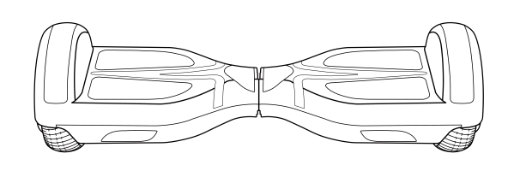

1

