Led Light Installation Guide

# **LeGo** 75292 The Razor Crest

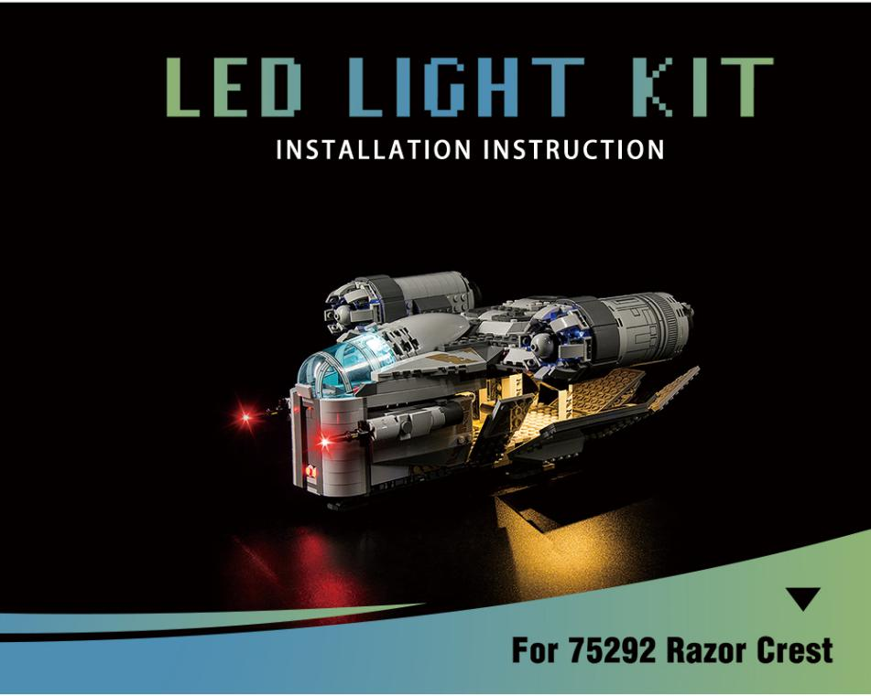

|  |  |
| --- | --- |
| 1 | 2 |
| 3 | 4 |

|  |  |  |  |  |  |  |  |  |  |  |  |  |  |  |  |  |  |
| --- | --- | --- | --- | --- | --- | --- | --- | --- | --- | --- | --- | --- | --- | --- | --- | --- | --- |
| 5 | | | | | | | | | 6 | | | | | | | | |
| 7 | | | | | | | | | 8 | | | | | | | | |
| 9 | | | | | | | | | 10 | | | | | | | | |
| 11 | | | | | | | | | 12 | | | | | | | | |
| 13 | | | | | | | | | 14 | | | | | | | | |
| 15 | | | | | | | | | 16 | | | | | | | | |
| 17 | | | | | | | | | 18 | | | | | | | | |
| 19 | | | | | | | | | 20 | | | | | | | | |
| 21 | | | | | | | | | 22 | | | | | | | | |
| 23 | | | | | | | | | 24 | | | | | | | | |
| 25 | | | | | | | | | 26 | | | | | | | | |
| 27 | | | | | | | | | 28 | | | | | | | | |
| 29 | | | | | | | | | 30 | | | | | | | | |
| 31 | | | | | | | | | 32 | | | | | | | | |
| 33 | | | | | | | | | 34 | | | | | | | | |
| 35 | | | | | | | | | 36 | | | | | | | | |
| 37 | | | | | | | | | 38 | | | | | | | | |
| 39 | | | | | | | | | 40 | | | | | | | | |
| 41 | | | | | | | | | 42 | | | | | | | | |
| 43 | | | | | | | | | 44 | | | | | | | | |
| 45 | | | | | | | | | 46 | | | | | | | | |
| 47 | | | | | | | | | 48 | | | | | | | | |
| 49 | | | | | | | | | 50 | | | | | | | | |
| 51 | | | | | | | | | 52 | | | | | | | | |
| 53 | | | | | | | | 54 | | | | | | | | |
| 55 | | | | | | | | 56 | | | | | | | | |
| 57 | | | | | | | | 58 | | | | | | | | |
| 59 | | | | | | | | 60 | | | | | | | | |
| 61 | | | | | | | 62 | | | | | | | | |
| 63 | | | | | | | 64 | | | | | | | | |
| 65 | | | | | | | 66 | | | | | | | | |
| 67 | | | | | | | 68 | | | | | | | | |
| 69 | | | | | | 70 | | | | | | | | |
| 71 | | | | | | 72 | | | | | | | | |
| 73 | | | | | | 74 | | | | | | | | |
| 75 | | | | | | 76 | | | | | | | | |
| 77 | | | | | | 78 | | | | | | | | |
| 79 | | | | | | 80 | | | | | | | | |
| 81 | | | | | | 82 | | | | | | | | |
| 83 | | | | | | 84 | | | | | | | | |
| 85 | | | | | | 86 | | | | | | | | |
| 87 | | | | | | 88 | | | | | | | | |
| 89 | | | | | | 90 | | | | | | | | |
| 94 | | | | | | 95 | | | | | | | | |
| 96 | | | | | | 97 | | | | | | | | |
| 98 | | | | | | 99 | | | | | | | | |
| 100 | | | | | | 101 | | | | | | | | |
| 103 | | | | | | 104 | | | | | | | | |
| 105 | | | | | | 106 | | | | | | | | |
| 107 | | | | | | 108 | | | | | | | | |
| 109 | | | | | | 110 | | | | | | | | |
| 111 | | | | | | 112 | | | | | | | | |