OLM3 Beginner's Guide

I: From installing the driver to using
1. Please install the driver before making the machine connection
2. Q: How to connect LightBurn to the machine?
3. Q: Do I need to do some settings for the software when LightBurn is connected to the machine for the first time?
4. How to use LightBurn with the machine for engraving
II: Some basic FAQ questions when connecting LightBurn to the machine
5. Q: Why does the machine not respond after pressing the power on button, the light of the button pressed and held is shown in red
6. Q: Why does the light show red and yellow light alternately after the machine is turned on?
7. Q: Why is the machine can be normal after the power on, but the light shows red
8. Q: Why does the machine's indicator light in the case of the display for the green light, will flash other colors of light at intervals
9 Q: the color of the light shows "red, green and blue" alternately flashing, the machine does not respond to operation
10. Q: Why does the machine homing abnormally, constantly emitting the sound of impact
11. Q: Why the engraved image is crooked
12. Q: Why is the machine always prompted to be busy, or said to be beyond the engraving range of the machine, or the machine stops in the middle of engraving
13. Q: Why the image is in the middle of the engraving area of the software, but when I click the Flame button to walk the track, it will hit the border?
14. how to use OLM3 with YRR
15. Is there a detailed description of the functions of the lightBurn software?
Three: APP through wifi connection machine common FAQ questions
16. how to connect OLM3 machine to APP
17. why APP can not connect to the machine
18. APP Control page STATUS prompt "Alarm" 19.
19. APP Control page STATUS prompt "unknown"

I: From installing the driver to using

1. Please install the driver before connecting the machine
Q: How to install the driver
A: Before installing the computer driver, please turn on the machine and connect the USB cable to the computer, and then select the driver file to install according to your computer system
电脑系统 | 驱动文件 | 教程文件
Win7 / win 8： | 可点击图标安装 | 注意：这个驱动安装的时候，机器要在开机的状态下，usb连接电脑，才可进行安装
Win10 | 可点击图标安装 | 在win10不能识别串口的情况下  请安装左侧驱动
Win11 | 不需要安装 | 如果实在找不到串口，请安装win10的驱动
Mac | 不需要安装
After the installation is finished: find Device Manager->Ports on your computer. at this time, unplug the USB cable, the new serial port will disappear on Ports, plug in the USB cable, a new serial port will be displayed. Proof, the driver is installed successfully
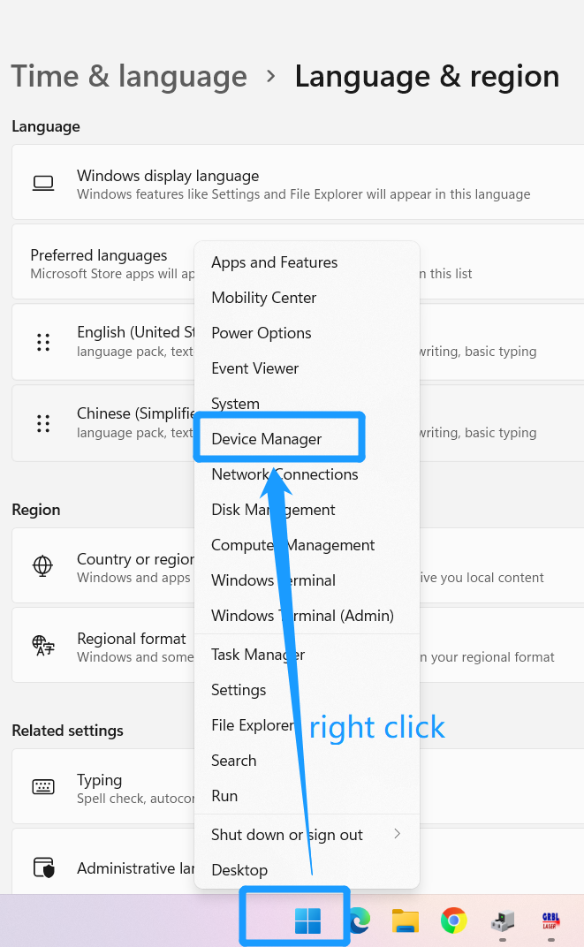
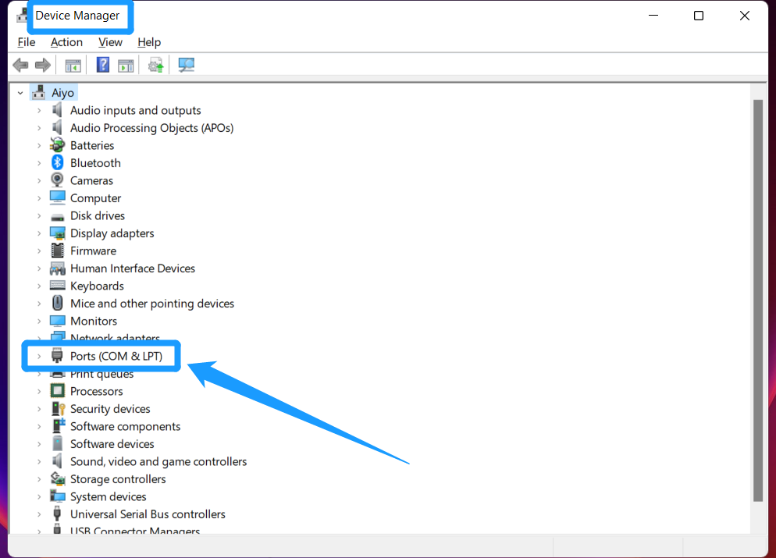

2. Q: How to connect LightBurn to the machine
A: Please follow the steps in the screenshot below to connect. Before doing the following, please make sure the machine is powered on and the USB is connected to the computer.
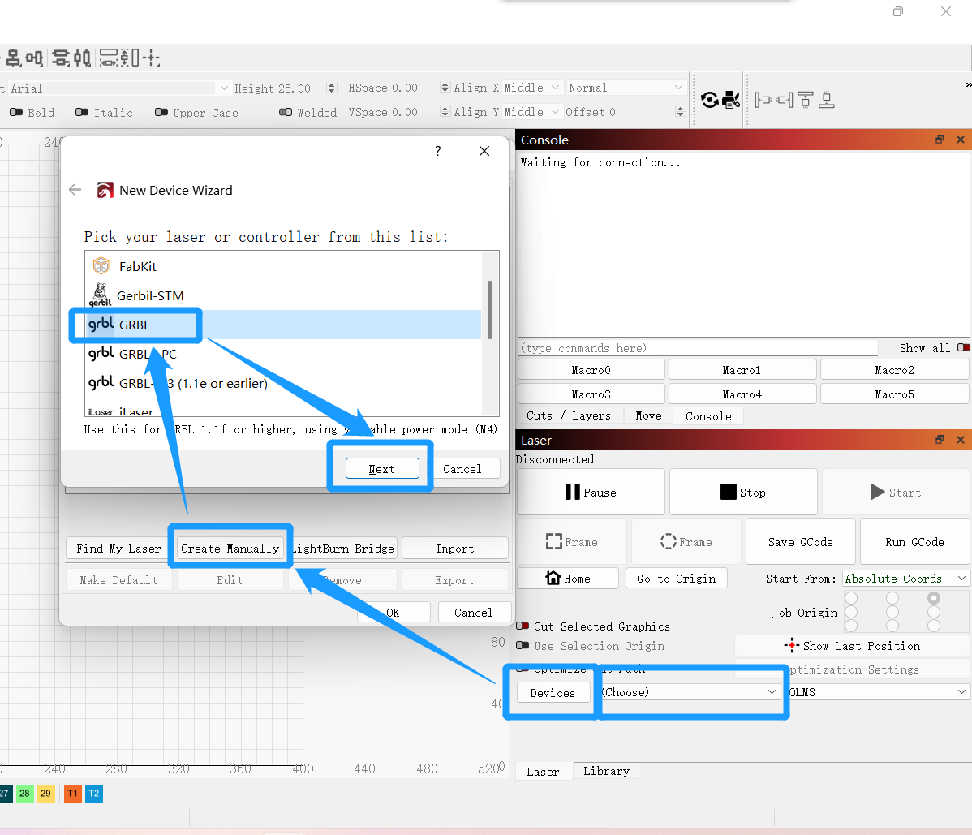
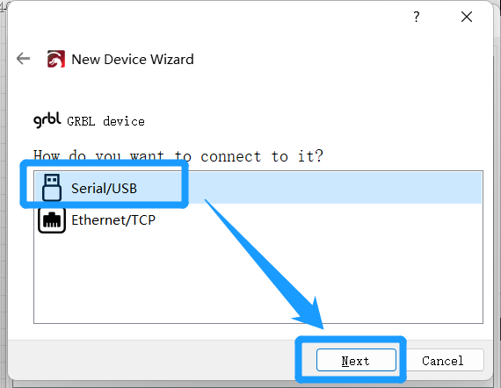
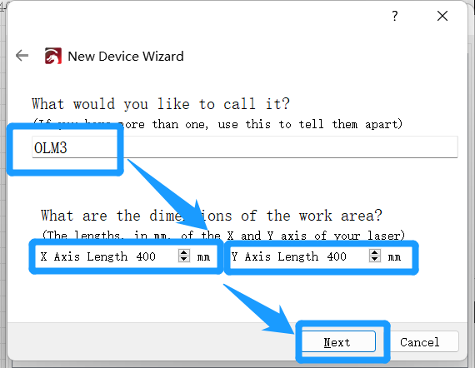
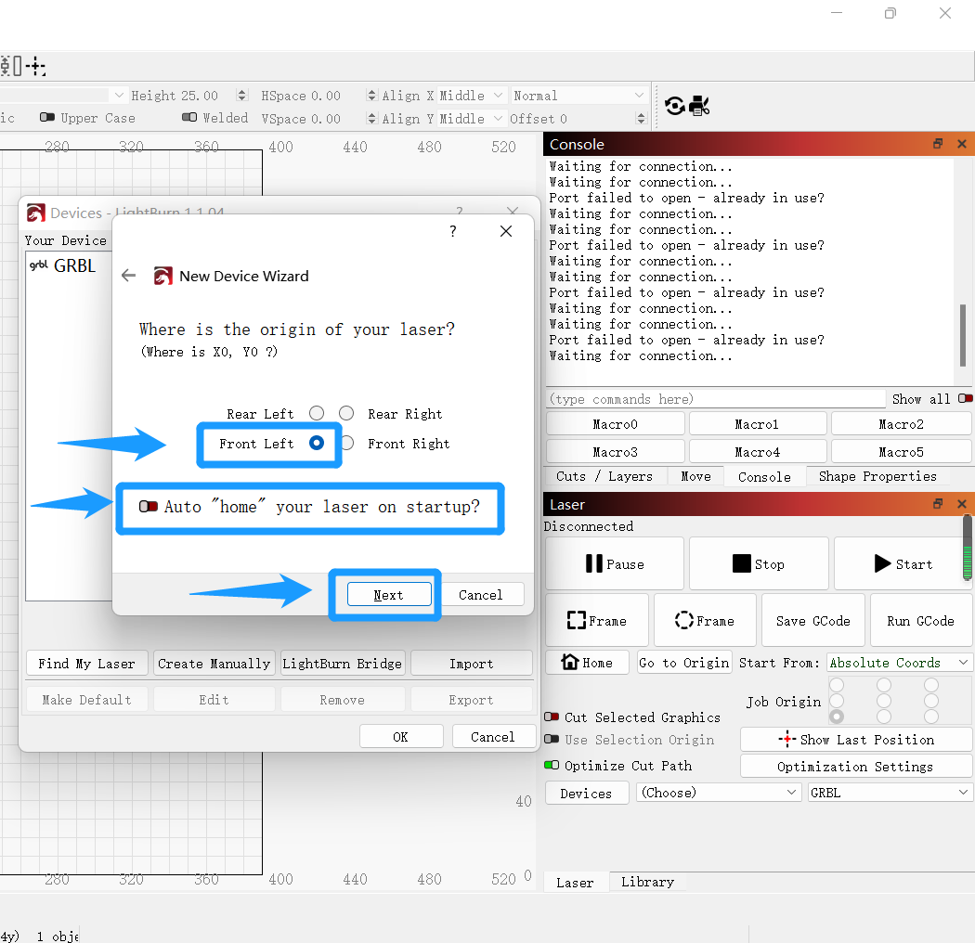
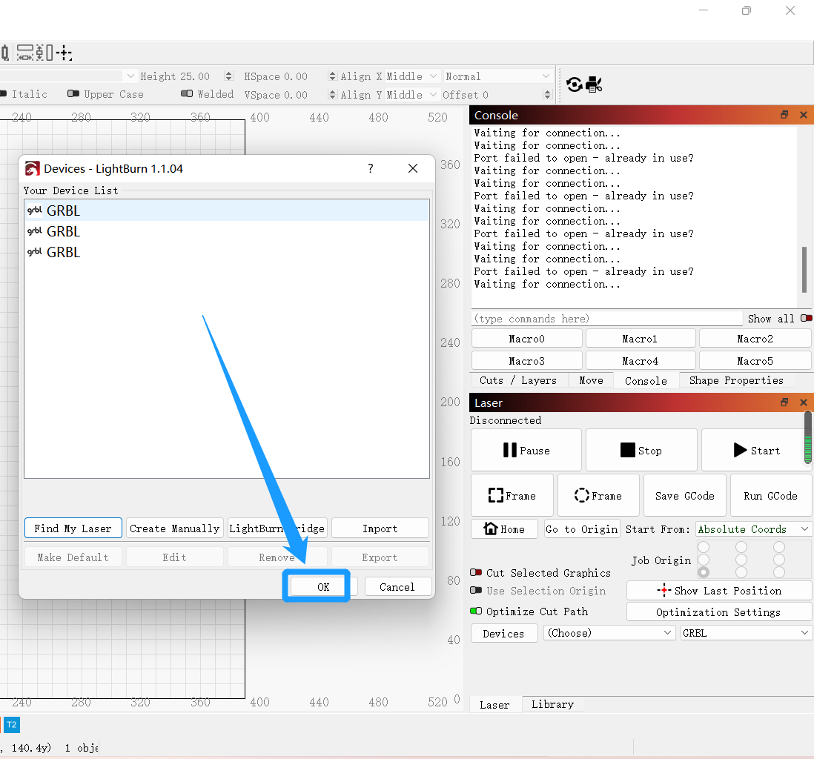
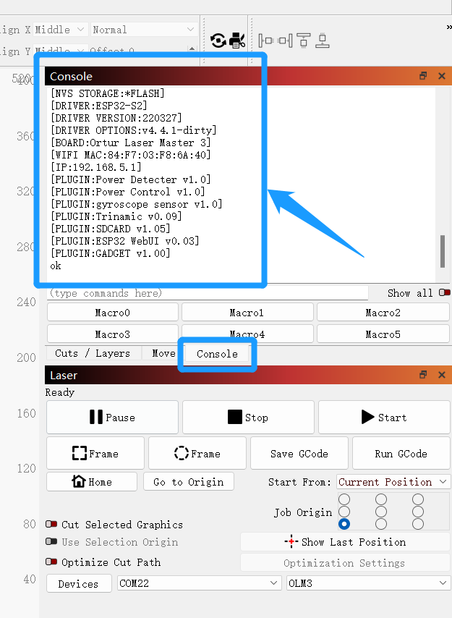
Until here means the connection is successful

2. Q: Do I need to do some settings for the software when LightBurn is connected to the machine for the first time?
A: Required, to avoid unnecessary trouble, please be sure to set up.
  - Edit -> Settings
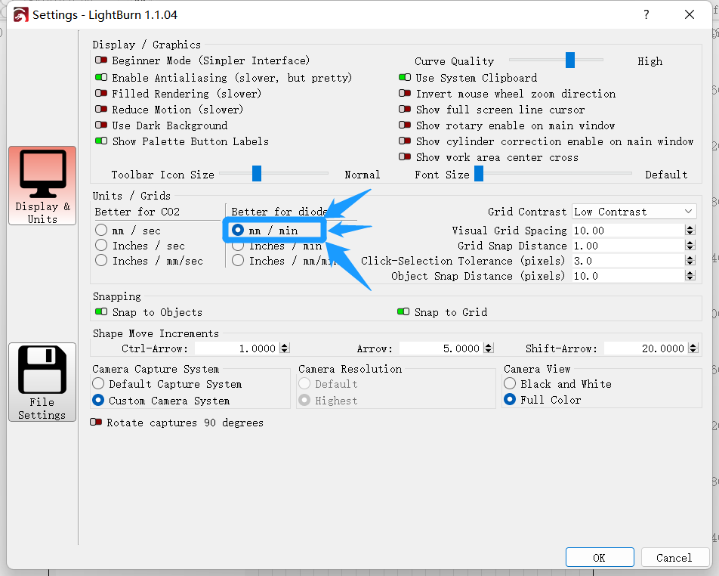
  - Edit -> Device Settings
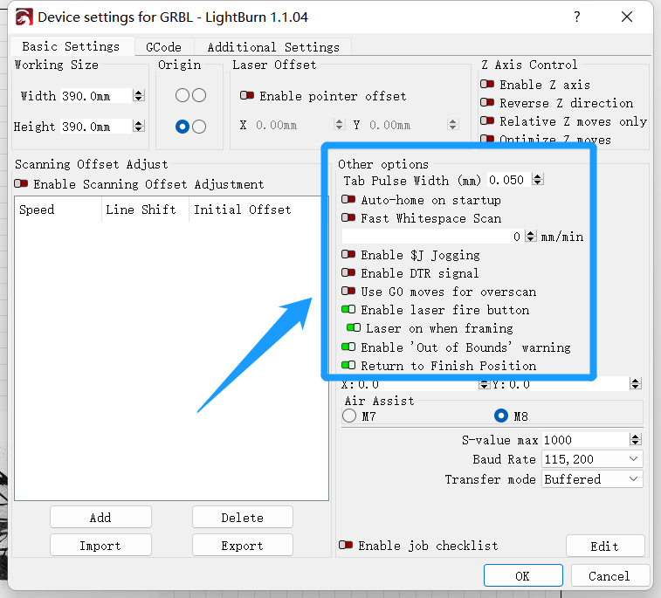
  - power exchange to 2%
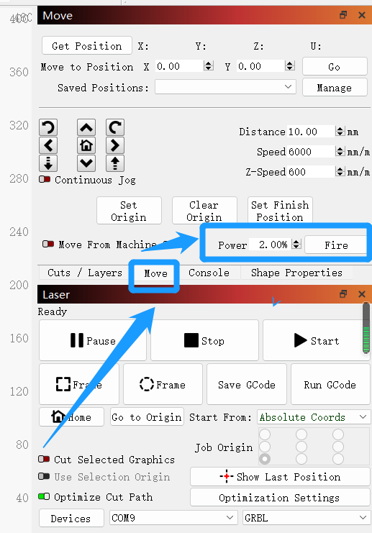
(4) Set the job origin of the software all to the lower left corner (because the machine origin of ORTUR's machine is the lower left corner)
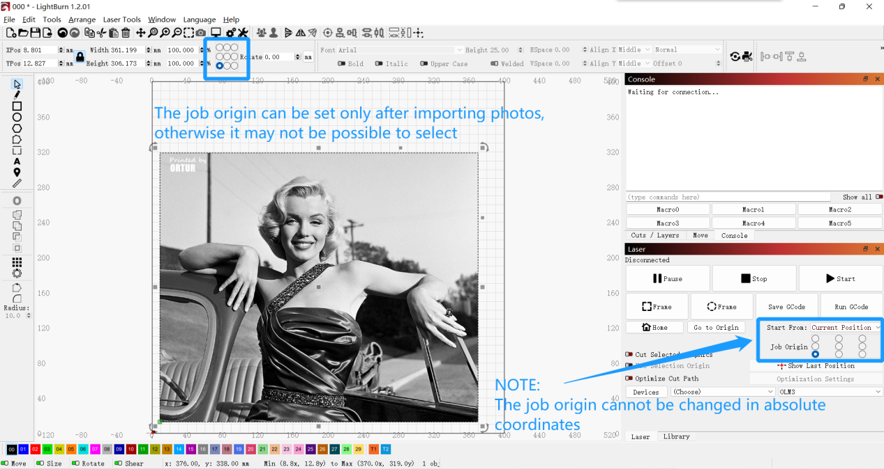

2. How to use LightBurn with the machine for engraving
A. Turn on the machine, connect the computer by USB, and select the corresponding serial port to connect the machine
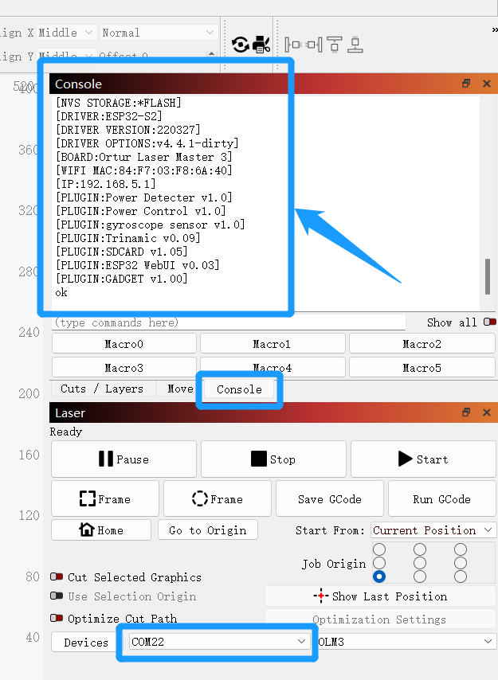
Console
A message from the machine appears in the window, indicating that the LightBurn software has successfully connected to the OLM3 machine

B.Import the pattern to be engraved
C. Set fixed parameters first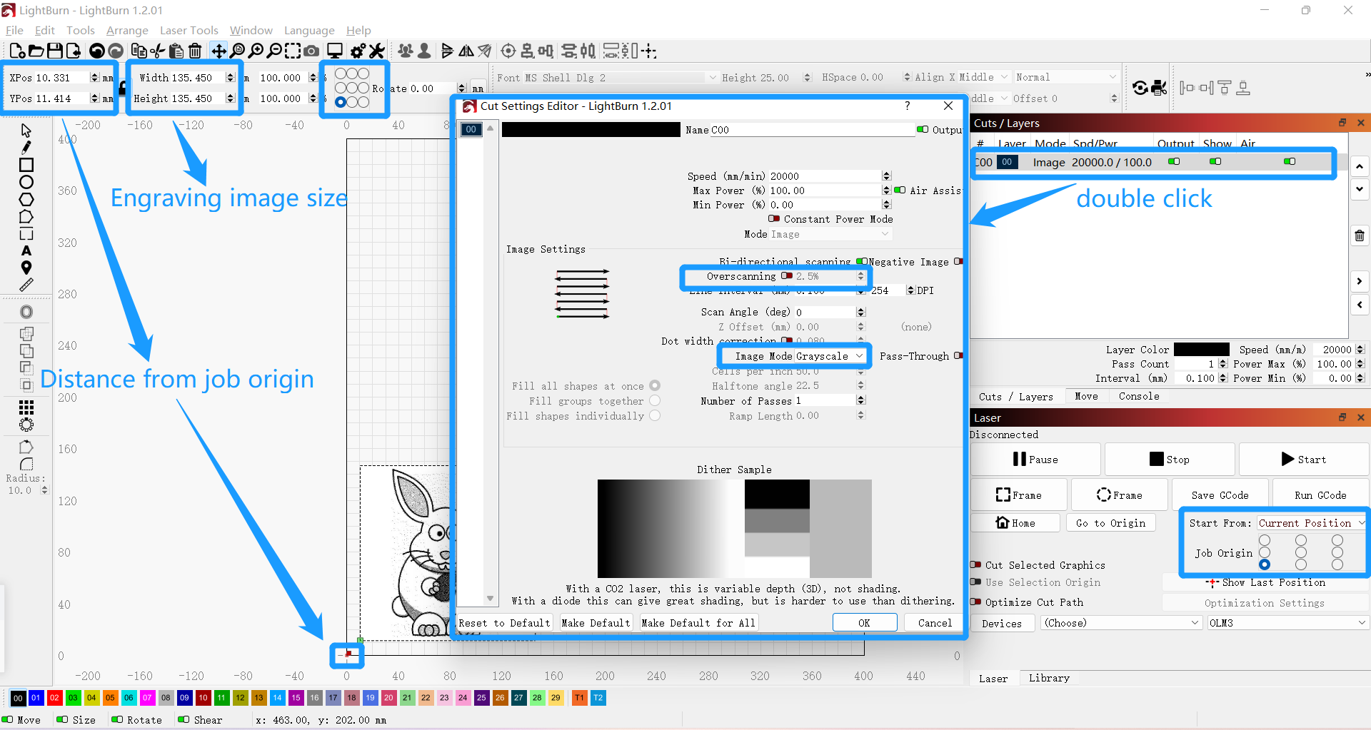
D.Then set the parameters that will change depending on the material
Speed / Max power / Min power / Line Interval (0.1mm = 1mm/10line --> Carve 10 lines at 1mm intervals)
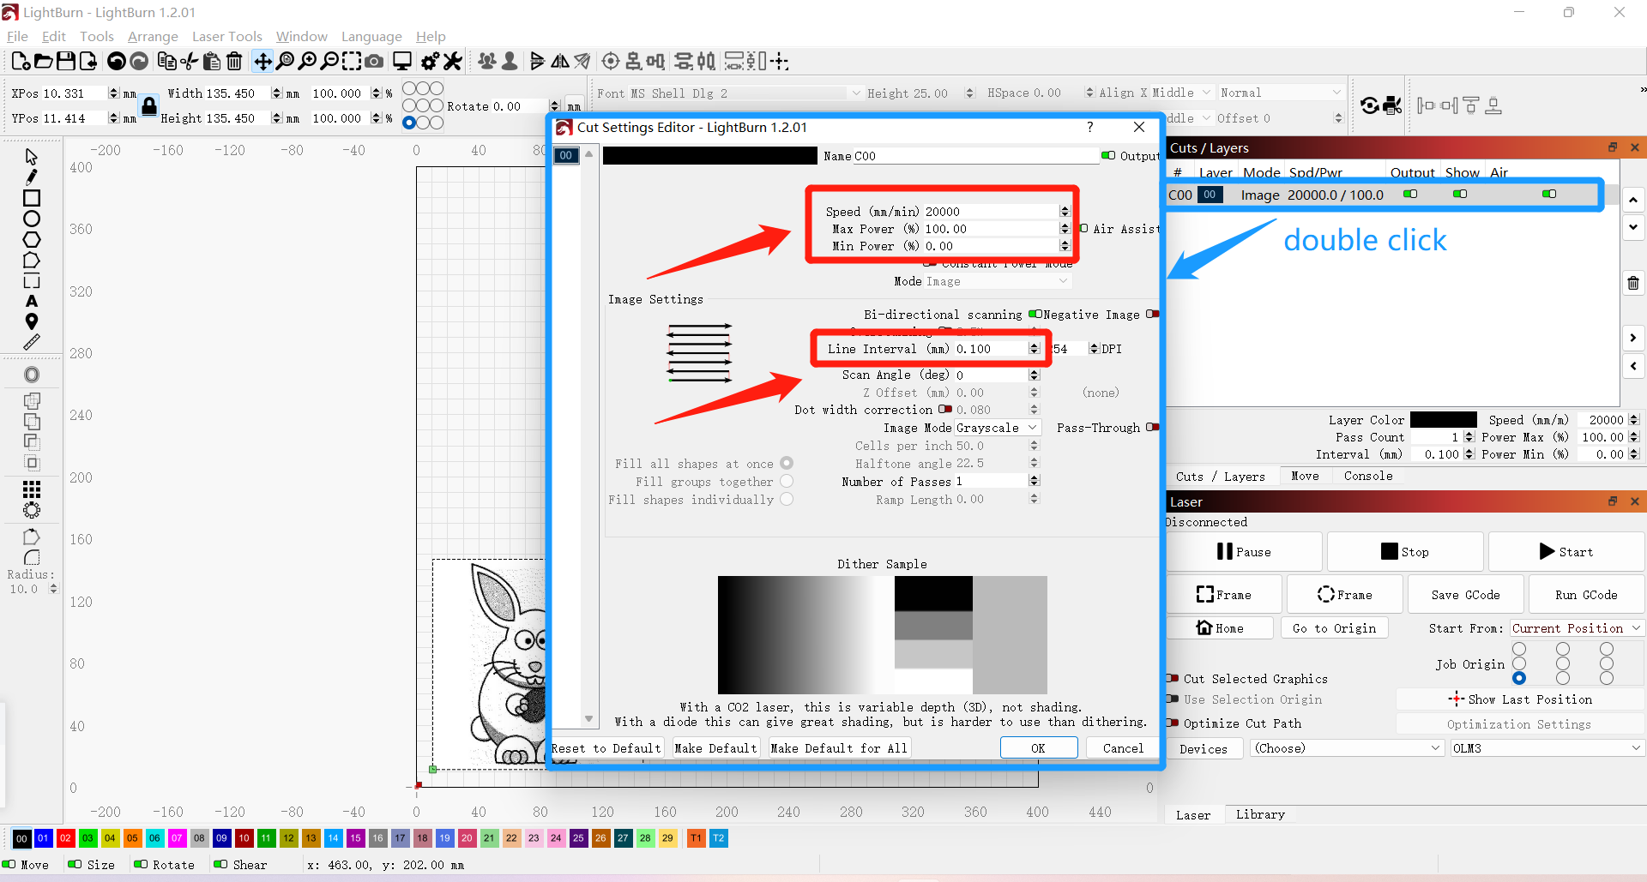
E.Move the laser module to the starting point of the position you want to engrave, click the Frame button to confirm that there are no errors in the engraving range, and then click the Start button to start engraving.

II: Some basic common lightBurn FAQ questions when connecting machines
2. Q: Why press the on button machine does not respond, press the button light shows red
A: That is because the child lock is not open, please insert the key, rotate to the right to open the child lock
3. Q: Why after the power on, the light shows red and yellow light alternately flashing
A: The light red and yellow light alternately flashing, means the emergency stop button is pressed, please rotate to the right to open the emergency stop button
4. Q: Why after the machine is turned on, the machine can be normal homing, but the light shows red
A: That is because there is no TF card inserted, please insert the TF card (Note: the machine must be inserted into the TF card before use, generally no special circumstances, do not just take off, so as not to cause the machine light display abnormalities, some carving abnormalities)
5. Q: Why is the machine's indicator light in the case of green lights, will flash other colors of light at intervals
A: Please ignore the other colors of the light display, as long as the overall display is green light can be. Because as long as the green light in the case of other colors of light display, are some status lights, customers do not need to pay attention to.
6. Q: The color of the light shows "red, green and blue" alternately flashing, the machine does not respond to the operation
A: This is a trigger for the machine's firmware upgrade mode, please shut down the machine, and then restart the machine can be. If you can not shut down the machine by holding down the switch button. Then, please click the RESET button to shut down the machine.
7. Q: Why is the machine homing abnormal, constant crashing sound
A: Please check whether the belt of X-axis or Y-axis has been inserted into the buckle. If inserted, please check whether the X-axis or Y-axis belt has been adjusted to tighten. If you are not sure or not debugged, please check the OLM3 adjust the X-axis or Y-axis belt video.
8. Q: Why is the carved image is crooked
A: Please check whether the belt of X-axis or Y-axis has been inserted into the buckle. If inserted, please check whether the belt of X-axis or Y-axis has been adjusted for good tightness. If you are not sure or not debugged, please check the OLM3 adjust the X-axis or Y-axis belt video.
9. Q: Why is the machine always prompted in busy, or out of the machine carving range, or the machine stopped in the middle of carving
A: The following points need to be noted when engraving images
When engraving the image, the image is at least 5MM and above from the side of the rated area (as to why 5MM, this is related to the default value of Overscanning of lightBurn), but not absolutely, only when this situation occurs, it is necessary to do so.
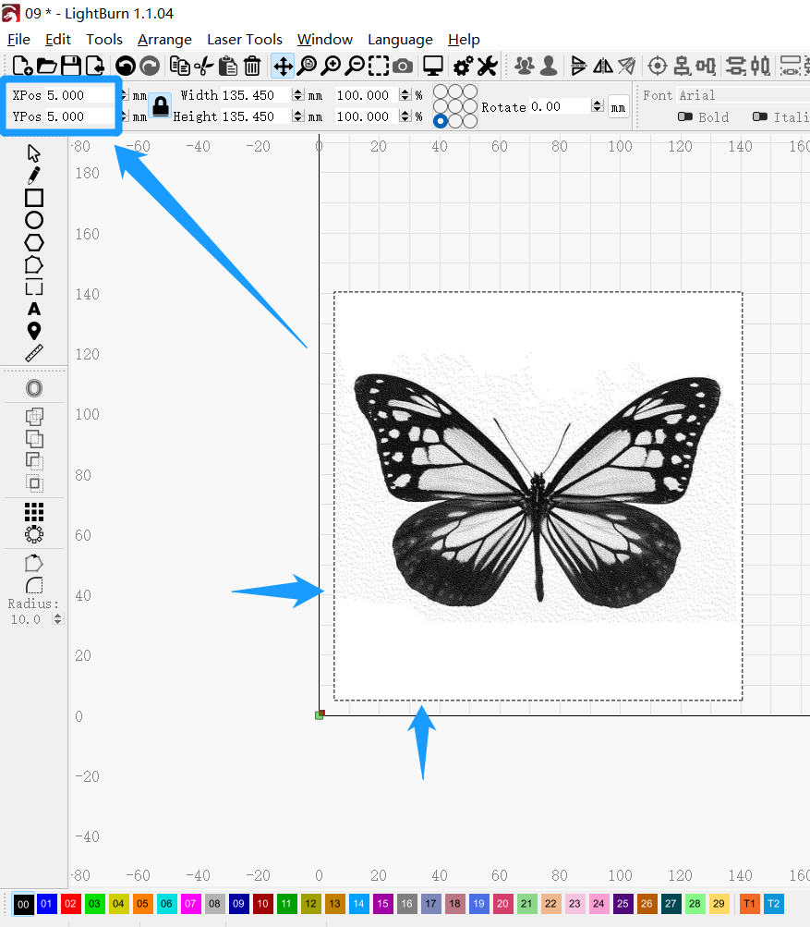
Also, you need to turn off Overscanning in the Image Settings in the Setting Editor after each selection of the engraved image.
(Note: In Line mode, this option is not available)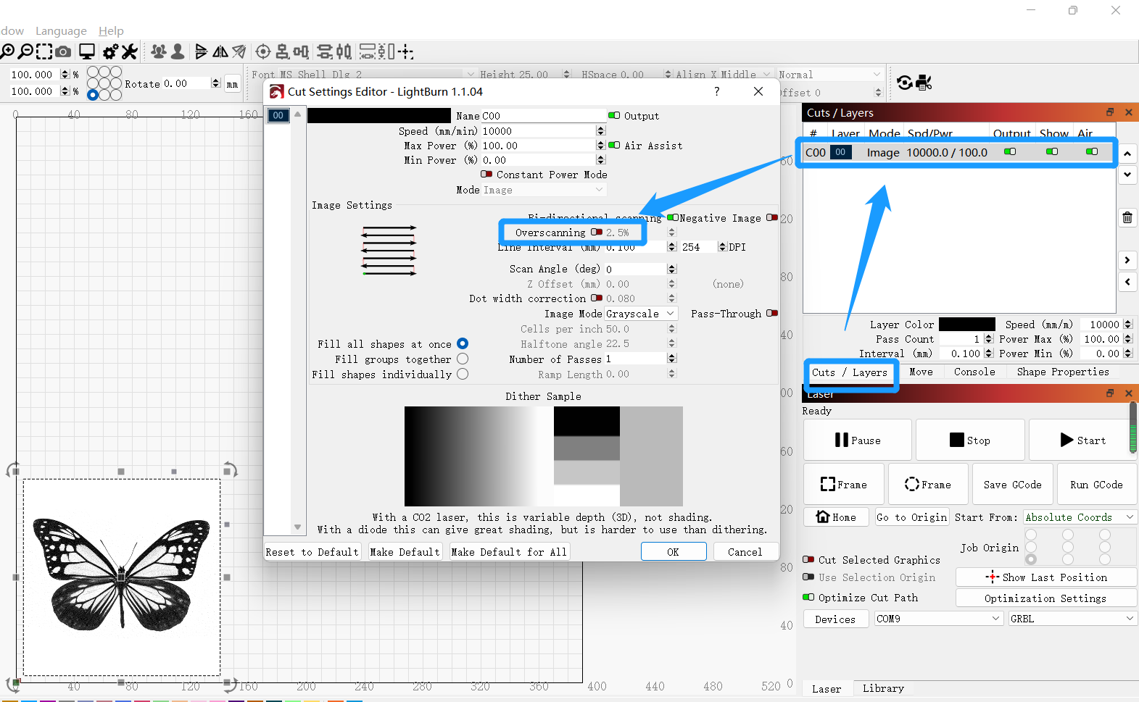

2. Q: Why is the image in the middle of the engraving area of the software, but when I click the Flame button to take the track, it will hit the border?
A: Because the range you set is too far away from the starting point of the machine, plus the size of the image itself, which adds up to more than the engraving stroke of the machine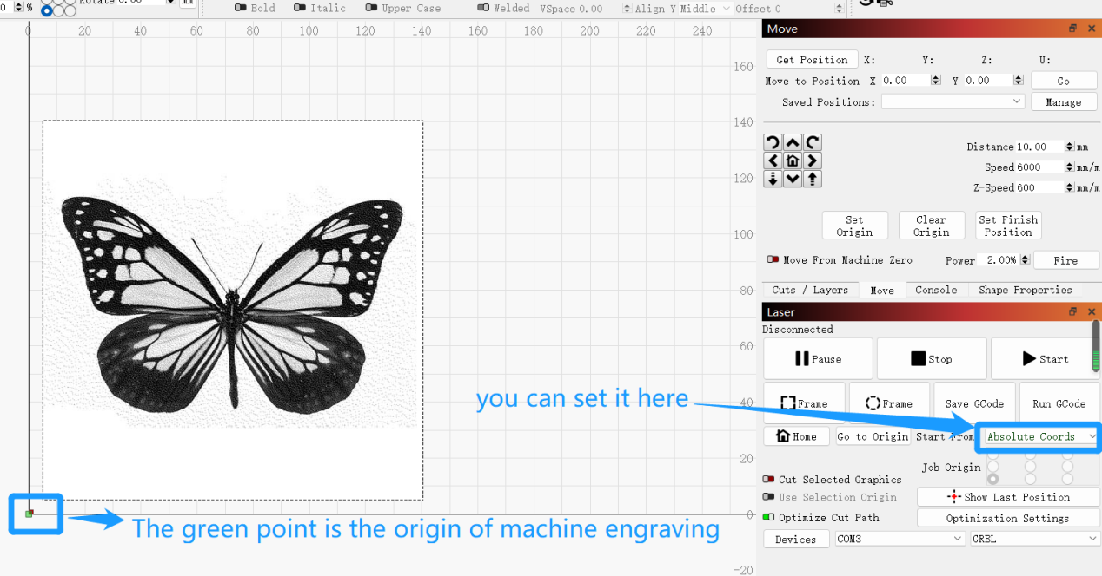
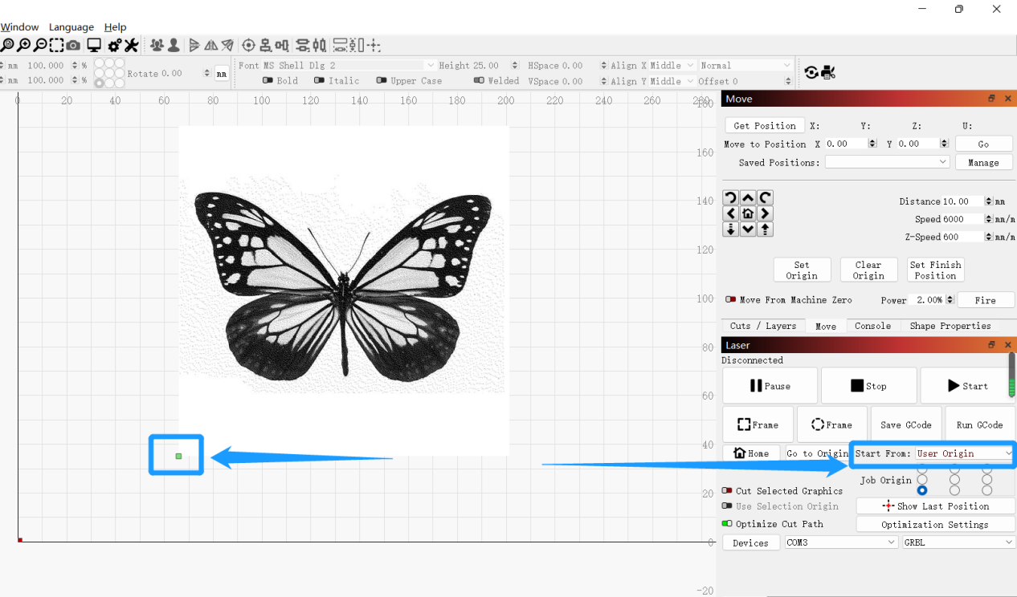

2. How to use OLM3 with YRR
1. Close the homing, change the parameter $22=1 to $22=0, then it is closed for homing.
Enter $22=0 in the console page of lightBurn, and then hit the Enter key, the setting will be successful if it shows OK.
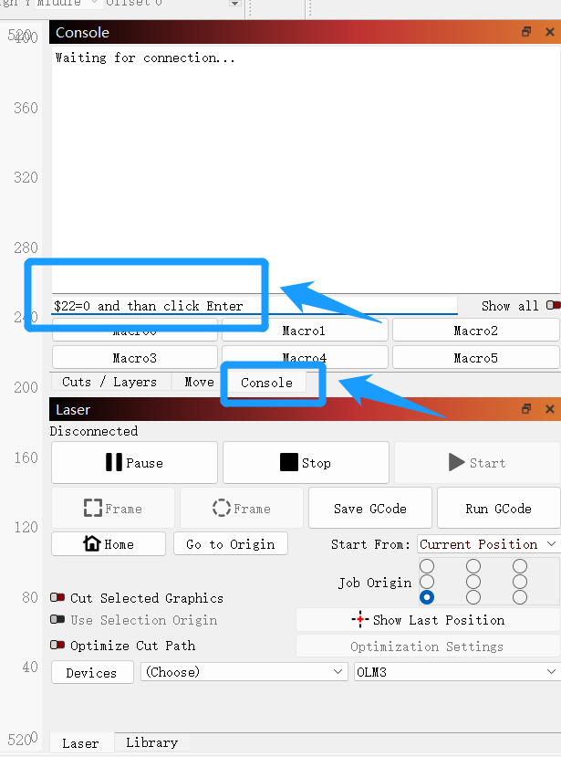
2. When using YRR, turn the machine switch to the direction marked as YRR
3. Change the parameter $101=100 to $101=80, then change the step rate of the YRR motor to match the OLM3 machine.
Enter $101=80 in the lightBurn's console page and hit the Enter key, the setting will be successful if it shows OK.

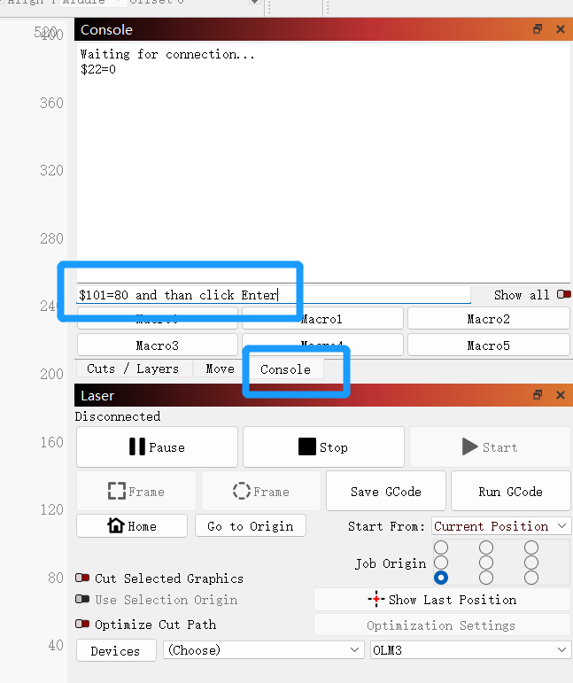
4. Modify the above parameters back to their original values when not using YRR
2. Is there a detailed description of the functions of the lightBurn software?
A: Please refer to LightBurn online documentation: https://lightburnsoftware.github.io/NewDocs/

Three: APP through wifi connection machine common FAQ questions
2.OLM3 machine how to connect APP
Download software
Scan the QR code to download
google play  （Android） | App Store  （IOS）
① The first connection method (use APP network allocation function to connect OLM3 --> Note: The current network allocation mode only supports OLM3 and subsequent new devices) --> the fastest connection method
1 Add new device: Click the device card to enter the search page In the search page --> "Add new device", select the current device to be connected, and click the corresponding card to enter the configuration network.
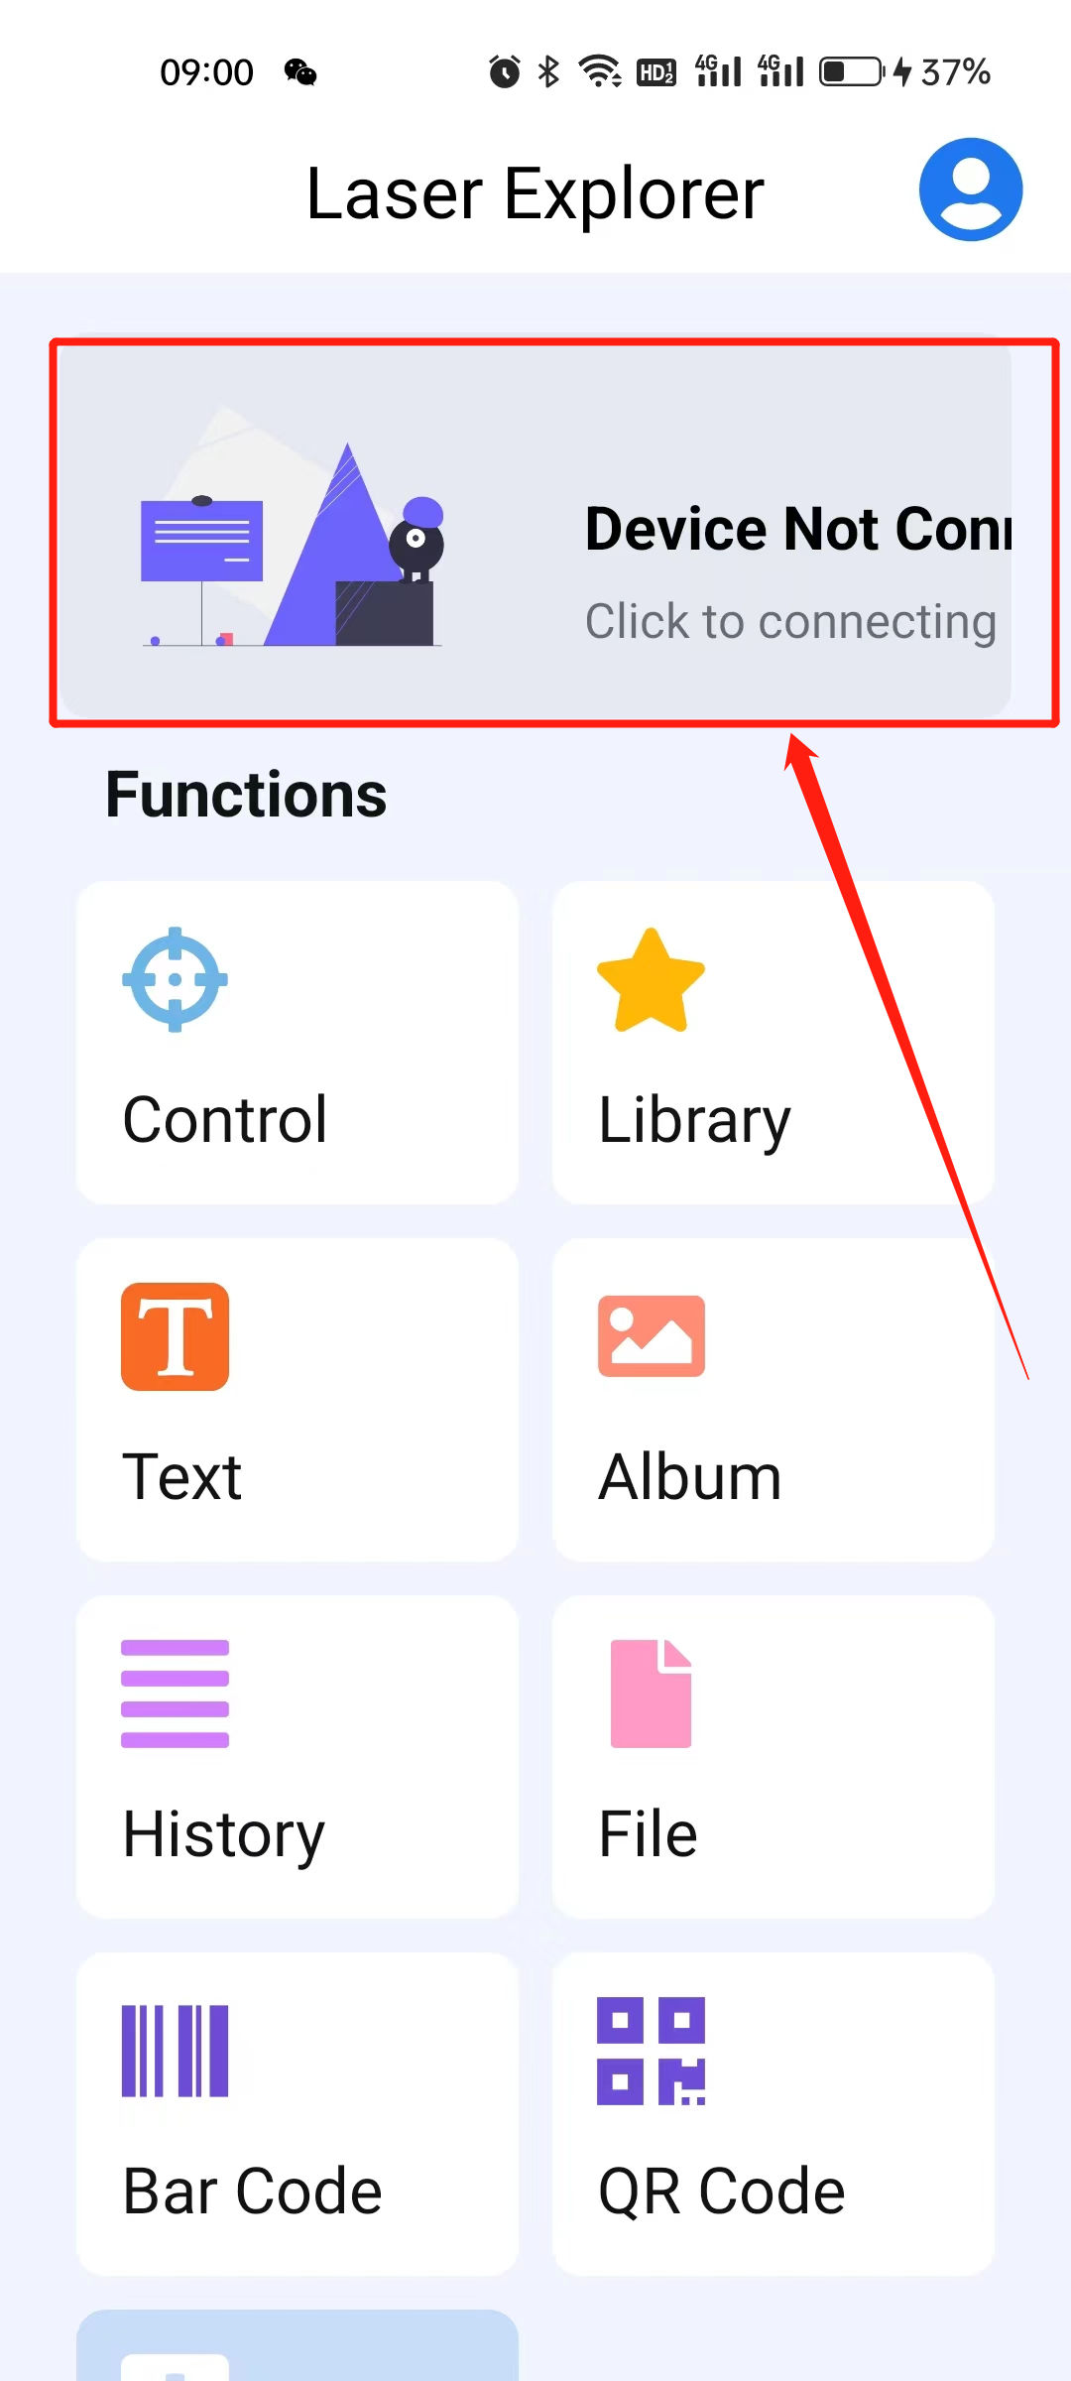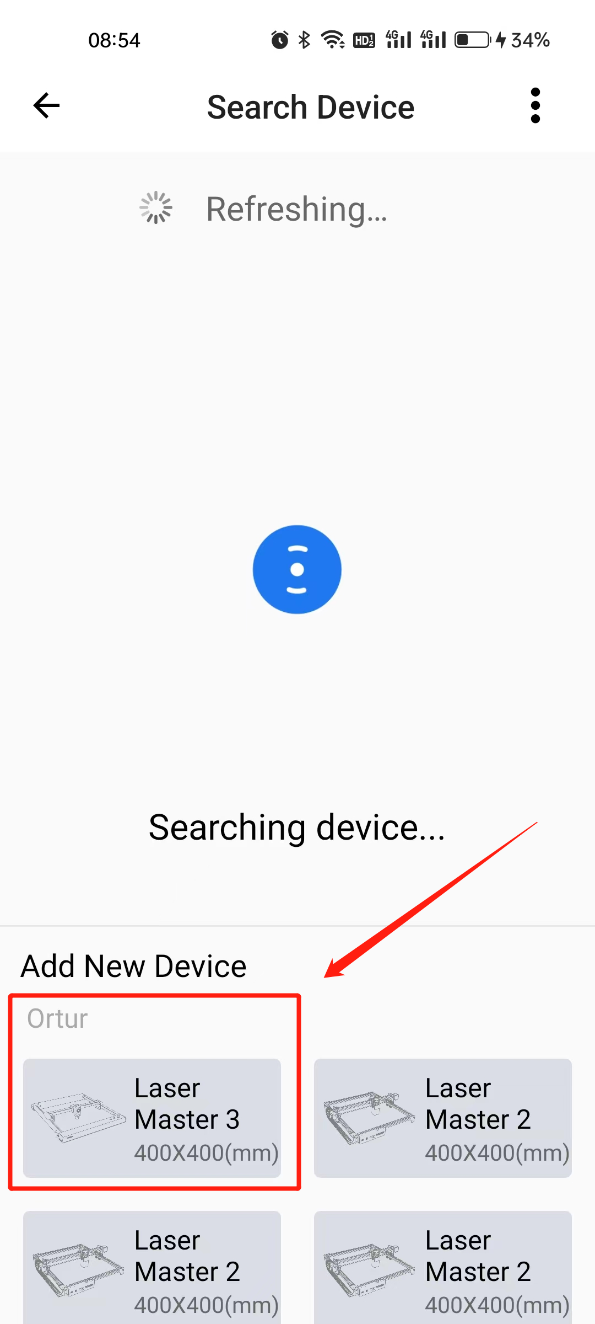
2 Configure network: After entering configure network, it will automatically fill in the current connected WiFi name, you only need to fill in the WiFi password, after filling in successfully, click next to enter the device with network.

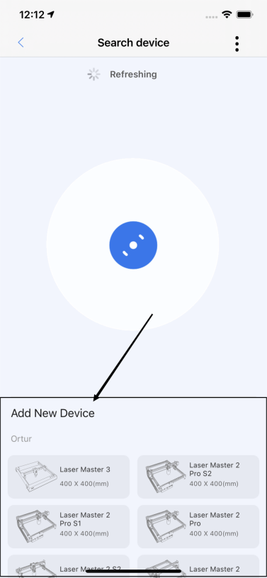 | 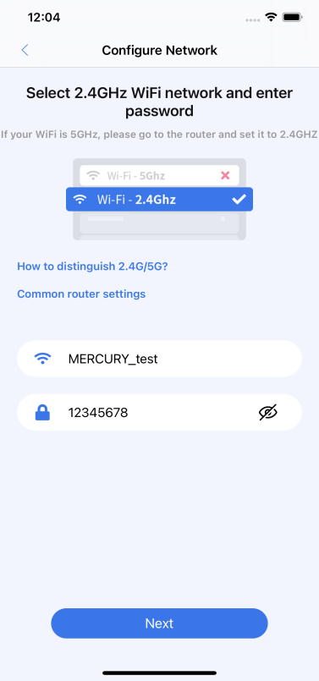
搜索页面 | 配置网络

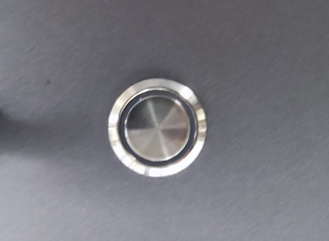
3 will enter the device into the distribution network: use the device to quickly and continuously press the device power on light 5 times, so that the device into the distribution network mode (the color of the light changes in color).
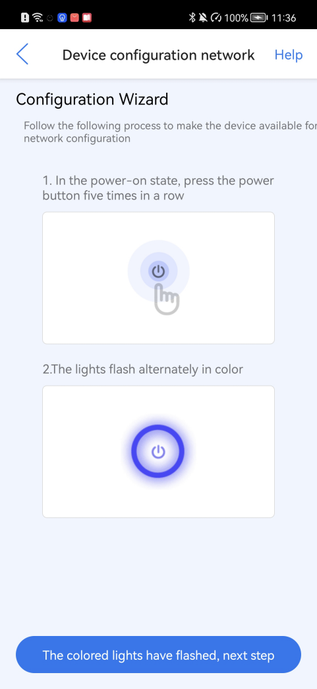
4 Device wiring: After the device successfully enters the wiring mode, click Next on the device wiring page to configure the network.

5 Wait for the successful configuration of the network: place the device as close as possible to the router to transfer data at a better speed, wait to connect the device, transfer information, wait for networking, and click on the confirmation after success to complete the automatic connection of the device and return to the home page.
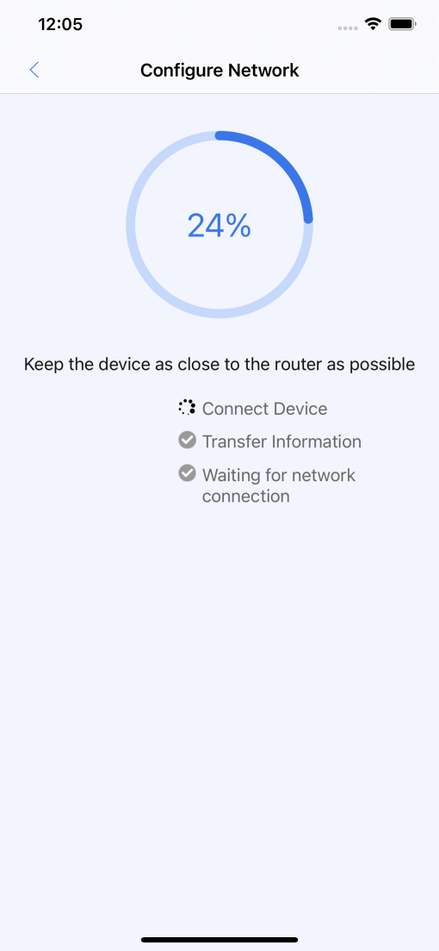 | 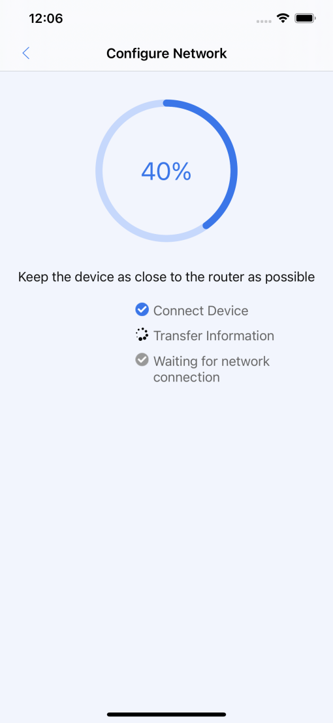 | 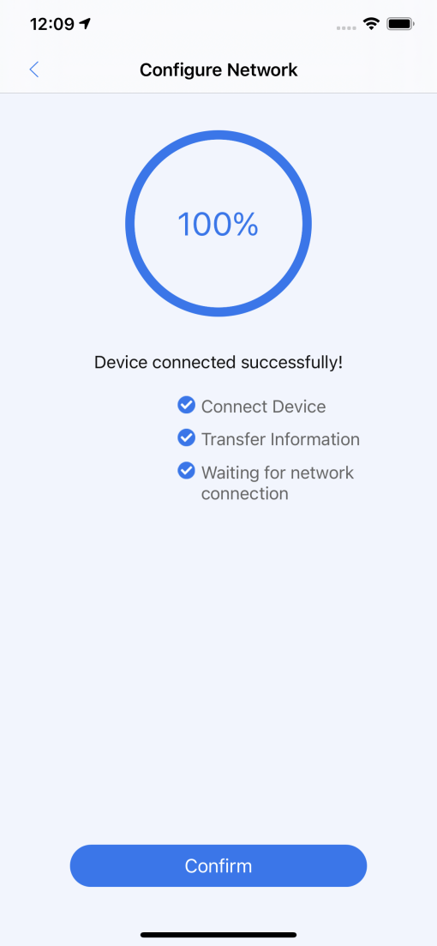

① The second way of connection: by using the device WIFI connection OLM3
1 In the console:
Enter the code; "$74=WIFI name" (for example: $74=lianTong), then click enter, a green ✔ will be displayed to indicate successful setup
Enter the code; "$75=WIFI password" (for example: $75=12345678), and then click enter, a green ✔ will be displayed to indicate successful setting
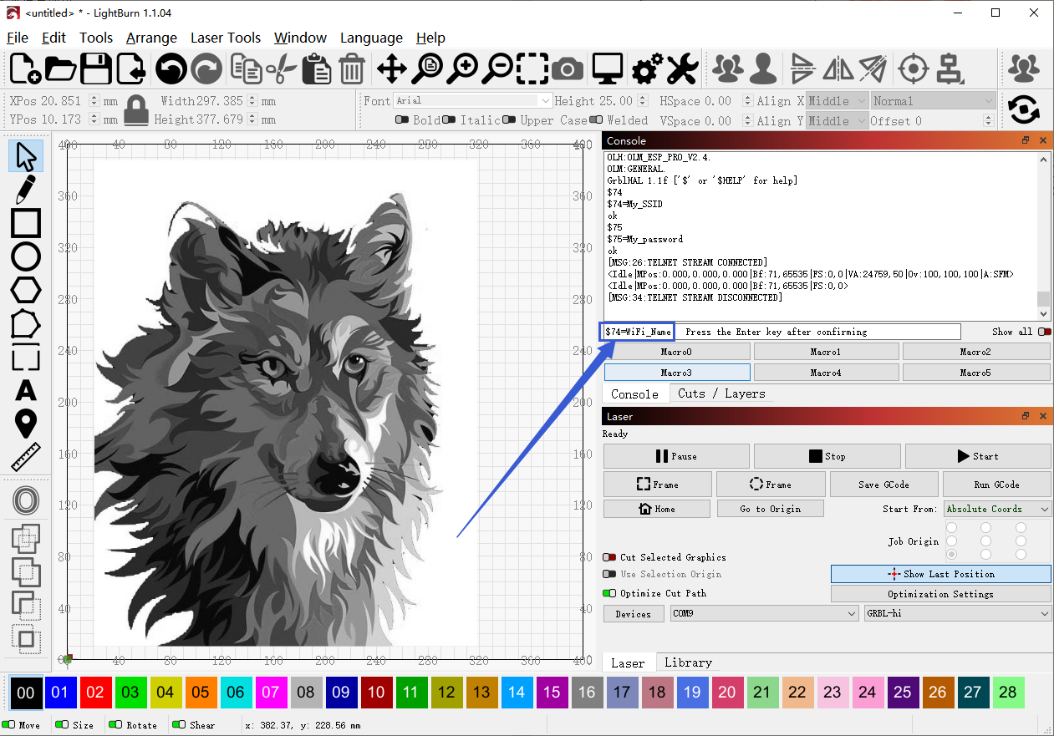
2 Finally, enter the code: "$WRS", then click enter, a green ✔ will be displayed to indicate successful setup. The meaning of $WRS code is simply understood as refresh. If it is not refreshed, you need to restart the device.
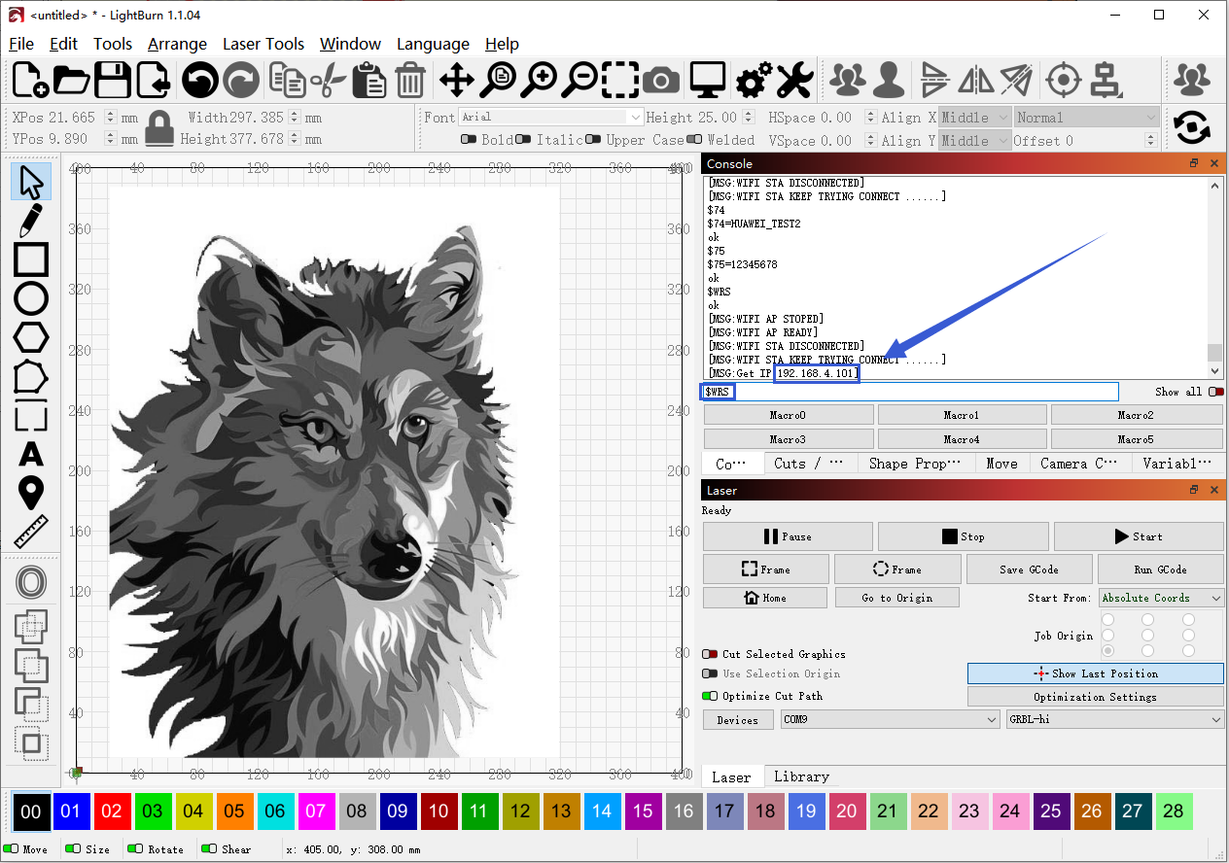
3 After connecting WiFi, open the APP and click the location selected in the box below to connect the device

4 Search and select connectable devices
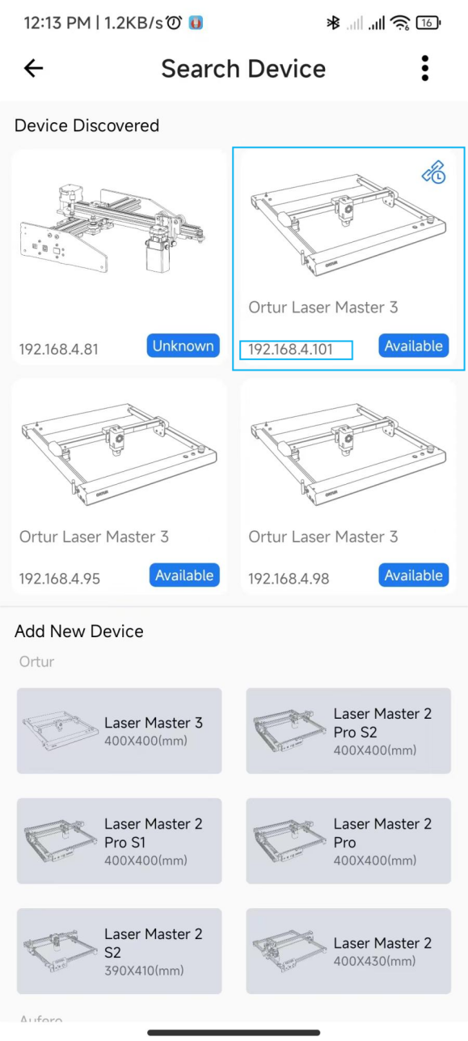

2. Why APP can't connect to the machine
1. Must use 2.4GHz band WiFi network
Please consult the instruction method in the APP at
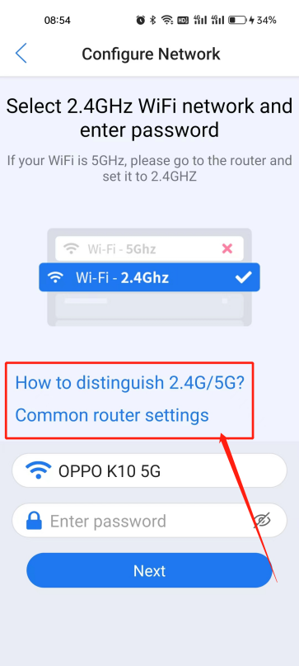
1. When using the APP to connect to the machine, try to stay as close as possible to the machine, at least within 5M distance.
2. If your phone has the function of automatically jumping if it recognizes the "network with stronger WiFi signal", please turn off this function. Because once WiFi auto-hopping occurs, the phone and the machine will be disconnected.
3. If the phone has the function of dual WIFI, please turn off one of the WIFI, because the dual WiFi function will affect the connection between the APP and the machine.

2.APP Control page of STATUS prompt "Alarm"
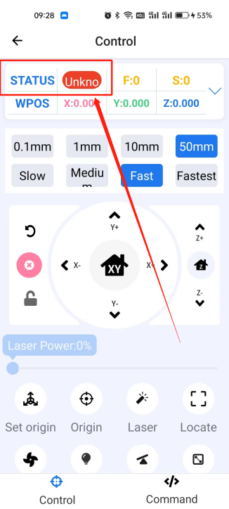
Then just click reset and then unlock
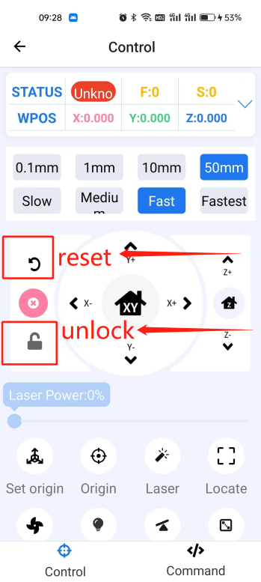

2.APP Control page of STATUS prompt "unknown"
This prompt is usually the APP and the machine disconnected, need to reconnect the machine.

