Aufero 2 connects to LightBurn -- FAQ
- Please install the driver before connecting the machine
Q: How to install the driver？
A: Before installing the computer driver, please turn on the machine and connect the USB cable to the computer, and then select the driver file to install according to your computer system
computer system | Driver files | Tutorial files
Win7 / win 8：
Win10 |  | Direct Installation
Win11 | No installation required | If you really can't find the serial port, please install the driver of Win10
Mac | No installation required
After the installation is complete: find Device Manager->Ports on your computer. at this time, unplug the USB cable, the new serial port will disappear on Ports, plug in the USB cable, a new serial port will be displayed. Proof, the driver is installed successfully.
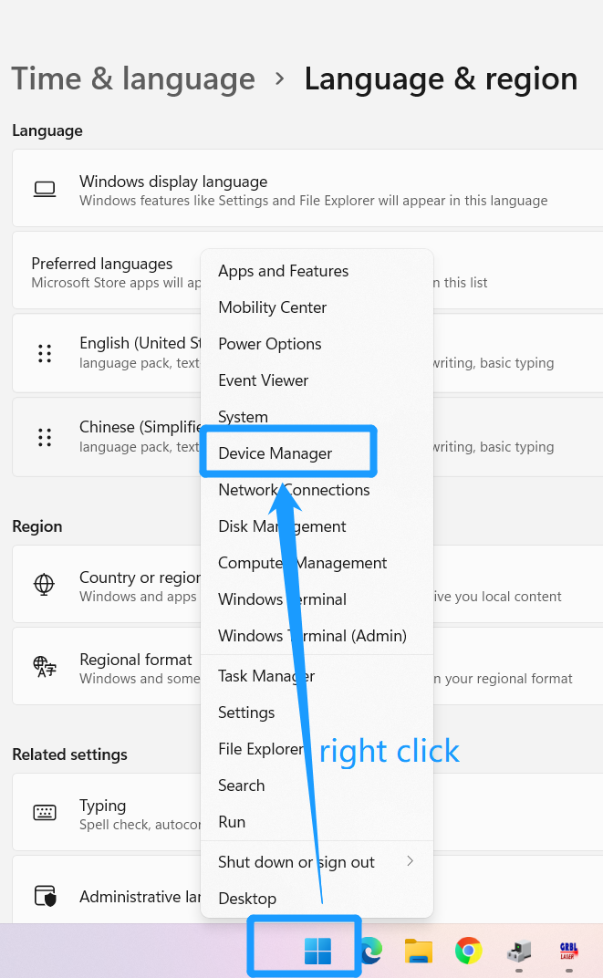
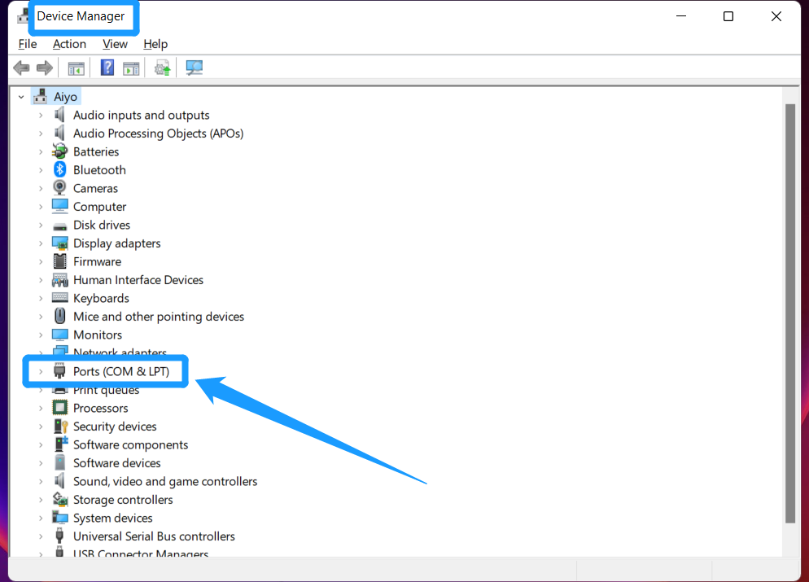
1. Q: How to connect the LightBurn to the machine
A: Please follow the steps in the screenshot below to connect. Before doing the following, please make sure the machine is powered on and the USB is connected to the computer.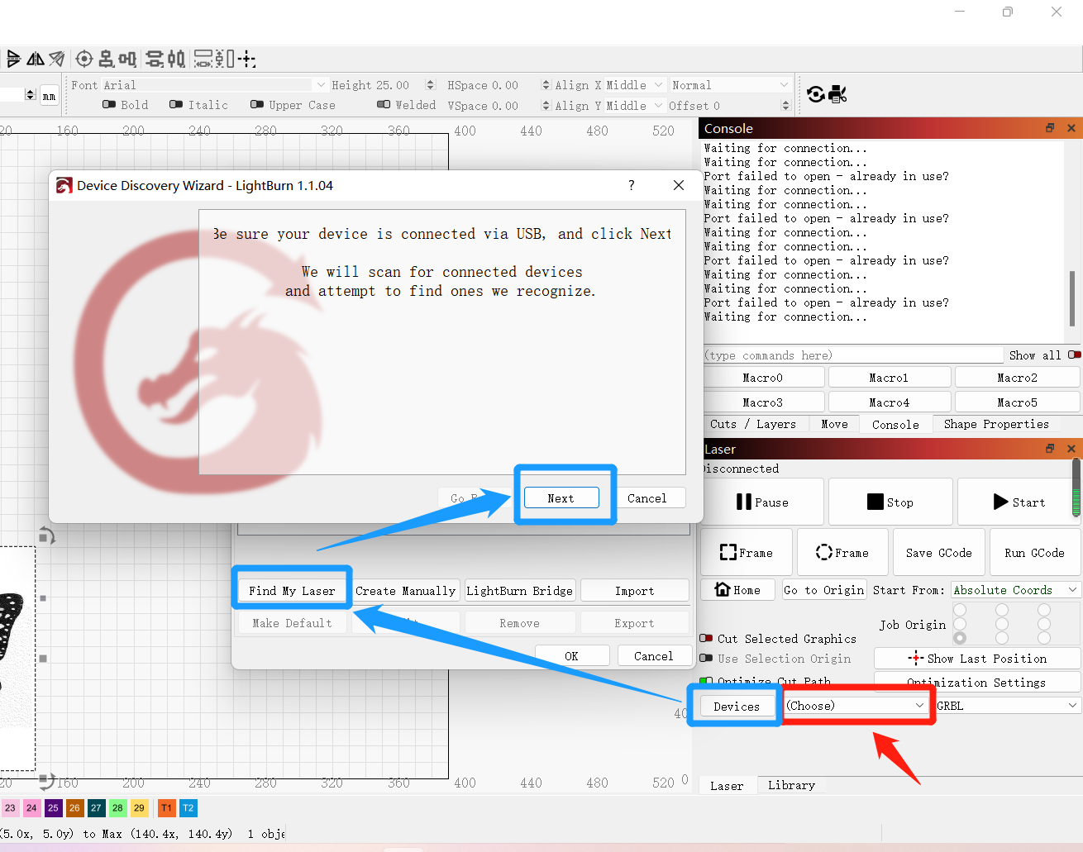
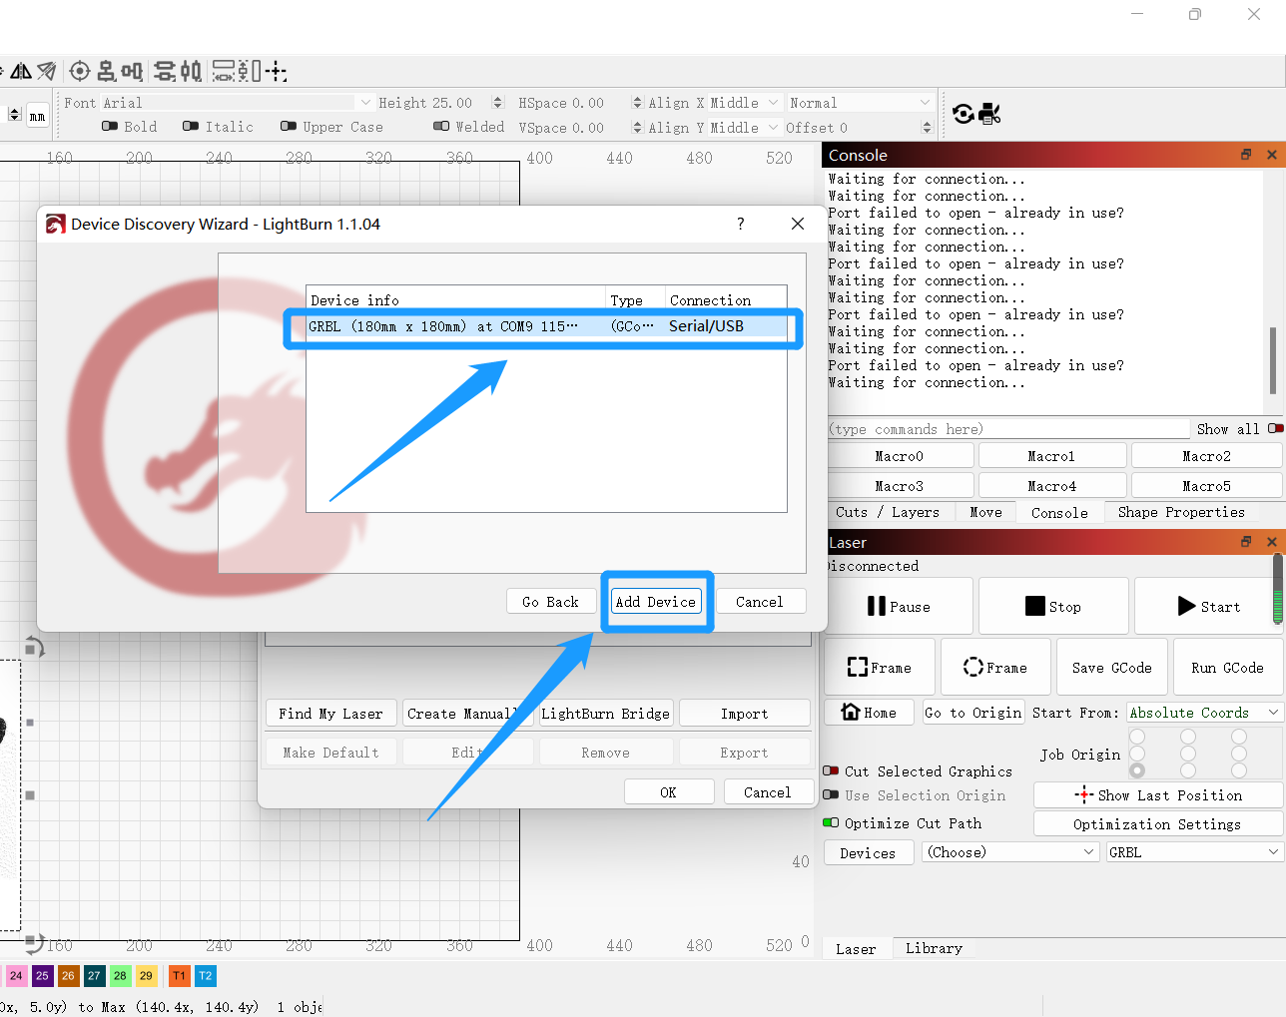
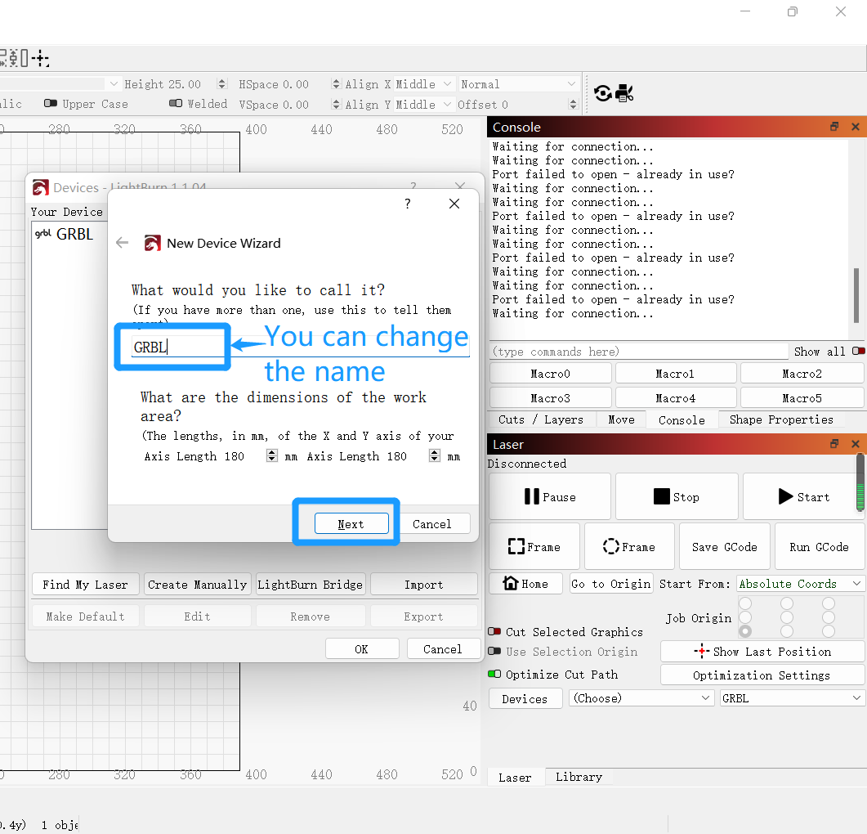
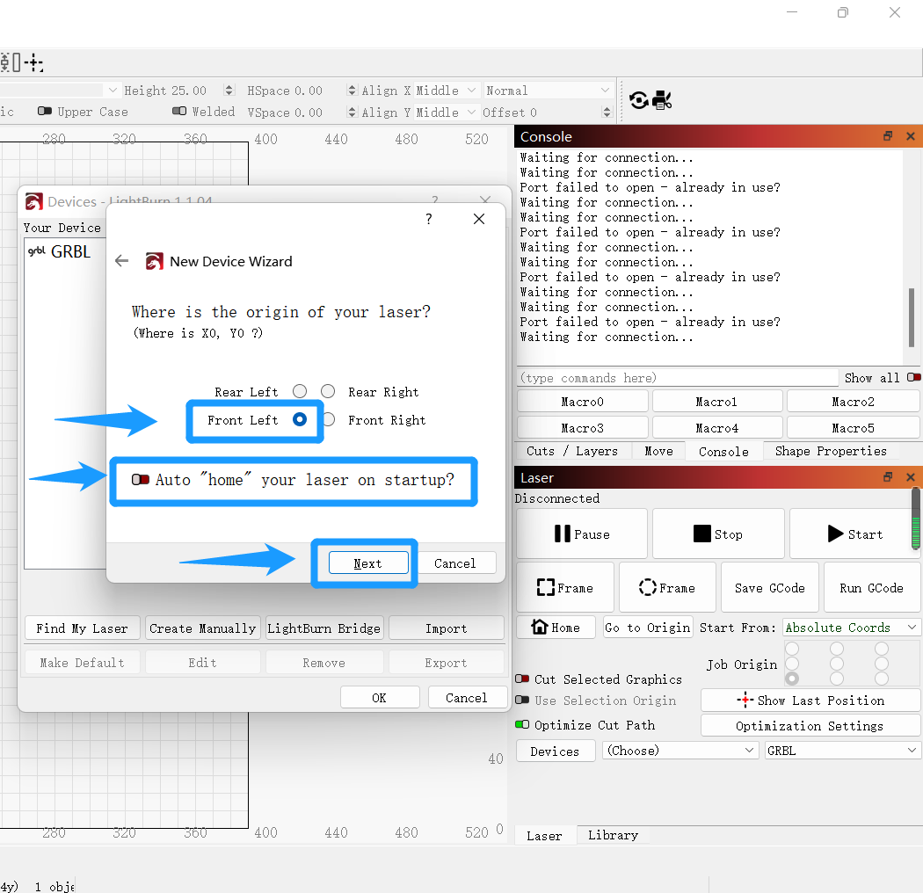
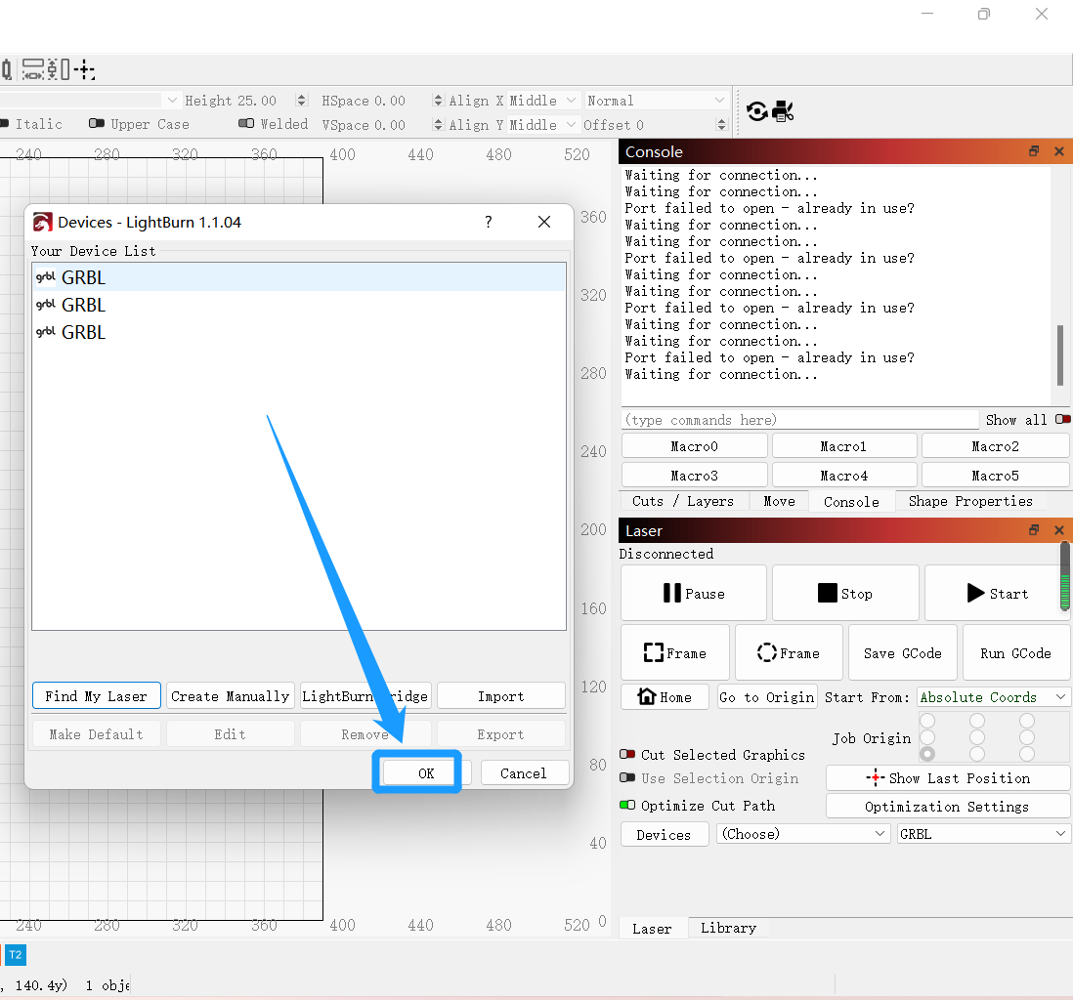
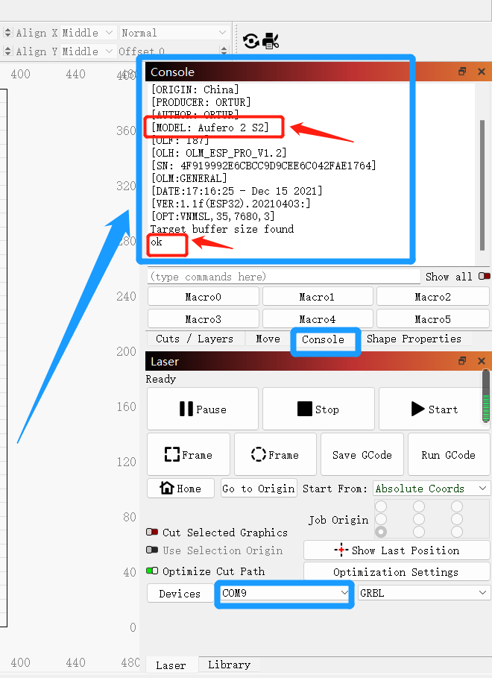
Until here means the connection is successful

Then click the stop button to unlock the machine, otherwise the machine will always be locked and can't run [Note that every time you reboot the machine, you have to unlock it before you can use it, the red light of the machine blinks to represent that the machine is still locked, after unlocking, the red light will no longer blink].

1. Q: LightBurn first connected to the machine need to do some settings on the software?
A: Yes, in order to avoid unnecessary troubles, please make sure to set up.
(1)Edit -> Settings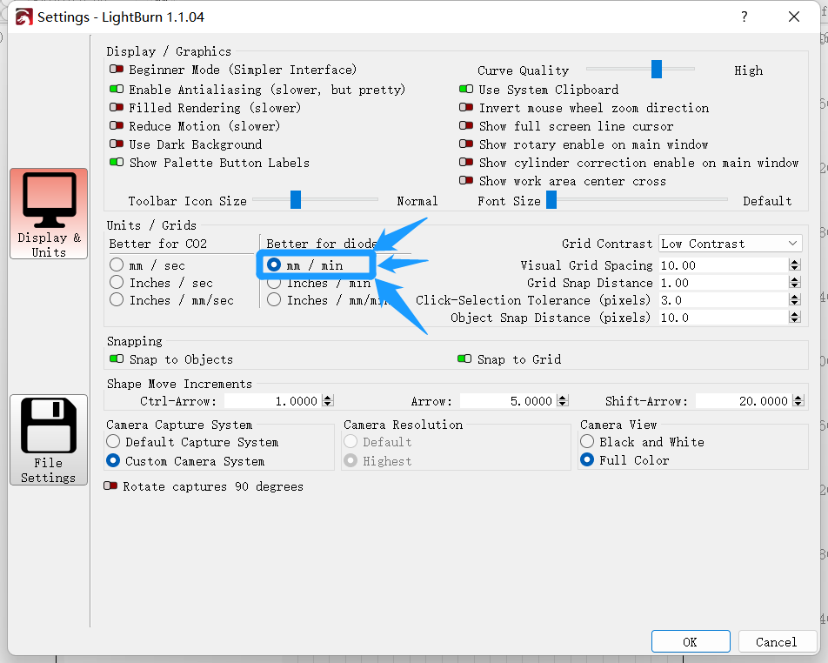
  - Edit -> Device Settings
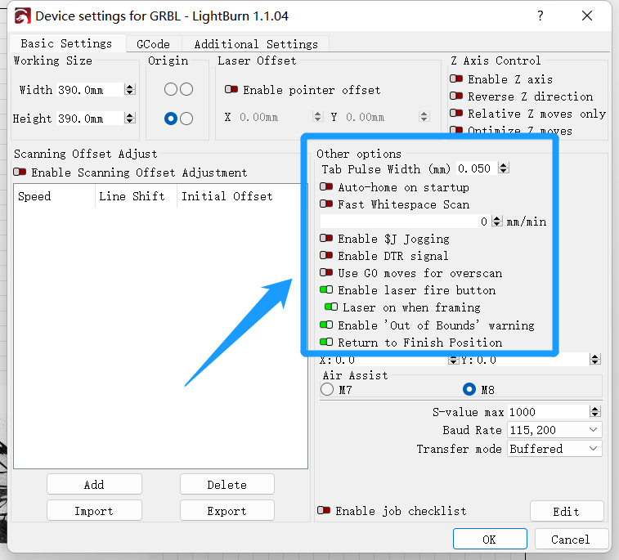
  - power exchange to 2%
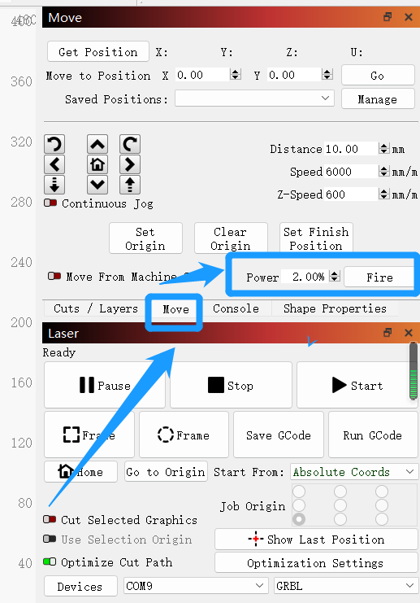

2. Q: Why is always prompting the machine is busy, or beyond the range of machine engraving, or the machine stops in the middle of engraving
A: When engraving images, you need to pay attention to the following points
When engraving the image, the image should be at least 5MM away from the rated area (as to why it is 5MM, it is related to the default value of Overscanning of lightBurn)
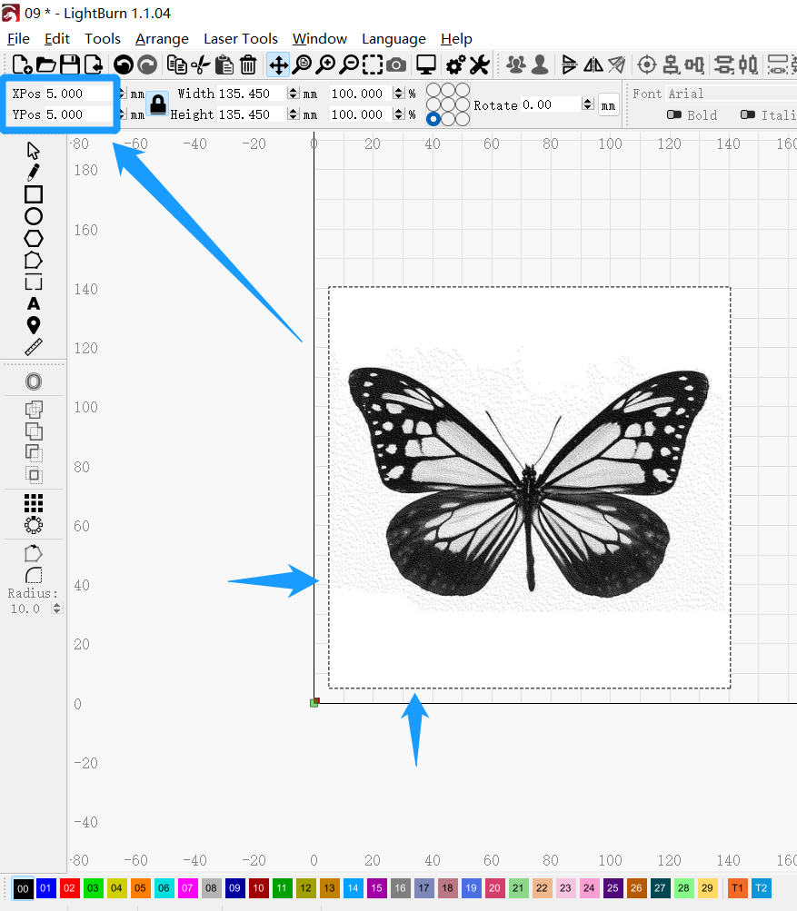
Also, turn off Overscanning in the Image Settings in the Setting Editor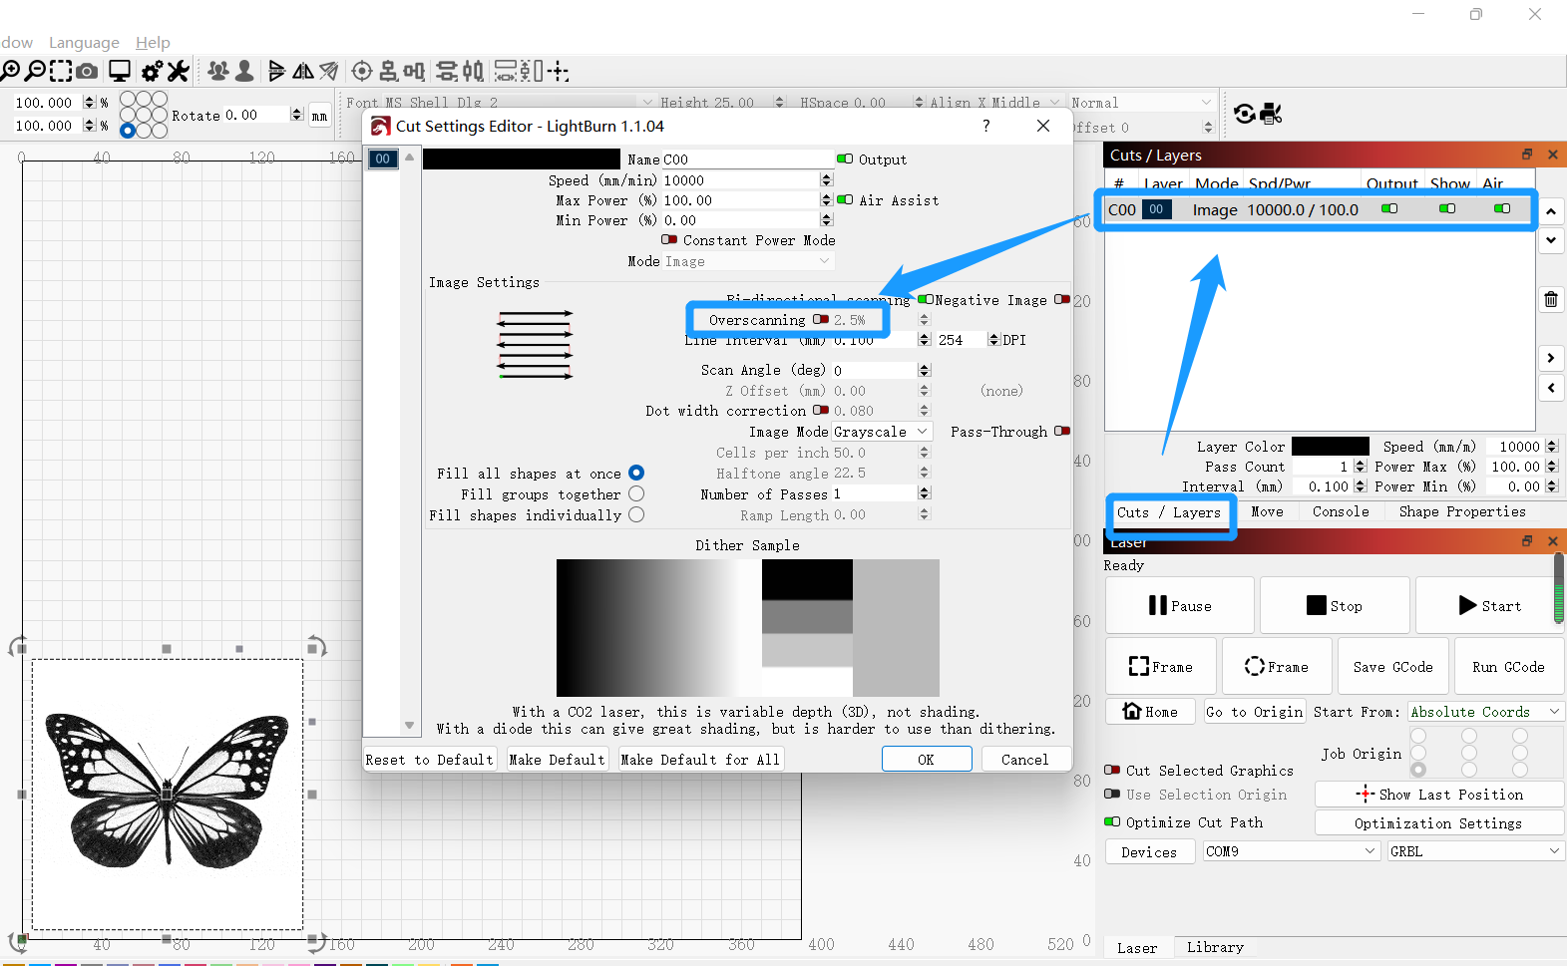

2. Why does the machine keep hitting the bezel when you click the Home button?
A: Aufero2 model does not have a limit switch, please do not click the Home button. Where the laser head is, where is the starting point of engraving.
2. Q: When you stop carving in the middle of the carving process and want to re-carve again, why does the machine frequently collide with the border?
A: Please click the go to origin button to make the machine return to the initial position of engraving or click the Frame button to take the track (the point after taking the track is the starting point of engraving). Otherwise, it is difficult to make the machine engrave as you want, unless you are already familiar with this laser engraver.

2. Why the image is in the middle of the engraving area of the software, but when I click the Flame button to take the track, it will hit the border?
Because the range you set is too far away from the starting point of the machine, plus the size of the image itself, which adds up to more than the carving stroke of the machine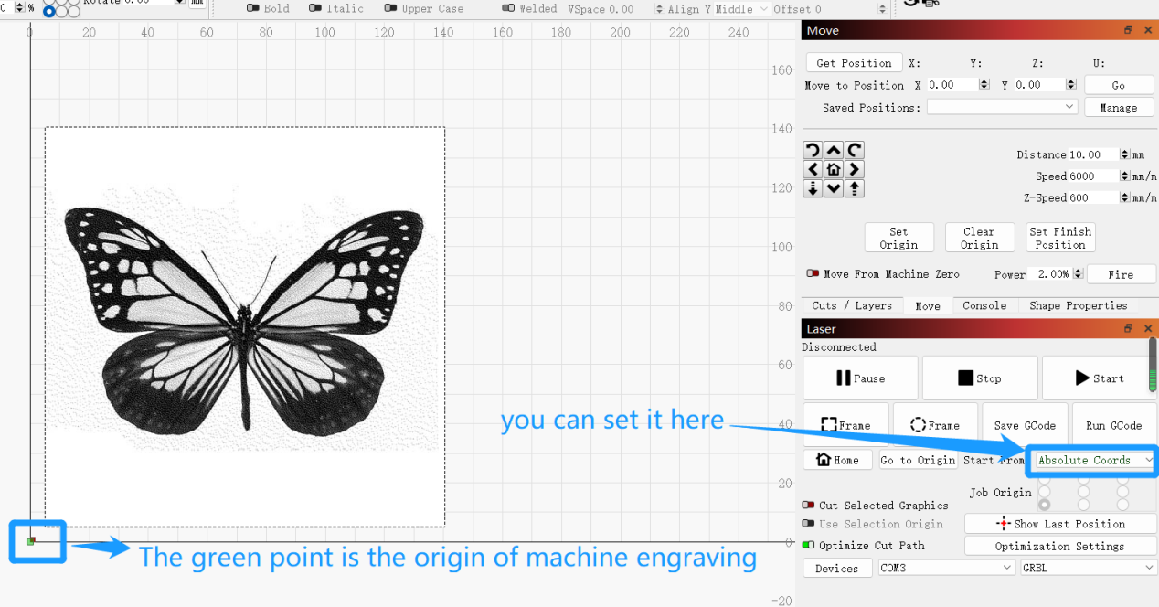
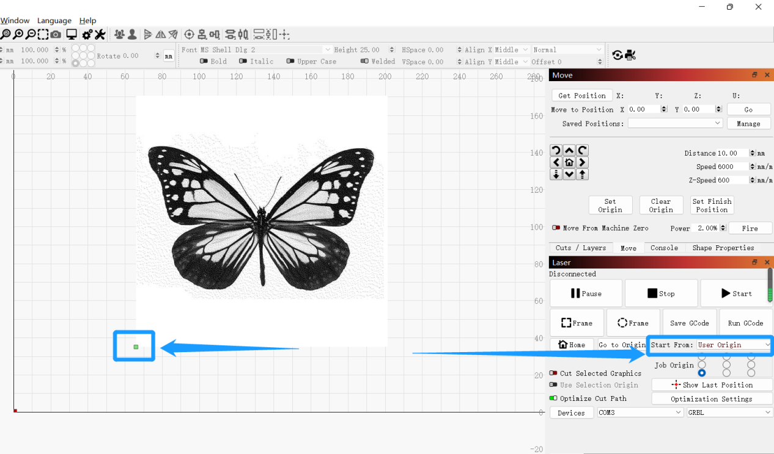

2.Is there a detailed introduction of lightBurn software?
A:Please refer to the LightBurn online documentation at:https://lightburnsoftware.github.io/NewDocs/

