Aufero1 Beginner's Guide and FAQ-lightBurn

1. Please install the driver before making the machine connection

2. Q: How to connect LightBurn to the machine?

3. Q: Do I need to do some settings for the software when I connect the machine for the first time to LightBurn?

4. Q: How to import the image files to be engraved

5. Q: Do I need to focus the laser module?

6. Q: How to set the engraving and cutting parameters

7. Q: After setting the parameters, how to determine the engraving range and start engraving

8. Q: How to enter the firmware upgrade mode and upgrade the firmware

- Please install the driver before connecting the machine
Q: How to install the driver？
A: Before installing the computer driver, please turn on the machine and connect the USB cable to the computer, and then select the driver file to install according to your computer system
computer system | Driver files | Tutorial files
Win7 / win 8：
Win10 |  | Direct Installation
Win11 | No installation required | If you really can't find the serial port, please install the driver of Win10
Mac | No installation required
After the installation is complete: find Device Manager->Ports on your computer. at this time, unplug the USB cable, the new serial port will disappear on Ports, plug in the USB cable, a new serial port will be displayed. Proof, the driver is installed successfully.
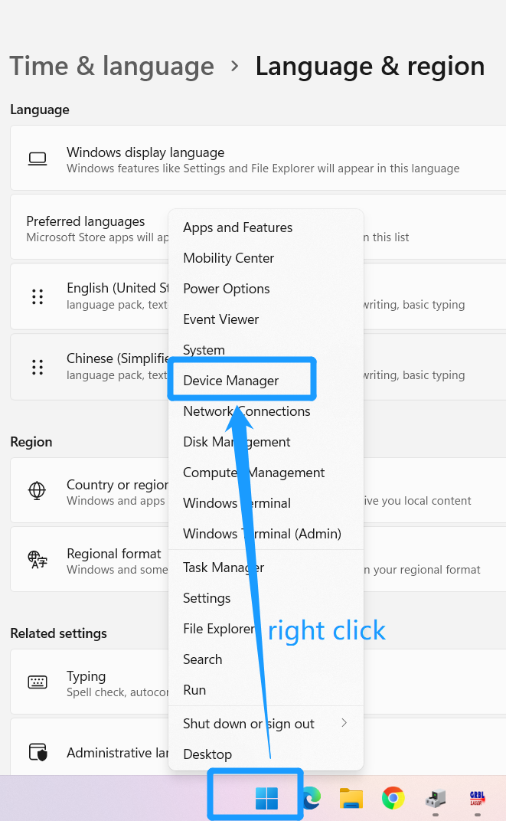
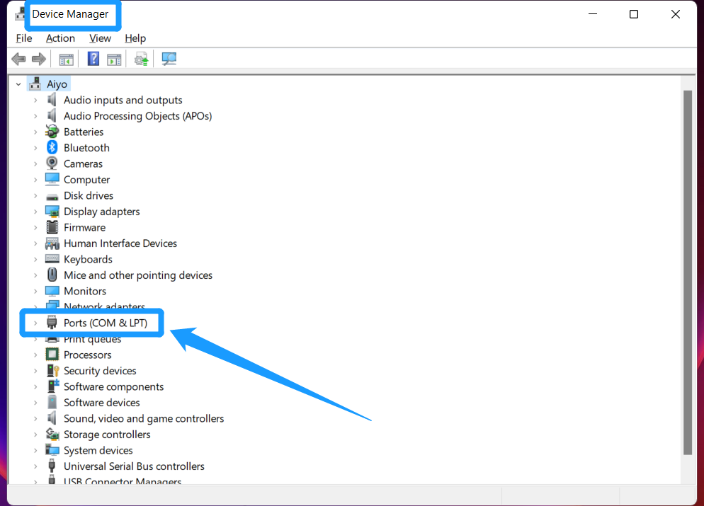

- Q: How to connect the LightBurn to the machine
A: Please follow the steps in the screenshot below to connect. Before doing the following, please make sure the machine is powered on and the USB is connected to the computer.
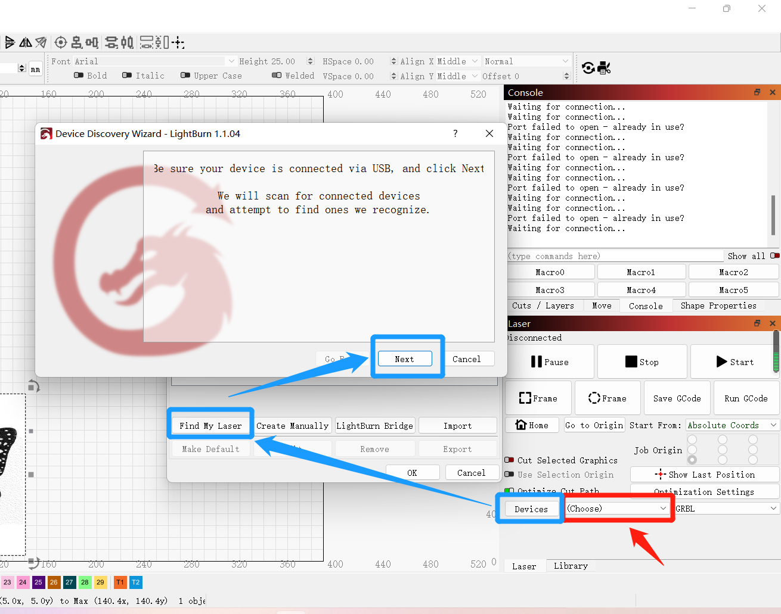
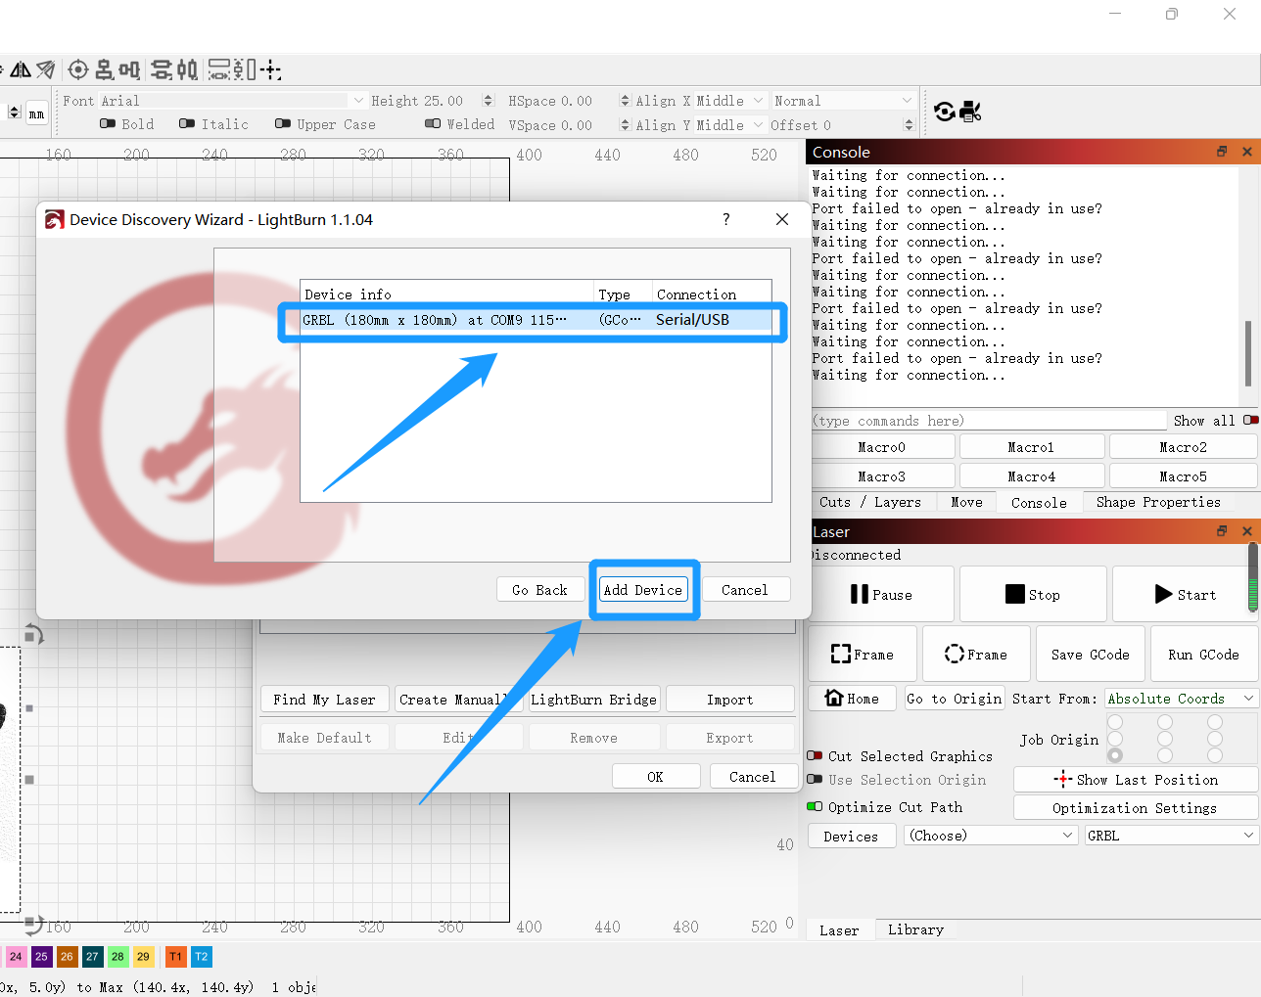
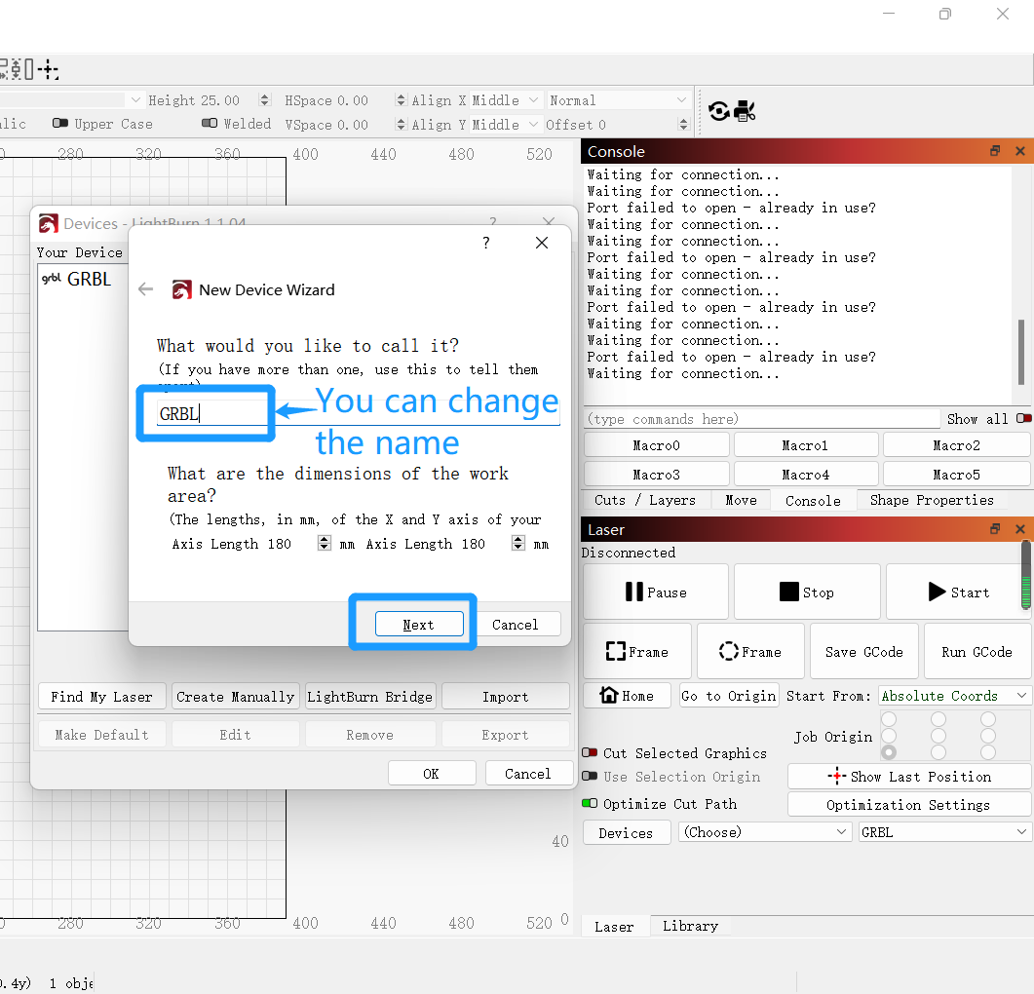
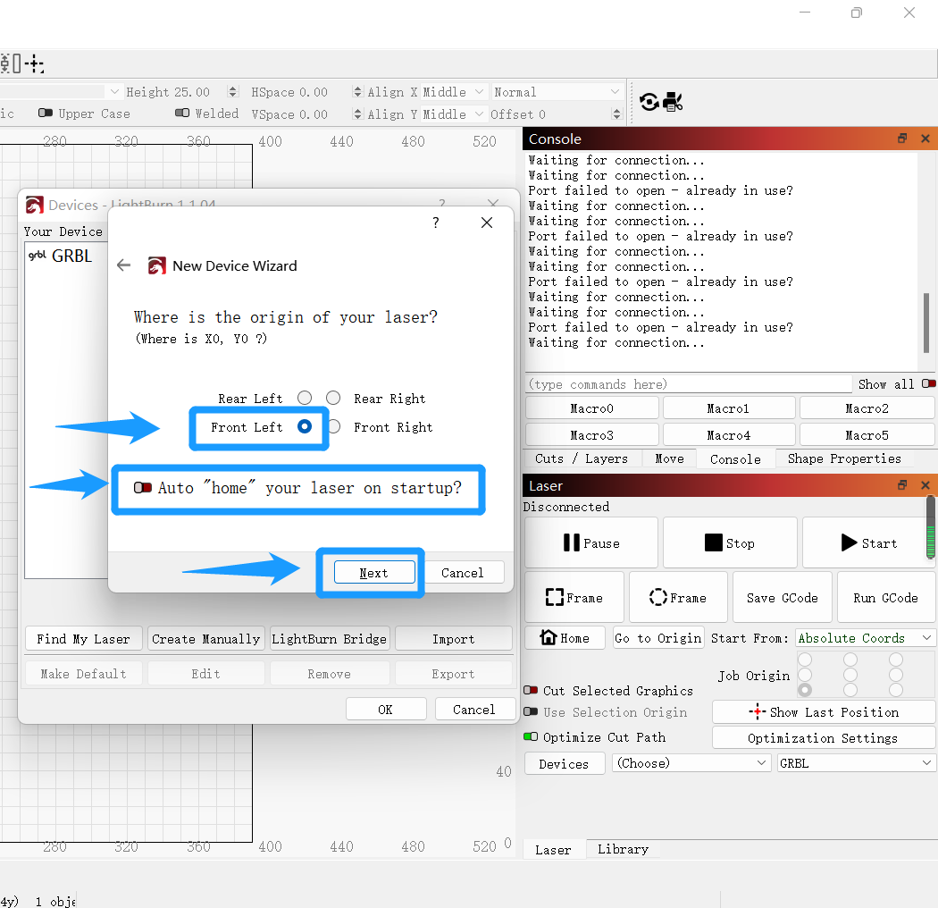
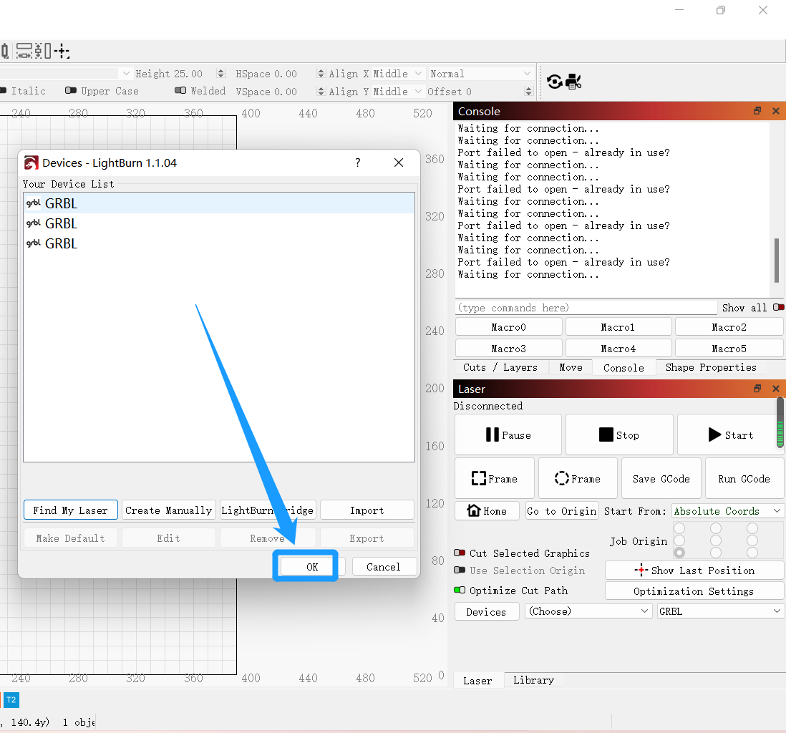
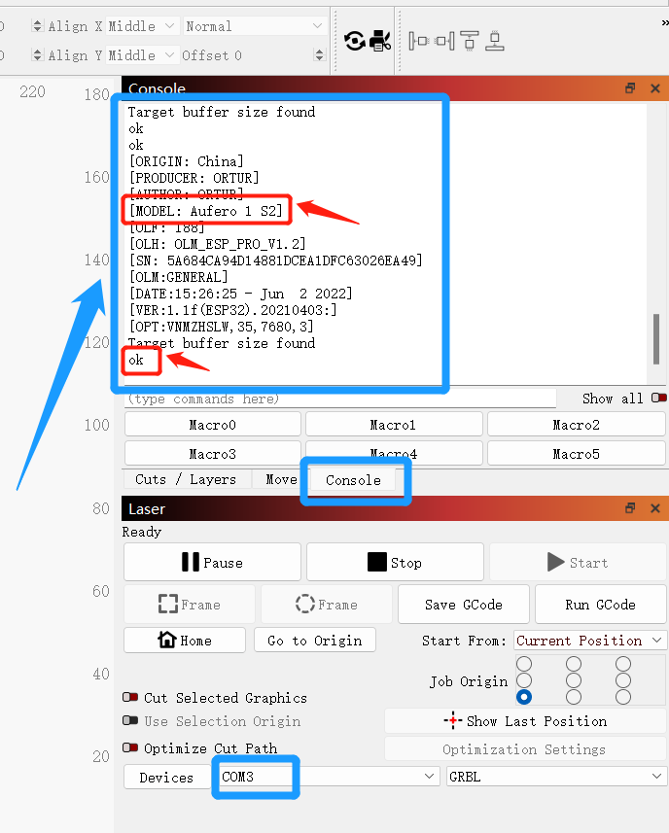
Until here means the connection is successful
- Q: Do I need to do some settings for the software when LightBurn connects to the machine for the first time?
A: Yes, please make sure to set up in order to avoid unnecessary troubles.
  - Edit -> Settings
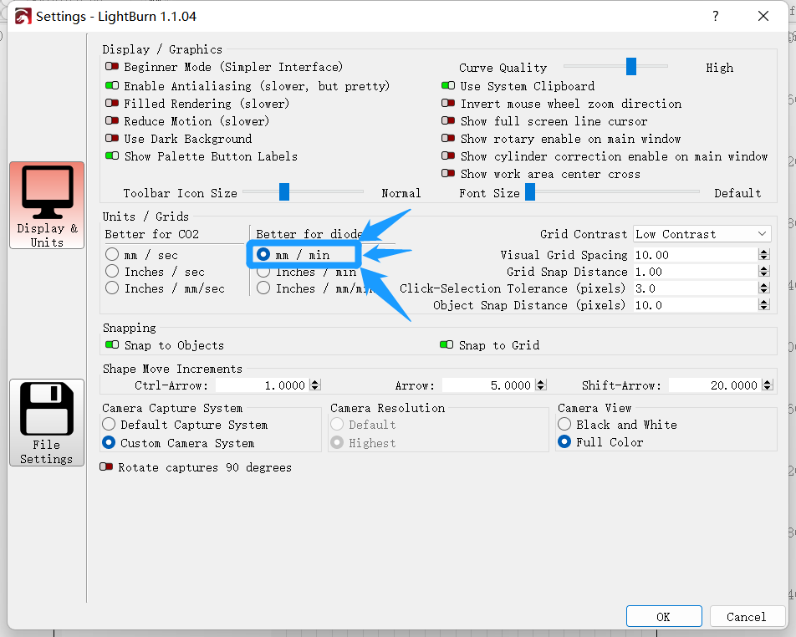
  - Edit -> Device Settings
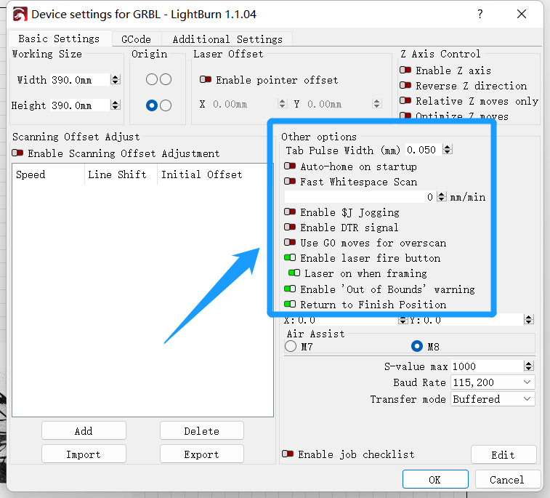
  - power exchange to 2%
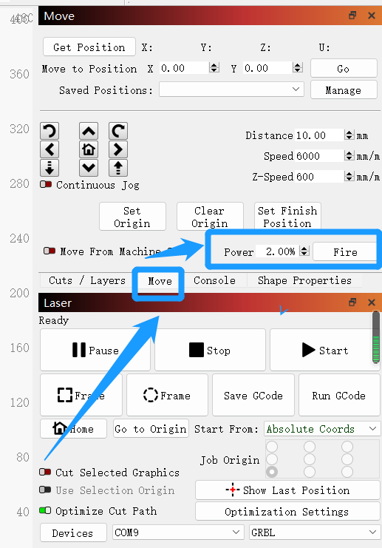
- Change the origin of all operations to the lower left corner
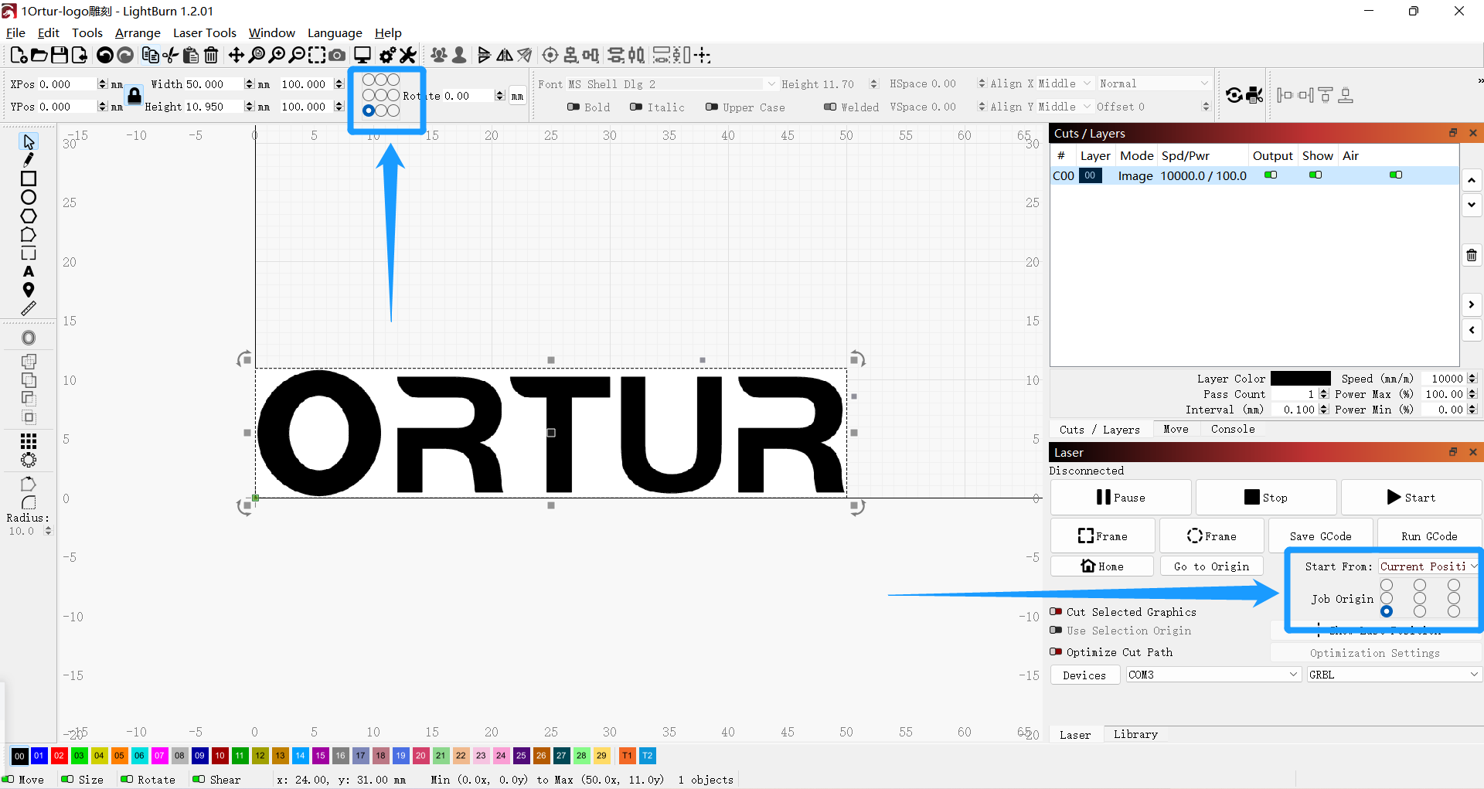
- Q: How to import the image files to be engraved？
A: Directly drag and drop the files to be engraved into the software
or
Click open file in the software
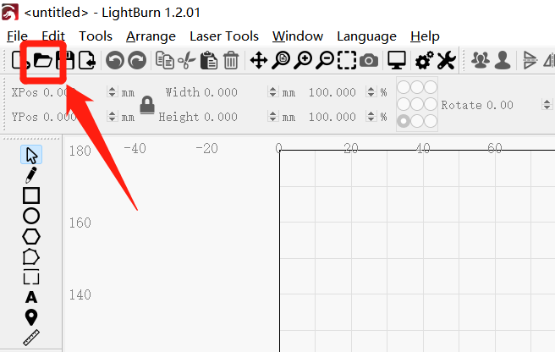

- Q: Do you want to focus the laser module

A: Yes. Only in the correct focus to carve a good effect (focus is the distance between the laser module and the surface of the carved object). Specific how to focus each laser module, please check the manual, not one by one.
- Q: How to set the engraving and cutting parameters

6.1 The engraving parameters setting page is as follows.
The main parameter settings are 6: Speed/Max power/Min power/Line Interval/Image Mode and Overscanning (this parameter should be turned off during each carving setting, otherwise it will trigger carving abnormalities)
The specific value of the parameters reference --- material power comparison table
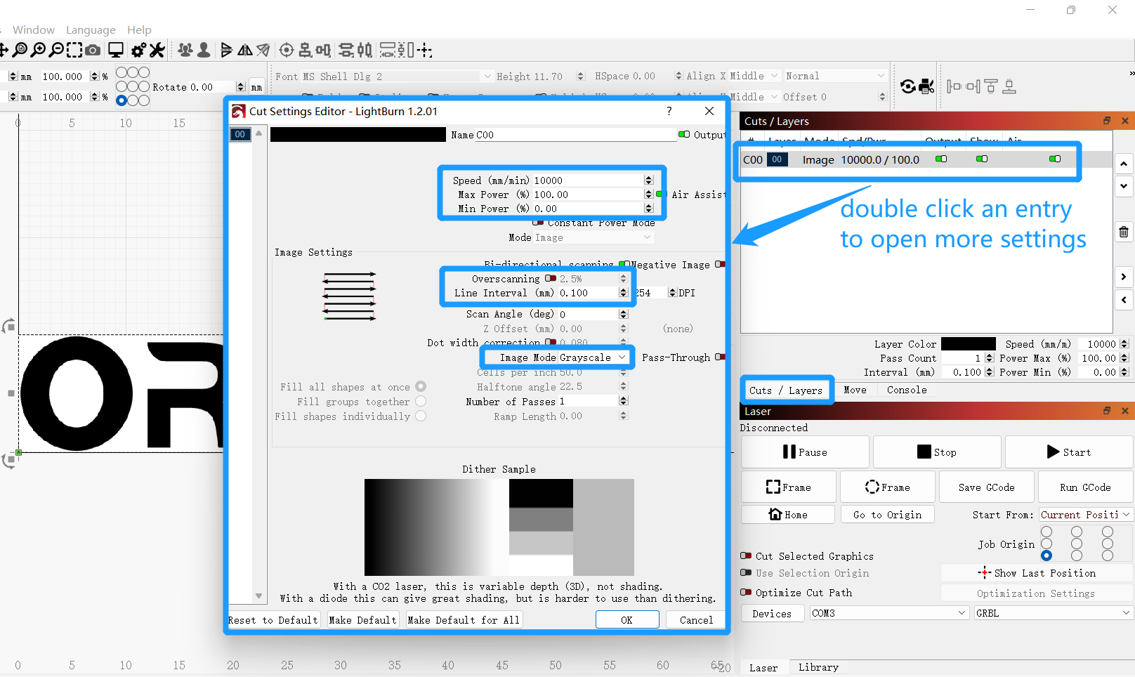
6.2 The cutting parameter setting page is as follows.
The main parameter settings are 4: Mode/Pass Count/Speed/Power
The specific value of the parameters reference --- material power comparison table
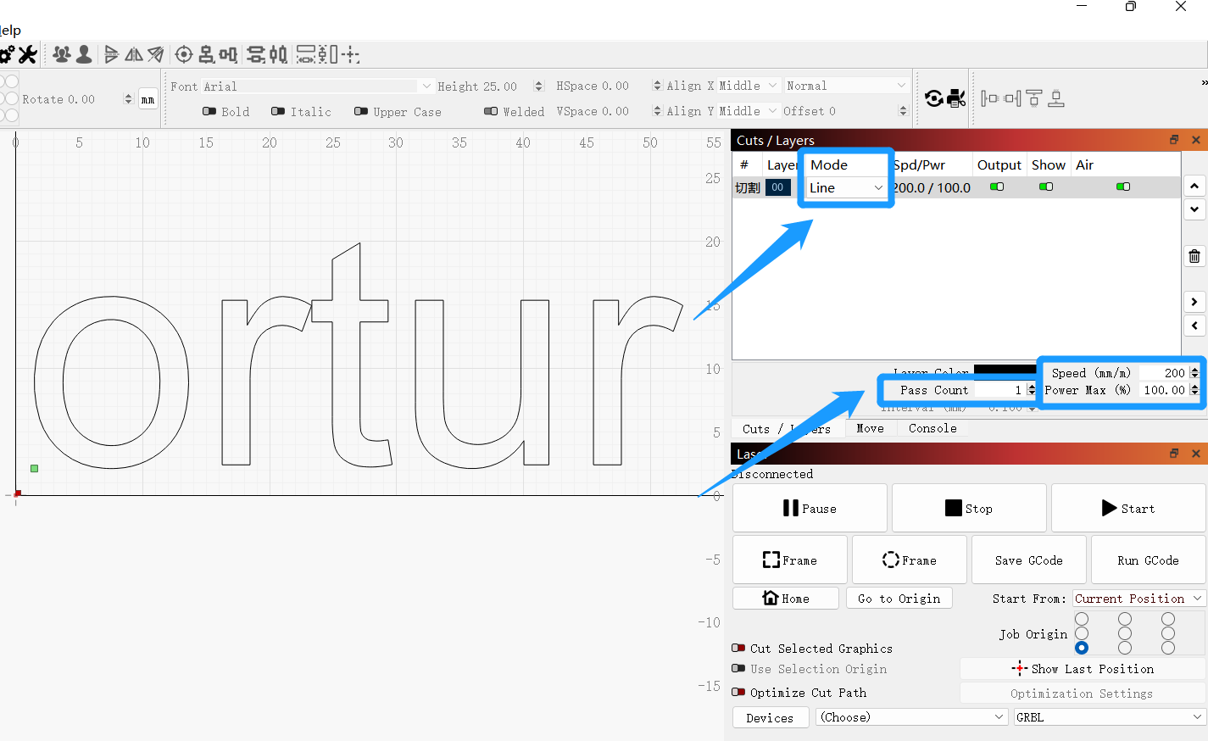

- Q: After setting the parameters, how to determine the engraving range and start engraving
A: First click on the Frame of marker 1 to determine the engraving range. Then click the start of marker 2 to start engraving.
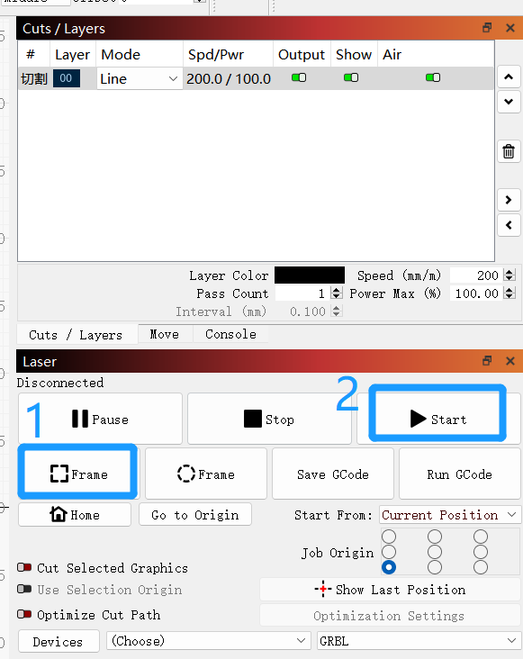

- Q: How to enter the firmware upgrade mode, and upgrade the firmware
A: Press and hold the power button, then click the rest button, then the light will be shown as red and blue lights flashing alternately, the computer appears ortur laser folder prompt, proving that it has entered the upgrade firmware mode. At this point, drag and drop or copy the latest firmware to the ortur laser folder, wait for the folder to exit automatically, and the machine will automatically shut down.
After rebooting the machine, you need to enter the software to restore all the parameters of the machine to the factory settings and overwrite the parameters that may not be covered by the old firmware.
In the following page location, enter: "$rst=*", and then click enter, the page prompts OK, then prove the success of the modification. At this point, turn off the machine, and then turn on the machine again, the firmware upgrade process ends here.
