UG30 Firmware Update Step

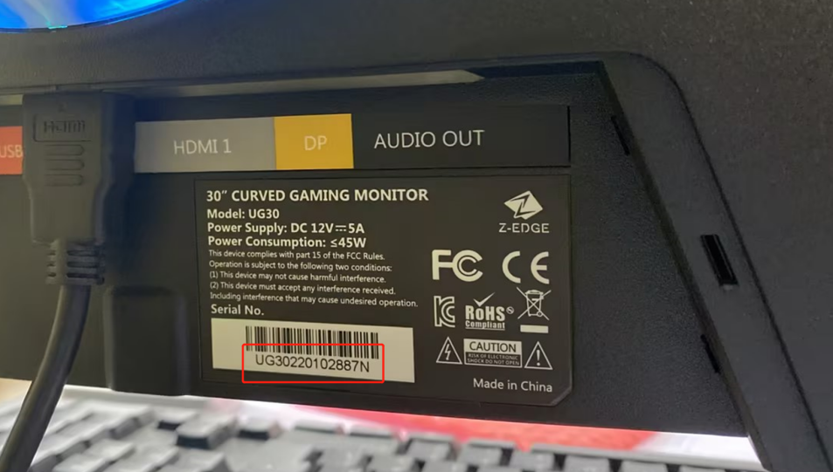
Note:
Please check the serial number first,
if the serial number is within UG30230207001 ~ UG30230209000 , then you can download the firmware and update your montior; if not, please do not update your monitor, otherwise the monitor will become useless.

Step 1 : Prepare a USB flash drive , format the USB flash drive to FAT32-Format on your computer. (Before formatting, please remember to backup all files you need)

Step 2 : Copy the update file (MERGE.bin) to the USB flash drive. Please note: do not create any file folder, just copy and save the update file to the USB flash drive directly.

Step 3 : Insert the USB flash drive into the USB port of the monitor.

Step 4 : Press the M button to enter the monitor’s setting menu, find the Firmware Update shown as the picture below, select and press M to confirm.

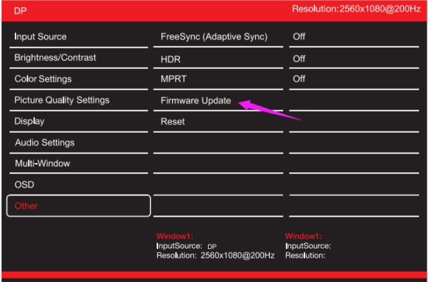

Step 5 : The device enters the automatic update process. During the update process, there will be a progress bar display. From left to right, the update is complete. After updating, the monitor will automatically restart.

