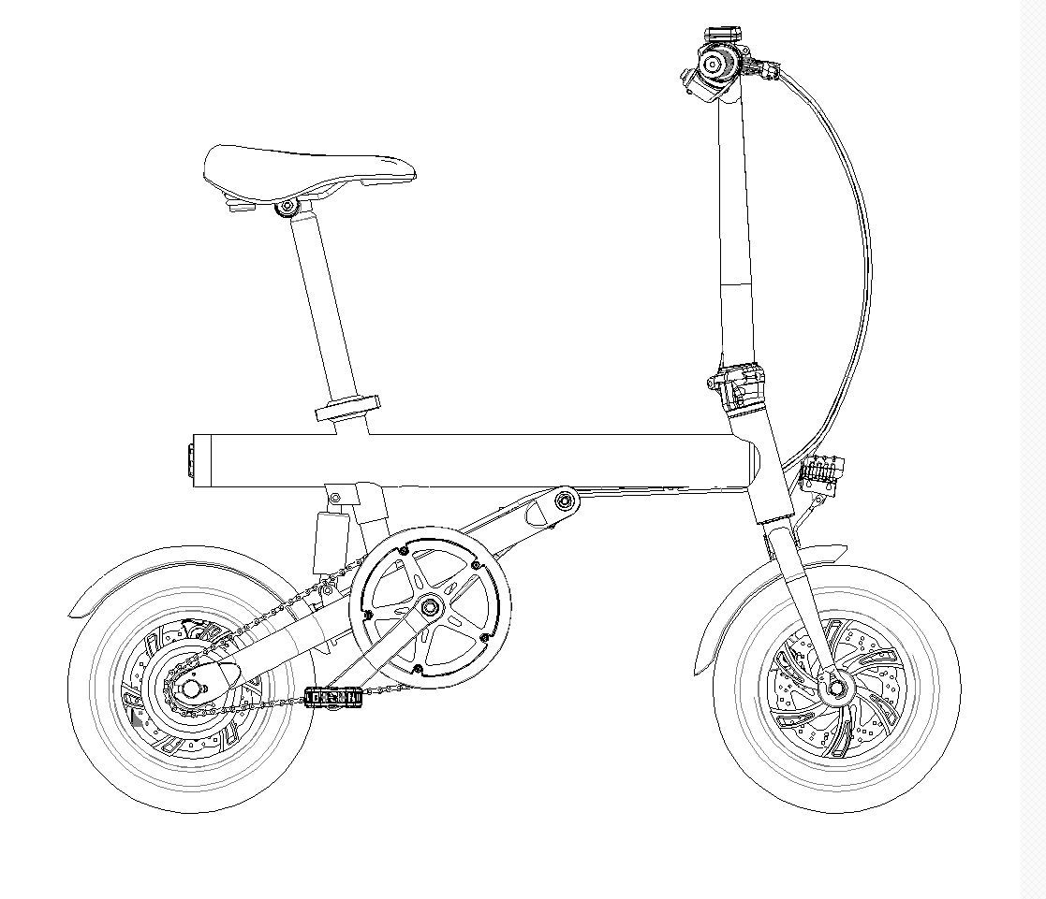
Smart 2.0
Moped Scooter

★ User Manual/Warranty Card
Table of Contents
- Products and accessories
- Moped scooter expansion method
- Self-folding method
- Brake mechanism adjustment
- Brief description of the screen display
- Charging mode
- How to ride
- Driving Safety Instructions
- Daily maintenance
- Model
- Warranty policy
- Legal Statement on Electric Vehicles

- Products and accessories

Moped Scooter
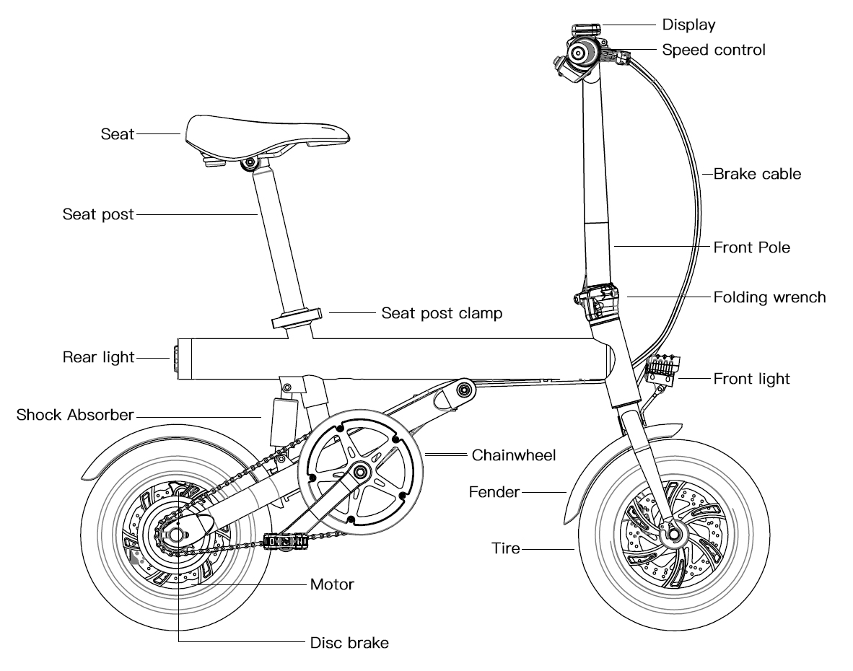
Accessories
Description | Picture | Quantity | Usage
Charger |  | 1 | Charge the moped scooter
M25 Hex wrench |  | 1 | Adjust the folding wrench
M3 Hex wrench |  | 1 | Fix the handlebar
M4 Hex wrench |  | 1 | Adjust the disc brake
Screw kit |  | 1 | Fix the handlebar
Scissor |  | 1 | Cut the cable tie
User manual |  | 1 | Moped scooter user manual

2. Moped scooter expansion method
Step 1：
Status after unpacking
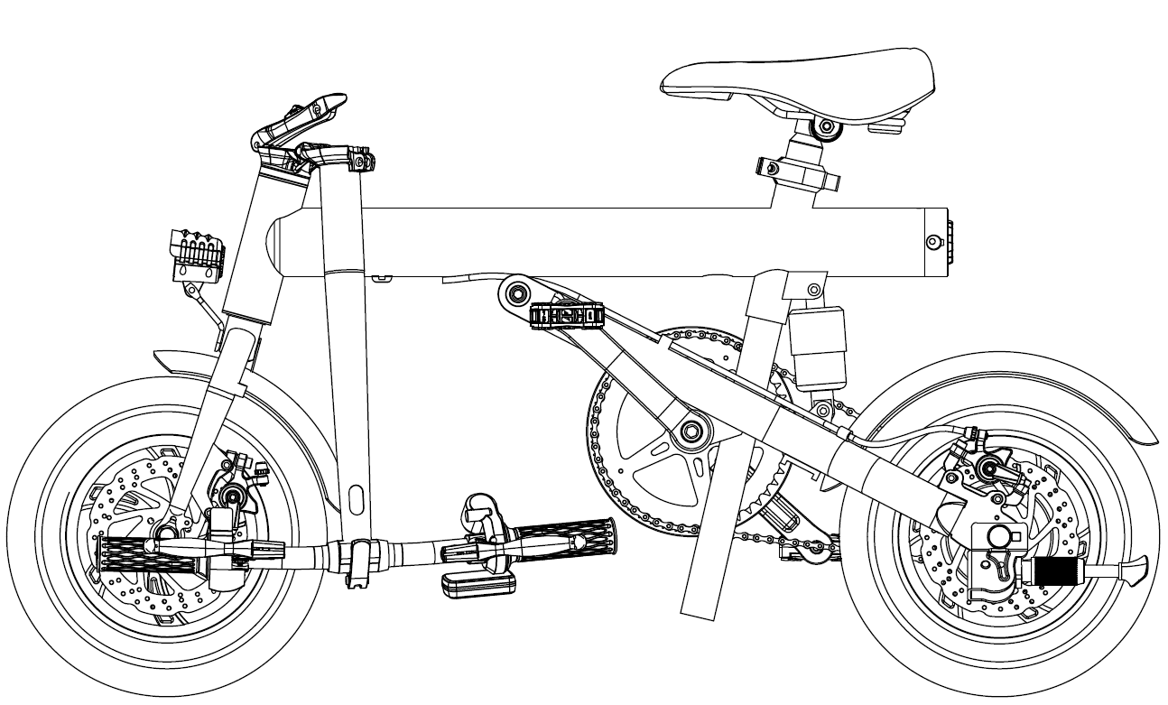
Step 2:
Front pole folding expansion
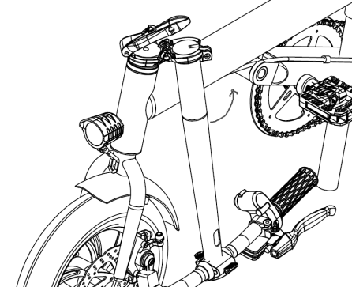
Figure 1 Figure 2 Figure 3

- Turn the front pole straightly from FIG 1 to the FIG 2;

- According to the arrow direction to pull the folding from FIG 2 to FIG 3 and lock it.

Step 3:
Adjust the handlebar

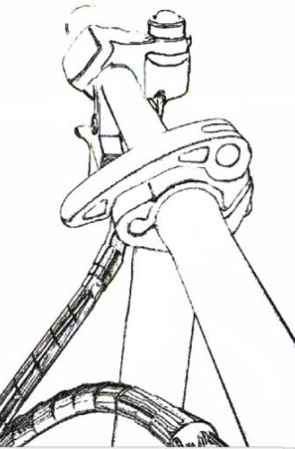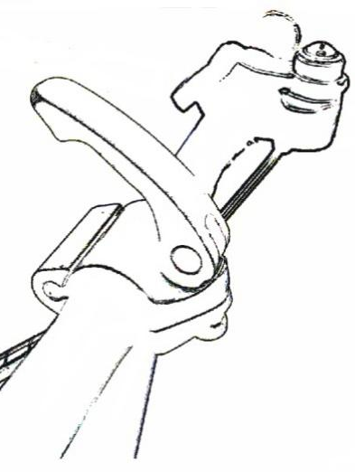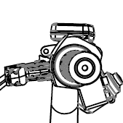

Figure 1 Figure 2 Figure 3
- Pull the clamp by the arrow direction of FIG 1 to FIG 2;

- Adjust the brake and the handlebar for normal use, and press the clamp to FIG 3 to lock the handlebar.

Step 4:
Install the seat post
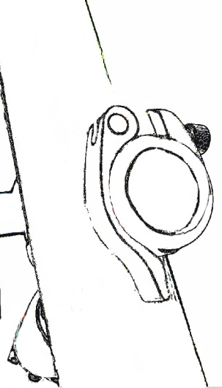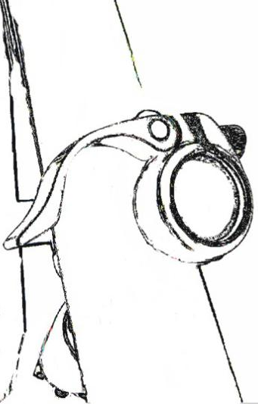

Figure 1 Figure 2 Figure 3

Figure 4
- Pull the seat post clamp by the arrow direction of FIG 1 to FIG 2, and then insert the seat post;

- Adjust the seat post height to suitable personal use, and press the seat post clamp from FIG 2 to FIG 4 to lock the seat.

3. Self-folding method

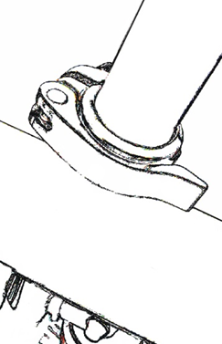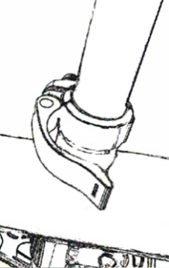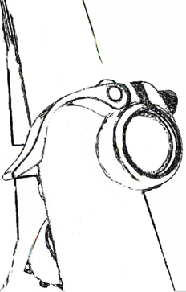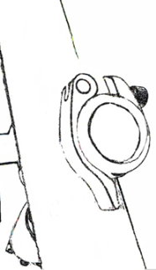
Figure 1 Figure 2 Figure 3 Figure 4

Step 1: Remove the seat post

- Pull the seat post clamp from FIG 1 to FIG 2, and then pull out the seat post;

2）Press the seat post clamp in FIG 4

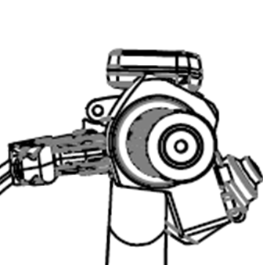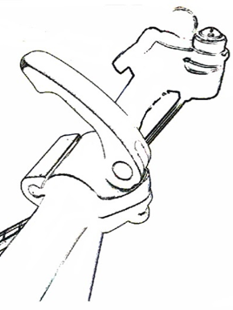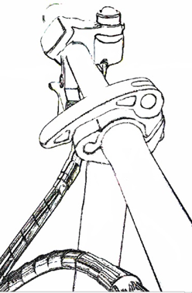
Figure 1 Figure 2 Figure 3

Step 2: Adjust the handlebar

- Pull the handlebar clamp from FIG 1 to FIG 2, and turn the handlebar to make the brake downward as FIG 3 shows;

- Press the handlebar clamp to lock the handlebar as FIG 3 shows.

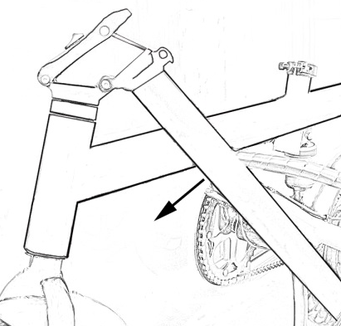
Figure 1 Figure 2 Figure 3

Step 2: Adjust the front pole

- Pull the front pole folding by the arrow direction of FIG 1 to FIG 2;

2） Fold the front pole by the arrow direction in FIG 3.

- Brake mechanism adjustment
Brake: Hold the brake handle down to 2/3 position when riding, the brakes are locked;
If not, pls adjust as follows.

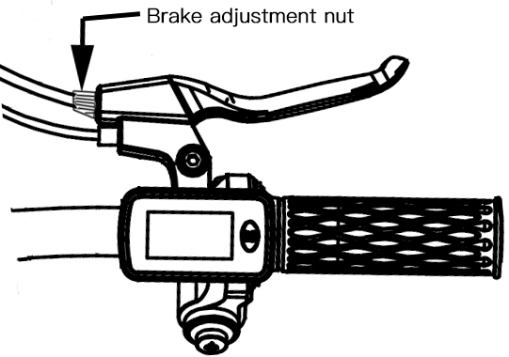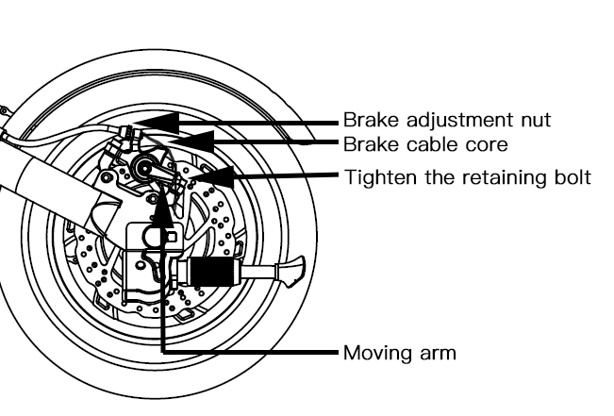

1）Adjust slightly:
Turn adjusting bolts (brake adjustment nuts in the above figures) counterclockwise, be careful not to spin out.

2）Wide range of adjustment:
Loosen and tighten the retaining bolt with M4 hex wrench, hold the end of the steel wire with pliers and pull it down. At the same time, rotate the movable arm clockwise to a certain position. Then lock and tighten the fixed bolt and hold the brake handle to test the braking effect.

- Brief description of the screen display

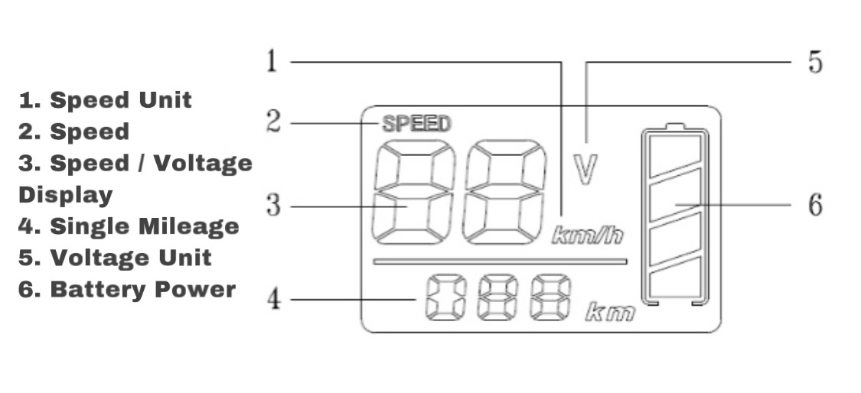
- Charging mode
After e propurchasing thduct, please charge it before unpacking for the first ride. When the meter's electric quantity shows up to the yellow grid, riding must be done after charging. Charging steps: open the rubber plug and insert the charging plug (the red indicator is on).

Charging time 3-5 hours (charging time varies with environmental temperature, etc.)
Pulling out the charging plug and fastening rubber plug after fully charged (green indicator light is on)

- How to ride
O Riding normally (at the risk of falling and injuring during riding, helmet and protective equipment can be worn)
- Turn on the moped and check whether the battery is sufficient
- Turn on the left power switch
- Pedaling with both feet means starting to assist riding
- If switch to the left pure electric die test, turn the throttle and starts riding

- Driving Safety Instructions
- Please avoid riding in the rain.
- Do not drive at high speed when encountering speed bumps, potholes and other unconventional roads.
- Avoid hitting your head against high obstacles such as door frames and elevators.
- Do not accelerate when going downhill.
- Do not turn the throttle when walking the moped.
- Please avoid obstacles and ride.
- Do not hang backpacks or other heavy objects on the moped.
- Do not stand on one leg while riding.
- Moped scooters are not allowed to enter the motorway.
- It is forbidden to turn the throttle sharply when riding at high speed.
- It is forbidden for more than one person to drive an moped at the same time or to ride with children in their arms.
- It is forbidden to remove your hands from the handlebar while driving.
- It is forbidden to ride the moped up or down stairs or jump obstacles.

● Riding in strict accordance with the instructions in this manual will protect the safety of you and others to the greatest extent and ensure compliance with traffic laws and regulations, etc.
At the same time, you need to understand that if you ride the moped on public roads or other public places, even if you fully follow this safe driving guide, you may face risks caused by illegal driving/improper operation of other people's vehicles. Just as walking or cycling can be harmed by other means of transportation; As with all vehicles, the faster you go on a moped, the longer the distance you need to brake, and slamming on some smooth surfaces can cause the wheels to skid and lose balance or even fall. It is therefore important to keep abreast of riding, to keep an appropriate speed, and to maintain a reasonable and safe distance from other people and vehicles.

When riding, please respect the right of way of pedestrians to avoid scaring pedestrians, especially children. When passing behind a pedestrian, remind the pedestrian and slow down when passing. If possible, pass from the left side of the pedestrian (applicable to countries where vehicles drive on the right side). When facing a pedestrian, stay to the right and slow down.

Please be sure to strictly comply with the safety requirements of this manual for riders. The Company shall not bear any direct or joint liability for financial losses, personal losses, accidents, legal disputes, or any other events resulting in conflicts of interest caused by any violation of the use of the manual.

● Do not lend the moped scooter to people who cannot operate it, so as to avoid injury. Please do a basic check on the moped before each ride, if discover the obvious parts loose, battery life reduce or excessive tire wear or steering the phenomenon such as a sound or failure, please stop using immediately, do not force to ride.
- Daily maintenance
O Moped Cleaning and storage
If moped surface stains, use soft cloth qiao take a small amount of water to wipe can; If it is difficult to clean the stain, use toothpaste smear and brush repeatedly with a toothbrush, and then clean with a wet cloth.
Tip: Do not use alcohol, gasoline, kerosene or other corrosive, volatile chemical solvent cleaning, otherwise it will seriously damage the appearance and internal structure of the moped scooter body. It is prohibited to use pressure spray gun for washing.
When not in use, try to store in a dry, cool place indoors and avoid outdoor storage for a long time. Exposure to the sun, too cold, too hot outdoor environment will accelerate the appearance of moped scooter and tires aging and less battery life.

Moped scooter battery maintenance
- Do not use battery packs of other models or brands, otherwise there may be safety risks.
- Do not touch the battery contacts, and do not open or puncture the case. Avoid short circuit caused by metal objects contacting battery contacts. Otherwise, it may cause battery damage and casualties.
- Please use the original charger for charging, otherwise the battery may be damaged or there may be safety risk.
4. Do not discard the battery pack at will. Improper disposal of used batteries may seriously pollute the environment, and local laws and regulations should be observed.
5. Please store the battery fully charged after use, which is beneficial to prolong the service life of the battery. Do not place the battery in an environment higher than 50℃ or lower than -20℃. Do not put the battery pack in the fire, otherwise the battery will fail, overheat and even be in danger of fire. If not in use for more than 20 days, please charge it fully and store it in a cool and dry place. Otherwise, damage to the battery will not be covered by the warranty.
6. Under normal temperature environment, battery pack can play a high range and performance, if the environment below 0℃ may reduce the range and performance, above 50℃ or below -20℃ environment, the range may be reduced by half or even less.

- Model parameter

Model parameter table
Performance Index | Item | Parameter
Product Size | Unfold Size(cm) | 114*49*99CM
 | Folding Size(cm) | 114*23*59CM
 | Packing Size(cm) | 117*27*63CM
Product Color |  | White / Black
Major parameter | Weight(kg) | About 16.65kg
 | Loading Weight(kg ) | ≤150kg
 | Frame Material | Aluminum alloy
 | Mileage(km/h) | Around 30 (Different mileage based on different battery pack, load, road conditions)
 | Max Speed(km/h) | 25km/h
 | Protective Capability | IPX4 for Vehicle, IP65 for battery
 | Max Slope(％) | Around 15
 | Terrain | Cement asphalt pavement, flat dirt pavement, not higher than 1cm steps, not more than 3cm wide channel
Battery | Nominal Voltage(VDC) | 36
 | Nominal Capacity(Wh) | 36V 7.8Ah
Motor | Nominal Power(W) | 250
 | Max Power(W) | 300
Charger | Input Voltage(VAC) | 100-240V～ 50/60Hz
 | Output Voltage(VDC) | 42V DC
 | Output Current(A) | 1.5A
 | Output Power(W) | 63W
 | Charing Time(h) | About 6hrs
Tyre | Size(inch) | 12
 | Type | Rubber air tyre
 | Disc brake | Yes
Riding requirements | Age | 16-50
 | Height(cm) | 145-180cm

- Warranty policy
Warranty period
- Within 7 days from the day you sign for it, the performance faults listed in this product will be detected and confirmed by our after-sales service center, and the products can be replaced or repaired free of charge.
- From the 8th to 15th day of your signature date, the performance failure rating of this product is confirmed by our after-sales service center, and you can enjoy free maintenance service.

Warranty Item | Warranty Time | Warranty Content
Moped scooter | One year
Battery | Half a year

Note: Appearance parts and consumables are damaged and not after sale. Consumables include inner tube, outer tube and the accessory gifts.

Attentions: The following situation is not a quality problem and does not apply to this warranty.
- Failure to follow instructions for use.
- Normal wear and tear, accident, abuse, neglect of care, improper assembly, or incorrect component repair and incorrect component use by any user.
- It belongs to the parts that will wear out naturally in normal use, and does not apply to the above warranty period for free maintenance.
- Failure to replace and maintain the consumables in time due to wear and tear, resulting in failure of other parts.
- The valid invoice or warranty card does not match the model of the scooter or is altered.
- Damage caused by overload, riding over obstacles (including but not limited to stairs, falls, etc.), doing extreme sports, etc.
- Damage caused by force majeure (e.g. fire, earthquake, lightning, water damage, etc.)
- Exceeding the warranty period.

After Sale Warranty Card
Product Serial Number:
User Name:
User Tel:
User E-mail:
User Address:

Maintenance Time | Error Description | Solution | Remark

- Legal Statement on Electric Vehicles

Thank you for choosing Smart moped scooter, Smart moped scooter is a fashion of sports equipment, but when it into the public area, it will have a transport properties, so there are all the possible risk, transportation or when you drive Smart moped scooter is out of control, the risk of collision and fall, you have the responsibility and obligation to learn how to ride the Smart moped scooter, and strictly abide by the relevant local laws and regulations. We want you to be safe and enjoy learning how to ride safely.

Think about how you learned to ride other vehicles. Maybe someone helped you learn, put you in a safe riding environment, and started learning. All of these experiences apply to Smart e-bike learning. Please read and learn "Smart Moped Scooter User Manual" and "Smart Moped Scooter Legal Statement" carefully before using, and obtain relevant learning information from our website, in order to help you learn safe riding skills.

Compared with other devices, riding a Smart moped scooter exposes you to the risk of injury. You can reduce the risk through the warnings and precautions in the Smart Moped Scooter User Manual, but you cannot eliminate the risk. Please read carefully the prohibitions and warnings listed in the Smart Moped Scooter User Manual, as well as the following legal notices.

Product Legal Statement

The more you know about moped scooters, the easier it will be to ride them, so please pay attention to the following:
- Read the Smart Moped Scooter User Manual carefully before riding practice;
- Please do not allow anyone to use your moped scooter without carefully reading the Smart Moped Scooter User Manual;
- All moped scooter parts must be installed in accordance with the Smart Moped Scooter User Manual, improper installation may bring the risk of loss of control, collision or fall. Please turn off the power before installation and maintenance. Please install the parts with proper strength. Too loose or too tight will lead to damage or failure of the scooter body;
- Do not charge in the wet state of the socket. When charging, plug the power cord into the correct socket (90V-264V-50/60Hz), keep it away from children and pets, and keep it away from flammable objects;
- Do not place the battery in a high temperature of more than 50℃ or a low temperature environment of less than -20℃;
- Do not continue to use the battery if it is damaged, smells, smokes or overheats, and avoid other objects coming into contact with the leaking battery;
- Do not attempt to open or remove the battery, as there are harmful substances in the battery;
- You need to be familiar enough with the operation method of Smart moped scooter to operate outdoors. The more you practice, the more you will be able to ride safely in a new environment. Please remember the following practice tips: first do the initial stage of the exercise, practice forward turning and stopping in the barrier-free area (≥10 m *10 m), and keep the body in a relaxed state. The first practice is best done under the guidance of an experienced person or coach, and as the practice progresses, try to practice through narrow areas, turning and stopping. Only after you accurately control the operation of the narrow area and simulate various terrain exercises can you enter the road for driving (e.g. the laws and regulations of your region and country allow you to drive the scooter into the public area);
- Before riding your moped scotoer, please check the body carefully to make sure there is no sign of loose or damaged parts before driving;
- No matter before riding, during riding or when braking, please pay attention to the intersection so as not to cause unnecessary damage to yourself or surrounding objects, people and small animals;
- If the tires show signs of looseness while riding, please stop to check immediately to avoid danger;
- To ride a Smart moped scooter, you must get on both sides of the scooter and wear professional protective gear;
- Don't wear high heels when riding a Smart moped scooter;
- Do not immerse the battery and scooter body in water, expose to heavy rain or drive in the rain for a long time. Do not clean the scooter body with strong water flow and high-pressure hose to avoid water in the charging port. If your e-bike has been exposed to heavy rain or riding in the rain for a long time, please wipe the body with a dry soft cloth in time, and immediately stop using and contact the after-sales service personnel in time. Do not perform any operation other than wiping on the body by yourself to avoid the risk of failure to guarantee due to improper conduct;
- On rainy days, the braking performance of the moped scooter (including other vehicles) will be greatly reduced, and the resistance of your tires will be relatively reduced. It makes it more difficult for cyclists to control their speed, which is more likely to lead to loss of control. To ensure safe riding in rainy weather, ride slower and brake earlier than normal dry conditions;
- In the state of low power display, the moped scooter may not have enough power to maintain your demand for high-speed riding. Please charge it timely to ensure the riding experience;
- The ease of use of the Smart moped scooter tends to cause overconfidence in your riding. If you ride at high speed over obstacles, uneven ground, slippery ground or steep slopes, you may lose control of your scooter, resulting in collisions, falls or injuries. Please be careful to ride slowly in complex road conditions;
- When riding, pay attention to the change of terrain, such as flat ground and grassland;
- Be careful when you turn! Please turn carefully! Turning quickly can easily lead to loss of control;
- Don't take risks. When you encounter steep slopes, uneven roads or other terrain you have not encountered before, please pay attention to your safety and don't risk riding through;
- Be on guard when you drive. Take care of yourself and other vehicles and pedestrians;
- When riding, you should always be prepared to deal with the following situations: the vehicle entering the road in front of you or coming from behind when speeding or turning, the open door, someone stepping out of the sidewalk. There are children or pets playing beside the road. Potholes, sewer partitions, railway tracks, expansion joints, road or sidewalk construction, debris and other obstacles and other dangerous conditions that may cause you to be distracted while driving. These can lead to steering, hanging on to wheel sets, or any other accident;
- If the laws and regulations of your region and country allow you to ride an e-bike on the road, please ride in the direction specified by the laws of the local government;
- Please do not be dragged along with your hands attached to another vehicle;
- Please don't do any special effects while riding;
- Riding is prohibited under the following circumstances. These include: poor weather, poor visibility at dawn, dusk or in the dark, or during periods of extreme fatigue, each of which increases the risk of accidents;
- Don't ride alone in remote areas. Even when riding with others, make sure that someone knows where you are going and when you expect to be back;
- When riding, you are taller than usual. Please pay attention to the extra height given by the moped scooter and helmet. Be vigilant when riding indoors, in front of doors or in other positions close to your head;
- When riding, do not wear loose clothes, so as to avoid friction between the clothes and the wheel body affect the normal operation;
- Protective glasses are recommended for riding: they keep dirt, dust and insects out of the air. Use lenses with different levels of brightness. Use dark lenses when the light is strong and transparent lenses when the light is low;
- Passengers are not allowed and Smart moped scooters are not suitable for pregnant women. Smart moped scooters are for one person, and it is forbidden to ride a moped scooter for two people at the same time, and it is also forbidden to ride with a child;
- Smart moped scooter is not a medical device. Please do not use it as a medical assistance tool. You must have the own conditions that you can get on and off the Smart moped scooter without any assistance before driving;
- Do not ride on stairs, lifts or through revolving doors;
- Do not ride in poor visibility. Make sure you are visible to each other while driving;
- The use of Smart moped scooters as freight vehicles is prohibited;
- When approaching or passing corners, doorways, etc., you need to walk slowly to avoid pedestrians, bicycles and motor vehicles;
- Smart moped scooters, like any other form of transportation, require you to be alert at all times when riding. Do not attempt to ride a Smart moped scooter if you are ill or cannot fully follow the Instructions in the Smart Moped Scooter User Manual. Do not drive a Smart moped scooter if you are under the influence of drugs or alcohol;
- In order to avoid being distracted while riding the Smart moped scooter, please do not answer the phone or do any activities that may distract you while riding, so that you can monitor the external environment well while riding;
- The annual requirement for riding a Smart e-bike is 16 to 50 years old. Special note for parents: as a parent or caretaker, you are responsible for the activities and safety of your minor child. It is recommended that you do not allow your child to ride a Smart moped scooter;
- Avoid sudden braking, especially on slippery roads, which can easily cause your tires to lose traction and increase your chances of falling;
- Parking without opening the parking bracket will easily cause the car body to tilt. Please be sure to open the parking bracket before parking;
- Modification of Smart moped scooter may endanger your safe driving. It is prohibited to modify Smart moped scooter without permission;
- If you ride a Smart moped scooter in summer, please pay special attention to the following: store the Smart moped scooter in a relatively safe environment, the temperature shall not be higher than 50℃, and shall not be exposed to the outdoor sun for a long time;
- If you ride a Smart moped scooter in winter, please pay special attention to the following: store the Smart moped scooter in a relatively safe environment, the temperature should not be lower than -20℃. If the storage environment is lower than 0℃, please put the e-bike in a greenhouse for half an hour before charging;
- You have an obligation to be aware of the laws of your territory and to comply with the applicable laws;
- It is not possible to assess whether every non-Smart moped scooter is unsafe to use in a product, and even with the approval of certain authorities, it is not possible to make the necessary guarantee for such products. If there are any problems with the products, please feel free to contact the sales department of our company, which is also your most secure choice;
- Data and parameters of Smart moped scooter vary with different models and are subject to change without prior notice.

This Declaration shall be governed by the laws of the People's Republic of China (except the laws of Hong Kong, The Macao Special Administrative Region and Taiwan, China).

The Company shall not be liable for all claims, liabilities and losses caused or likely to be caused by the consumer's violation of the above terms and conditions of the statement, and the rider shall be solely liable for the unforeseen or unavoidable risks encountered during driving.

You may choose to accept the above terms for the use of the product; You can also choose not to accept the above terms, return processing. When returning the goods, please keep the products and packing in good condition, which will not affect the second sale.

