USER MANUAL

Pre-Setup
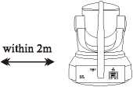
☑Connect your phone to the WiFi network (2.4GHz only).
☑ Place the camera within 2 meters of the router during configuration.
☑ Power on the camera and wait fbr about 30 seconds to finish booting.
☑ If it is your first time to connect the camera, there is no need to reset it. If you cannot hear " Please use APP for WiFi configuration'* when the camera startups, please reset the camera. Reset method: Using a needle to hold on the reset button fbr about 5 seconds until you hear^{n}Reset completed" (You can find the reset button from "Product Description")

Step 1 : APP Download and Registration
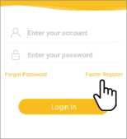
Search for "Eyecloud" in App Store or Google Play, or scan the QR code to download the app.
❷ Click "Register¹*, enter the user name and password to complete the registration.
Note： PC client and other tools can be downloaded at http://www.eyecloud.so

Step 2: Add Devices to the APP
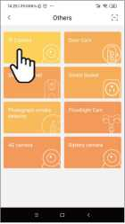
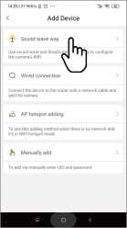
Click add device and select IP camera.
< Quick Setup
Searched
connect it?
I Name: NetCaml
❷ Choose the sound wave way
and follow the instructions.
ote: For Android phone, it will pop up some system permission window, please select "Allow”
❸ After about 60 seconds, the binding interface will appear and the camera password will be required to be changed later.

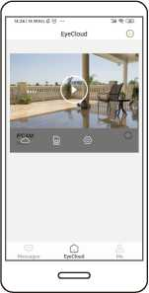
Ybu^{J}re Done!
Wait for about 30 seconds, the APP will prompt "bind successfully"
Note: If the adding fails, please connect the network cable to the camera and re-configure.
Please write down your device information:
Eyecloud account name: Eyecloud account password:

If the wireless configuration fails, please insert a network cable and reconfigure.

Step 1:
Network cable
Please connect the camera to the LAN port of the router with a network cable.
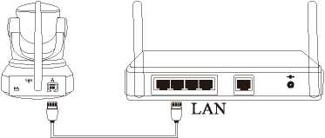

Step 2: Add Devices to the APP

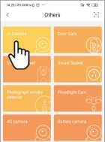
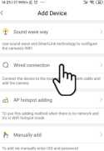
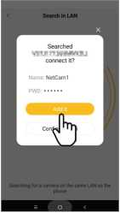

O Click add device and
select IP camera.
❷ Select wired connection and
follow the instructions.
❸ The binding interface will appear in about 60 seconds. You may directly add it or configure wifi.

Step 3 : Configure WiFi

Enter camera parameters ❷ Select WiFi settings.
ote: During WiFi configuration, please do not unplug the camera power supply. Please don't unplug the network cable until the wifi configuration is done i (which will take about 60s)
Select your home WiFi and
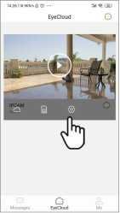
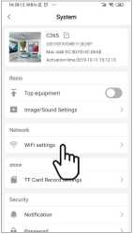

enter the WiFi password
correctly.

Cloud Storage
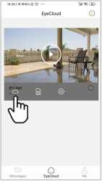
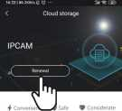
Cloud Storage Privileges
Simultaneous storage of alarm footage and video,catching every momen

The camera supports cloud storage service. After activated the cloud storage service, when the motion detection is triggered, the video will be uploaded to the cloud storage server immediately, and the video can be viewed even if the camera is stolen

