S200 hidden camera detector instructions
With imported infrared scanning laser lamp and nano-filter, this product can identify all pinhole cameras.
With large window, it can find out any reflecting red spot of camera with a scanning distance of 10 meters. Cameras, whether working or not, can be identified.
1.Generally, hidden pinhole cameras can be at:
Clothes hook, smoke detector, photo frame, socket, tissue box, TV, bath heater, shower gel, fan, bulb, air con, bed lamp, table lamp, mural, electronic clock, router, remote control, charger, speaker, ceiling, lighter, watch, pen, etc.
2.How to find hidden cameras quickly? (Turning off the lights in the room recommended)
Hidden candid cameras are as big as pinholes and have limited reflective angles, so front scanning is required. However, the camera shoots in one director, so it is recommended to scan from multiple directions and angles.
3.Such as in the direction facing the bed in a hotel, we may scan in all directions with the bed as the center, especially the equipment and places where hidden cameras are often set.

Picture of the product:
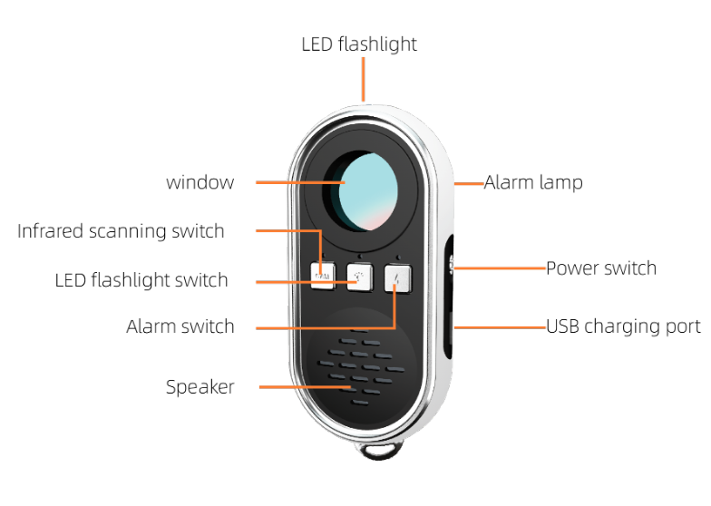

1；Operations: Turn it on, press CAM and keep your eye close to the observation window (laser light faces forward).
If there is a flashing red dot, check whether there is a hidden camera.
Press CAM once, flash switches to another mode.

(Slow Flash – Flash – Always On – Off)
2；LED is a torch for finding the camera
3；ALARM: Press to activate alarm. Hang it on the luggage, or valuables or door, when there is any motion or vibration, it gives out an alarm and red and blue lights flash. Press it again to turn it off.
Product parameters
Size: 70x35x13cm Weight: 22g Materials: ABS Battery capacity: 200MA Operating current: 50 MA Charging time: 2 hours Continuous working: 5-6 hours vibration sensor LED： F3 speaker；1.5W
Suitable for
1. Hotel-based business travelers
2. Beautiful ladies
3. Frequent visitors to public entertainment
4. People who often go to fitting rooms in malls
5. People who respect the privacy of themselves and others
6. People who contact and keep trade secrets
7. Security personnel in sites of business and/or technology secrets
8. Anti-candid and anti-eavesdropping professionals
Check and scan in hotel rooms, guesthouses, bathrooms, dressing rooms, public toilets, entrainment venues, cars.

