使用说明

USER GUIDE
- 连接耳机，并USB驱动安装完成；
(Connect the headset and install the USB driver;)
2.点击文件找到“Setup.exe”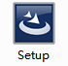，双击开始安装；
(Open the file to find the “Setup.exe” , and double click it to install;)

- 点击“下一步（N）”；
(Click “Next Step(N)”;)
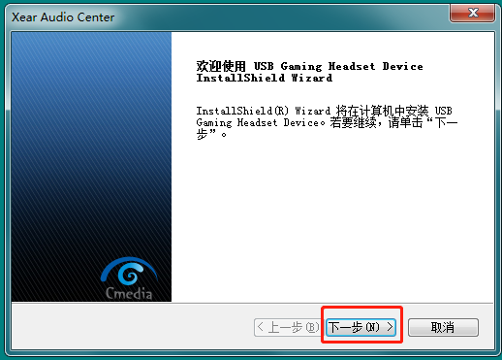

- 选中“我接受许可证协议中的条款（A）；
(Choose “I accept the terms of the license agreement(A)”)
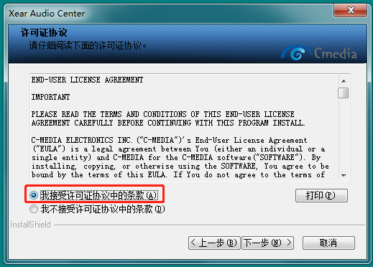

- 点击“安装”；
(Click “Install”;)
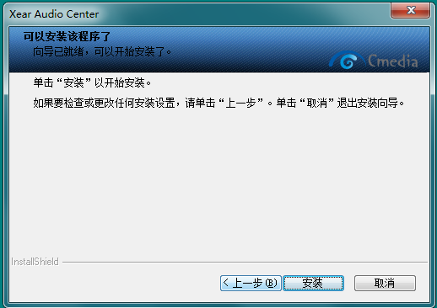

- 点击安装完成并重启；
(Click “Install complete” and restart;)

- 双击程序“Xear Audio Center”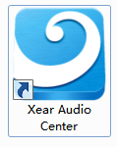；
(Double click the application “Xear Audio Center” )

- 打开设置可以选择语言；
(Open the setup to choose language;)
