INTELLIGENT SOLAR CHARGE CONTROLLER
USER’S MANUAL

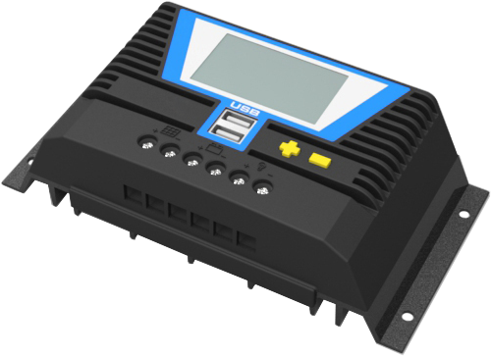

Thank you for choosing this series Solar Charge Controller. Please read this Manual carefully before using the product.

Contents
1. Product Features ................................................................................................................................................................1
2. System Connection .............................................................................................................................................................2
3. Operation ............................................................................................................................................................................3
4. Protections ........................................................................................................................................................................12
5. Troubleshooting .................................................................................................................................................................13
6. Technical Specification .......................................................................................................................................................14

1. Product Features:

This series controller is a PWM charge controller with built in LCD that adopts the most advanced digital technique. The multiple load control modes enable it can be widely used on solar off grid system, traffic signal, solar street light, etc.

- System voltage of battery 12V/24V or 12V/24V/36V/48V automatic recognition;
- Intelligent 4 stages PWM charging: Bulk, Absorption, Equalize, Float;
- LCD display with Back-lighting shows device’s operating data and working condition;
- Humanized simple button operation; Adjustable charge-discharge control parameters;
- Support more kinds of battery: Lead-acid battery (Sealed, Gel, Flooded) and Lithium battery (LiCoMnNiO2, LiFePO4);
- Multiple load control modes: 24Hours Working Control, Light Control, Light and Dual Time Control;
- Automatic temperature compensation and accumulated function of charge and discharge KWH;
- Double USB output 5V/2A;
- Perfect electronic protections.

2. System Connection:
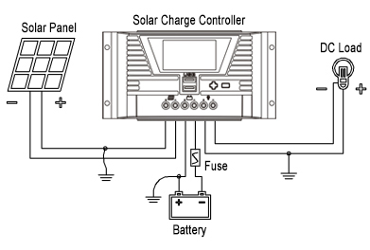
2-1. Order of Connection:
① Connected with Battery first; ② Connected with Load; ③ Connected with Solar Panel.

NOTE:
① This series is a positive ground controller. Any positive connection of Solar Panel, Load or Battery can be earth grounded.
② The fuse should be installed as close to battery as possible, the suggested distance is about 150mm;
③ If inverter or other load with big start current is necessary in system, please connect it with Battery, not solar controller;
④ When disconnecting the system, the order will be reversed.
3. Operation:
3-1. LCD Symbol:

Icon | Meaning | Icon | Meaning | Icon | Meaning
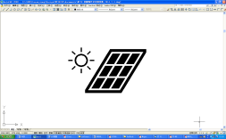 | Day | 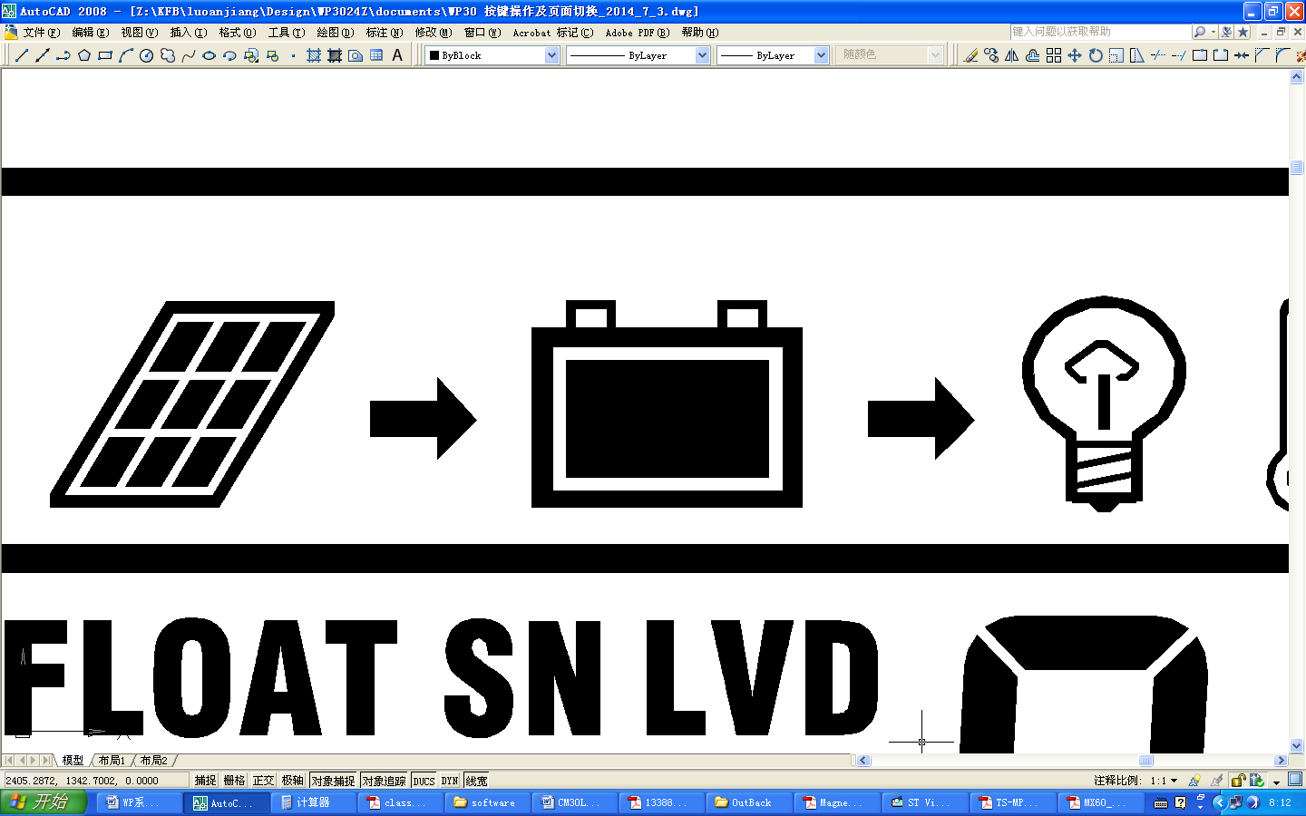 | Data Relates to Charging | FLT | Float Charging
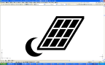 | Night |  | Data Relates to Discharging | ABS | Absorption Charging
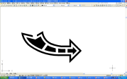 | Charging | 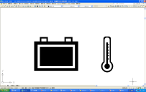 | Data Relates to Temperature | EQU | Equalizing Charging
 | No Charging | 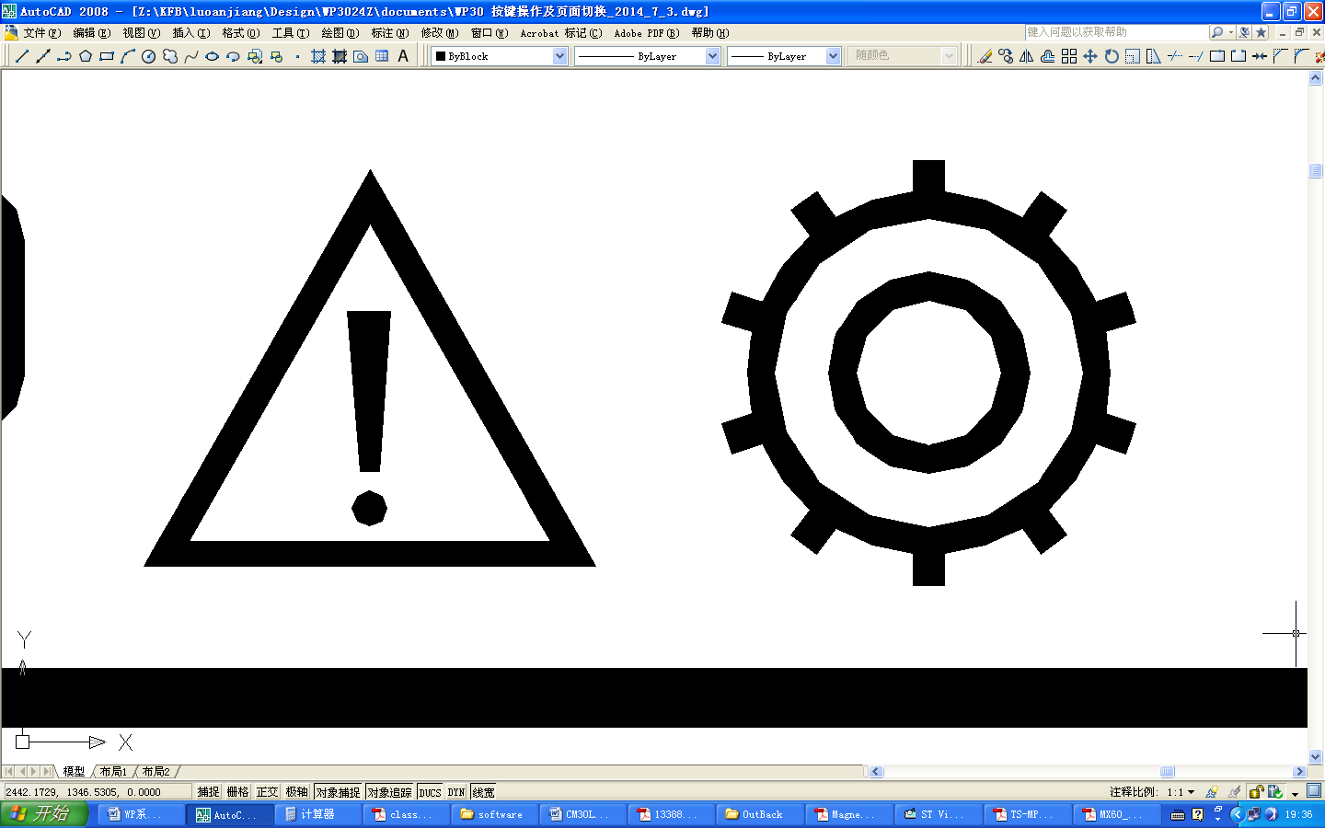 | Data Adjustable | SCI | Max Charging Current
 | Load On |  | Data not Adjustable | RCV | Recovery Charging Voltage
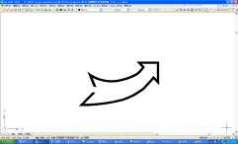 | Load Off | 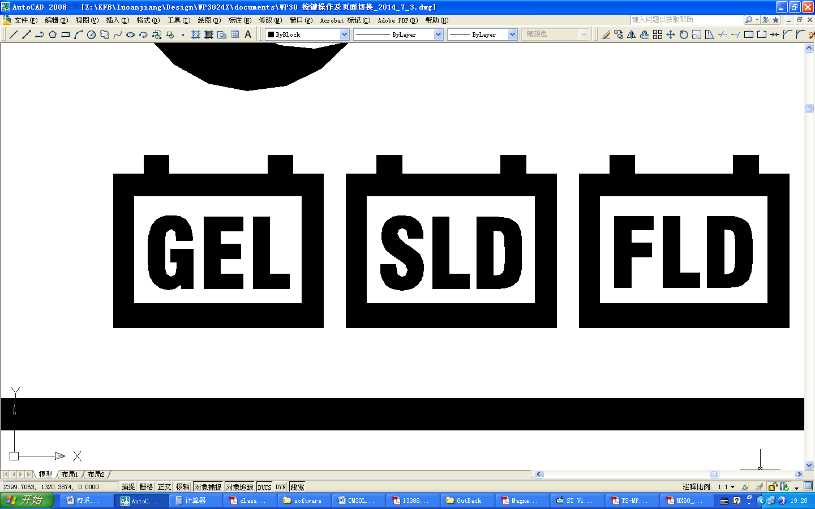 | Sealed Battery | SCV | Constant Charging Voltage
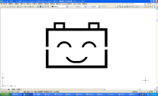 | System Works Normally |  | GEL Battery | LVD | Low Voltage Disconnection Voltage
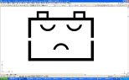 | System Works Abnormally |  | Flooded Battery | LVR | Low Voltage Re-connection Voltage

3-2. Button Function:

Modes | Operation
Browse Interface | Short press button “＋” or “－”.
Load On/Off | When load in 24H working mode, short press button “－” in Main interface.
Parameter Setting | In the settable interface, long press button “＋” into setting, and then short press “＋” or “－” to set parameter, long press button “＋” to save and exit.  (Long press button “－” to cancel the parameter and back to last setting)
Factory Reset | Long Press button “＋” 5s in the interface of Ambient Temperature.

3-3. Browse Interface:
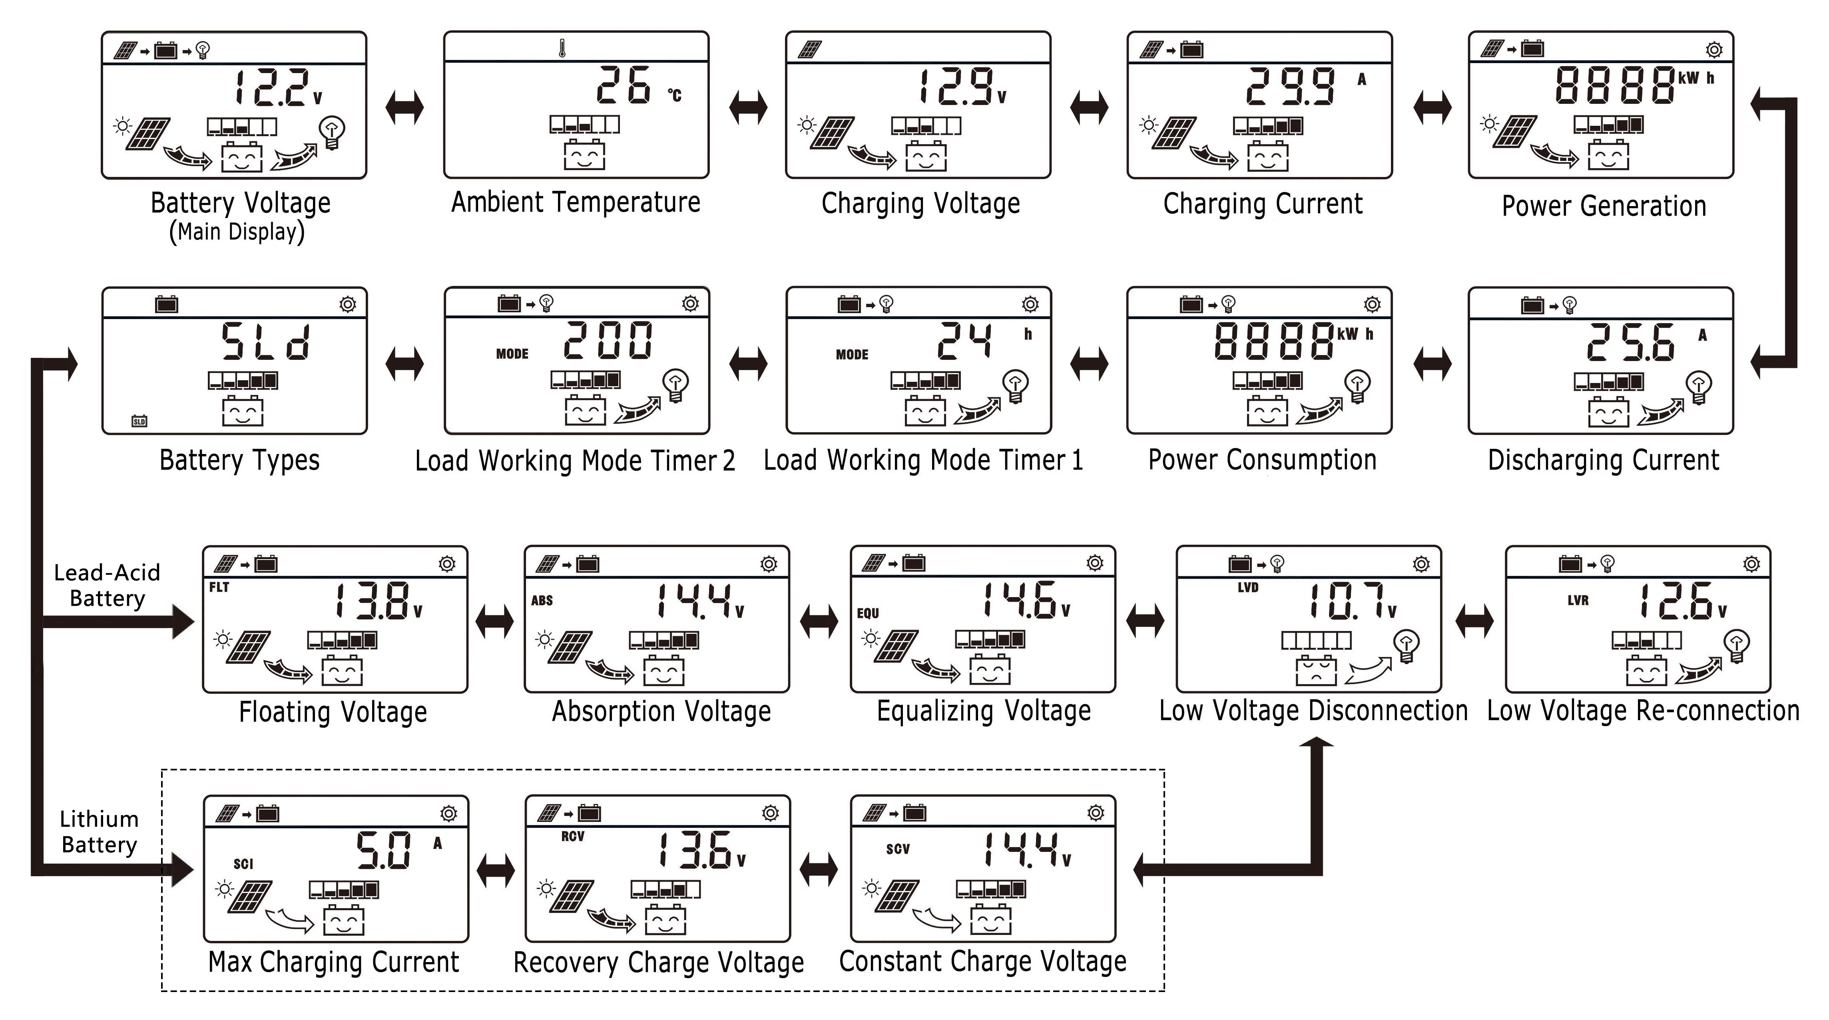
NOTE:
① After connected with Battery, LCD will go into an interface that automatically recognizes the battery voltage level, 3 seconds later, it will enter to the main interface of LCD;
② Equalizing charge will be after every 90 times Floating charge, or one charge in three months;
③ Default maximum charging current of Lithium battery is 5A, but it can be adjusted by users within the rated current range.
④ Under the interface of Accumulated KWH, long press button “＋” to clear the value;

⑤When no operation 30s, the interface will be back to main interface, and back-light will be turned off.

3-4. Battery Types：
Under the interface of battery types, long press button “＋” into the type setting, then short press button “＋” or “－” to choose battery type, and then long press “＋” again to save and exit.

Icon | Battery Type
SLD | Sealed Battery (Default)
GEL | Gel Battery
FLD | Flooded Battery
USE1 | Lead-Acid Battery (User-defined)
3.2-4 | LiFePO4: 3.2V-4S /8S /12S /16S
3.2-5 | LiFePO4: 3.2V-5S /10S /15S /20S
3.7-3 | LiCoMnNiO2: 3.7V-3S /6S /9S /12S
3.7-4 | LiCoMnNiO2: 3.7V-4S /8S /12S /16S
USE2 | Lithium Battery (User-defined)

3-5. Battery voltage automatic identification range:

Battery Types | Lead-Acid Battery | Lithium Battery
Battery Types | Lead-Acid Battery | LiFePO4  3.2V-4 | LiFePO4  3.2V-5 | LiCoMnNiO2  3.7V-3 | LiCoMnNiO2  3.7V-4
12V System | ≤17.6V | ≤18V | ≤22.5V | ≤15.9V | ≤21.2V
24V System | ≤29.9V | ≤30.4V | ≤38V | ≤26.9V | ≤35.8V
36V System | ≤42.1V | ≤42.8V | ≤53.5V | ≤37.8V | ≤50.4V
48V System | ＞42.1V | ＞42.8V | ＞53.5V | ＞37.8V | ＞50.4V
3-6. Control parameters of Lead-acid battery:

Lead-Acid Battery Types | SLD |  |  |  | GEL |  |  |  |  | FLD
Battery Voltage Level | 12V | 24V | 36V | 48V | 12V | 24V | 36V | 48V | 12V |  | 24V | 36V | 48V
Float  Charging Voltage | 13.8V | 27.6V | 41.4V | 55.2V | 13.8V | 27.6V | 41.4V | 55.2V | 13.8V |  | 27.6V | 41.4V | 55.2V
Absorption  Charging Voltage | 14.4V | 28.8V | 43.2V | 57.6V | 14.2V | 28.4V | 42.6V | 56.8V | 14.6V |  | 29.2V | 43.8V | 58.4V
Equalizing  Charging Voltage | 14.6V | 29.2V | 43.8V | 58.4V | NO |  |  |  | 14.8V |  | 29.6V | 44.4V | 59.2V
Charging time of  Absorption/Equalizing | 2 Hours

Lead-Acid Battery Types | SLD / GEL / FLD
Battery Voltage Level | 12V | 24V | 36V | 48V
Low Voltage Disconnection | 10.7V | 21.4V | 32.1V | 42.8V
Low Voltage Re-connection | 12.6V | 25.2V | 37.8V | 50.4V
Load Over-Voltage Disconnection | 16V | 32V | 48V | 64V
Load Over-Voltage Re-connection | 15.5V | 31V | 46.5V | 62V

3-7. Control parameters of Lithium battery:

Lithium Battery Type | LiFePO4
Icon | 3.2-4 |  |  |  | 3.2-5
Battery Serial Number | 4S | 8S | 12S | 16S | 5S | 10S | 15S | 20S
Recovery  Charging Voltage | 13.6V | 27.2V | 40.8V | 54.4V | 17V | 34V | 51V | 68V
Constant  Charging Voltage | 14.4V | 28.8V | 43.2V | 57.6V | 18V | 36V | 54V | 72V
Stop Charging Current | 0.1A |  |  |  | 0.1A
Low Voltage  Disconnection | 11.2V | 22.4V | 33.6V | 44.8V | 14V | 28V | 42V | 56V
Low Voltage  Re-connection | 12.8V | 25.6V | 38.4V | 51.2V | 16V | 32V | 48V | 64V
Load Over-Voltage Disconnection | 18.5V | 37V | 55.5V | 74V | 18.5V | 37V | 55.5V | 74V
Load Over-Voltage Re-connection | 18V | 36V | 54V | 72V | 18V | 36V | 54V | 72V

Lithium Battery Type | LiCoMnNiO2
Icon | 3.7-3 |  |  |  | 3.7-4
Battery Serial Number | 3S | 6S | 9S | 12S | 4S | 8S | 12S | 16S
Recovery  Charging Voltage | 12V | 24V | 36V | 48V | 16V | 32V | 48V | 64V
Constant  Charging Voltage | 12.6V | 25.2V | 37.8V | 50.4V | 16.8V | 33.6V | 50.4V | 67.2V
Stop Charging Current | 0.1A |  |  |  | 0.1A
Low Voltage  Disconnection | 9.9V | 19.8V | 29.7V | 39.6V | 13.2V | 26.4V | 39.6V | 52.8V
Low Voltage  Re-connection | 11.1V | 22.2V | 33.3V | 44.4V | 14.8V | 29.6V | 44.4V | 59.2V
Load Over-Voltage  Disconnection | 18.5V | 37V | 55.5V | 74V | 18.5V | 37V | 55.5V | 74V
Load Over-Voltage  Re-connection | 18V | 36V | 54V | 72V | 18V | 36V | 54V | 72V

3-8. Load Working Modes：
Under the load mode setting interface, long press button “＋”, when Timer 1 or Timer 2 begin flashing, short press button “＋” or “－” to set parameter, then long press button “＋” to save and exit.
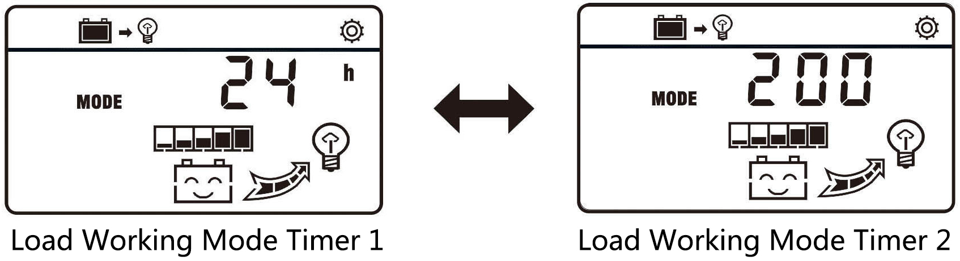

Icon | Load Working Mode Timer 1 | Icon | Load Working Mode Timer 2
24h | Load 24 Hours working (Default). | 200 | Disable.
00h | Light Control: Load On since sunset, Load Off when sunrise. | 200 | Disable.
101~115 | Load On for 1~15 hours since sunset. | 200~215 | Load On for 1~15 hours before sunrise.
-00h | Reversed Light Control: Load On since sunrise, Load Off when sunset. | 200 | Disable.

4. Protections:
- Solar Panel Reverse-Polarity:
If the solar panel is connected with controller in reversed polarity, controller will not be damaged and will work as normal when correctly connected.
- Battery Reverse-Polarity:
If the battery is connected with controller in reversed polarity (solar controller is not connected with solar panel), controller will not be damaged and will work as normal when correctly connected.
- Battery Reverse-Discharge:
Controller is able to protect battery from reversed discharging to solar panel at night.
- Over-Heating Protection:
Once the internal temperature is detected to be higher than a certain value by the controller, it will stop charging the battery and then recharging the battery automatically after the temperature drop to a certain value.
- Battery Over-Current:
Controller will stop charging when excess current is detected from the solar panel, and recharging automatically after 2 min.
- Load Over-Load:
The load will be turned off when the output current of load exceeds its rated current for a while, and turned on automatically after 2 min.
- Load Short-Circuit:
Controller will be in protection state when the load is short circuit, and recharging automatically after 2 min.
- Battery Low-Voltage:
Controller will turn off the load when the battery voltage is lower than the value preset for low-voltage disconnection, and turn on the load when the battery voltage reaches the value preset for low-voltage re-connection. The value for low-voltage disconnection and low-voltage re-connection can be set by users in a certain range.
- Battery Over-Voltage:
Controller will turn off the load when the battery voltage is higher than the value preset for over-voltage protection, and turn on the load when the battery voltage is 1V lower than the value preset for over-voltage protection.
- Lightning Protection:
The lightning protection function of controller is limited and it is recommended to install devices for lightning protection on the input side to increase system reliability.

5. Troubleshooting:

Error Code | Cause | Solution
E01 | Battery Low-Voltage | Recharging the battery or change a new one.
E02 | Load Over-Load | Check the loads connection or reduce the electric equipment.
E03 | Load Short-Circuit | Check the loads connection or reduce the electric equipment.
E04 | Load Over-Voltage | Check the loads connection or reduce the electric equipment.
E05 | Solar Panel Over-Current | Check the power of solar panel or reduce the solar panel.

6. Technical Specification:

Max Current | 10A/20A |  | 30A/40A | 50A/60A | 80A
Battery Voltage | 12V/24V Auto |  | 12V/24V/36V/48V Auto
Max PV Open Circuit Voltage | 100V
Self-consumption | ≤30mA
Loop Voltage Drop | ≤0.3V
USB Output | 5V/2A *2
Temperature Compensation | -4mV/℃/2V (25℃)
Operating Temperature | -20℃~+50℃
Protection Category | IP32
Humidity | 95%, no-condensing
Terminals | 8AWG/10mm² |  | 6AWG/16mm² | 4AWG/25mm²
Mounting Hole Size | 137*52mm-Φ6mm |  | 177*60mm-Φ5mm | 190*104mm-Φ5mm
Dimension | 147*82*36mm |  | 187*96*47mm | 200*132*61mm | 200*132*62mm
Weight | 0.22KG | 0.19KG | 0.4KG | 0.73KG | 0.79KG

Any changes will be without prior notice!
V3.0-EN

