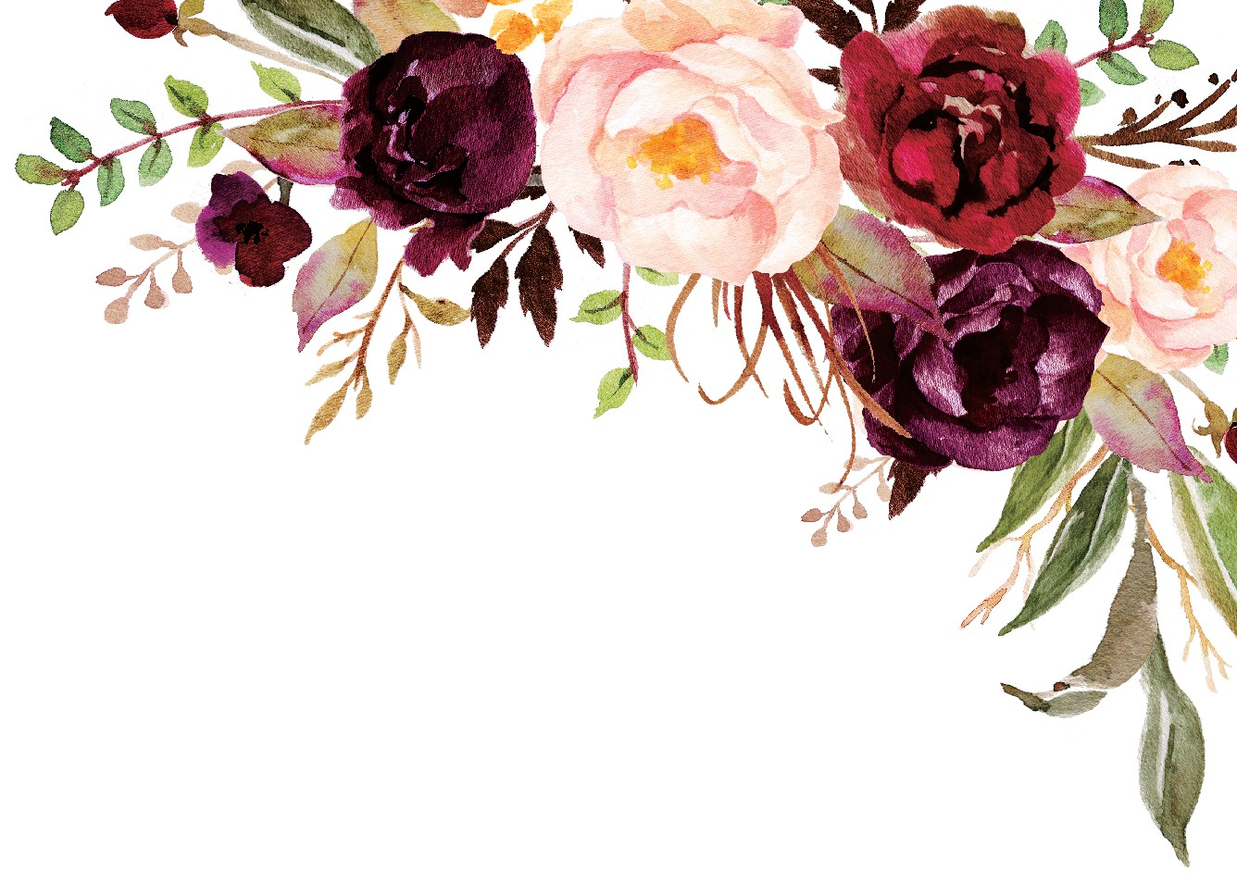

Together with their families Emily & James Request the honour of your presence at
the ceremony of their marriage

Saturday, 5 th of October 2019 at three o' clock in the afternoon

e Members Club at Wildewood 90 Mallet Hill Rd
Columbia, SC Reception to follow immediately

