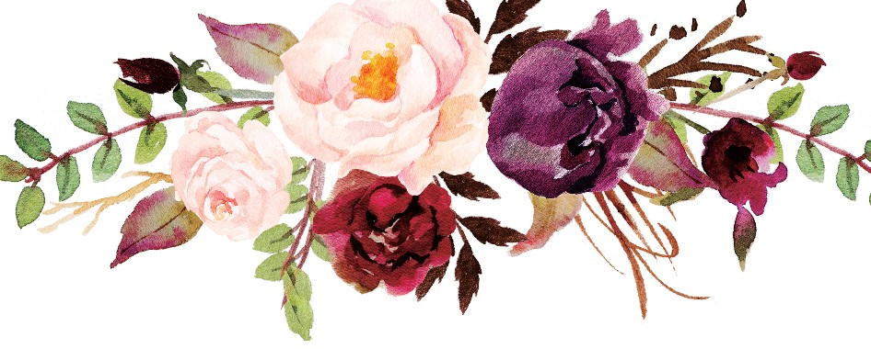

Rsvp
Kindly Respond by

20th August 2019

Via our wedding website: www.theknot.com/Emilyandjames or
by email at Emilyjames@xxx.com

