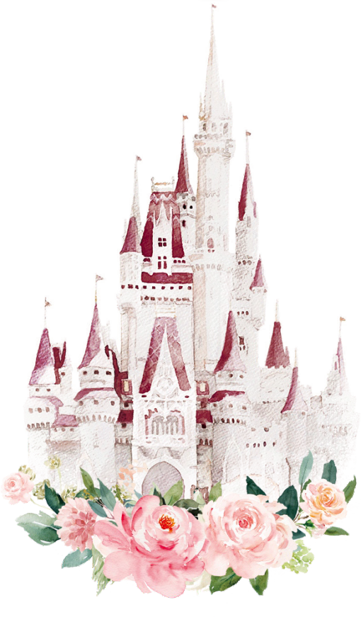

Sophie & David
10.23.2022

th

Sophie White
&
David Branson
request the honor of
your presence at their wedding

Sunday, October 23th, 2022 at 5:00 pm
Location Name Street, City, State, 112233

Please RSVP to Anna by September 23th 123 234 5555

Reception to follow

