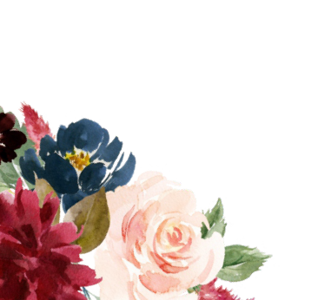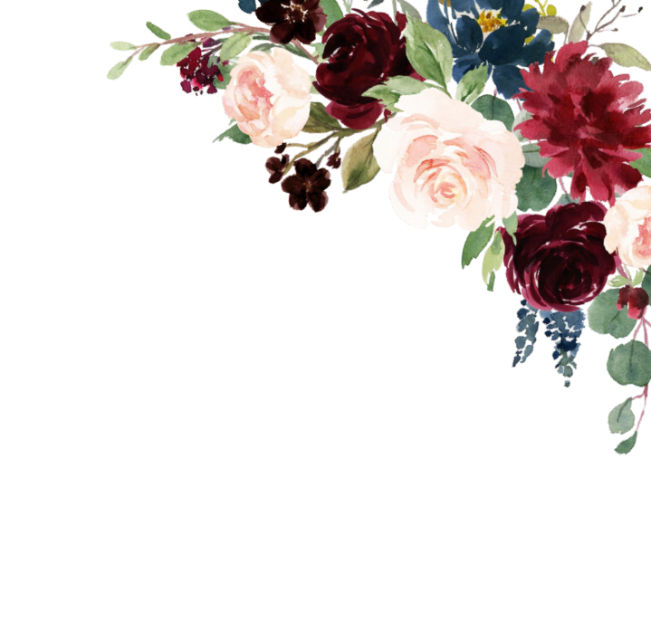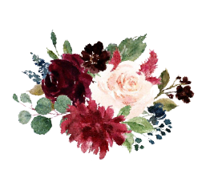

Together with their families

Daniel & Meli�a

request the honor of your presence at their
eddin

Saturday, September 24th, 2022 at 3:30 PM

Happy House
1508 Love Road, Happy City, CA 15984

Reception to follow

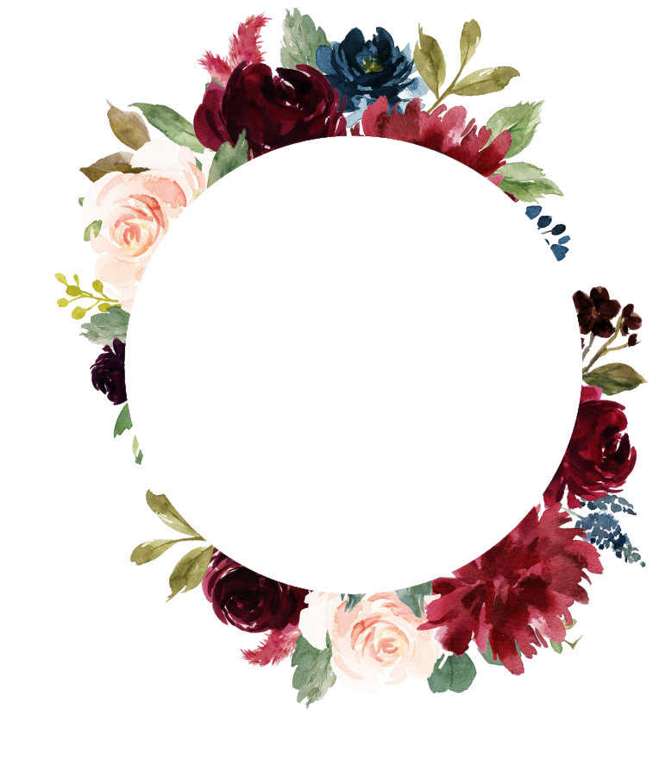

Dl
&

M□

are getting married!

SAVE THE DATE

09.24.2022

Happy City, CA

