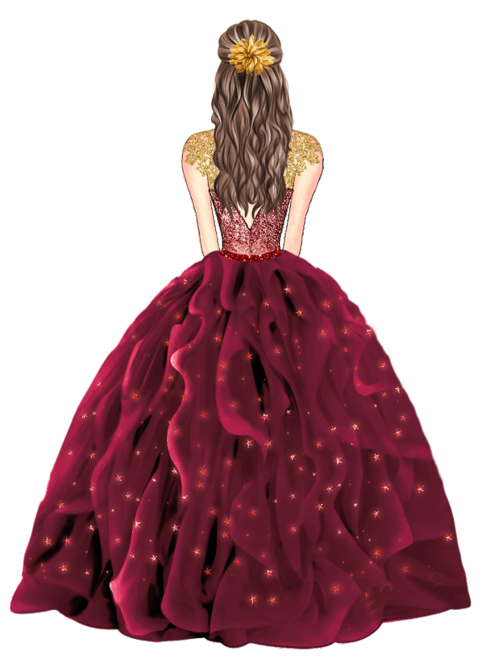

Jezaida
MIS XV AÑOS 05.14.2022

MR. & MRS. WHITE CORDIALLY INVITE YOU TO CELEBRATE THE
Quinceañera

OF THEIR DAUGHTER
Jezaida

Saturday,May 14th, 2022

Mass: at 2:00 pm
ST PETER’S CHURCH
YOUR ADDRESS

Reception: at 4:00 pm LOVELY PLACE YOUR ADDRESS

Rsvp: 123-456-7890

