MR. & MRS. ROSALES CORDIALLY INVITE YOU TO CELEBRATE THE
Quinceañera

OF THEIR DAUGHTER
Jessica

Saturday,May 14th, 2022

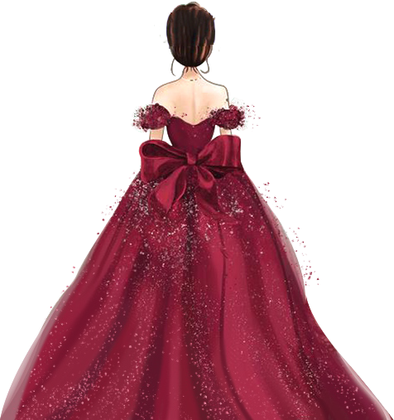Mass: at 2:00 pm ST PETER’s CHURCH
YOUR ADDRESS CITY, STATE 18444
Reception: at 4:00 pm LOVELY PLACE YOUR ADDRESS CITY, STATE 18444

Jessica

X V

Saturday,May 14th, 2022

