Together with their families

Amanda Grifﬁn
AND

David Brown
Request the honor of your presence at the ceremony of their marriage

Saturday, the 8 th
of October

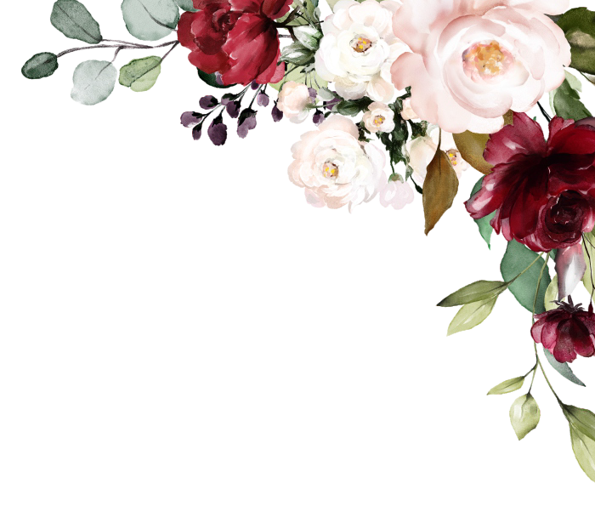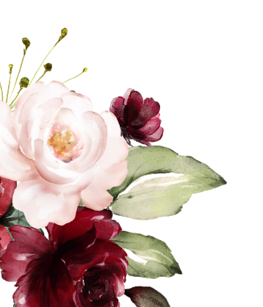
two thousand and twenty two at three o' clock in the afternoon

The Members Club at Wildewood 90 Mallet Hill Rd
Columbia, SC 29223

Reception to follow

Amanda &
David

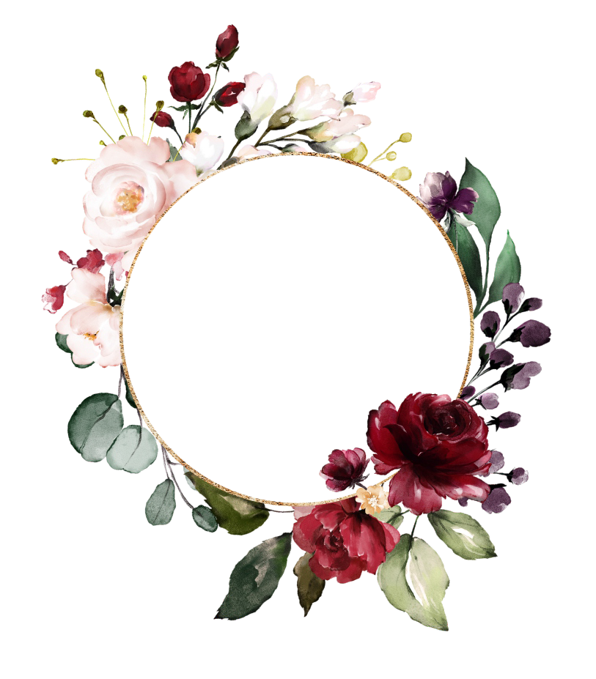

Save
the
Date

10.08.2022

