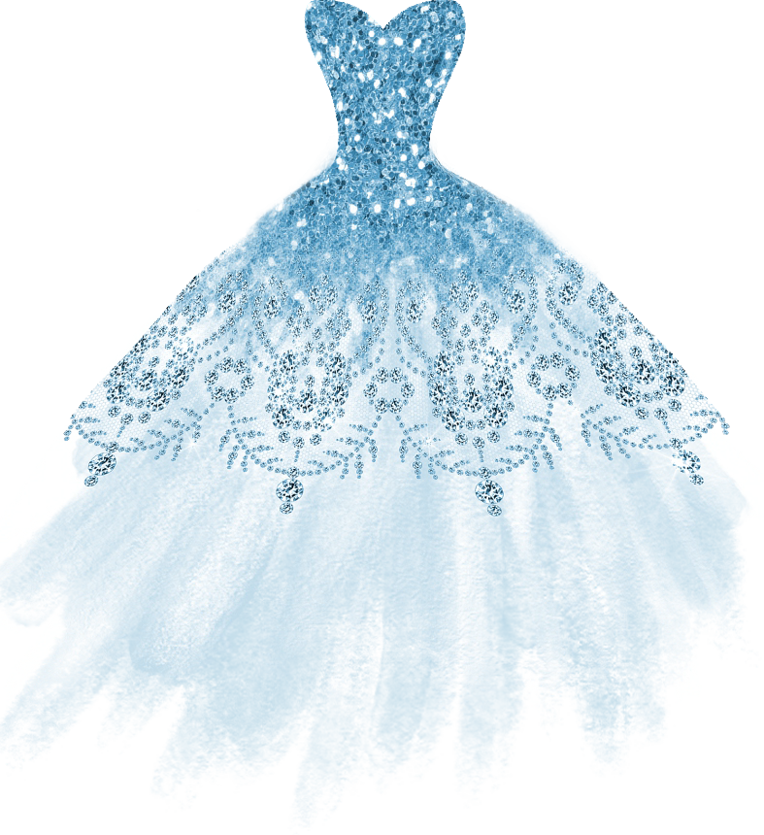

Amelia

Mis XV Años
10.15.2022

JOIN US FOR A

Quinceañera

C E L E B R A T I O N

IN HONOR OF

Amelia Jackson
Saturday, October 15th, 2022 at 6:00 pm Venue Location Name
1234 Street Address City, State Name 26829

Hosted by the Jackson Family

RSVP to {Name} by September 1st at 555.555.5555
or name@email.com

