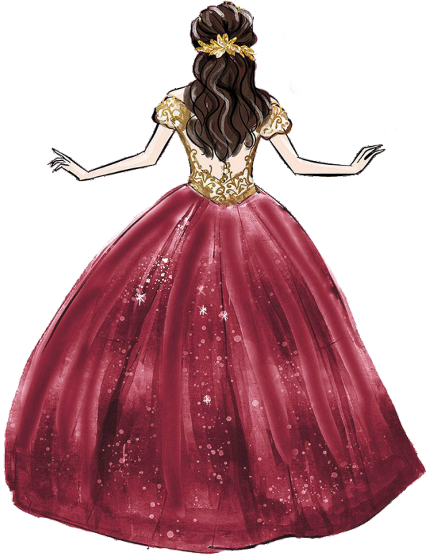

Amelia

MIS
XV AÑOS

10.12.2019

JOIN US FOR A
Quinceañera
C E L E B R A T I O N

IN HONOR OF

Amelia Jackson Saturday, October 12th, 2019 at 6:00 pm Venue Location Name
1234 Street Address
City, State Name 26829

Hosted by the Jackson Family

RSVP to {Name} by September 1st at 555.555.5555
or name@email.com

