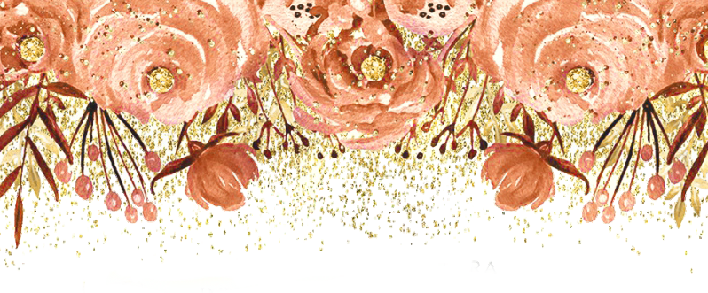
Reyna

MIS XV AÑOS

July 27th, 2019

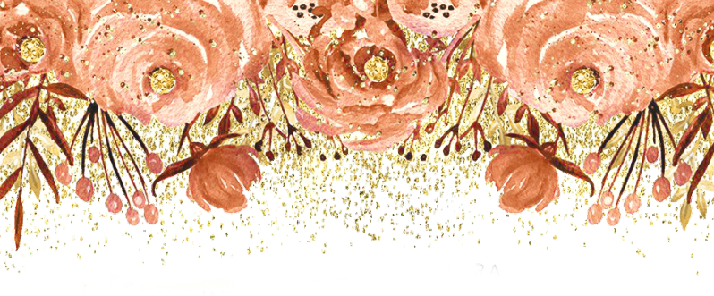

JOIN US FOR A
Quinceañera
C E L E B R A T I O N

IN HONOR OF

Reyna Hernández
Saturday,July 27, 2019 Mass- Imacculate Heart of Mary
500 Fairview ave
Brentwood ca, 94513 Time 2:00pm

Reception- 193 Grifﬁth lane Brentwood, ca 94513
Time 4pm-11pm Dinner 4pm-6pm

