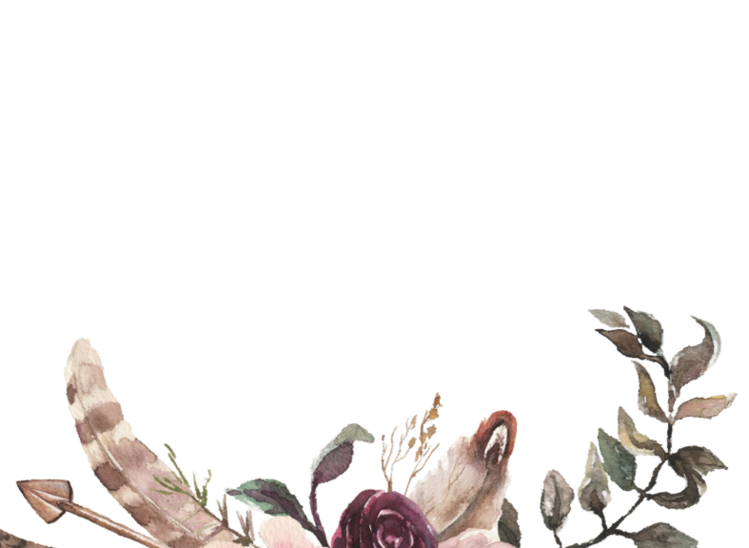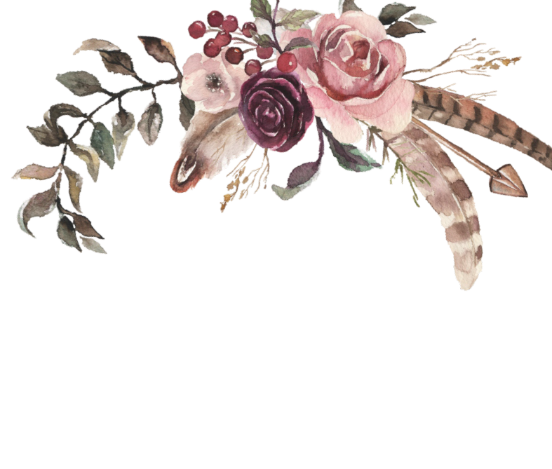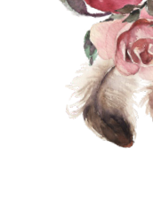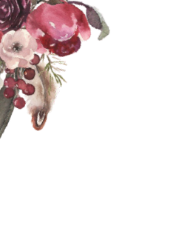

Together with their families
Emily & James

Request the honour of your presence at the ceremony of their marriage

Saturday, the 14 th of October

two thousand twenty three
at three o'clock in the afternoon

le Members Club at Wildewood 90 Mallet Hill Rd Columbia, SC

Reception to follow immediately

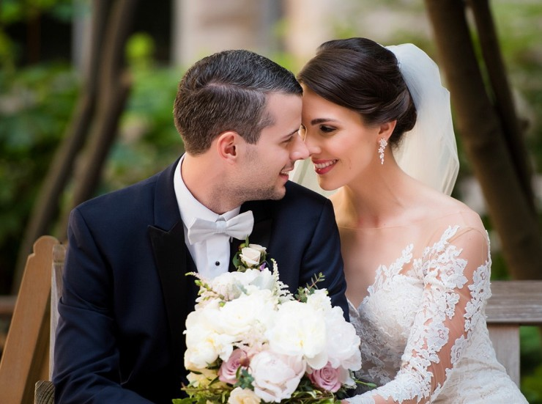

Thank you

for sharing this special day with us!

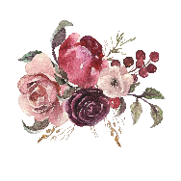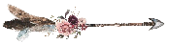Emily & James
10.14.2023

