catalogue
1 How to put customs value 1
2 .1 year warranty 1
3.How to find out product stickers in the box 1

1 How to put customs value
we will not put its real value of this order
and customs will check its item value when the package pass customs

2 .1 year warranty
Please remember test it.
If you have problem to use it, please contact us immediately
And lease tell us the problem details, it is better take video or photos to show us its problem more clearly, then we will solve the problem for you as soon as possible
And please to know that the order one year warranty already comes into effect.

3.How to find out product stickers in the box
in order to pass customs faster
We need to hide item logos, please check these way to find out its logo and stickers.
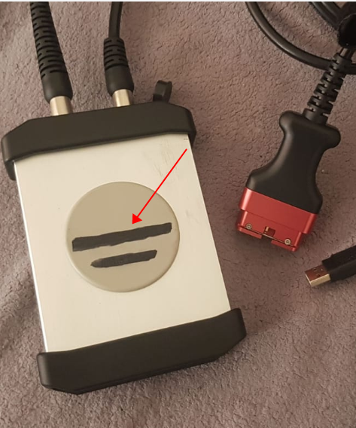
- we have used black mark pen to erase the logo, after you receive the parcel, please use alcohol clean it

2)please find out this mark pen black color line on the box outside, and use knife to open it, then take out the label
Please check photos to learn more
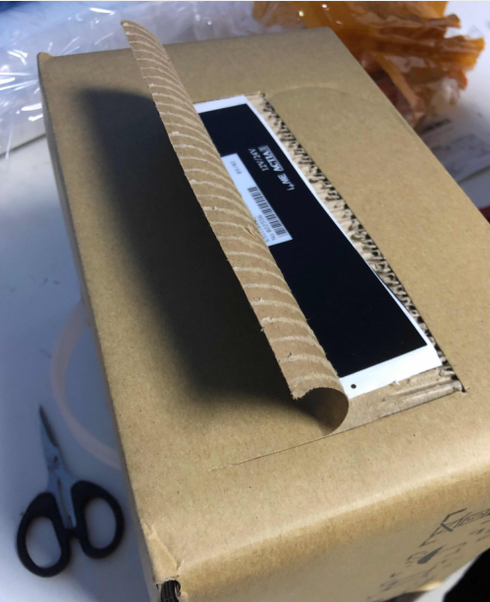
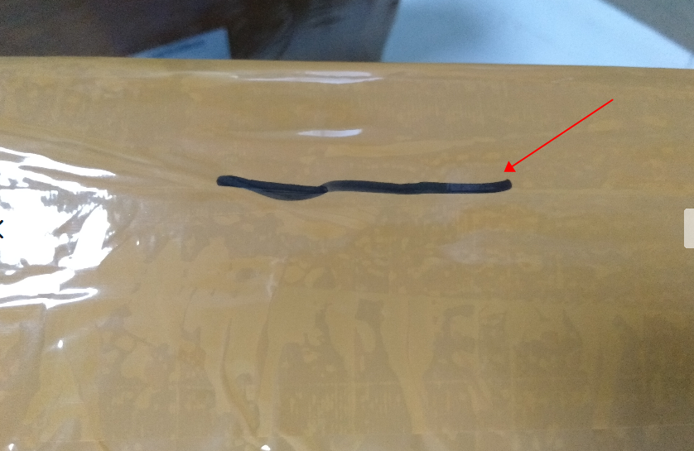

3) If there is no mark on the box, please check whether stickers hide inside of the box as follow picture.
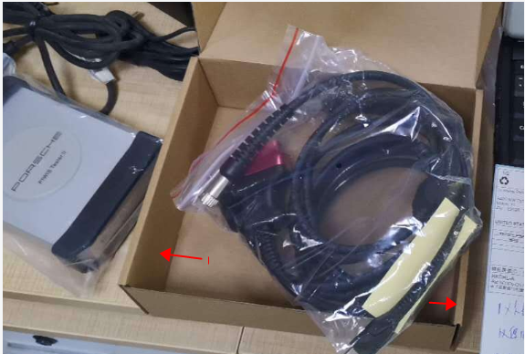

- we will use some Black stickers cover logo, when you get it, just take the stickers off
Please to know that our C4 not has Mercedes Benz logo sticker anymore
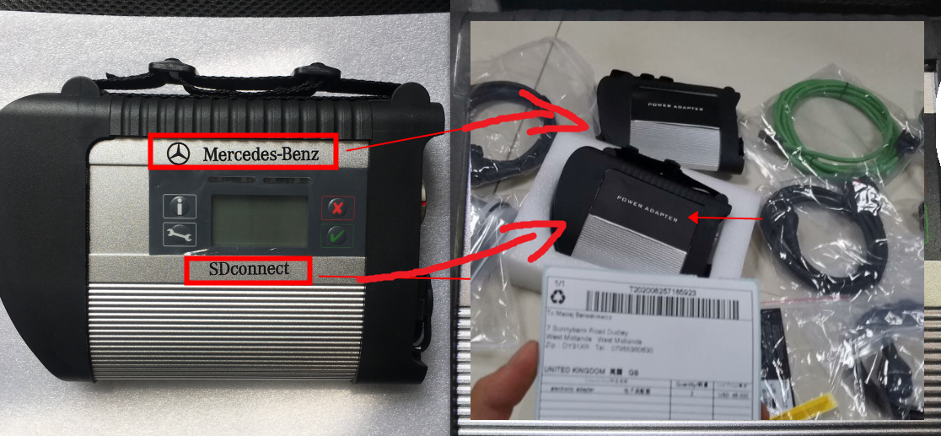

5)we have used black adhesive tape to hide VCDS HEX V2 logo
and after you receive it you can rip off the black adhesive tape​

