contents
1. How to put customs value 1
2. How to insert disk drive into laptop 1
3. Notes 1
4. 1 year warranty 2

1. How to put customs value
we will not put its real value of this order
and customs will check its item value when the package pass customs
- How to insert disk drive into laptop and activate software.
- Please remember not use it as external hard disk drive
Also please remember not use antivirus software with our software
otherwise it will damage software.
Check video https://vimeo.com/751897548
you also can check below photos show
- Please remember send us its todesk or teamviewer ID and password like attachment screen shot show.
Then we will activate software for you.
3) After technician finish activation, you can directly use this software.
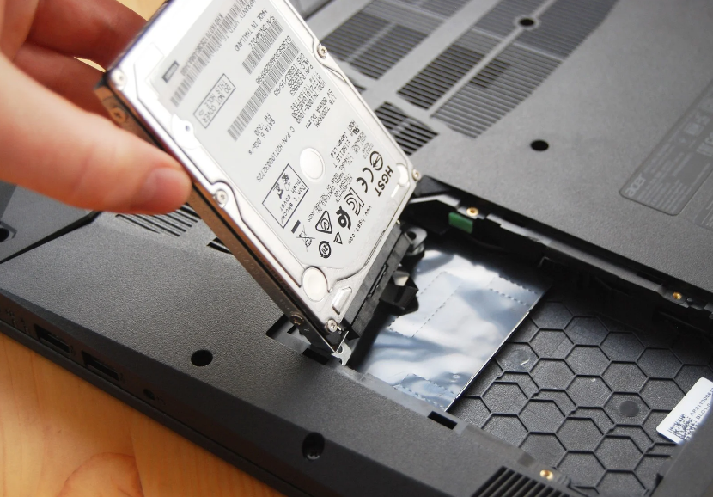

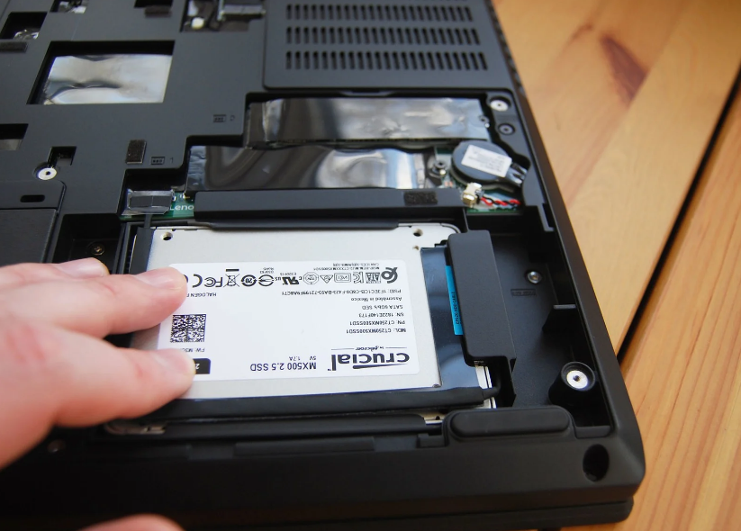

1 year warranty
Please remember test it.
If you have problem to use it, please contact us immediately
And lease tell us the problem details, it is better take video or photos to show us its problem more clearly, then we will solve the problem for you as soon as possible
And please to know that the order one year warranty already comes into effect.

