catalogue
1 How to put customs value 1
2. Notes for C4 1
3.How to insert disk drive into laptop and activate software. 1
4.todesk or teamviewer ID and password 2
5 .1 year warranty 3
6.How to find out product stickers in the box 3

1 How to put customs value
we will not put its real value of this order
and customs will check its item value when the package pass customs

2. Notes for C4
Please to know that only C4 software with laptop will be activated before we ship it, without laptop software disk drive need to be activated when client receive it.

3.How to insert disk drive into laptop and activate software.
Please remember not use it as external hard disk drive
Also please remember not use antivirus software with our software
otherwise it will damage software.
Check video https://vimeo.com/751897548
Please remember send us its todesk or anydesk ID and password like attachment screen shot show.
Then we will activate software for you.
After technician finish activation, you can directly use this software.
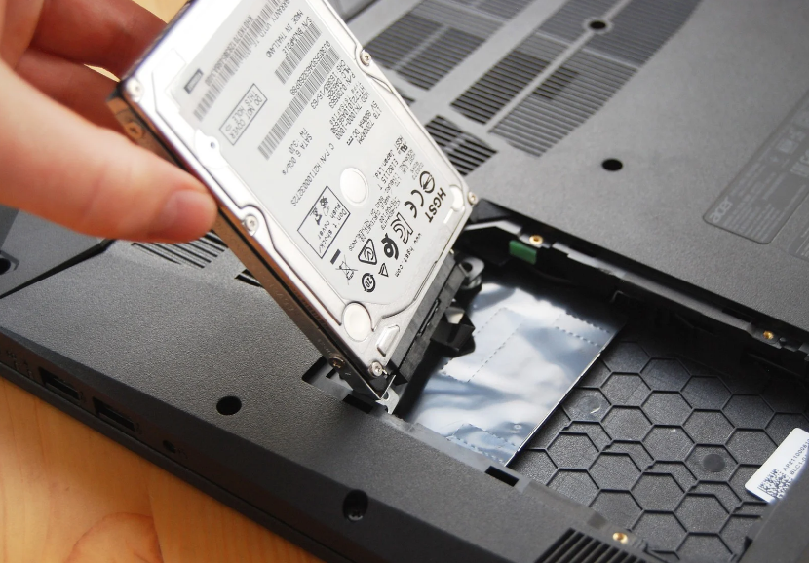

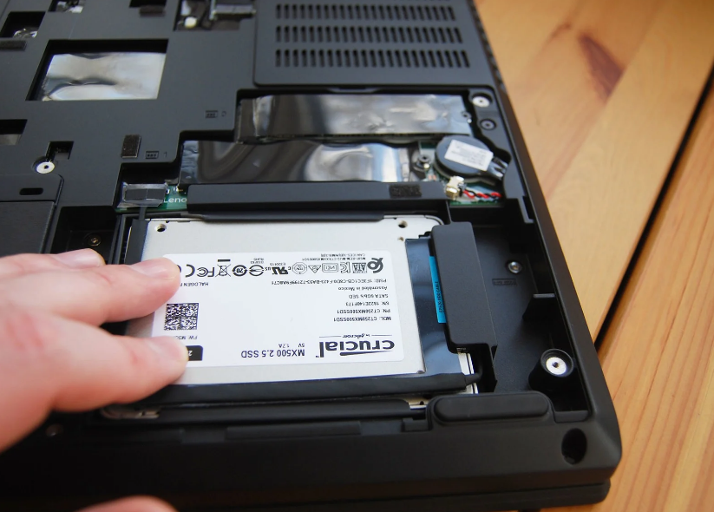

4.todesk or teamviewer ID and password

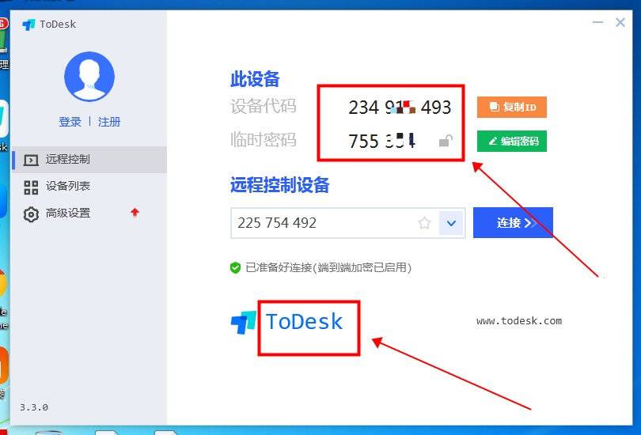

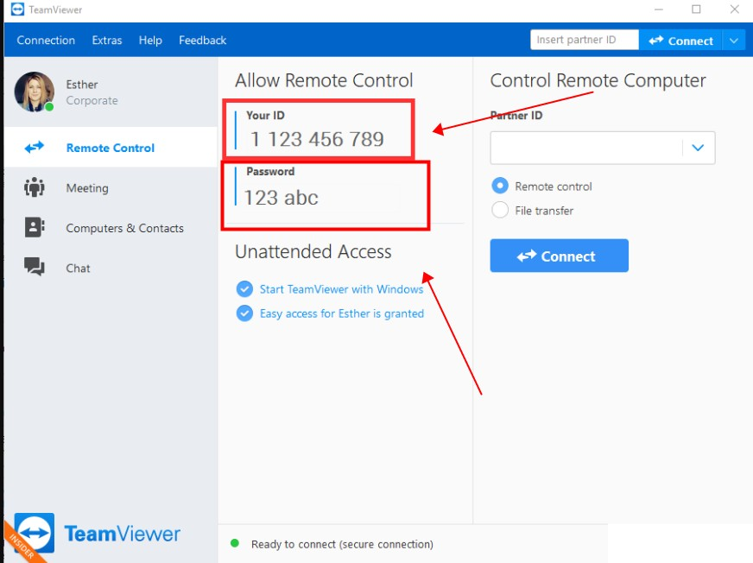

5 .1 year warranty
Please remember test it.
If you have problem to use it, please contact us immediately
And lease tell us the problem details, it is better take video or photos to show us its problem more clearly, then we will solve the problem for you as soon as possible
And please to know that the order one year warranty already comes into effect.

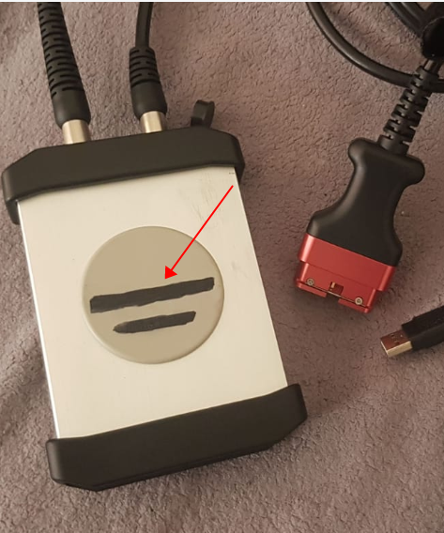
6.How to find out product stickers in the box
- we have used black mark pen to erase the logo, after you receive the parcel, please use alcohol clean it

2)please find out this mark pen black color line on the box outside, and use knife to open it, then take out the label
Please check photos to learn more
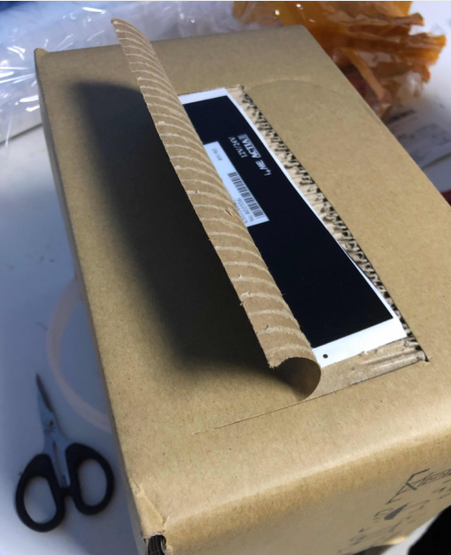
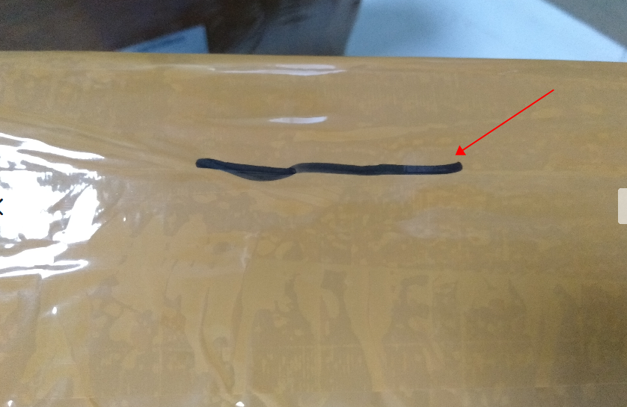

3) If there is no mark on the box, please check whether stickers hide inside of the box as follow picture.
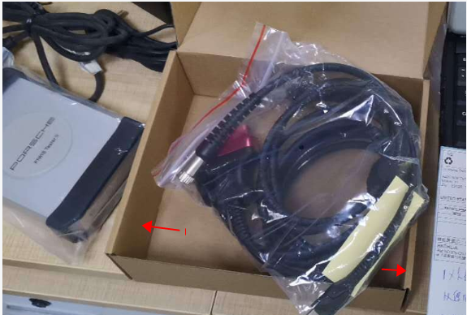

- we will use some Black stickers cover logo, when you get it, just take the stickers off
Please to know that our C4 not has Mercedes Benz logo sticker anymore
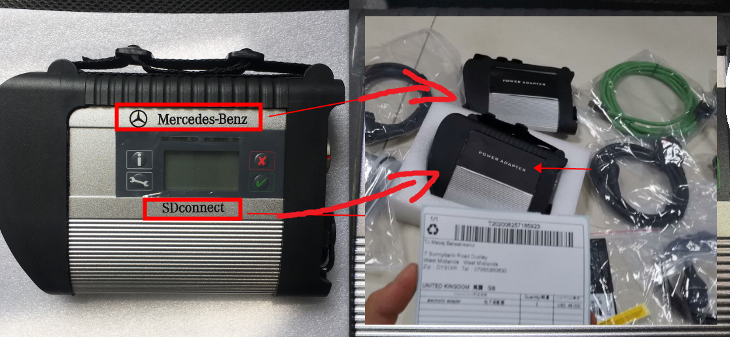

5)we have used black adhesive tape to hide VCDS HEX V2 logo
and after you receive it you can rip off the black adhesive tape​

