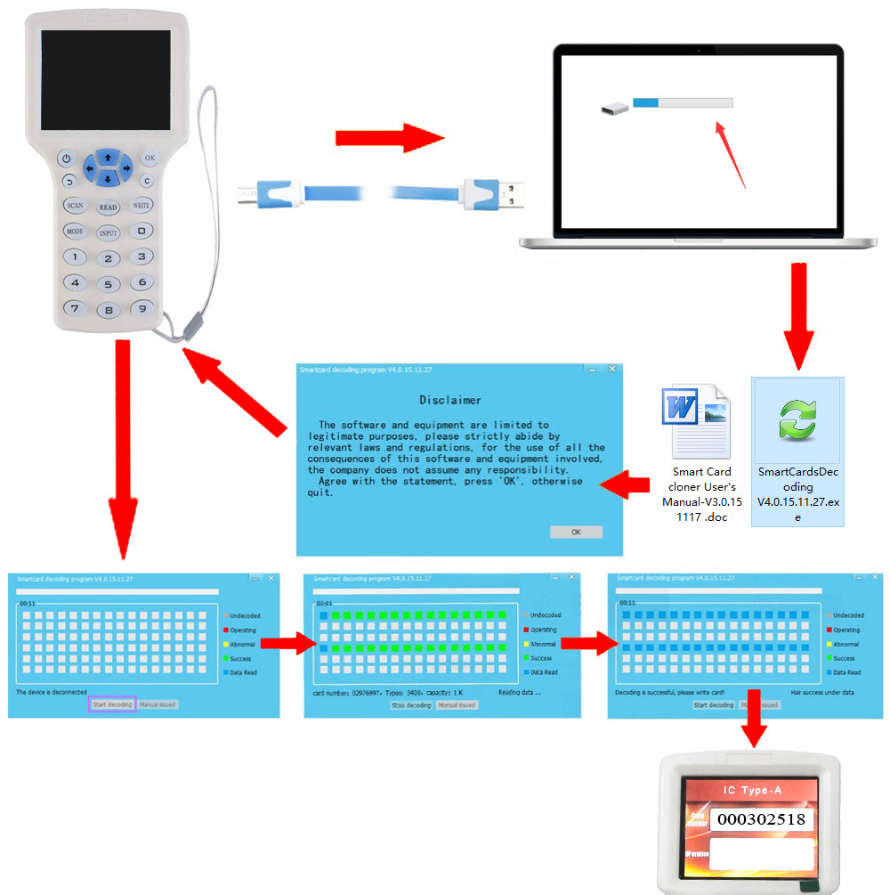

Check encrypted 13.56MHz card:
- Connect the writer to computer via USB cable and then press the "Power On/Off" button. The copier will show the "Disclaimer", then press "OK" button to agree. DO NOT press any button.
- Your computer will show a removable disk. Click to open it, there is a manual and software inside.
- Put your original card on the back of the "Card Read/Write" area and then press "Scan" button to check the password. After 2-5 minutes, the password should be shown.
- Put a UID card on the "Card Read/Write" area and then press "Write“ button.

Copy 125KHz RFID cards:
- Press the "Power On/Off "button.
- Put the original 125KHz card on the back of the copier. The copier will show the "Disclaimer", then press "OK" button.
- Put the card on the back of the writer and press "Scan" button.
- The copier will scan and show the card number.
- Put a writable card on the back of the writer, then press "Write" button.

