A12S77 Wiring
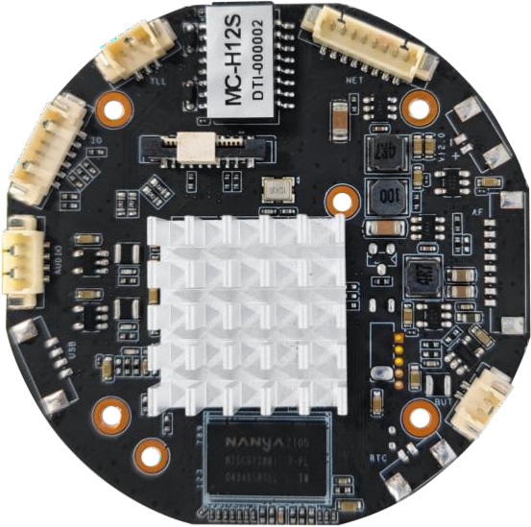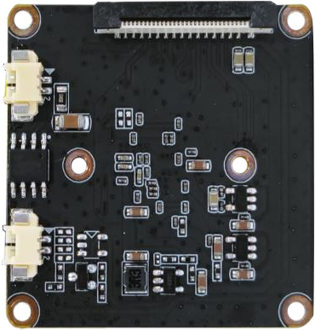
1
D5：2 pin Reset
D4：4 pin Audio
D3：6 pin Serial port
D2：3 pin Infrared signal control
D1：8 pin net&power
1
D7：2 pin CDS
D6：2 pin IR-CUT

The white arrow points to the first pin

Interface pin definition

Code | Function | Number | Definition | Function of pin
D1 | 8 pin Net&Power | 1 | DC 12V+ | DC 12V
 |  | 2 | GND | GND
 |  | 3 | RJ45_6 | RJ45_6 RX-
 |  | 4 | RJ45_3 | RJ45_3 RX+
 |  | 5 | RJ45_2 | RJ45_2 TX-
 |  | 6 | RJ45_1 | RJ45_1 TX+
 |  | 7 | LED+ | LED
 |  | 8 | LED+ | LED
D2 | 3 pin Infrared signal | 1 | PWM0 | White(warm)light
 |  | 2 | PWM1 | Infrared light
 |  | 3 | GND | GND

D3 | 6 pin Serial port | 1 | GND | GND
 |  | 2 | AF_TX | AF Autofocus
 |  | 3 | AF_RX | NC
 |  | 4 | AF_TX | -
 |  | 5 | AF_RX | -
 |  | 6 | SPK_EN | Amplifier IO
D4 | 4 pin audio | 1 | GND | GND
 |  | 2 | AUDIO_OUT | Speaker
 |  | 3 | AUDIO_IN | Audio Pickup
 |  | 4 | GND | GND
D5 | 2 pin RESET | 1 | RESET | RESET
 |  | 2 | GND | GND
D6 | 2 pin IR-CUT | 1 | IR-CUT | Filter switcher
 |  | 2 | IR-CUT | Filter switcher
D7 | 2 pin LED CDS | 1 | CDS_IN | LED signal in
 |  | 2 | GND | GND

