在您使用带有SpeedyBee Wifi功能的Mamba飞控时，若您的板载Wifi模块固件版本低于V1.08，可能出现飞控首次通电后与APP通信不畅的问题。为了方便您使用本产品，请务必按照以下步骤更新板载Wifi模块固件：
When using a Mamba FC with SpeedyBee Wifi function, there may be some communication issues between FC and the APP if the firmware version of the onboard Wifi module is older then V1.08. Please follow the instruction to update the firmware of the onboard Wifi module for your own convenience.

- 打开SpeedyBee APP，向右滑动主页面调出菜单，点击“设置”选项
Open SpeedyBee APP, slide the main page to the right to call up the menu and click "Settings"
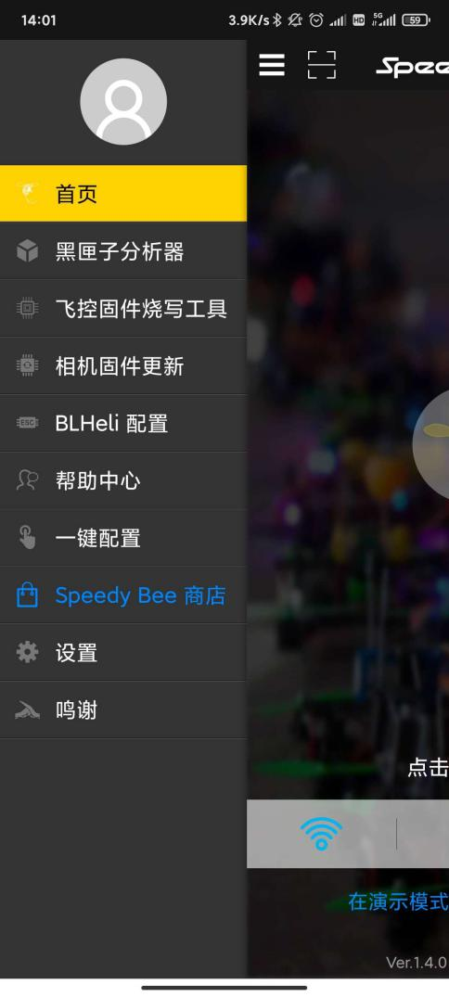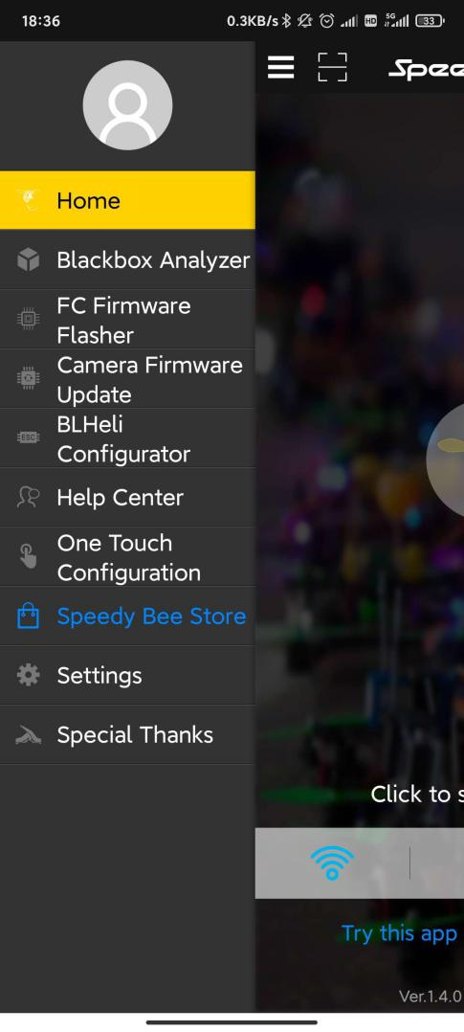

- 选择"WIFI模块固件更新"
Click “WIFI module firmware update”
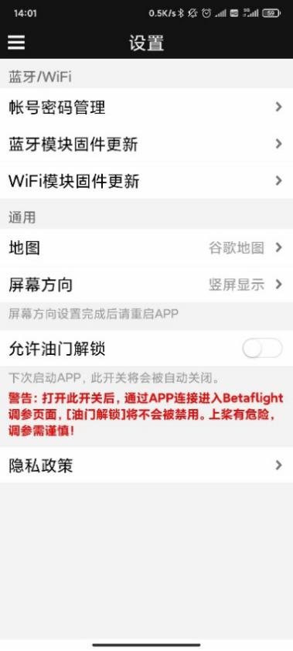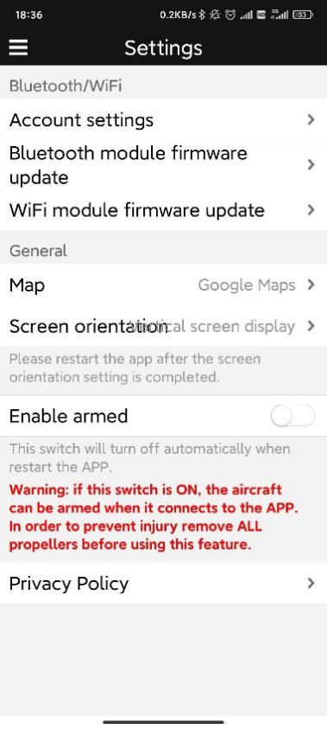

- 在“Wifi Type”下拉菜单中选择 "FC-WIFI "并点击“下载固件”；固件下载完成后点击“开始烧写程序”, APP将跳转至Wifi连接页面
Select “FC-WIFI” in the “Wifi Type” menu and click “Download Fiemware”; Click “Start Burning” after the firmware downloaded, the APP will jump to Wifi connection page.
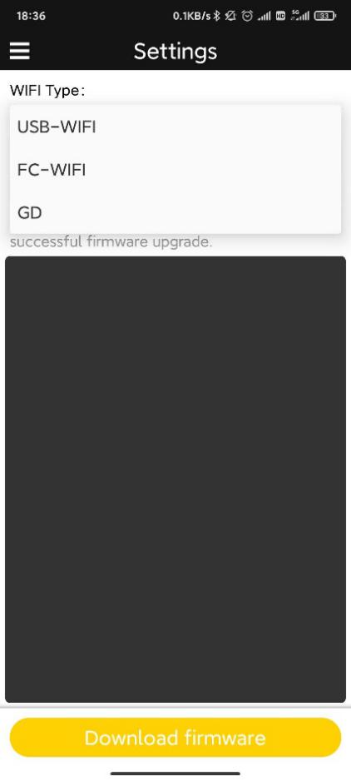

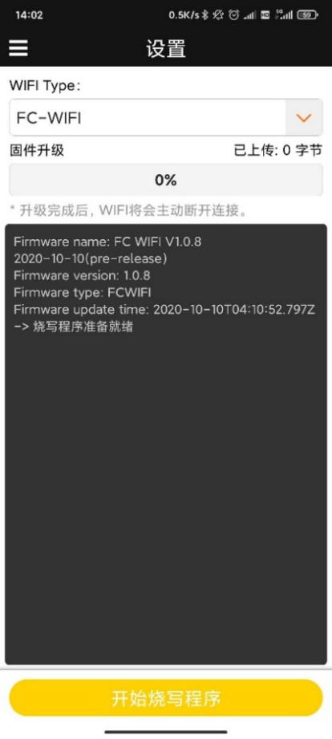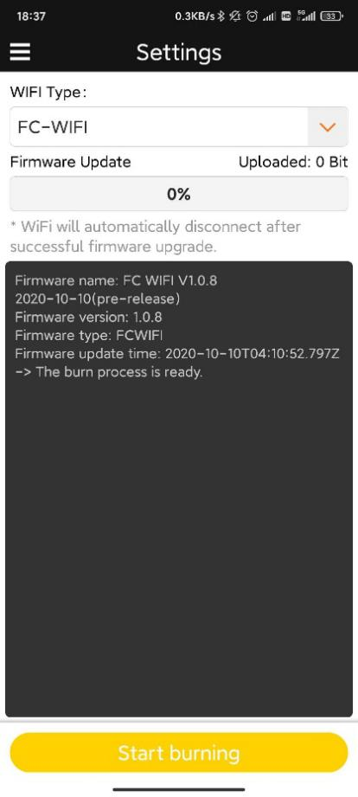

- 先使用USB线将飞控连接至电脑，再使用电池通过电调向飞控供电。
Power the FC with USB cable first, then connect the battery through the ESC.

- 在Wifi连接页面选择含有“Mamba Stack ****”等字样的Wifi热点连接；正确连接后飞控上的蓝色指示灯将常亮
Connect the Wifi hotspot named by “Mamba stack ****”; The blue LED on FC will stay on when connected correctly.

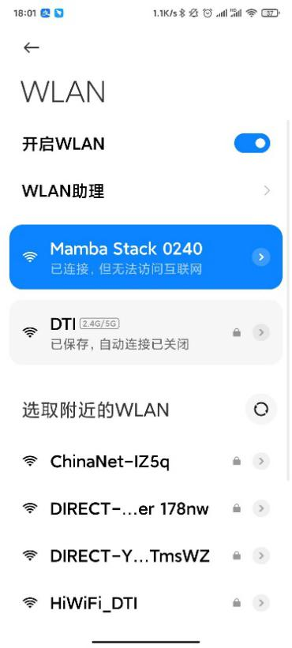
- 返回APP，点击“开始烧写程序”，等待烧写完成后重新启动飞控即可。
Back to the APP and click “Start burning”; Restart the FC when it is done.
