Resources：Refer to the linked document to solve
https://www.online-tech-tips.com/computer-tips/usb-device-not-recognized/
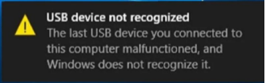

Method 1- Restart & Disconnect USB Devices
The next thing you can try is to disconnect all USB devices and then restart the machine. once you have restarted, try to connect the USB device that was causing the problem.
If that particular USB port doesn’t recognize it, try another one. If the device is recognized by a different USB port, there could be a hardware problem with one of the USB ports. If no USB port recognizes the device, then keep reading because it’s probably something else.
If the above method is not resolved, the power must be turned off and left unattended
Laptop power off for half an hour
Desktop computer can be unplugged and wait 15 minutes to retry.
First turn off your computer using the Shut Down option in Windows or pressing the power button and then UNPLUG the PC from the wall outlet. Let stand for 15 minutes and plug in again.

Method 2 – USB Root Hub
Open "Device Manager"-"expand USB Serial Bus Controllers"-right-click "USB Root Hub"-"Properties".
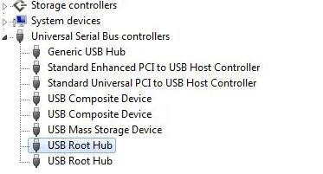
Click the "Power Management" tab- uncheck the "Allow the computer to turn off this device to save power" box. If you have more than one USB Root Hub listed, you need to repeat these steps for each one. At last restart your computer.
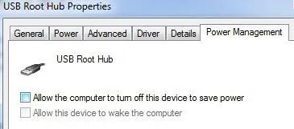
Reconnect the USB device and see if it is recognized. If not, go back to the power management tab for each one and check the box.

Method 3 – Uninstall Hidden Devices
By default, Device Manager doesn’t show all devices that have been installed in the system. Certain hidden or ghost USB devices can cause conflicts with current USB devices. You can view hidden devices in Device Manager by first opening a command prompt and then typing the following two commands:
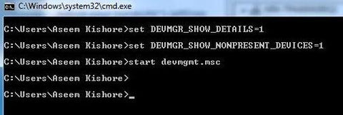
set DEVMGR_SHOW_DETAILS=1
set DEVMGR_SHOW_NONPRESENT_DEVICES=1
start devmgmt.MSc
Once Device Manager loads, you need to click on View and then click on Show Hidden Devices.
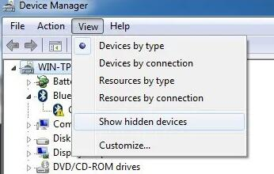
Expand Imaging Devices, Universal Serial Bus Controllers, and Unknown Devices. If you see anything listed there that is greyed out or unknown device, go ahead and right-click them and choose Uninstall.
Method 4- Download device manufacturer's website Audio Drives Provided
If these steps didn't solve your audio issue, visit your device manufacturer’s website and install the most recent audio/sound drivers for your device. Following is an example of a driver download page for a sound device manufacturer.
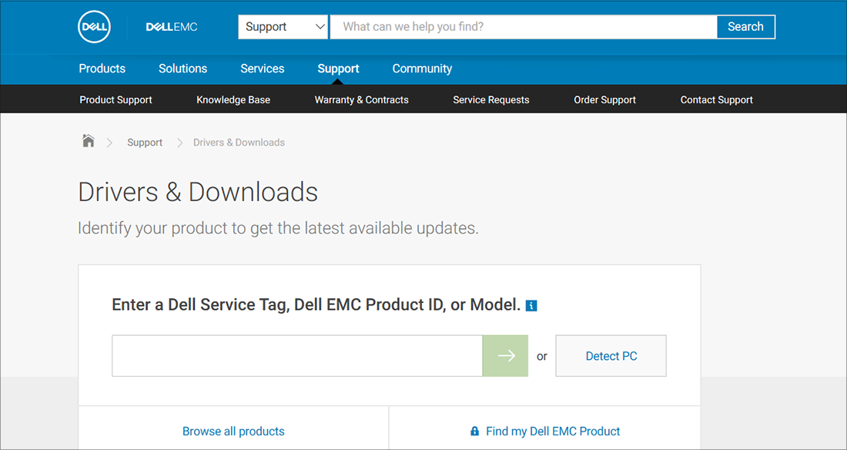
If you have audio issues after installing updates
If your audio was working before you ran Windows Update and now isn’t working, try rolling back your audio driver.
To roll back your audio driver
- In the search box on the taskbar, type device manager, then select it from the results.
- Select the arrow next to Sound, video and game controllers to expand it.
- Right-click the listing for your sound card or audio device, then select Properties.
- Select the Driver tab, then select Roll Back Driver.
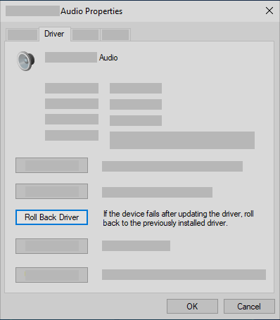

Method 5 – Connect to Another Device
Connect the USB mic to another machine, such as PS4 or even your smartphone (via a USB adapter) and if it does recognize the device properly, then reconnect it to the original computer.
If there's only another PC available, after connecting the USB mic to it successfully, then eject the USB properly from that computer. Chances are the mic will suddenly start to show up on the original computer.

