This article explains what you can do if your USB (external) microphone is not working properly on your Mac.
Check your settings
Configure Microphone Settings
A common reason for Microphone not working on MacBook, Mac Mini or iMac is due to the Microphone not being properly setup or the input volume being kept at a low level.
Click on Apple Logo in top-menu bar and select System Preferences in the drop-down menu.
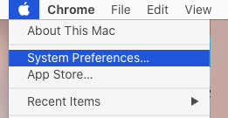
On System Preferences screen, click on the Sound tab.
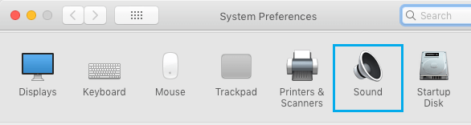
On the next screen, switch to Input tab > select your Microphone from the list and make sure the Input volume is set to maximum level.
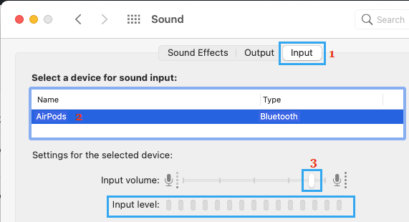
After this, speak into the Microphone and you should be able to see the level bars filling up the entire selection.
Make Sure External Microphone is Listed as Sound Input Device
If you are using an External Microphone for Skype, Zoom or Microsoft Teams calls, make sure that the external Microphone is being recognized by your Mac.
Go to System Preferences > Sound > make sure the External Microphone is available under “Select a Device for Sound input” section.
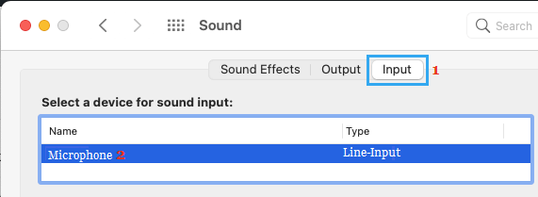
If it is not being recognized, you may need a TRS to TRRS Adapter to make the external Microphone work on your Mac.

Test your microphone
It is possible that the problem is with your microphone. You can easily test this. Do you have another device? Simply plug your mic into another device. Does your mic work now? If it is still not working, it is highly likely that the problem is with your mic. Here is what you can do:
- Check your mic and its cable for signs of damage.
- On your Mac, verify that the microphone is plugged in securely. Make sure that it is connected properly and firmly.
- Disconnect the microphone and reconnect it into the same USB port. Do this a few times.
- Disconnect your microphone and reconnect it into a different port on your Mac.
- If it is still not working, you may want to contact its manufacturer.
If the mic works on a different computer, then we can say that the problem is with your Mac. If this is the case, see the steps below.

Allow Apps to Access Microphone
If the Microphone on your Mac is not working while using third-party Apps (Skype, Microsoft Teams or Zoom), the problem is usually due to the App not being allowed to access the Microphone on your computer.
Go to System Preferences > Security & Privacy > select Microphone in the left-pane. In the right-pane, make sure the Third-Party App is Allowed to access Microphone.
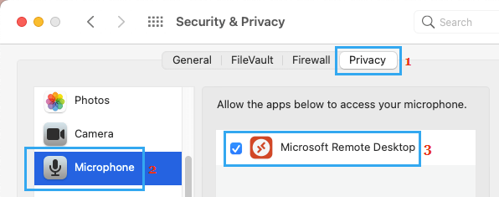
After this, you should be able to use the Microphone on your Mac.

Switch on Dictation
Switching on Dictation mode on Mac (even if you are not using it) should initiate the required launch agents to activate the Microphone.
Open System Preferences > click on Keyboard > on the Keyboard screen, switch to Dictation tab and select the ON option next to Dictation.
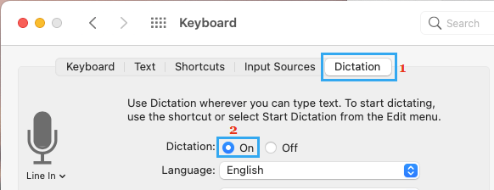
This should download the relevant files required for proper functioning of the Microphone on your Mac.

Make Sure the Microphone is Working
Open the built-in QuickTime Player on your Mac > click on the File tab in top-menu bar and select New Audio Recording option in the drop-down menu.
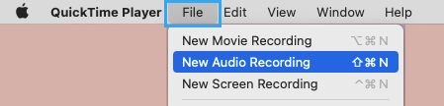
Turn up the volume in QuickTime Player and try to record something in your voice.
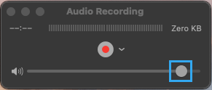
.

Make sure the microphone isn’t turned off or muted
Depending on the microphone, your device may have a mute button or volume control buttons. Check these buttons and ensure that your microphone is not muted. And turn up the volume if needed. And lastly ensure that your microphone is turned on.

Restart Mac
Sometimes, the problem is due to a stuck program, process or minor software glitch interfering with proper functioning of the Microphone.
Click on Apple Logo in top-menu bar and select Restart option in the drop-down menu.
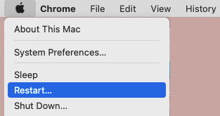
After Mac restarts, check to see if the Photo Stream Album is now showing on your device and it is showing the latest uploaded Photos.

Update
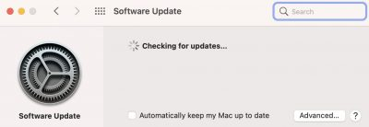
Ensure that your Mac has the latest version of macOS. You can check for updates by going to the Apple menu > System Preferences > Software Update. And if there is an update, click the Update button to update your Mac.

