STEP 1: Go to "Windows setting".
STEP 2: Select "System"
STEP 3: Select "Sound"and go to "Sound Control Pannel"
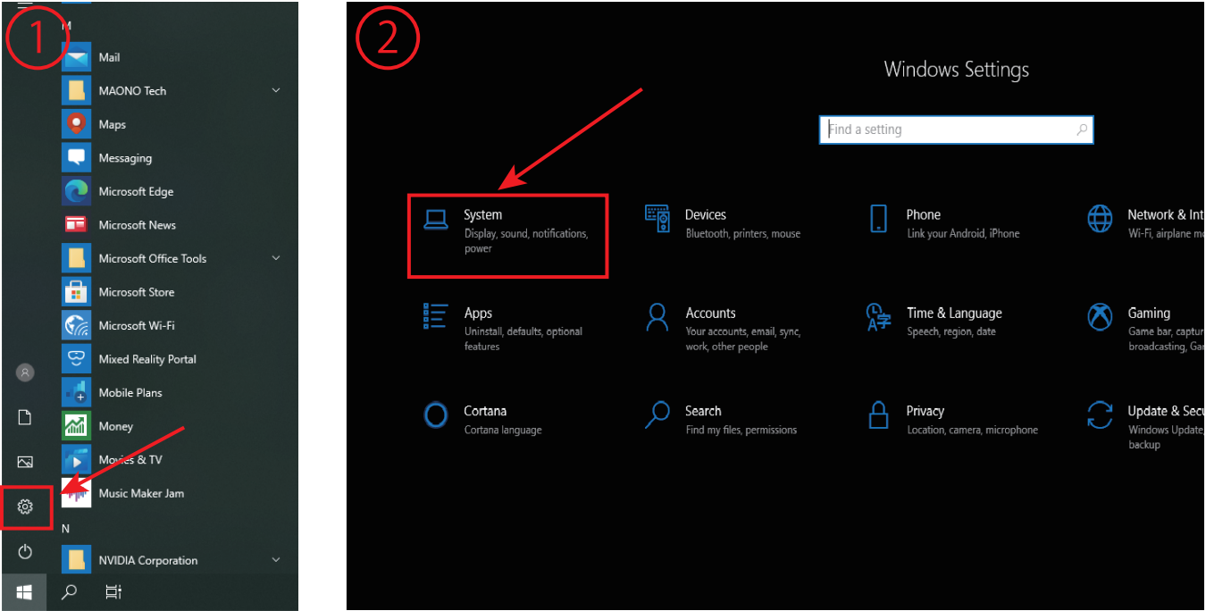
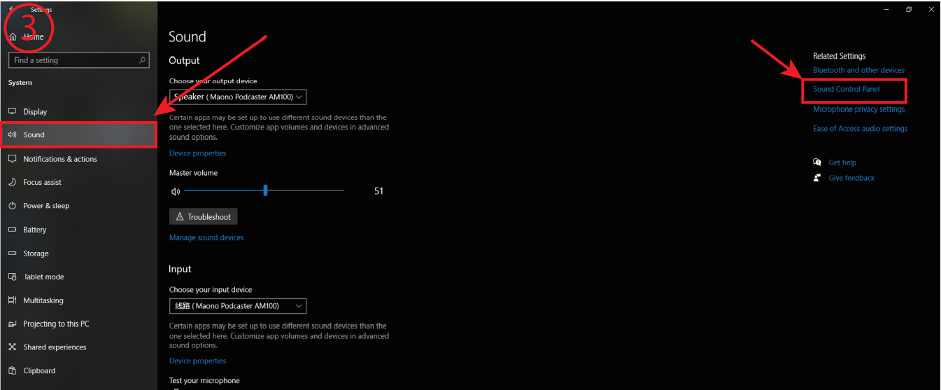

STEP 4: Set AM100 as default recording device in
"Recording"of sound setting.
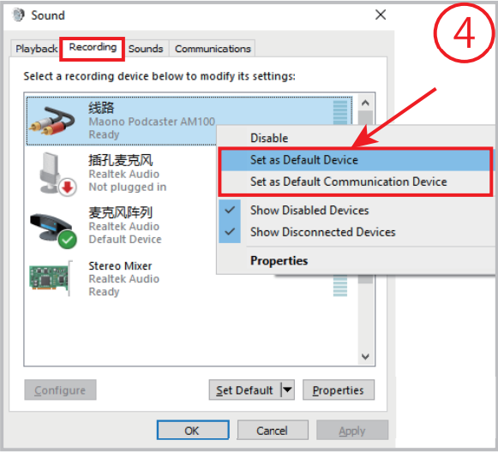
STEP 5: Double click "Maono podcaster AM100"
go to "Properties",and select "Levels"and set it
to100.
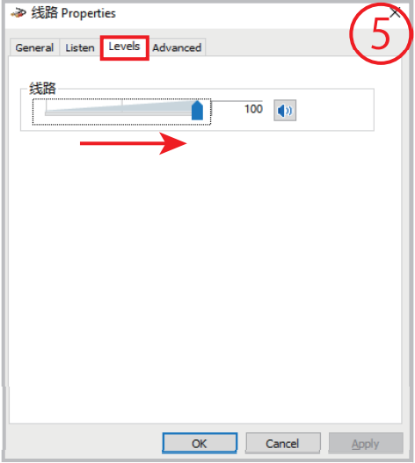
STEP 6: Set the AM100 as default playback
device in "Playback"of sound setting.
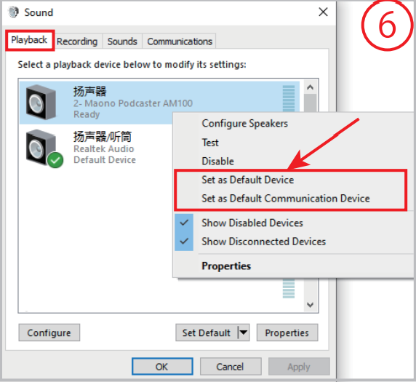

- 打开‘’设置‘’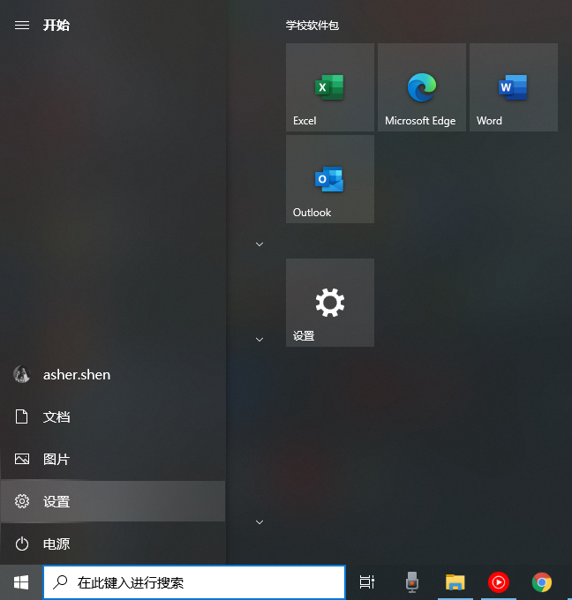
- 打开‘’系统‘’设置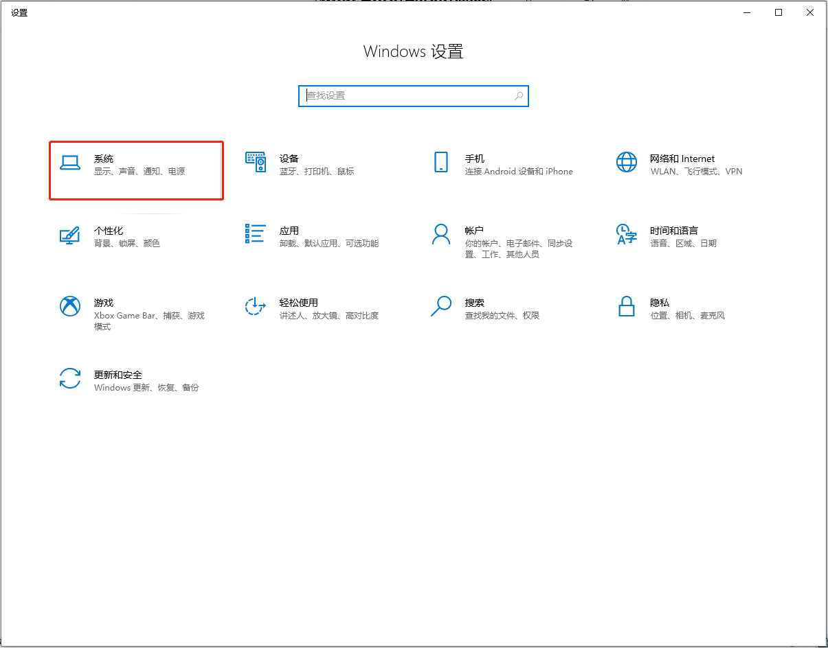
- 选择‘’声音‘’
- 选择“声音控制面板”
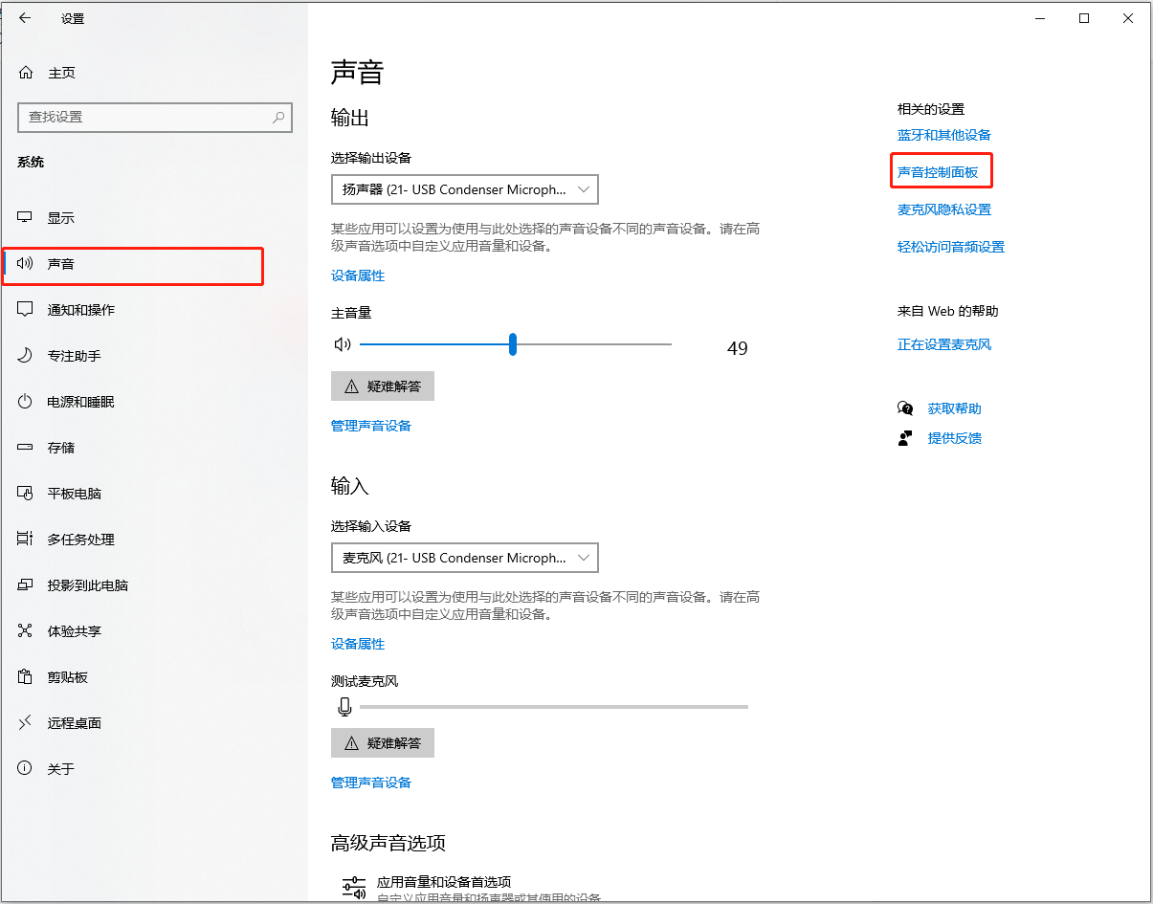

将录制选择‘’设置为默认设备“”设置为默认通信设备”
