Adjust the sound level
Right click on the sound icon
click on“Sound”

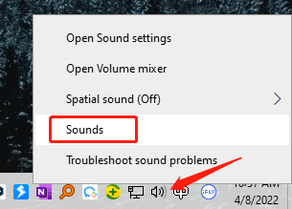

Set Microphone as default recording device in
"Recording" of sound setting.
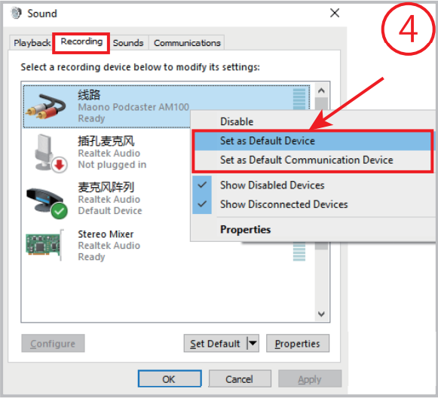
Double click "Maono Microphone"
go to "Properties", and select "Levels" and set it
to 100.
